**Universidad Rafael Landívar**

**Facultad de Ingeniería**

**Ingeniería en Informática y sistemas**

**Arquitectura del Computador II**

**Sección 1**

**Ing. Jefferson Esquivel**

**Laboratorio No. 10 y extra**

**Alexander Gabriel Villatoro Muñoz**

**1182118**

**Guatemala, 28 de abril de 2021**

**Screenshot y Codigo**

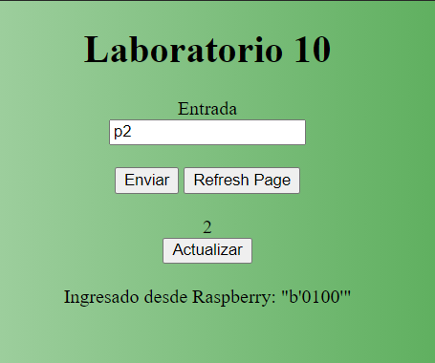

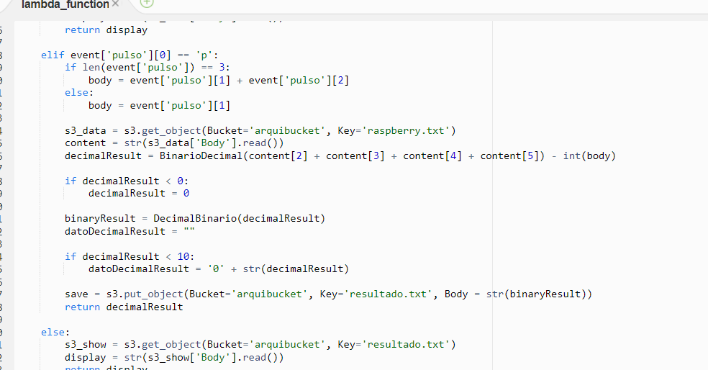

import RPi.GPIO as GPIO

import requests

import time

GPIO.setwarnings(False)

GPIO.setmode(GPIO.BCM)

GPIO.setup(9,GPIO.OUT) #0

GPIO.setup(11,GPIO.OUT) #1

GPIO.setup(5,GPIO.OUT) #2

GPIO.setup(6,GPIO.OUT) #3

GPIO.setup(13,GPIO.OUT) #4

GPIO.setup(19,GPIO.OUT) #5

GPIO.setup(2,GPIO.OUT) #6

GPIO.setup(8,GPIO.OUT)

GPIO.setup(26,GPIO.OUT) #led

GPIO.setup(20,GPIO.IN) #dip bit0

GPIO.setup(16,GPIO.IN) #dip bit1

GPIO.setup(12,GPIO.IN) #dip bit2

GPIO.setup(7,GPIO.IN) #dip bit3

GPIO.setup(18,GPIO.IN) #dip mandar mensaje bit

GPIO.output(26,True)

time.sleep(1)

GPIO.output(26,False)

def binarioDecimal(binario):

if binario == "11111100":

return 0

if binario == "01100000":

return 1

if binario == "11011010":

return 2

if binario == "11110010":

return 3

if binario == "01100110":

return 4

if binario == "10110110":

return 5

if binario == "10111110":

return 6

if binario == "11100000":

return 7

if binario == "11111110":

return 8

if binario == "11110110":

return 9

if binario == "11111101":

return 10

if binario == "01100001":

return 11

if binario == "11011011":

return 12

if binario == "11110011":

return 13

if binario == "01100111":

return 14

if binario == "10110111":

return 15

while True:

binario = ""

contador = 1

display = ""

while GPIO.input(18):

if GPIO.input(20): #si es uno

binario = binario + "1"

else:

binario = binario + "0"

if GPIO.input(16): #si es uno

binario = binario + "1"

else:

binario = binario + "0"

if GPIO.input(12): #si es uno

binario = binario + "1"

else:

binario = binario + "0"

if GPIO.input(7): #si es uno

binario = binario + "1"

else:

binario = binario + "0"

URL = 'https://w95davn4k4.execute-api.us-east-2.amazonaws.com/Fase1/'

URL = URL + "?pulso=r" + str(binario)

response = requests.get(URL)

time.sleep(5)

URL = 'https://w95davn4k4.execute-api.us-east-2.amazonaws.com/Fase1/'

URL = URL + "?pulso=" + str(1)

response = requests.get(URL)

bit0 = response.text[3]

bit1 = response.text[4]

bit2 = response.text[5]

bit3 = response.text[6]

bit4 = response.text[7]

bit5 = response.text[8]

bit6 = response.text[9]

bit7 = response.text[10]

if bit0 == "1" or bit0 == "0":

if bit0 == "1":

GPIO.output(9,True)

else:

GPIO.output(9, False)

if bit1 == "1" or bit1 == "0":

if bit1 == "1":

GPIO.output(11,True)

else:

GPIO.output(11, False)

if bit2 == "1" or bit2 == "0":

if bit2 == "1":

GPIO.output(5,True)

else:

GPIO.output(5, False)

if bit3 == "1" or bit3 == "0":

if bit3 == "1":

GPIO.output(6,True)

else:

GPIO.output(6, False)

if bit4 == "1" or bit4 == "0":

if bit4 == "1":

GPIO.output(13,True)

else:

GPIO.output(13, False)

if bit5 == "1" or bit5 == "0":

if bit5 == "1":

GPIO.output(19,True)

else:

GPIO.output(19, False)

if bit6 == "1" or bit6 == "0":

if bit6 == "1":

GPIO.output(2,True)

else:

GPIO.output(2, False)

if bit7 == "1" or bit7 == "0":

if bit7 == "1":

GPIO.output(26,True)

else:

GPIO.output(26, False)

display = bit0 + bit1 + bit2 + bit3 + bit4 + bit5 + bit6 + bit7

numeroDecimal = binarioDecimal(display)

while contador <= numeroDecimal:

GPIO.output(8,True)

time.sleep(1)

GPIO.output(8,False)

time.sleep(1)

contador += 1

GPIO.cleanup()

