Heuristic Analysis

Planning Search for Air Cargo Transport System

**Performance Summary**

Three **uninformed** **search** algorithms are evaluated and their respective KPIs are as follows.

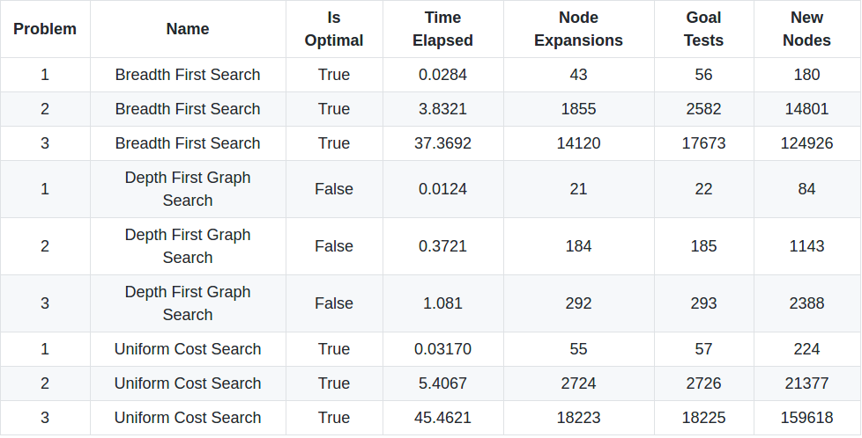Three **automatic heuristics with A* search** algorithms are evaluated and their respective KPIs are as follows.

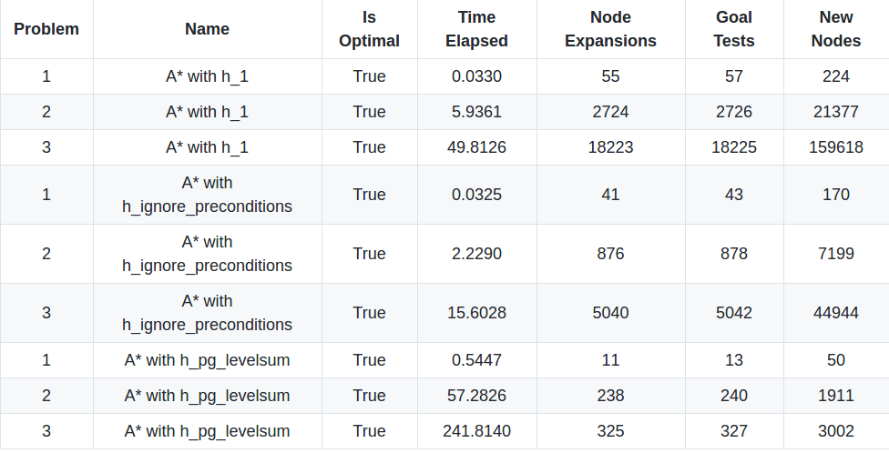

**Performance Comparison**

From the above performance summary, **the A* search with h_ignore_preconditions heuristic appears to be the best planning algorithm for air cargo planning**. The reasons are as follows.

1. The algorithm is optimal.

2. Among all optimal algorithms, it has the second least node expansions, that is, the second least resource constraints on target system.

3. Among all optimal algorithms, it has the fastest running time and scales well as the problem complexity goes up.

Compared with uninformed algorithms, namely BFS, UFS and A* with trivial heuristic, the best one has far less node expansions due to the knowledge induced by informative heuristic. Since less node expansions means less resource constraints on target system, the best algorithm is on the one hand resource friendly.

On the other hand, although the A* with h_pg_levelsum has the least number of node expansions, it suffers from significant runtime overhead incurred by the dynamic construction of planning graph. It makes the algorithm not scalable as the problem complexity goes up.

To sum up, the A* search with h_ignore_preconditions heuristic is the best planning algorithm for air cargo planning.