Heuristic Analysis

Isolation-Playing Agent through Adversarial Search

**Implementation**

Here three custom heuristics are implemented.

The **first** one is just a simple modification of the improved heuristic. Here L2 norm is used to encourage the agent to pursuit a larger margin of the number of legal moves between active and opponent players.

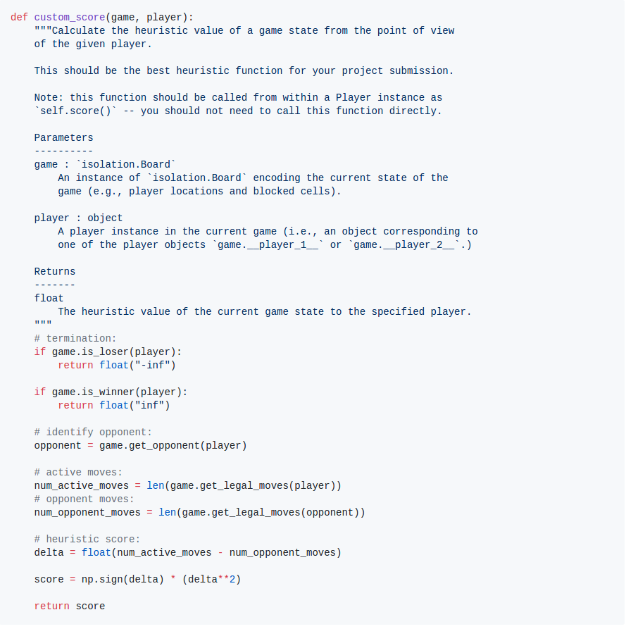

The **second** one is also a simple modification of the improved heuristic. Here L3 norm is used to encourage the agent to pursuit a larger margin of the number of legal moves between active and opponent players.

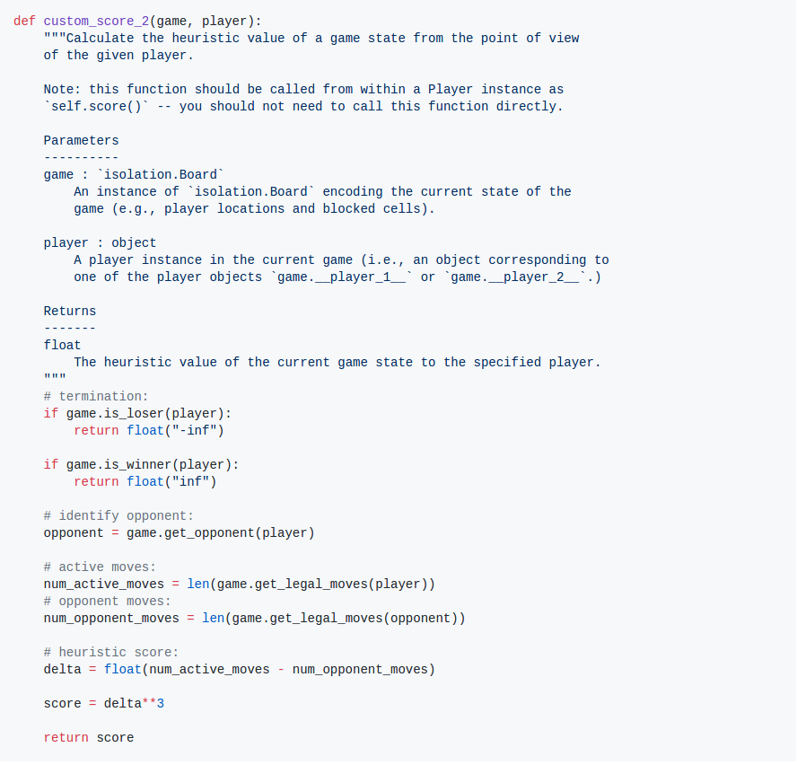

The **third** one combines the ideas from improved and center heuristics. Here a combined score is calculated from both the difference of number of legal moves and center score between active and opponent players.

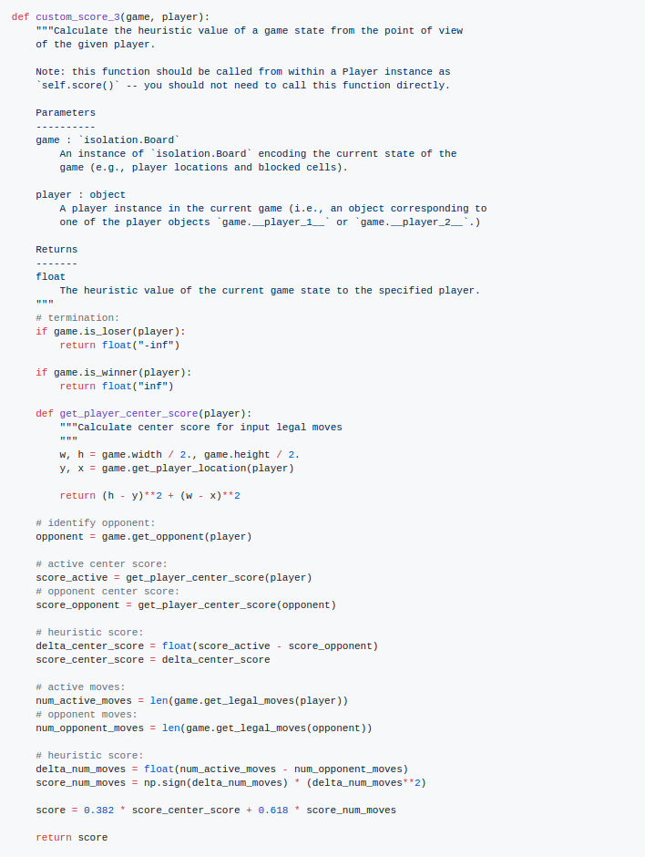

**Performance Summary**

The tournament was carried out three times and the results are as follows:

**Tournament 1**

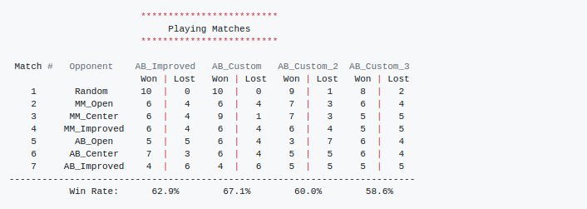

**Tournament 2**

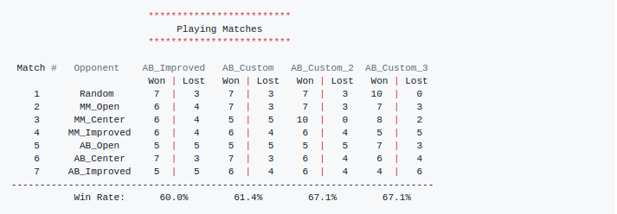

**Tournament 3**

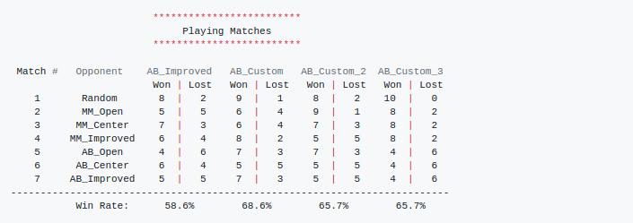

**Heuristic Recommendation**

From the above results, the custom heuristic using L2 norm outperforms the baseline one 3 out of 3 times.

So here the first custom heuristic is recommended for the following reasons:

1. Steadily improved performance over the baseline heuristic.

2. No extra computing overhead(compared with heuristics based on complex human knowledge).

3. No hyper-parameter tuning(compared with the third custom heuristic).