Hyper-V VM setup

2.Setup NAT & StaticRoutes on Routing & remote access

* NIC - 10.2.0.4 - NAT - eth3 / 6
* NIC 10.2.1.4 - LAN - eth4 /5

Machine generated alternative text:
Network Interfaces 
a Remote Access Logging 
General 
Static Routes 
IGMp 
NAT 
I Pv6 
New Interface for Network Address Translation (NAT) 
This routing protocol runs on the interface that you select below 
Interfaces: 
Ethemet 3 
Ethan-et 4 
Intamal 
v Ethemet (Nested) 

Machine generated alternative text:
File Action View Help 
Routing and Remote Access 
Server Status 
v thomas hyperv (local) 
Network Interfaces 
a Remote Access Logging 
General 
Static Routes 
IGMp 
NAT 
I Pv6 
Interface 
Network Address Translation Properties - Ethernet 3 Pr... 
NAT Address Pool Services and P orts 
Interface Type 
Private interface connected to private network 
Public interface connected to the Int emet 
Enable NAT on this interface 
NAT enables clients on this network to send data to and receive 
data from the Intemet using this interface 

Static Routes

1. Setup RAS VPN to Azure Gateway (Can only be configured after group have deployed Landing zone with VPN Gateway)

* Create LocalNetwork Gateway in Azure

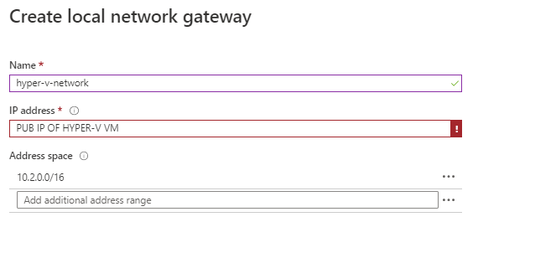

* Configure a new VPN gateway

* Configure a new VPN gateway connection as below (Note down Shared key as it will be used on hyper-v VM later)

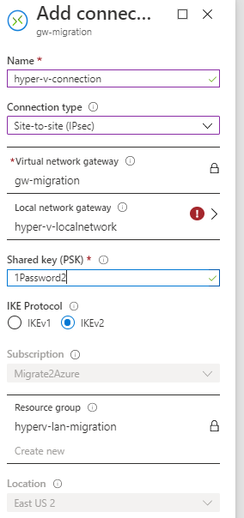

Open Routing and remote access on Hyper-V VM

* Network interfaces -> New-Demand dial interface

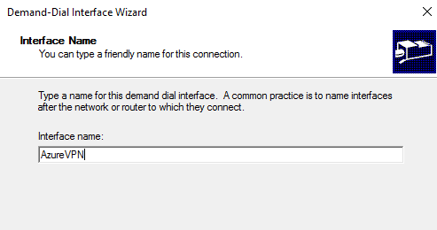

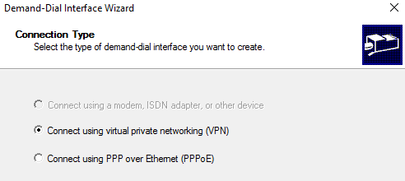

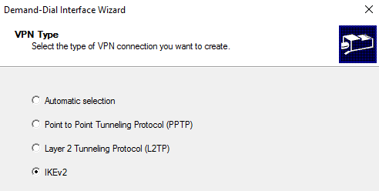

Public IP of Azure VPN Gateway to be added

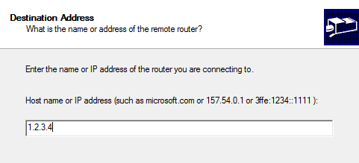

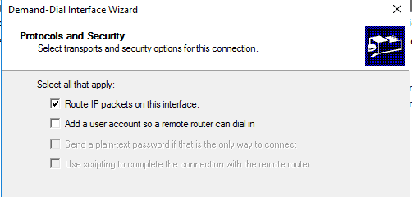

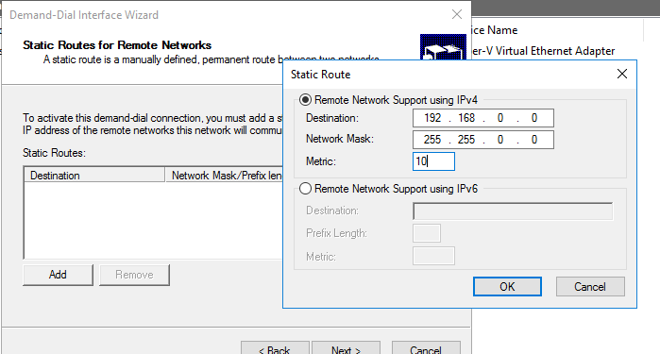

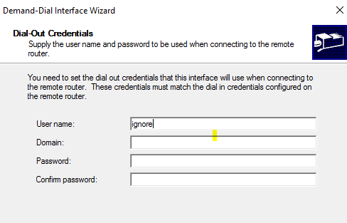

Click Finish

Right click on new interface -> properities -> security and enter the VPN GW connection key you created earlier

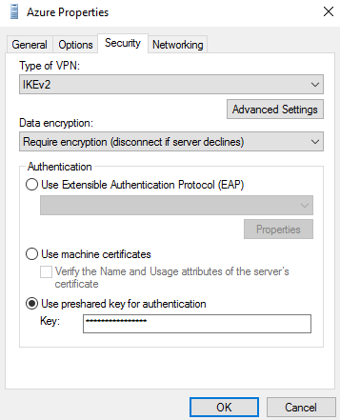

Right click on device and connect

1. Follow Instructor notes.docx
   1. Setup Create the Azure Migrate project and add assessment and migration tools (Migration VM already on Hyper-V just follow instructions to configure with Azure subscription
   2. Configure a server assessment and setup dependency view pre-requirements
   3. Configure and setup Log analytics and dependency agent on each Windows VM & Ubuntu VM that will be planned to be migrated