**UX/UI 23.3.2023 Class Notes – Design Principles**

GUIDELINES  
Efficient information assimilation – This means organize the information that is appropriate for the user audience. E.g., A kid’s app will use more basic words and sentences than a university info app would.

User control over data – The more control you give to users, the more likely they can get confused.  
Data Consistency – Keep it consistent! Same font, font size, styles, etc.

Grab the Users attention!  
This can be size, colour, blinking, size or markings. Audio is commonly used for information. Such as a harsh loud sound for an error or alarm, or a soft tone for notification or function selection.

Facilitating Data Entry  
This should be an efficient process that eliminates frustration and minimize the chances of erroneous mistakes creeping in.

* Consistency
* Minimum unput actions required from user.
* Minimal memory loading
* Limits or bounds of values entered – How can you constrain the information that the user enters? E.g age ranges when requiring a user’s age for enrolment.
* Error detection and notification
* Customization and flexibility (be cautious as this may lead to inconsistency)

PRINCIPLES

1. Determine your target audience the user’s skill. Characterise the users after obtaining info. Do not assume you know your users! Are they novice users? Experts? Knowledgeable intermittent users?
2. Identify the Tasks. All identified tasks have their frequency of use and estimated impact.   
   Special keys or shortcuts may be assigned for frequent tasks, functions, and activities.

Less frequent tasks may involve longer shortcuts or no shortcuts at all.

1. Choose an interaction style. With users and tasks well quantified, decide on the interaction style.  
    - Direct manipulation  
    - Menu selection  
    - Form fill in
2. The Eight Golden Rules.

* Strive for consistency.
* Universal usability
* Informative feedback
* Prevent errors. Constrain user input.
* Dialogs and interactions yield closure. E.g., after a bank transfer if would tell you your new balance. Show what happened!
* Reduce or eliminate memory load.
* Permit easy reversal of actions (Undo)
* Support internal locus of control. Put your users in the driver’s seat. At least give the perception that they know what is happening.

1. Retaining human control.

* Making critical decisions. What should machines do and what should people do?
* Coping with unexpected events. What happens if a user deletes their database? Can you restore a backup? Can you protect your users from making these impactful mistakes?
* Planning future actions or activities. Are machines doing what they should be doing? Are people overseeing the machines to ensure its operation?

THEORIES

1. Theory types: grouped as four main elements.  
   Predictive – compare execution time, error rates. Did users find settings faster or slower than the previous design iteration?  
   Descriptive – Useful for developing new terminology  
   Explanatory – Sequence of events, cause and effect. How does something operate?  
   Prescriptive – Guidance for designers’ choice much like a doctor prescribing medication. If you’re creating an application to suit civil engineers, you should use “this” specific language.
2. Theory types part 2  
   Motor – pointing with a mouse, keyboard strokes (human motor skills)  
   perceptual – locating an object on the display, predicting reading times  
   cognitive – a sequence of steps to complete a task such as transferring funds  
   Taxonomies – grouping into understandable categories such as gaming devise or user personality types ( Convergent vs Divergent).Divergent is shallower thinking but more lateral. Thinking outside the box is divergent thinking.
3. Design by levels  
   Text

   Description automatically generated

Lexical is much more specific than the previous levels and more solidified. Conceptual is just the idea and what the requirements are. We haven’t yet designed and interface but at the lexical level we should have solidified all requirements to a concise and detailed level. Feedback to the user indicates their task has been initiated/completed.

1. Stages of action models is the alternative approach to developing the explanatory theories is to show the stage of action the users go through when trying to use an alternative device.   
   a. Forming the goal  
   b. Forming the intention  
   c. Specifying the action  
   d. Executing the action  
   e. Perceiving the system rate  
   f. Interpreting the system state.  
   g. Evaluate the outcomes.

For every task your user has to take, go through these levels of stage of action models.

Consistency in some regards is a virtue. This is called sustained inconsistency. A good example of this is the QWERTY keyboard that continues to be present through the modern day.

CONTEXTUAL THEORIES

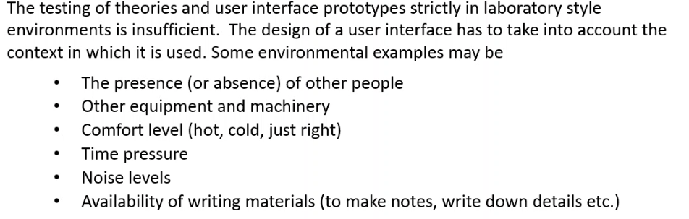

Context is important! Design a user interface with context in mind. Not the elements itself, but what is happening around the user such as the environment. Is the screen in direct sun? Does it need more contrast? Is it on a mobile phone where sunlight might glare on it? Design your elements accordingly in relation to the context and environment of its users.

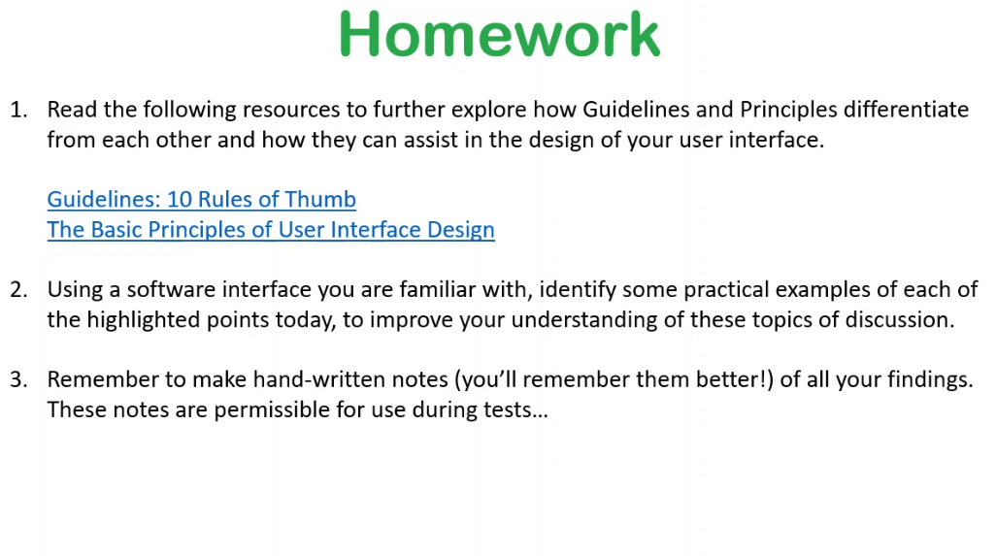

Homeowrk links  
10 Rules of Thumb - <https://www.interaction-design.org/literature/article/user-interface-design-guidelines-10-rules-of-thumb>

Basic Principles of UI Design - <https://www.uxpin.com/studio/blog/ui-design-principles/>