Alex’s Music Forum – Lab 4 https://www.doc.gold.ac.uk/usr/473/

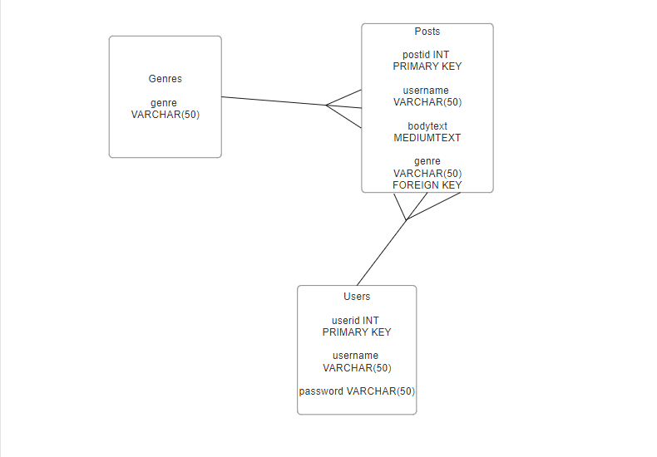

Extensions

User Profile page for every user
Use of bootstrap for aesthetics
User login
Only used GitHub, no filezilla

