1.GET:https://212.98.189.156:12490/jetCloud/apps/zjblessons/jblesson02/v01/01.xsodata/zjblessons_base_Headers

GET:https://212.98.189.156:12490/jetCloud/apps/zjblessons/jblesson02/v01/01.xsodata/zjblessons_base_Headers('100')

2.POST:https://212.98.189.156:12490/jetCloud/apps/zjblessons/jblesson02/v01/01.xsodata/zjblessons_base_Headers

Body:{

"Version":"A",

"HeaderID":"",

"DocumentNumber":"53",

"PlantID":"2225",

"Description":"cherry nine 777",

"CreatedByFullName":"Aleksandr Sokolovskii"

}

3.PATCH:https://212.98.189.156:12490/jetCloud/apps/zjblessons/jblesson02/v01/01.xsodata/zjblessons_base_Headers('d1b1000454')

3.GET:https://212.98.189.156:12490/jetCloud/apps/zjblessons/jblesson02/v01/01.xsodata/zjblessons_base_Headers?$filter=CreatedByFullName eq 'Aleksandr Sokolovskii'

GET:https://212.98.189.156:12490/jetCloud/apps/zjblessons/jblesson02/v01/01.xsodata/zjblessons_base_Headers?$select=CreatedByFullName,Version

GET:https://212.98.189.156:12490/jetCloud/apps/zjblessons/jblesson02/v01/01.xsodata/zjblessons_base_Headers?$skip=10

POST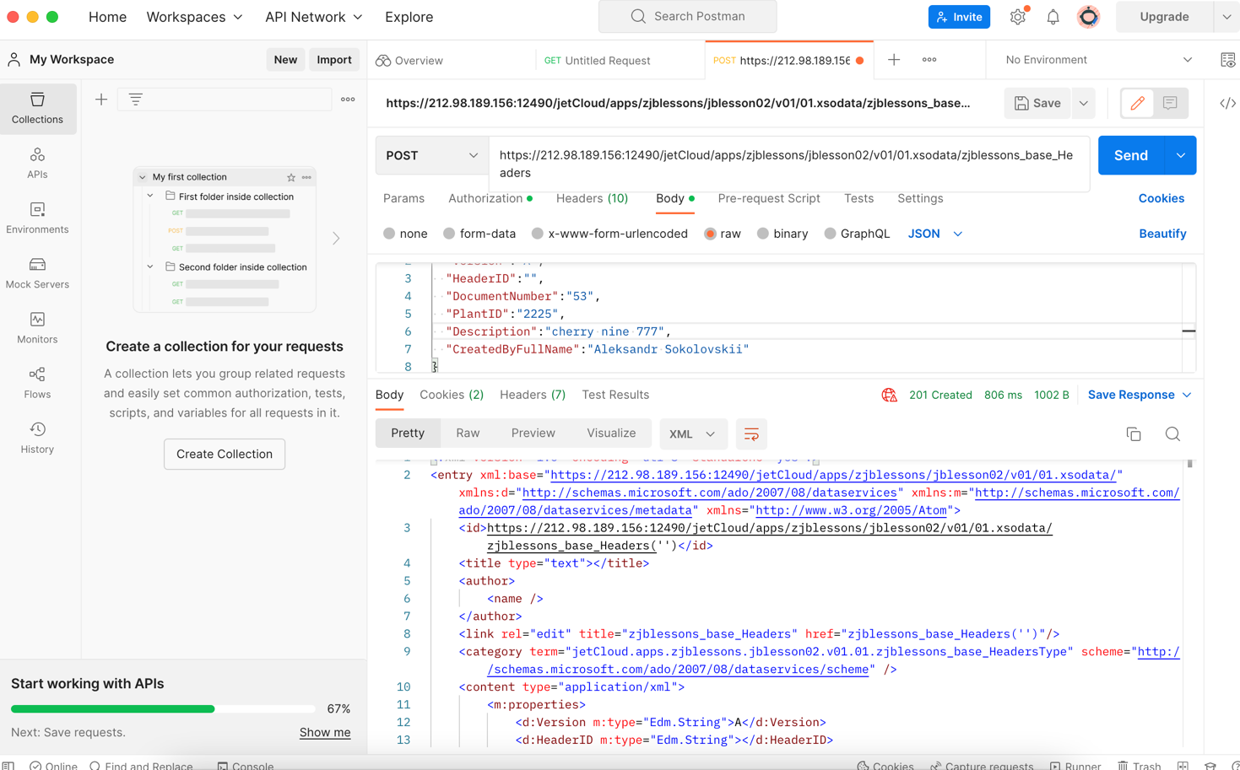

PATCH