Justin Keeling
Alex Harry
John Lambrecht
1) MAX-DISTANCE: Poof

2) O (V-1)

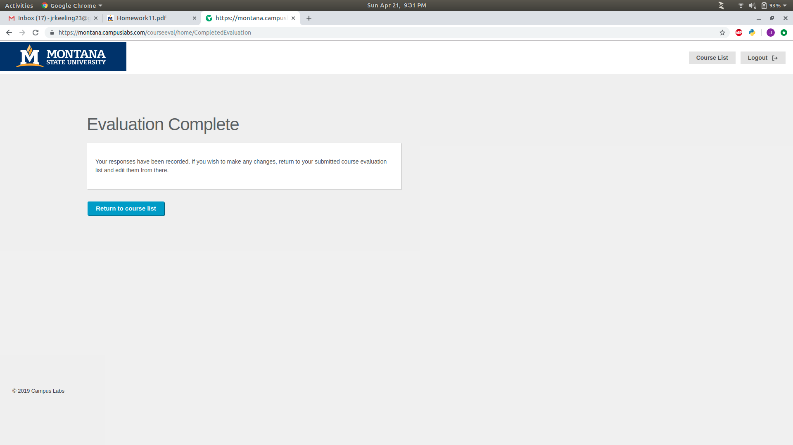
3)

