Student name : **Aly** **Elalwany**

Neptun code : **WGL13Q**

## The content will be used with the wireframe submitted along with this MSWord file.

### Home page

Picture of the author to be displayed on the homepage. Along with a short description.

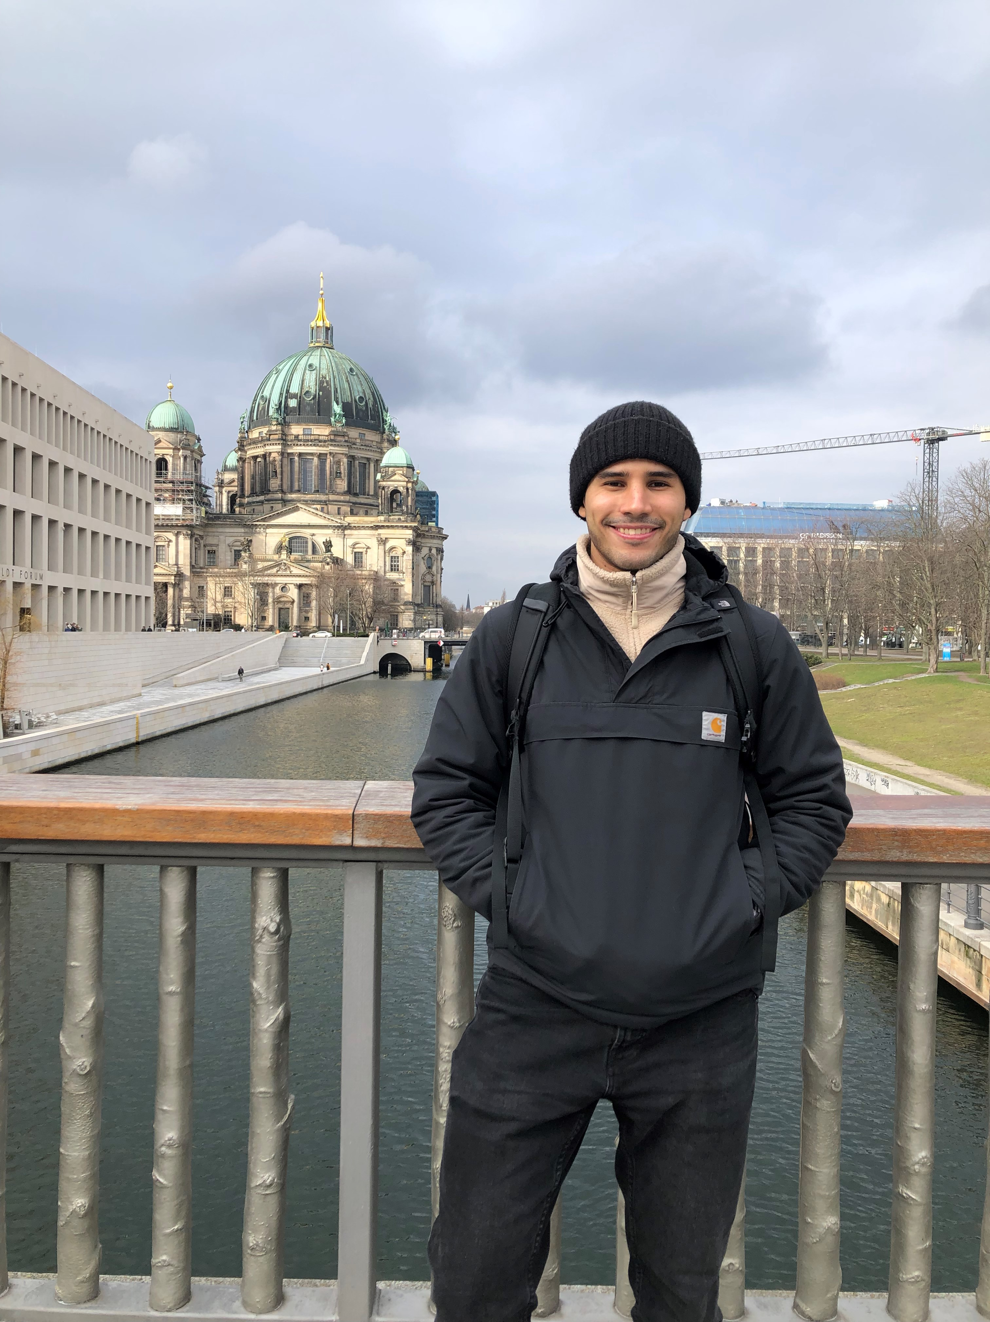

A video thumbnail to be used as a trigger to call the URL to the video on the respective platform.

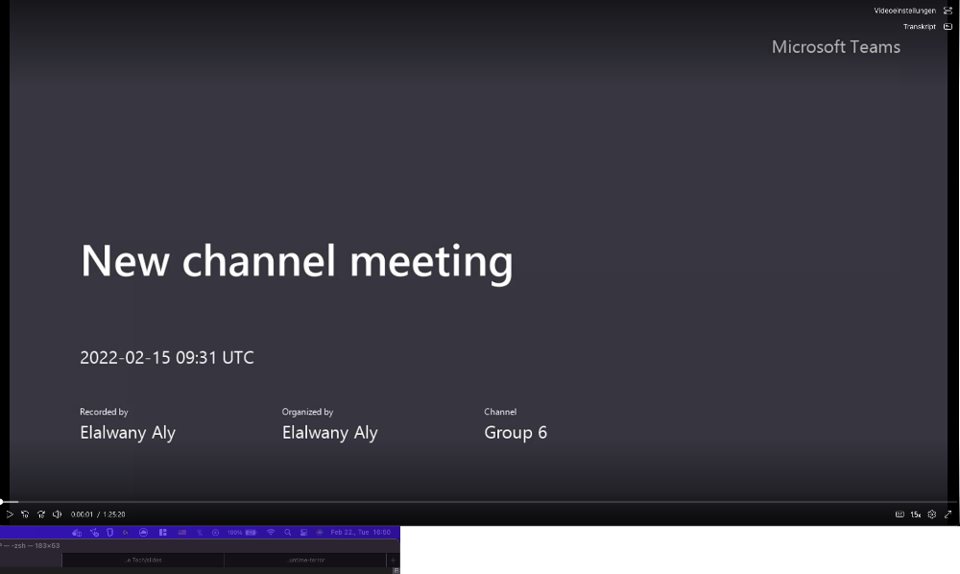

A picture of a mountain climber to be used with a small description of the author’s afk activities. 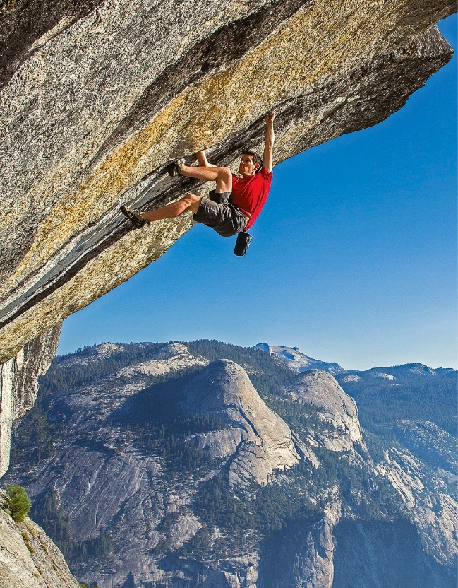

### Projects page

Picture of SAP’s logo along with a short description of the project the author is currently involved with.



Picture of LambdaRent’s logo along with a brief documentation of the technologies used in the project the author is currently involved with.



Picture of ELTE’s logo along with some responsibilities and text about the title.



### Gear page

Picture of a **Macbook** **Pro** **2018** which the author is using.



Picture of a **Lenovo** **Thinkpad** **T440** which the author is using.

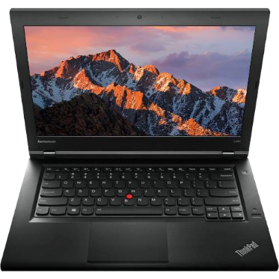

Picture of a **Razer** keyboard the author recommends for fast typing. 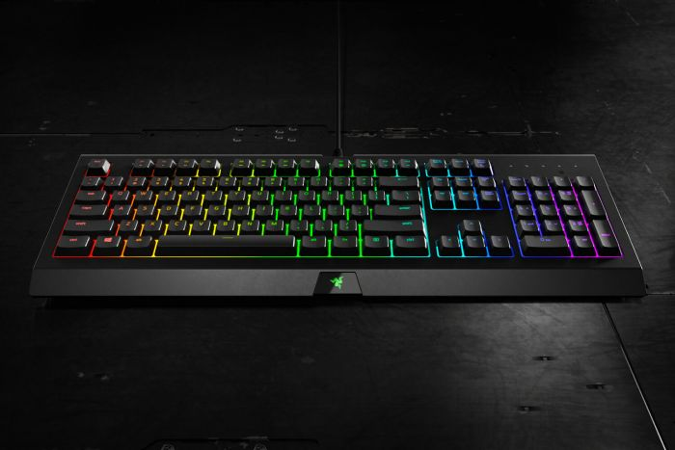

Picture of a **Logitech** mouse the author recommends for increased productivity.

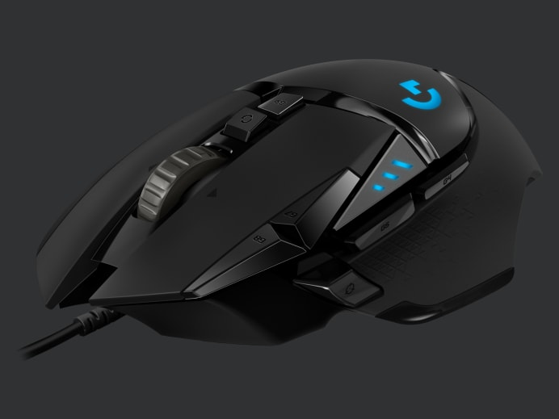

Picture of **VSCode**- the code editor the author uses – and the color theme of **GitHub**.

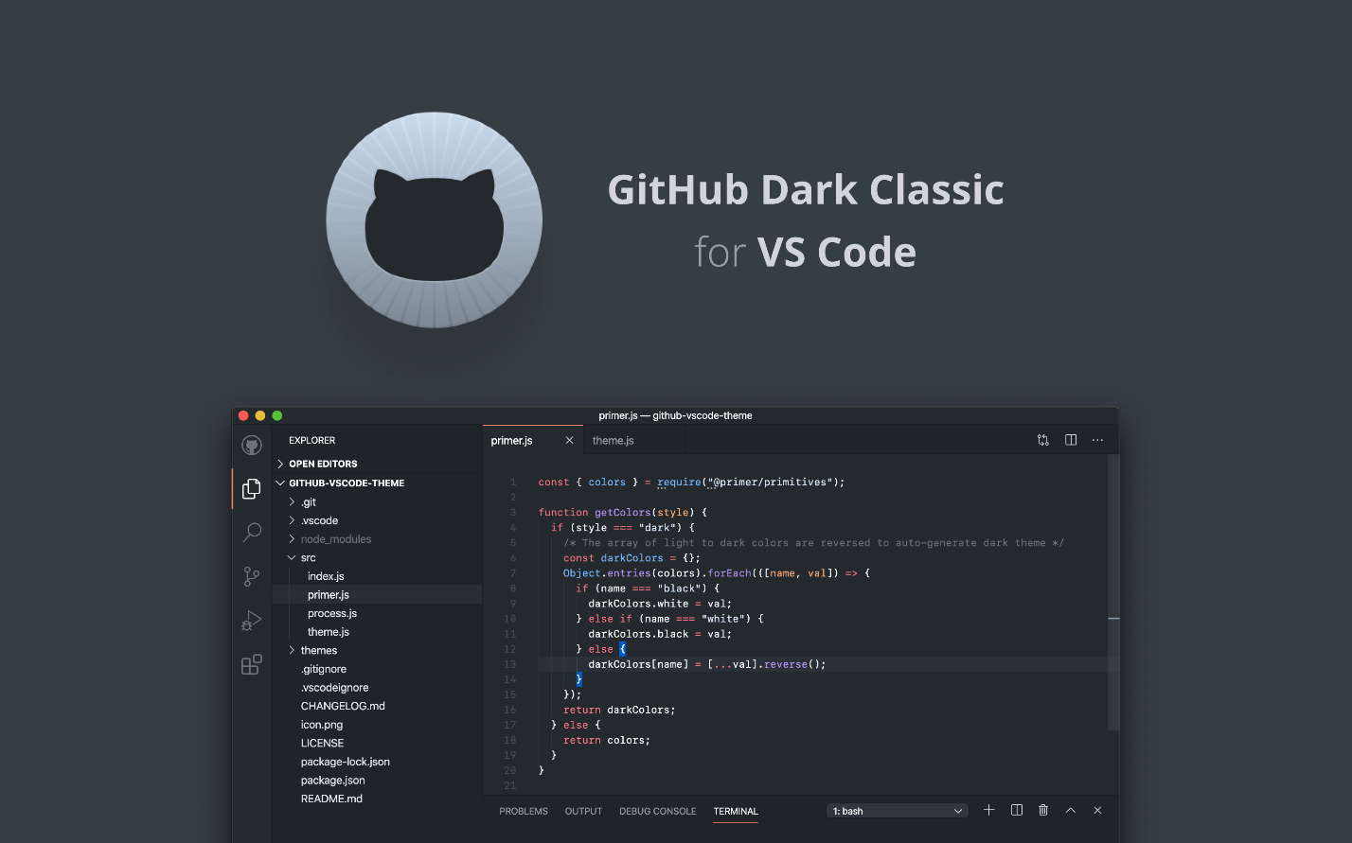

Picture of a terminal window for **iTerm2** which the author recommends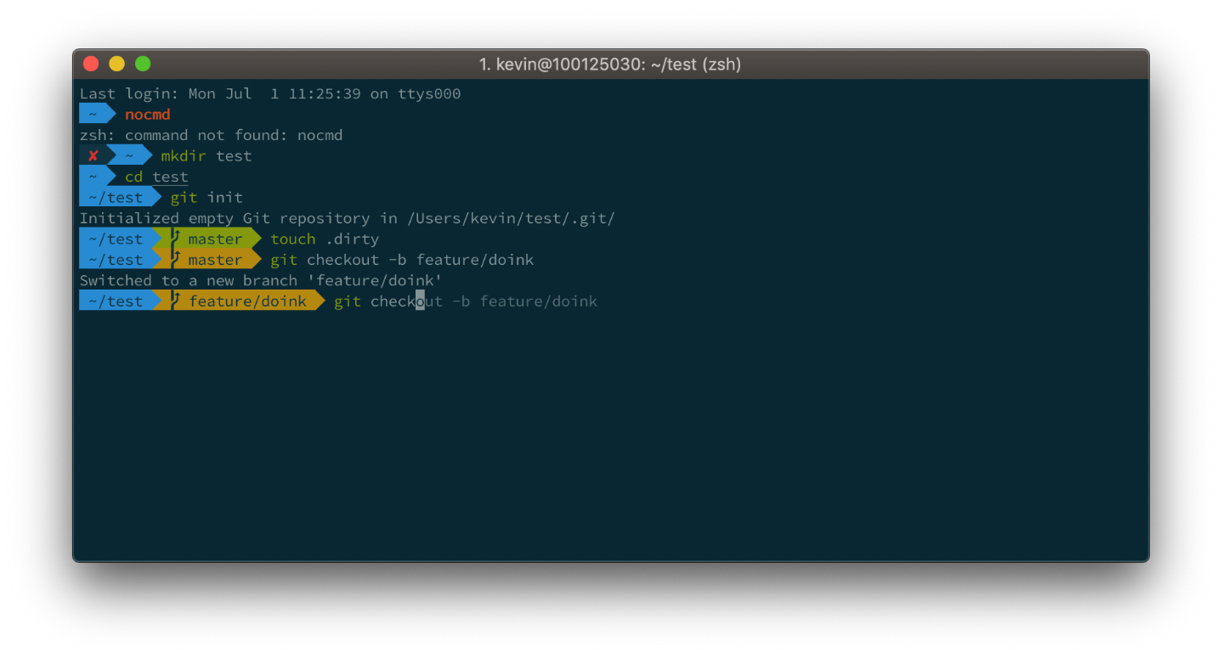

Courses page   
  
This page only contains the background image behind the OOP timetable. The blurriness is desired because it will be a background image.



This is not a picture but an embedded form which the user can use.

