Design of an Attendance Management and Registration System for Cultural or Organizational Events.

Double-blind peer review of authors is not guaranteed if authors are listed.

After acceptance, you upload the final version with authors and their affiliations

~~First Author~~ ~~1~~ ~~; Second Author~~ ~~2~~ ~~; Third Author~~ ~~3~~



~~1.3~~ *~~First and Third Author's University, Country, first.author@email.edu, third.author@gmail.com~~*

~~2~~ *~~Second Author's University, Country,~~* [*~~second.author@email.com~~*](mailto:second.author@email.com)

***Abstract– In the management of cultural and organizational events, having an efficient attendance management and registration system is key to success. This article proposes the design of an attendance management and registration system for events, optimizing the control and administration of participants. Based on PHP Laravel and MySQL, the system uses QR codes to streamline attendance registration, ensuring accuracy, security and speed in real time.***

***The system development follows the agile Scrum methodology, allowing for constant iterations and improvements based on feedback. Its user-centered design, based on UX/UI principles, ensures an intuitive and accessible platform, reducing the learning curve for organizers and attendees.***

***In addition to automating administrative tasks, the system incorporates real-time data analysis, allowing for monitoring capacity, evaluating participation and optimizing event planning. Integration with MySQL databases ensures secure and structured storage, complying with data protection standards through JWT and OAuth2.***

***With a focus on efficiency, scalability and usability, this prototype represents an innovative solution for event management. Its design, based on the experience and needs of the Department of Art and Culture of the Don Bosco University, where it is intended to be implemented in the future, guarantees its adaptation to a real environment and its capacity to optimize the organization and use of resources in different sectors.***

***Keywords—Attendance registration, Database, Event Management, User Experience, User Interfaces .***

# I. Introduction

Managing and recording attendance at events presents multiple challenges, especially in terms of accuracy, efficiency, and accessibility. In many cases, organizers rely on manual methods, such as paper lists or spreadsheet records, which are prone to errors, data loss, and difficulties in consolidating information in real time. Furthermore, the lack of automation complicates the analysis of attendance metrics, making it difficult to make strategic decisions for future editions of the event [1].

Another common issue is user experience, for both attendees and organizers. Unintuitive check-in processes can lead to long lines, delays, and difficulties with identity verification. Additionally, the lack of integration with emerging technologies, such as quick response (QR) codes, limits the possibilities for optimizing and personalizing the cultural experience [2].

From an administrative point of view, the absence of a centralized system prevents the generation of real-time reports, making it difficult to access key information to evaluate the impact of the event and improve the planning of future activities. An efficient attendance record not only allows controlling the access of attendees, but also managing the capacity level of the venue, facilitating the organization and optimization of resources [3].

Among the main advantages of an automated attendance register are greater security, by allowing exhaustive control of the occupancy level of each area of the event; greater efficiency, since appropriate technology reduces queues and crowds at entrances and exits; and a better experience for attendees and staff, since the combination of security and efficiency increases general well-being during the event [4].

Being able to control the occupancy of the venue is a crucial aspect in event management. In addition, optimizing resources at each moment of the event allows for increasing staff in high attendance areas and reducing it when attendance is low, which improves efficiency and reduces costs. It is also important to define and control the attendees who go to each room, which allows us to know their preferences and, in the future, offer more personalized experiences. Likewise, generating reports on the length of stay of each attendee helps to identify the busiest areas of the event and the average stay, which facilitates the improvement of future editions and the optimization of the user experience [5].

To address these challenges, this article presents the design of an attendance management and registration system for cultural and organizational events. The proposal includes the conceptualization of a platform that allows automated access control through modern technologies, improving security, efficiency and attendee experience. In addition, a structured data model is proposed to facilitate the generation of real-time reports and the analysis of key metrics for future editions of the event.

The design of the system is based on the experience and needs of the Department of Art and Culture of the Don Bosco University, where it is intended to be implemented in the future. This collaboration allows the solution to be adapted to a real environment, ensuring that it responds to the specific requirements of cultural event management at the institution. In this context, this work focuses exclusively on the design phase of the system, addressing architectural, technological and usability aspects, with the aim of laying the foundations for its future implementation and improvements.

# II. Methodology

*A.*  *Description of the development methodology*

For the design of the event management and attendance registration system, the agile SCRUM [6] methodology was selected due to its set of good practices that encourage collaborative teamwork, optimizing the project results. This methodology allows for flexible development through partial and regular deliveries of the final product, prioritizing those functionalities that provide the greatest value to the user.

The project is executed in short, fixed-length cycles of two weeks. Each iteration provides a complete and functional result of a requirement item, which facilitates adaptation to changes and continuous improvement of the system. In addition, for the design of the interface (UI) and the early validation of the user experience (UX), prototyping in Figma[7] is used, allowing the visualization and adjustment of the user interaction before its implementation.

*B.*  *Technologies used*

For the design of the event management and attendance registration system, various technologies were used. Laravel[8], as a PHP[ 9 ] framework, was used to create the structure and logic of the system, facilitating the implementation of the MVC[10] model, and the efficient management of routes and controllers. MySQL[11] was used as the database management system, allowing the storage and consultation of event and attendee information. Finally, PHP was the main programming language, providing the basis for the system's functionality and its integration with the other technologies mentioned.

*C.*  *System architecture and its operation*

The Event Management and Attendance Registration System is a web platform designed to facilitate event management, registration and attendance control in cultural activities. It is aimed at organizers, administrators and attendees, providing an efficient solution for planning, monitoring and analyzing participation in events. For its development, the Laravel framework was used, which follows the MVC (Model-View-Controller) architecture, allowing efficient management of routes, user authentication and database manipulation. As a database management system, MySQL was used, optimized for efficient queries and the management of large volumes of information. The main programming language is PHP, which facilitates integration with the database and the management of system logic through controllers and models.

To ensure a homogeneous development and production environment, the system is based on Docker, which allows the deployment of the application in containers. Through Docker Compose, multiple containerized services are orchestrated, MySQL database and, optionally, while an SMTP service allows sending email notifications.

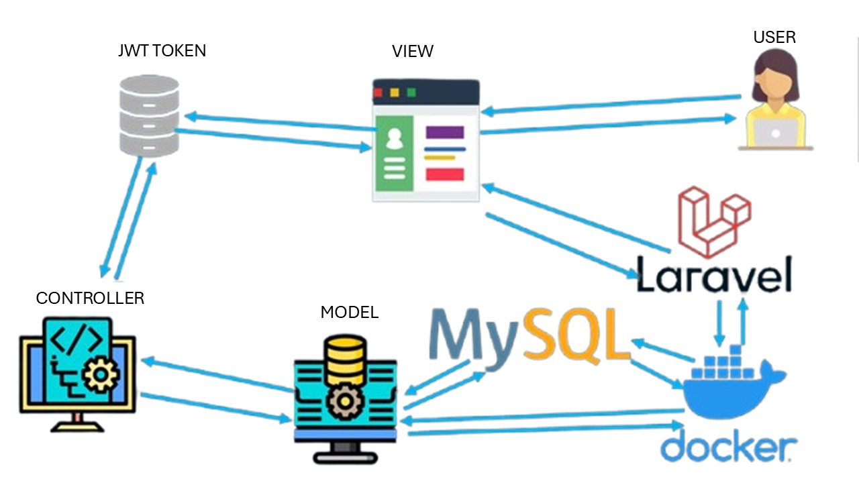

Fig. 1 Shows an example of the recommended software architecture for a project

# II. System Design

*A. System Description*

The system's main functionalities include event management, where organizers can create, edit, and delete events with details such as date, location, and capacity. It also allows for user registration and authentication, where users can manage their attendance at events. Each attendee receives a unique QR code that can be scanned to validate their attendance quickly and securely. Administrators have access to a dashboard where they can view attendance statistics, manage users, and configure events. Additionally, the system sends email notifications to confirm registrations and send event reminders. Thanks to this architecture and integration with modern technologies, the system offers a scalable and efficient solution for event management.

*B. User interface*

The design of the user interface (UI) and user experience (UX)[12] in an event registration and management system is a key factor in ensuring its effectiveness and adoption. Since these types of systems are often used by organizers, administrators, and attendees with different levels of technological experience, it is essential that the interface is intuitive, accessible, and efficient in managing registrations and queries.

The UI design of the system should prioritize a clear organization of the elements on the screen, with a structured navigation that allows users to quickly access essential functions, such as event creation, participant registration, report generation, and real-time attendance monitoring. It is recommended to see Fig. 2 to observe the use of a color palette that differentiates important sections, understandable iconography and legible fonts to improve the visual experience and speed in decision-making.

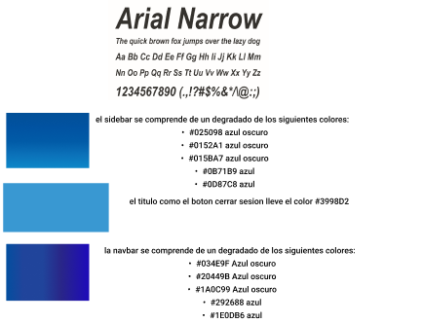

Fig. 2 Shows an example of the recommended color palette and typography for a project

From a user experience (UX) perspective, the system should minimize the learning curve by offering streamlined workflows and reducing the number of unnecessary steps in the registration and administration processes. Integrating dynamic forms, auto-completion, real-time validations, and interactive notifications can improve system efficiency and reduce data entry errors (see Fig . 3 ).

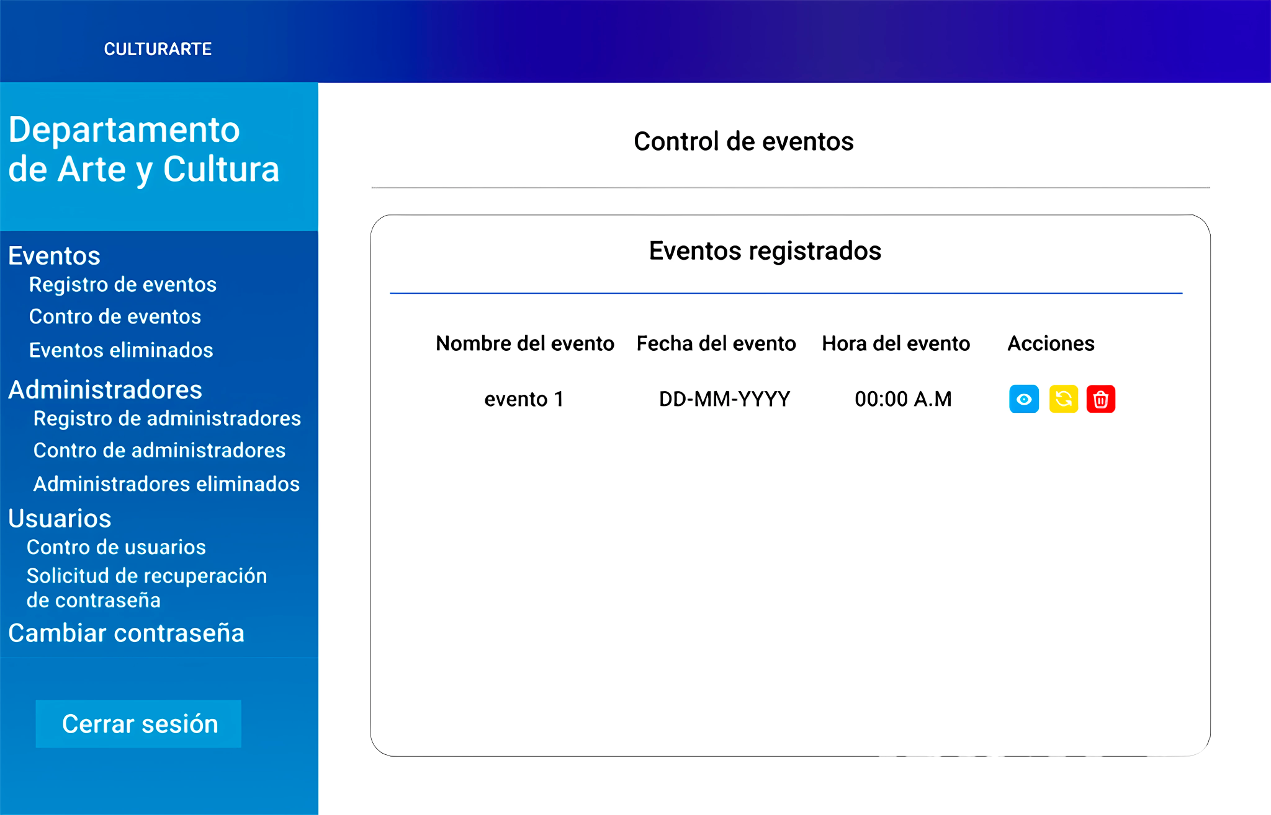

Fig. 3 Shows the main screen from where all administration options are managed.

In terms of usability, the system must ensure that administrators can manage events quickly and effectively, while attendees can register their participation without difficulty. To do this, mechanisms such as the generation of QR codes for quick access, synchronization with external databases, advanced filters for searching for records and automatic reports that facilitate decision-making can be implemented. Accessibility must also be considered, ensuring that people with different abilities can interact with the platform through options such as compatibility with screen readers, hotkeys and customizable settings in the interface.

*C. Automation and data collection*

The event management and registration system is designed to optimize participant management and data collection by using integrated databases with API services. This architecture allows for seamless communication between the user interface and the backend, ensuring efficient processing of information in real time. Thanks to data centralization and process automation, the accuracy of attendance registration is improved and decision making based on up-to-date data is facilitated.

The system database stores all relevant information in a structured manner, recording events, attendees, organizers and attendance details. Through the use of a well-defined API, this data can be securely accessed, modified and queried from any authorized device. This approach not only prevents redundancies and errors in information, but also allows for the synchronization of multiple access points, ensuring data consistency.

Real-time attendance registration and validation is one of the key features of the system. Using API services, attendees can register and confirm their attendance using various methods such as web forms, QR codes. The API interacts with the database to automatically verify the validity of registrations, avoiding duplication or incorrect information. This automation reduces the operational burden on administrators and improves the attendee experience as the registration process becomes more streamlined and secure.

Another key aspect of the system is process automation and report generation. Through API queries, administrators can access detailed information about event attendance, apply filters based on specific criteria, and export data in formats such as PDF. This functionality allows the effectiveness of organized events to be evaluated and facilitates decision-making based on accurate information. The ability to generate real-time statistics provides analytical insight that can be used to improve the planning and management of future events.

*B. Security and data protection*

Integration with other services and platforms is another important benefit of using APIs in this system. Thanks to this technology, the system can connect with email platforms to send automatic notifications, authentication systems such as OAuth or SSO to improve security, and messaging tools for direct communication with attendees.

Security and access control are critical aspects of event attendance management, and the APIs implemented in the system ensure the protection of information through authentication and authorization mechanisms. Technologies such as JWT and OAuth tokens allow only authorized users to access certain levels of information or modify specific records, ensuring data integrity and preventing unauthorized access. These security measures are essential to comply with data protection regulations and build trust among system users.

# III. Discussion

The proposed design has been evaluated in comparison with existing solutions on the market and in academic literature, which has allowed us to identify its main advantages and opportunities for improvement. Unlike other implementations, this proposal stands out for being cheaper and integrating new technologies to be able to migrate to the cloud in the future. This comparison showed strengths such as ease of use, scalability, and interoperability and areas where it is still possible to optimize its performance, especially in aspects such as compatibility.

During the design phase, several constraints were identified that influenced the viability of the project. These included limitations regarding hardware restrictions, compatibility with existing platforms, and the need for high processing capacity. These limitations represented a significant challenge, as they conditioned the full development of certain functionalities and led to the need for adjustments in the project planning.

Throughout the development process, several challenges also arose that prevented the full implementation of the solution at this stage. Key obstacles encountered included regulatory barriers and compatibility issues with existing infrastructures. These factors highlight the importance of detailed planning and exploring alternatives to overcome these barriers in future iterations of the project.

# IV. Conclusion and Future Work

The presented design represents an innovative solution for the administration and control of attendance at events, integrating automation, connectivity and real-time data analysis. Its implementation has the potential to generate a significant impact in areas that manage events, by offering improvements in process optimization, cost reduction, and greater precision in decision-making. Although there are still aspects to improve, the results obtained so far indicate that this proposal is viable and represents a promising alternative within its field of application.

The implementation of this solution could bring multiple benefits, such as better accessibility to information and greater efficiency in production processes. In addition, its modular and scalable design allows it to be adapted to different scenarios and needs, expanding its applicability and relevance in different contexts.

To complete the development and implementation of the solution, a series of steps have been identified that will improve its functionality and applicability. First, it is necessary to optimize the prototype, fine-tuning both the hardware and the software to improve its efficiency and stability. Subsequently, experimental validation in real environments is required to evaluate its performance in practical conditions and make the necessary adjustments based on the results obtained.

Another key aspect is to address the limitations identified in the design phase, such as compatibility with other technologies. This will improve the overall performance of the system and ensure its effectiveness in the intended application. In addition, the exploration of technological alternatives that can further enhance the solution is proposed, including the use of emerging tools and innovative methodologies.

These steps will ensure that the design moves towards successful implementation, ensuring its viability and maximizing its impact in the application area. With these improvements and strategies, the project will be able to evolve into a consolidated and effective solution within the field for which it was designed.

Acknowledgement

The Department of Art and Culture of Don Bosco University did not provide information about its experience in organizing cultural events, which would have served as a basis for the development of this system .

References

1. D. Sánchez Silva, "Digital transformation in event planning: keys to innovate and optimize the process," *Daniela Sánchez Silva* , [Online]. Available: [https://www.danielasanchezsilva.com/post/digital-transformation-in-event-planning-keys-to-innovate-and-optimize-the-process](https://www.danielasanchezsilva.com/post/transformaci%C3%B3n-digital-en-la-organizaci%C3%B3n-de-eventos-claves-para-innovar-y-optimizar-el-proceso) . [Accessed: 12-Feb-2025].
2. M. Ruiz González, *Technological innovation: immersive events* , Final Degree Project, Degree in Protocol, Event Organization and Corporate Communication, Univ. Rey Juan Carlos, Vicálvaro Campus, Spain, 2024.
3. Á. Recalde Alguacil, *Capacity control system at events using mobile technology with security services* , Master's Thesis, Master in Computer Engineering, Polytechnic University of Madrid, Higher Technical School of Computer Engineers, Spain, 2023
4. D. Sánchez, "The importance of security in mass events," *Daniela Sánchez Silva* , [Online]. Available: <https://www.danielasanchezsilva.com/post/importancia-de-la-seguridad-en-eventos-masivos>. [Accessed: 12-Feb-2025].
5. Event Analytics: How to Use Data and Analytics to Optimize Your Event Strategy," *Faste Capital* , June 2, 2024. [Online]. Available: [https://fastercapital.com/en/content/Event-Analysis--How-to-Use-Data-and-Analysis-to-Optimize-Your-Event-Strategy.html]. [Accessed: Feb 12, 2025].
6. M. Trigás Gallego, *Scrum Methodology* , Bachelor's thesis, Universitat Oberta de Catalunya, 2012.
7. Figma, "Figma: The collaborative interface design tool," [Online]. Available: [https://www.figma.com](https://www.figma.com/) . [Accessed: 12-Feb-2025].
8. Laravel, "Laravel 11.x Documentation," Laravel, 2024. [Online]. Available:<https://laravel.com/docs/11.x/readme>. [Accessed: 13-Feb-2025].
9. PHP, "PHP Manual," PHP, 2025. [Online]. Available:<https://www.php.net/>. [Accessed: 13-Feb-2025]
10. E. Bascón Pantoja, "The Model-View-Controller (MVC) design pattern and its implementation in Java Swing," *Acta Nova* , vol. 2, no. 4, pp. 493-507, 2004. [Online]. Available:<http://www.scielo.org.bo/scielo.php?script=sci_arttext&pid=S1683-07892004000100005&lng=es&tlng=es>. [Accessed: 13-Feb-2025].
11. Oracle, "What is MySQL?," Oracle, 2025. [Online]. Available:<https://www.oracle.com/es/mysql/what-is-mysql/>. [Accessed: 13-Feb-2025].
12. P. Rajesh, M. Selvadurai, V. Saranya Selvamani, and P. Chandrasekar, *Fundamentals of UX/UI (An Approach to Design Principles)* . Aug. 2022. DOI: 10.47715/JPC.B.87.2022.9789391303389. ISBN: 9789391303389.