**PARTIE RESEAUX**

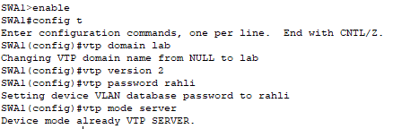**1. Vlans configuration Site A**

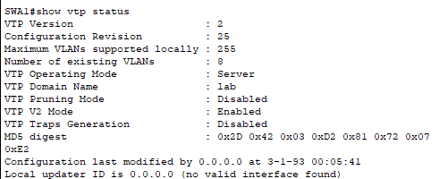

On fait la même chose pour les switch SWA2 et SWD

**SWD :**

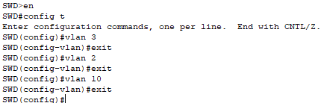

* Interfaces de SWD

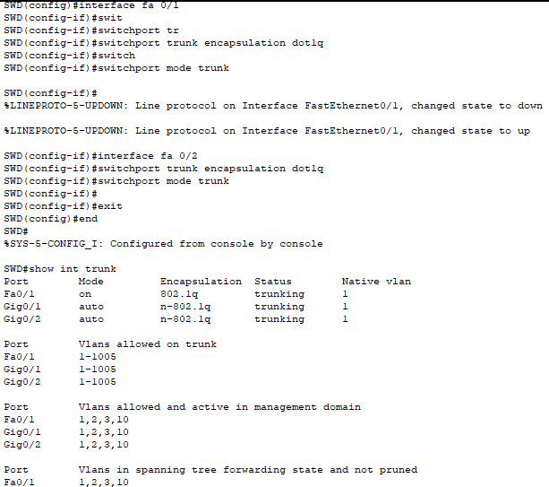

* Interfaces de SWA1

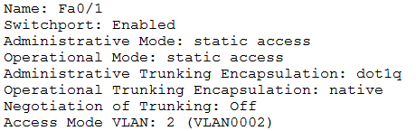

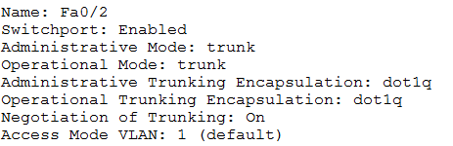

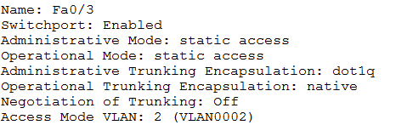

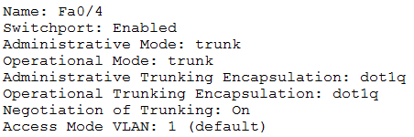

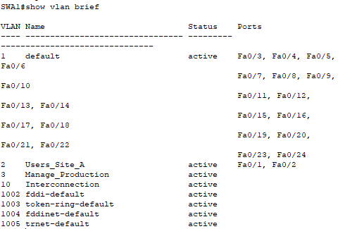

* Interfaces de SWA2

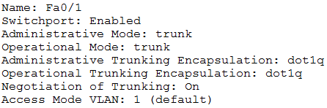

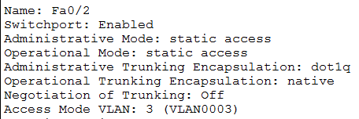

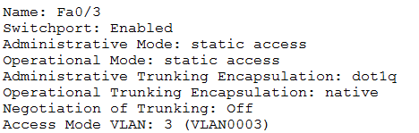

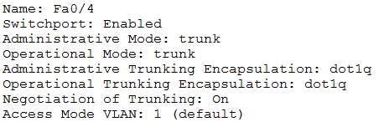

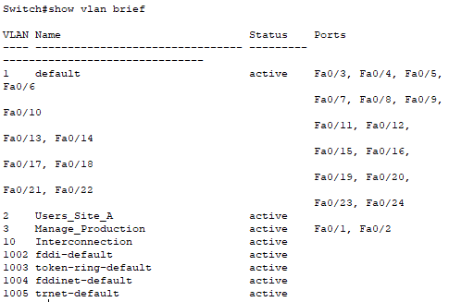

**2. Spanning-tree**

* **SWA2**

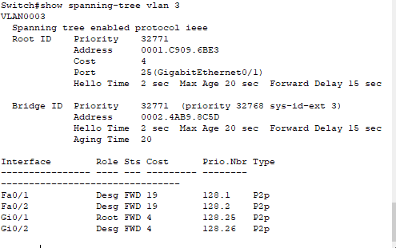

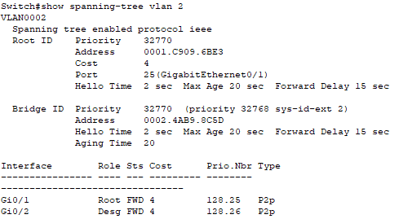

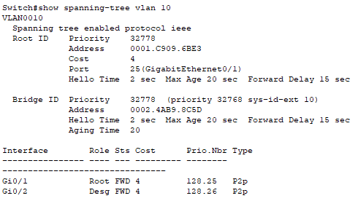

* **SWD**

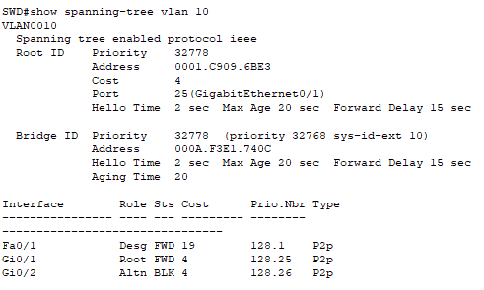

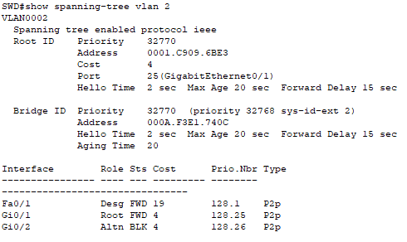

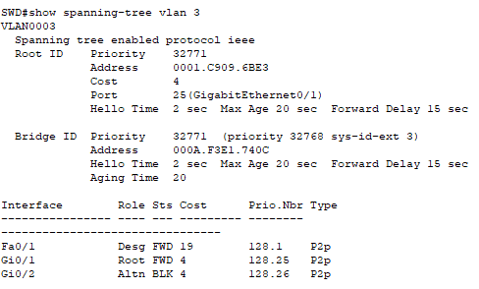

* **SWA1**

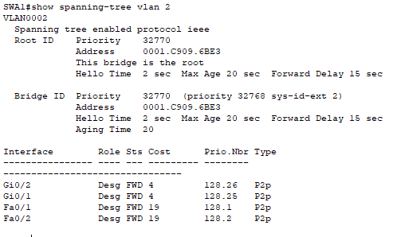

**3. Configure IP for cisco devices**

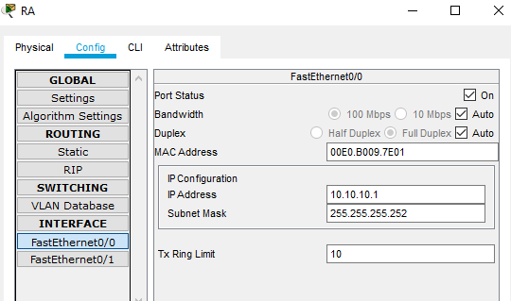

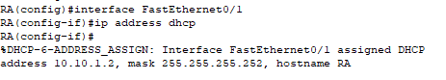

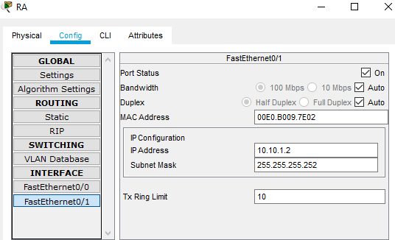

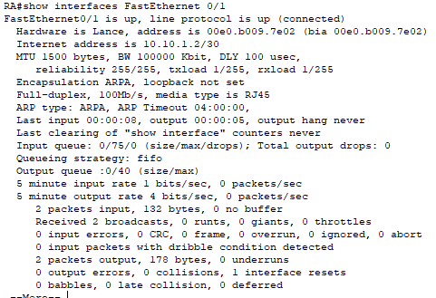

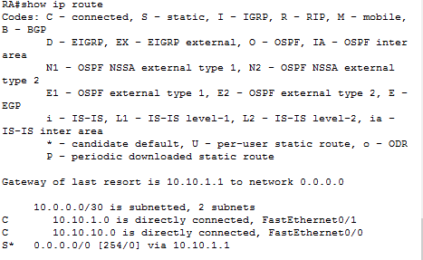

* **RB**

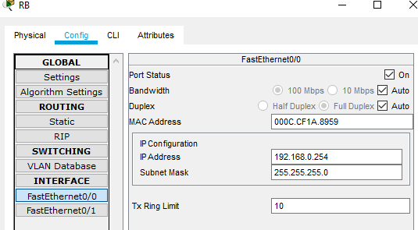

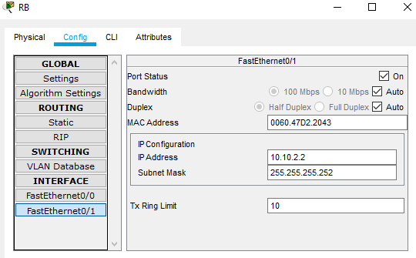

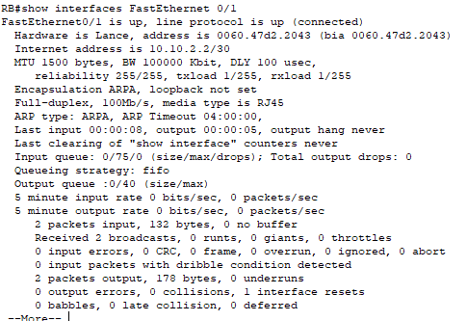

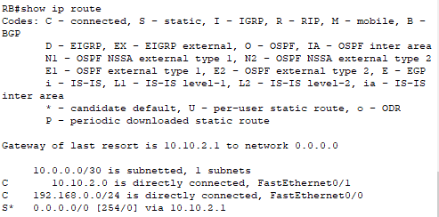

**SWD : VLAN interfaces**

**VLAN 2 : 192.168.2.254/24**

**VLAN 3: 192.168.3.254/24**

**VLAN 10 : 10.10.10.2/30**

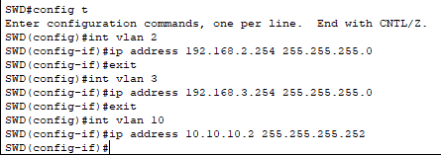

**4. Configure the DHCP Server to attribute the IP configuration to PCA.**

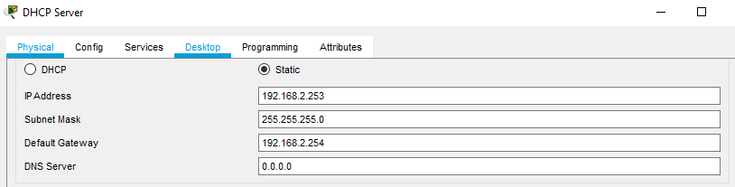

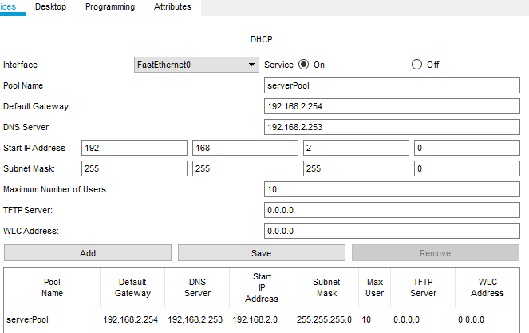

**5. Configure the PCA on DHCP**

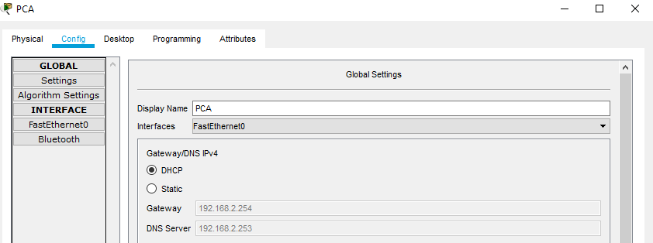

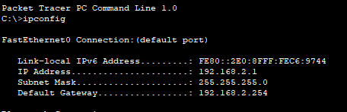

**6. Configure PCT et HTTP server**

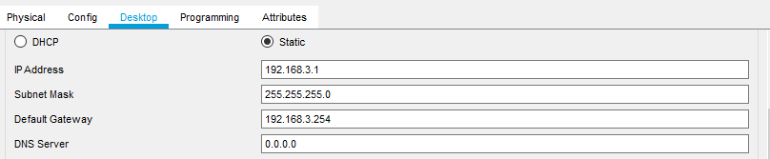

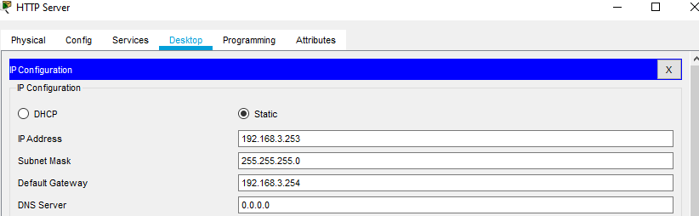

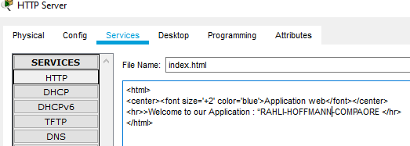

**7. Ping et verification**

**FROM PCT TO PCA AND DHCP SERVER**

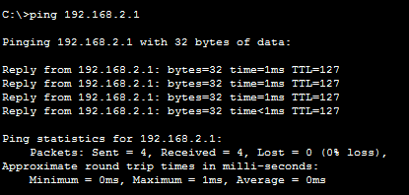

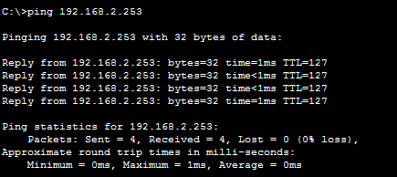

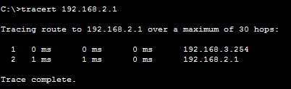

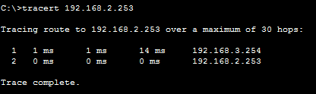

**From PCA to HTTP Server**

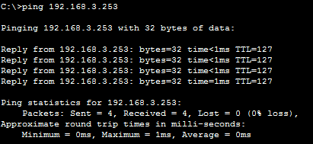

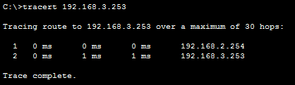

* **Use the Web Browser of PCA to connect to the HTTP Server**

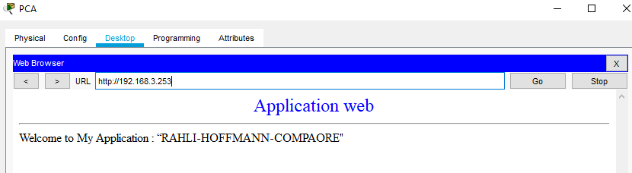

**8. Configure the routing on SWD and RA :**

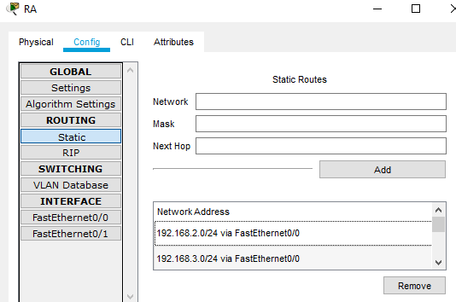

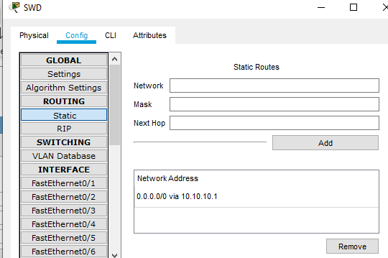

* **Make a show ip route on RA and SWD (copy screenshot hereafter)**

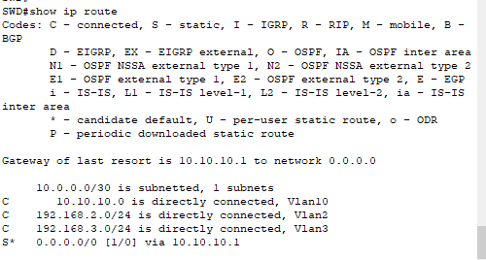

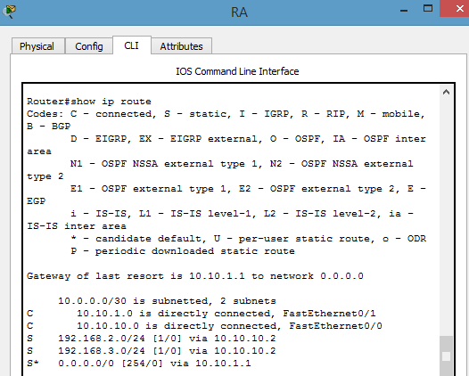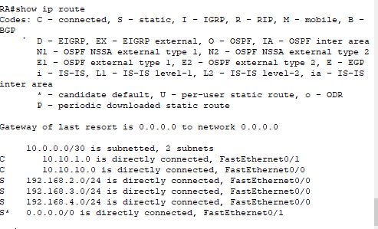

**9. Configure dhcp server on the router RB**

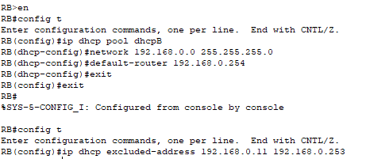

**10. Configure the PCB on DHCP**

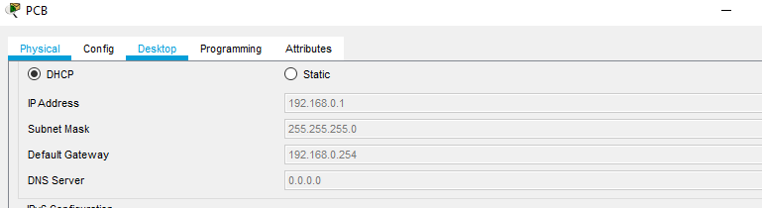

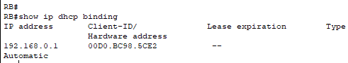

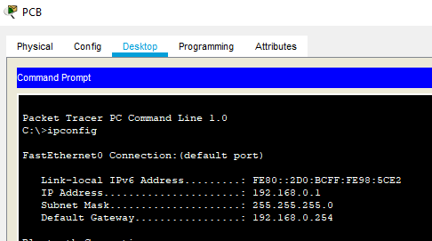

**PARTIE SECURITE**

**11. You will configure a tunnel IPSec between RA and RB to provide a secure communication between Site A and Site B.**

* **Configure a ISAKMP policy**
* **RA**

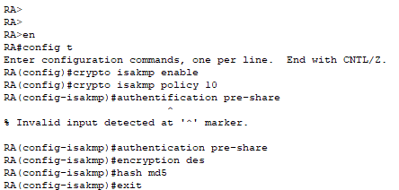

* **RB**

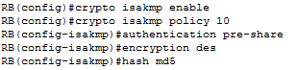

* **Configure a pre-shard key ( the same key must be configured on the two routers) with the peer WAN IP address ( RA is the peer of RB)**





* **Configure transform-set labset , you will use esp protocol**
* **Encryption algorithm 3DES**
* **Hash algorithm sha**





* **Configure an access-list 100 to define interesting VPN traffic (the LANs subnet => encryption domains).**





* **Configure the crypto map labmap**
* **Set the peer address**
* **Use the transform labset.**
* **Match the access-list 100**

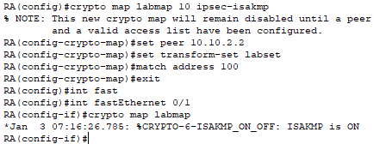

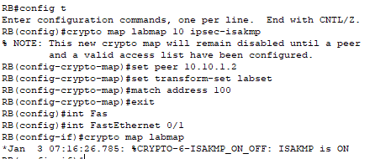

**12. Ping Server HTTP from PCB (copy screenshot hereafter).**



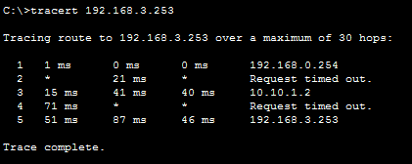

**15. Execute the commands on the RA and RB (copy screenshot hereafter).**

* **show crypto map**

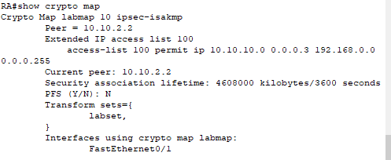

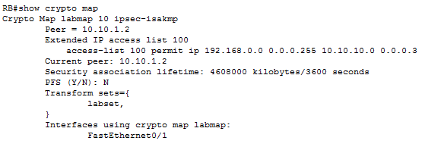

* **show crypto isakmp sa**

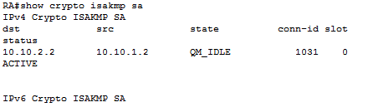

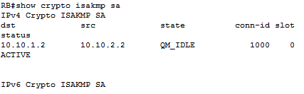

* **show crypto ipsec sa**

**RA :**

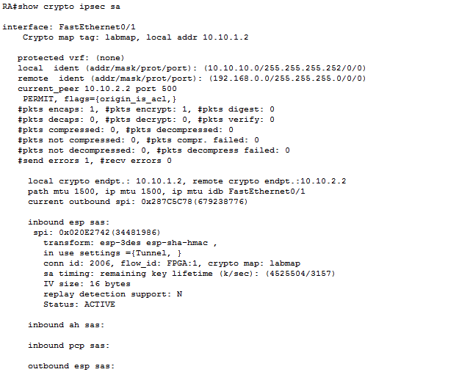

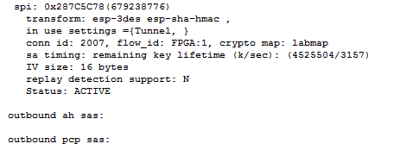

**RB:**

