- Boolean values are True and False
- Flowchart: is a type of diagram that represents a workflow or process
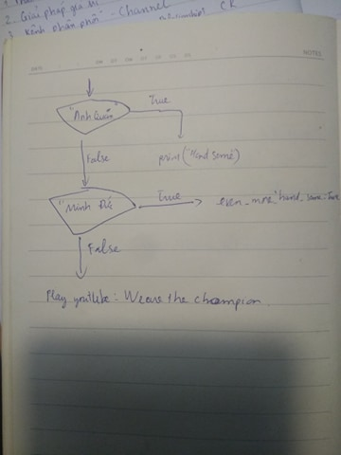
- Nested condition: One conditional can also be nested within another. (It is the same theme of compossibility, again)
Code:
If x<4:
if x>1:
Print(“1<x<4”)

