Final Project Report: Gamification-Based Learning Platform - Scavenger Hunt

i. Project Objectives
The main objective of this project is to develop an interactive educational platform based on the concept of gamification, using a scavenger hunt game to facilitate learning and knowledge assimilation related to Modules 1 and 2. This approach allows students to learn through active engagement by solving challenges and questions in an engaging game environment.
The project aims to enhance the learning process through:
- Creating an interactive system based on questions related to learning modules.
- Encouraging students to collaborate and explore areas on the map.
- Providing real-time evaluation and feedback based on correct answers.
- Offering an immersive and motivating learning experience.

ii. Analysis/Documentation ('State of the Art')
To fully understand the technological and educational framework behind the project, an analysis was conducted on existing platforms that use gamification to enhance learning. Gamification leverages elements such as rewards, challenges, and instant feedback to increase student engagement. Popular platforms like Duolingo, Kahoot, and Quizlet exemplify how integrating these elements transforms traditional educational methods.
A key component of our project is the use of the Raylib library, a simple and efficient C library for developing 2D games. The project’s code is structured using object-oriented programming (OOP) with classes like Player, Zone, and Question, which ensures a modular and extendable architecture—ideal for adding new interactive challenges and educational content.
SWOT Analysis:
Strengths:
- Engaging gamification elements enhance motivation and learning.
- Modular, OOP-based design allows for easy updates and extensions.
- Raylib enables rapid development and efficient 2D graphics.
- Comprehensive code documentation and a clear structure facilitate maintenance and future development.
Weaknesses:
- As an initial prototype, it may lack some advanced features.
- The user interface could benefit from further refinement.
- Limited scalability for handling more complex interactions or a larger user base.
Opportunities:
- Expansion through additional educational modules and interactive features.
- Potential collaboration with educational institutions to further improve the platform.
- Integration with emerging technologies (e.g., mobile devices, AR/VR) to enhance interactivity and broaden usage.
Threats:
- Competition from well-established gamified educational apps.
- Rapid technological changes may require continuous updates.
- Resistance from traditional educational approaches may limit the platform's adoption.

iii. Solution Justification
The proposed solution was chosen based on several factors:
1. The use of gamification to stimulate active learning.
2. Creating an educational game that involves students and motivates them to learn through interaction.
3. Using a simple and efficient graphical framework (Raylib) to ensure rapid game development.
4. The ability to easily expand the game by adding new modules or questions as the curriculum evolves.
iv. Implementation Description
a) UML Diagrams: Classes and Sequences
UML diagrams are an essential part of the design process for a software system. In this project, class and sequence diagrams were used to visualize the structure and flow of the application.
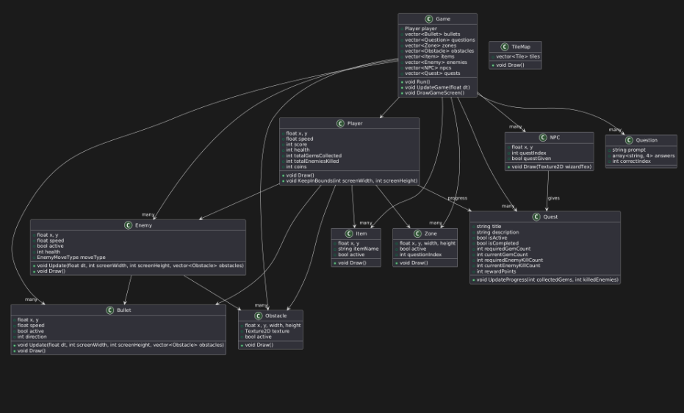
b) Object-Oriented Programming (OOP) Elements Used in the Implementation
Several OOP elements were used in this project:
- `Player` Class: Represents the player, with attributes such as position, speed, score, and texture.
- `TreasureZone` Class: Represents the areas on the map containing questions.
- `Question` Class: Represents the questions and their options.
- Inheritance: Not directly used in this project, but the system could be extended to include derived classes.
- Polymorphism: Could be applied in future project extensions to implement various object behaviors.
v. Performance Indicators
Performance indicators are essential for evaluating the efficiency of the game and the learning platform. In this project, the following indicators were defined to measure the success of the implementation:
- Application response time: Must be under 1 second to ensure a smooth user experience.
- Number of questions and map areas: Measures the diversity and complexity of learning challenges.
- User feedback: Providing instant feedback on responses, encouraging progress.
vi. Conclusions
The project demonstrated that the gamification-based educational approach can enhance student motivation and engagement in the learning process. The Scavenger Hunt platform offered an interactive and captivating method to assimilate knowledge from Modules 1 and 2 while being simple to implement and extend.
Additionally, the use of Raylib as a graphical library allowed for rapid game development with minimal impact on application performance.
Another important aspect of this project is that the platform can be easily expanded by adding new questions or map areas, thus adapting to future educational needs.

