Final Major Project

2D World Generator

Alex Izak – Q15581713

Table of Contents
Project Rationale 3
Aims 3
Objectives 3
Strech Goals 4
Product Specification and Scope 4
Algorithm Implementation – main focus 4
Tiles 4
Helper classes and functions 4
Pitch 5
Project Feasibility 5
Product Design 6
The Technical Design 7
Uml 7
Flowchart 8
Pseudo-Code 9
Project Plan 10
Work Breakdown Structure 10
Gantt Chart 11
Risk Assessment 12
Tracking Plan 14
Source control 14
Bug Tracking 14
Reference List 15
Bibliography 15

Project Rationale
I will be developing a world generation algorithm highly inspired by the sandbox game ‘Terraria’ (Re-Logic, 2011), which has a lot of very intricate rules and details in its procedural generation. I will be aiming to recreate a small portion of a Terraria style world, focusing mainly on terrain and ignoring elements like vegetation on the surface, maybe with the exception of trees as a challenge if everything looks to be going too well. This will be done in Unity C# as I plan to turn it into a tool at some point down the line if not able to within the scope of this project.
The elements I plan to introduce to the algorithm, in the scope of this final major project at least, are defined below.

Aims
The main aims I want to achieve or get closer to by undertaking this project are to gain experience regarding procedural generation, getting more familiar with the algorithms and the approach to randomly generating worlds, which effectively leads into actually developing a bespoke procedural generation product. I also wish to step foot into tool development, since after completing this, I plan to turn it into an extension of Unity’s tools. Lastly, this counts for both aim and motivation, I wish to create something as close as possible to a Terraria clone, since I am a very big fan of the game.

Objectives
- Generate a 2D tilemap world of different sizes, acting as a container for the ‘tiles’ [w/c 01.03] – just the back-end system which would take into consideration depth and adjacent tiles
- Generate ore veins [w/c 08.03] – once an ore tile spawns, more of the same tile clumps around it; size and type is decided by the depth
- Generate caves [w/c 15.03] – caves will start from the underground, going downwards through big rooms and corridors that connect them, the size of the cave is decided by depth
- Have at least 5 different types of tiles [w/c 29.03] – a biome should comprise of at least 5 tiles, which some would be general and others would be exclusive to the biome
- Create a secondary biome – e.g. desert or jungle [w/c 12.04] – follow the same principles to create another biome containing new tiles and slightly different generation in the case of caves and ore

Strech Goals
- Generate some chests in caves (just visual for this scope) [w/c 19.04]
- Generate random trees on the surface through code [w/c 26.04]
- Generate biome specific objects/backgrounds (unique chest/back walls) [w/c 03.05]
- Chunk loading and unloading based on screen position

Product Specification and Scope

Algorithm Implementation – main focus
Generating world
- Generate layers of dirt and rock to simulate terrain
- Mix multiple tiles to add detail to the layers
- Generate hollow areas for detail and for the caves
- Use noise to generate terrain with a random seed
Generating caves
- Empty out rooms underground in different shapes and sizes
- Generate some corridors through noise
- Generate ‘surface’ caves – entrance on the surface which leads to a small tunnel network
Generating ore
- Ore veins generated in a similar way to caves, just filling instead of removing
- Veins increase in size based on depth
- Different ore spreading in different vein shapes (seems interesting to try)

Tiles
- Create a basic class or scriptable object that holds all relevant information
- Inherit to create different types (may use scriptable objects)
- Make a unique one that sparkles or has an effect (e.g. ore)

Helper classes and functions
- Out of Bounds Check to ensure complex structures like caves don’t generate off map
- Switching Backgrounds in different biomes and at depth
- Remove tiles in bulk – look into the Unity functionality and maybe extend it

Tool Customisation (stretch goal)
- World size – small/medium/large
- Cave size (depending on world size) – 0/2/4/6 rooms
- Biomes – 1 biome world or based on world size – 2/3/4
- User swapping in and out biomes through scriptable objects

Pitch
What would initially start off as a program that creates a random 2D world, I am planning to develop into a tool that can be edited by the end user to mix procedural generation with user-specified parameters.
In the scope of the final major project, I am going to focus on the algorithm for the world creation very closely to ensure that the generated worlds have enough detail and follow the rules decided at planning. This just boils down to the quality of the caves, ground layers and terrain (hills/slopes), as well as the blending/transition of at least 2 biomes.
Once satisfied, I am going to introduce some level of tool development, which would include basic UI and a few drop-down options for the user to create something more to their liking.

Project Feasibility
I have been wanting to undertake procedural generation for a long time and have researched different algorithms, trying to tackle it. Some examples would be in the second-year studio, researching Perlin noise and the like since I was assigned to making levels midway, which didn’t really lead anywhere; and during summer, working on a project under Thunder Blossom Studios, I was working on grid based proc-gen.
Another reason is my great interest in the topic, sparked by Terraria many years ago. The more I played Terraria, the more I noticed each detail in the world generation, especially since I saw changes with each new update because I was playing quite a lot. However, these details were only taken seriously into consideration once I started undertaking the programming course, to be completely honest, since I could now understand and start to picture each algorithm and rule behind each area of the map.
This is highly feasible in my opinion because it is a very modular project, requiring step-by-step development, but still retaining a decent level of challenge in certain areas. Also, as I am sure can be gleamed in the above paragraphs, I am quite aware of the steps and highly interested in undertaking this project, which is hopefully enough proof of my ‘motivation’.
“Now I’m motivated!” – Vergil

Product Design
My product, being closer to an extension or tool, will not have any Game Design, but instead I will compare it to Terraria to show how I will ‘design’ my code to perform.
Below are some screenshots from the world generation of Terraria which I will essentially use as concept sketches during my development. They are ordered progressively, showing the phases of the generation algorithm.
Terrain – Just generating a layer of dirt and a layer of stone
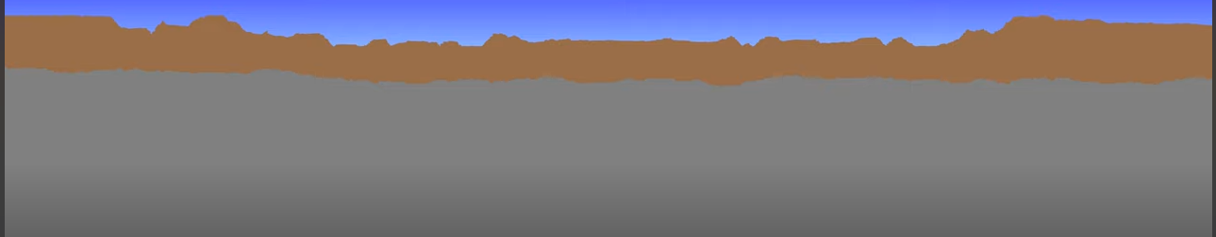
Mixing tiles in layers – use noise algorithms to change tiles
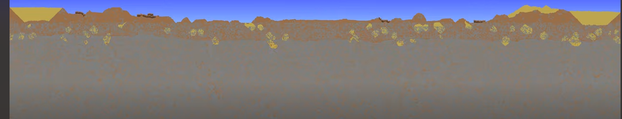
Hollow areas – same as above, but affecting more than 1 tile at a time
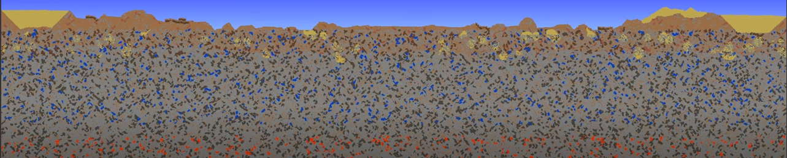
Caves – create random shapes and empty them out
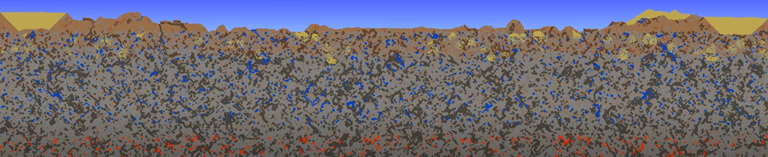
Next would be the ore, but that is too small of a change to be shown on this scale. It will be similar to the mixing tiles stage, just in fewer amounts and clumped together.

The Technical Design

Uml

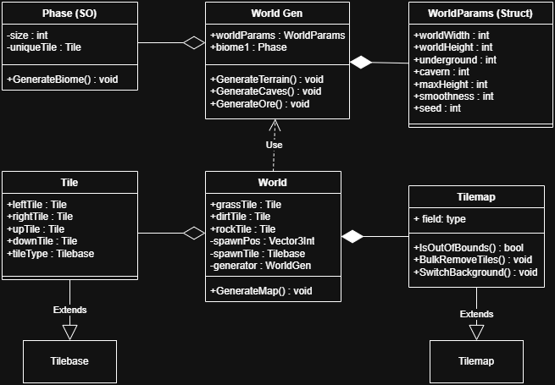

Flowchart
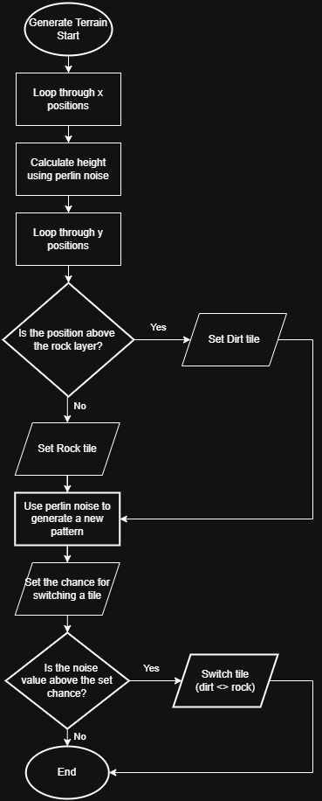

Pseudo-Code
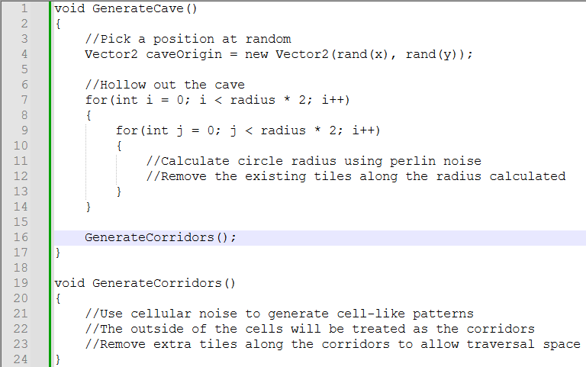

Project Plan

Work Breakdown Structure
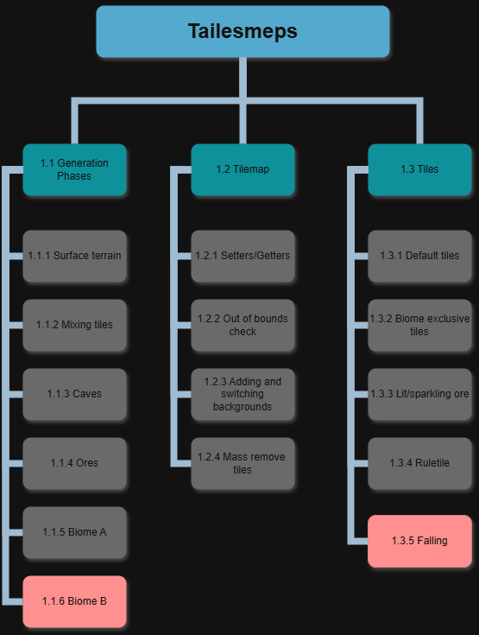
Red – Potential Cut

Gantt Chart
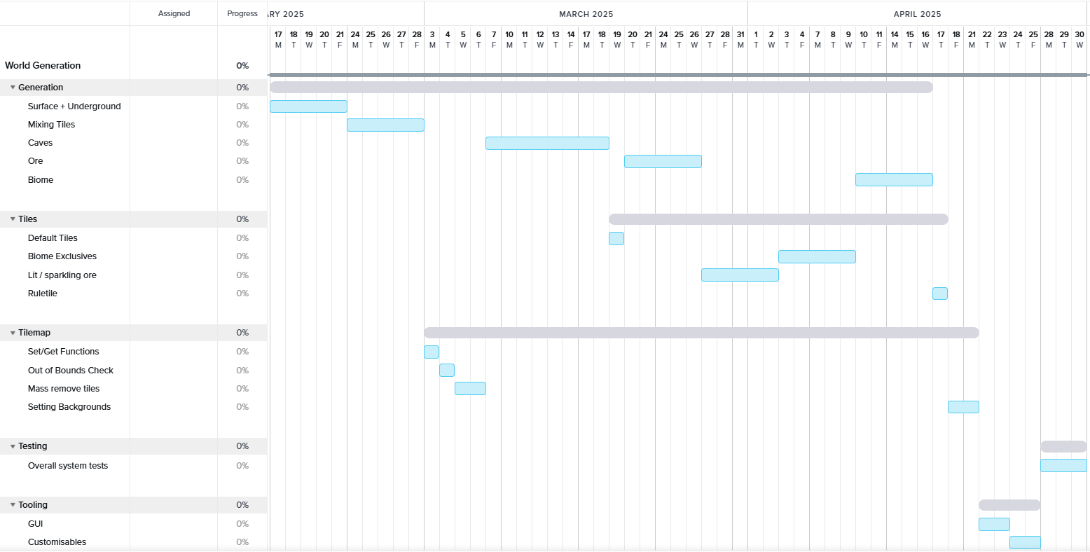

Risk Assessment
ID | Risk | Probability | Trigger | Impact | Contingency
01 | Working with noise algorithms for the first time so the knowledge gap might set me back in development | 50% | Not getting a desired result out of one of the noise algorithms for example | Progress might slow down due to necessary research or trial and error | Ask for some guidance or work in an isolated scene to better understand the process
02 | Being rusty with Unity C# | 30% | Forgotten how to use certain functionality | Might attempt complex solutions, when simpler ones are available | Use either Youtube or documentation in areas of the development I am stuck in
03 | End product being too simplistic for an FMP | 20% | Algorithm not being polished enough or generated map looking dull | Grade and portfolio will be affected negatively | Ask for feedback if I run out of ideas for improvements
04 | Lacking beta testing due to the nature of the project | 65% | Users not being able to test due to no interface or UX | Won’t get any feedback | Add some customization features so at least users can engage with the product
05 | Issue with noise not generating caves in a visually appealing way | 40% | Caves not looking at least halfway natural | World would look to have lower quality | Try a different noise algorithm or change the values to mold the shape
06 | Not being able to showcase my product | 50% | The build of the game being too zoomed in or out | Details would be missed | Add functionality for zoom in/out and panning around the world
07 | Internet issues making me unable to upload to GitHub | 40% | Internet going down | Won’t be able to show progress in class sessions | Mobile hotspot or just switch to laptop mainly for a while
08 | Motivation running very low due to multiple good games coming out | 80% | Release date of Monster Hunter: Wilds | Procrastination will increase massively | Make sure I make some amount of progress before playing games
09 | Biomes not overwriting the terrain properly | 60% | Some surface tiles might be ignored, being outside the biomes range | Hill tops will stand out being different tiles | Make the biome spread a little bit outside its boundaries, but not overwrite empty tiles
10 | Wasting time on functionality that Unity already has | 30% | Working on tiles and tilemap | Scope might be lost unnecessarily | Look into base functionality first before extending classes
11 | Performance issues | 30% | World being too large or too many noise functions | Loading times will be long or world might not even display | Use as much of the Unity functionality to ensure clean creation and deletion
12 | Build-only bugs | 50% | Trying to run a build of the project | Worst case, world might not generate | Try to make builds early on and consistently
13 | Unity debugging not working with my Visual Studios | 60% | Trying to break point a line of code for testing | Not finding out the cause for issues and bugs | Learn how to fix it so that I don’t have to waste time every time it happens
14 | Surface terrain being too bland | 40% | Perlin noise generating either too boring or too exaggerated terrain | World would look weird or uninteresting | Try to patch together multiple different Perlin noises for more variety

Tracking Plan
In terms of tracking software, I decided to use Trello. The reason for this was pretty simple, I wanted to give it a try. On top of that, the ones I had used before, Hack n Plan or Jira were not industry standard or I just was not a fan of, respectively.

Source control
GitHub will be my go-to software for source control, mainly because it is what I have been mainly using until now, but also because I like it and have not had any issues with it. Furthermore, it has many available plugins for other software if I decide to expand my project later (e.g. Jenkins).

Bug Tracking
Apart from the testing table which will be in the overall documentation, tracking bugs will be done through Excel spreadsheets because it is simple to add entries and read the data by highlighting rows.

Reference List
Re-Logic (2011) Terraria [game, Windows] Re-Logic, USA ()

Bibliography
Patricio Gonzalez & Jen Lowe (2015) The Book of Shaders. Available at: https://thebookofshaders.com/11/ [Accessed 27th January 2025]
Patricio Gonzalez & Jen Lowe (2015) The Book of Shaders. Available at: https://thebookofshaders.com/12/ [Accessed 6th February 2025]

