WalletSavy

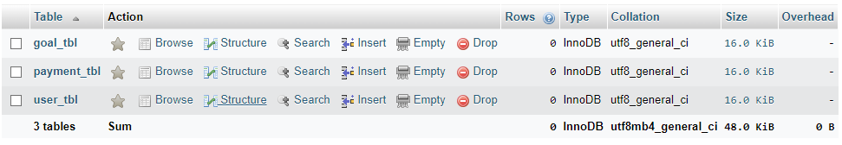

Payment_tbl

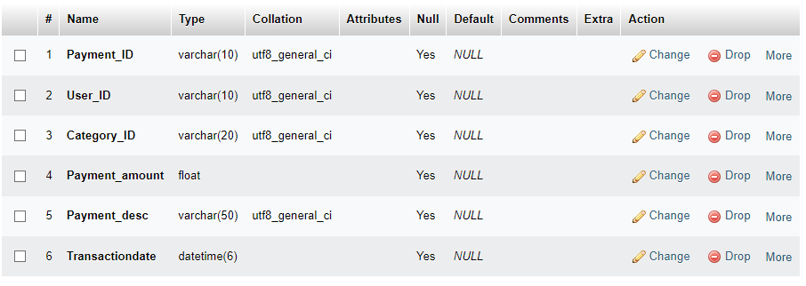

Goal_tbl

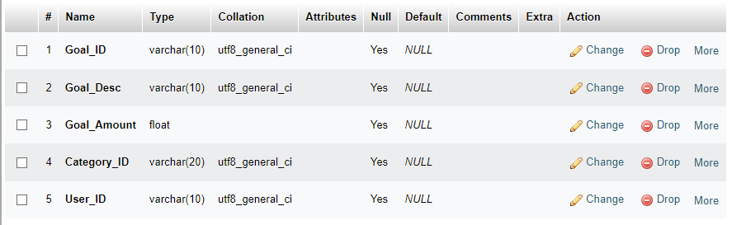

User_tbl

