EN.605.202.81 Section 84
Alexander Shah
Lab 4: Sort Analysis
December 5, 2023
This program implements five sorting methods, using four variations of quicksort and natural merge sort. The versions of quicksort pick different locations to create pivot points and may use insertion sort to recombine them. The different methods of picking mid points causes the algorithm to vary depending on the length and ordering of the data. By running different length tests with varied ordering, we are able to analyze the sorting efficiency based on the number of comparisons the algorithm makes as well as exchanges of elements during its runtime. This data shows us that as the number of elements increases, so does the number of comparisons and exchanges but at different rates depending on the sort and order. For example, ascending and descending orders make quicksort based approaches very inefficient and quicksort tends to have extremely high numbers of comparisons for ordered data which can be costly just to determine that the items are already in order.
A good example is quicksort using first pivot running on ascending and descending data. When ascending the sort required only 49 exchanges for 50 numbers but the descending order required 674. This large step up in exchanges illustrates the inefficiencies some sorts can experience just by ordering. Choosing the median pivot was better than using the first number as a pivot. And the difference in threshold for insertion sort, 100 vs 50, made little difference for large files. As the sizes of files grew, the effect that ordering had on quicksort grew as well. Overall the most important factors as the size grew were the pivot choice for quick sort, with median being preferred over insert, over first pivot, and the order of the data. Comparatively, natural merge sort was more resistant to ordering changes and file sizes. Natural merge sort operated more efficiently compared to a straight merge sort which recursively divides data and uses extra space to hold the arrays. By choosing an in place sort that uses a stack, a quick structure that lends itself well to popping on and off ordered sequences of data, the natural merge sort ran fairly consistently and efficiently but crucially it used far less space than a straight merge sort would have. Natural merge sort is also faster for data that has partial order, compared to straight merge which performs similarly regardless of order. Natural merge sort is more consistent overall compared to quicksort, and would be faster than straight merge sort regardless of order or size.
Justification for Design Decisions
Initially I tried implementing the sorts using recursion but ran into trouble running them with large amounts of data. I was getting recursion errors, that max depth had been reached, leading to most of the sorts failing to complete. I went back and reimplemented the sorts using iterative approaches by using the MyStack class made in previous labs to act as a stack structure. Choosing a stack was a natural fit given our experience in previous labs, as well as for the task, the stack was a good choice for time and space efficiency of operations.
What I Learned/What I would Do Differently
Implementing 5 recursive sorts resulted in a lot of recursion failures, so I would first attempt iterative designs over recursion until I am sure the method would benefit from recursion. It has been much harder to debug recursive problems than iterative ones.
Sort Name | Order | Size | Comparisons | Exchanges
Quicksort first pivot | random | 50 | 277 | 119
Quicksort first pivot | random | 1000 | 10569 | 5653
Quicksort first pivot | random | 2000 | 23399 | 12554
Quicksort first pivot | random | 5000 | 68270 | 35059
Quicksort first pivot | random | 10000 | 157753 | 80463
Quicksort first pivot | ascending | 50 | 1225 | 49
Quicksort first pivot | ascending | 1000 | 499500 | 999
Quicksort first pivot | ascending | 2000 | 1999000 | 1999
Quicksort first pivot | ascending | 5000 | 12497500 | 4999
Quicksort first pivot | ascending | 10000 | 49995000 | 9999
Quicksort first pivot | descending | 50 | 1225 | 674
Quicksort first pivot | descending | 1000 | 499500 | 250999
Quicksort first pivot | descending | 2000 | 1999000 | 1001999
Quicksort first pivot | descending | 5000 | 12497500 | 6254999
Quicksort first pivot | descending | 10000 | 49995000 | 25009999
Quicksort insert 100 | random | 50 | 725 | 727
Quicksort insert 100 | random | 1000 | 23416 | 20537
Quicksort insert 100 | random | 2000 | 48713 | 42335
Quicksort insert 100 | random | 5000 | 127638 | 105268
Quicksort insert 100 | random | 10000 | 274484 | 218722
Quicksort insert 100 | ascending | 50 | 49 | 49
Quicksort insert 100 | ascending | 1000 | 494550 | 999
Quicksort insert 100 | ascending | 2000 | 1994050 | 1999
Quicksort insert 100 | ascending | 5000 | 12492550 | 4999
Quicksort insert 100 | ascending | 10000 | 49990050 | 9999
Quicksort insert 100 | descending | 50 | 1225 | 1274
Quicksort insert 100 | descending | 1000 | 499500 | 253449
Quicksort insert 100 | descending | 2000 | 1999000 | 1004449
Quicksort insert 100 | descending | 5000 | 12497500 | 6257449
Quicksort insert 100 | descending | 10000 | 49995000 | 25012449
Quicksort insert 50 | random | 50 | 725 | 727
Quicksort insert 50 | random | 1000 | 16172 | 12778
Quicksort insert 50 | random | 2000 | 31958 | 24297
Quicksort insert 50 | random | 5000 | 92209 | 66858
Quicksort insert 50 | random | 10000 | 207732 | 146252
Quicksort insert 50 | ascending | 50 | 49 | 49
Quicksort insert 50 | ascending | 1000 | 498275 | 999
Quicksort insert 50 | ascending | 2000 | 1997775 | 1999
Quicksort insert 50 | ascending | 5000 | 12496275 | 4999
Quicksort insert 50 | ascending | 10000 | 49993775 | 9999
Quicksort insert 50 | descending | 50 | 1225 | 1274
Quicksort insert 50 | descending | 1000 | 499500 | 251599
Quicksort insert 50 | descending | 2000 | 1999000 | 1002599
Quicksort insert 50 | descending | 5000 | 12497500 | 6255599
Quicksort insert 50 | descending | 10000 | 49995000 | 25010599
Quicksort median pivot | random | 50 | 218 | 173
Quicksort median pivot | random | 1000 | 9107 | 5570
Quicksort median pivot | random | 2000 | 20861 | 12116
Quicksort median pivot | random | 5000 | 60807 | 37644
Quicksort median pivot | random | 10000 | 134190 | 81497
Quicksort median pivot | ascending | 50 | 193 | 148
Quicksort median pivot | ascending | 1000 | 7987 | 4960
Quicksort median pivot | ascending | 2000 | 17964 | 10916
Quicksort median pivot | ascending | 5000 | 51822 | 30713
Quicksort median pivot | ascending | 10000 | 113631 | 66421
Quicksort median pivot | descending | 50 | 245 | 187
Quicksort median pivot | descending | 1000 | 14205 | 9001
Quicksort median pivot | descending | 2000 | 32880 | 20499
Quicksort median pivot | descending | 5000 | 98004 | 60501
Quicksort median pivot | descending | 10000 | 218585 | 133464
Natural merge sort | random | 50 | 217 | 269
Natural merge sort | random | 1000 | 8737 | 9738
Natural merge sort | random | 2000 | 19395 | 21396
Natural merge sort | random | 5000 | 56820 | 61825
Natural merge sort | random | 10000 | 123668 | 133673
Natural merge sort | ascending | 50 | 161 | 213
Natural merge sort | ascending | 1000 | 5052 | 6053
Natural merge sort | ascending | 2000 | 11104 | 13105
Natural merge sort | ascending | 5000 | 33356 | 38361
Natural merge sort | ascending | 10000 | 71712 | 81717
Natural merge sort | descending | 50 | 133 | 185
Natural merge sort | descending | 1000 | 4932 | 5933
Natural merge sort | descending | 2000 | 10864 | 12865
Natural merge sort | descending | 5000 | 29804 | 34809
Natural merge sort | descending | 10000 | 64608 | 74613

Figure 1. Comparisons and Exchanges for 5 different sorts
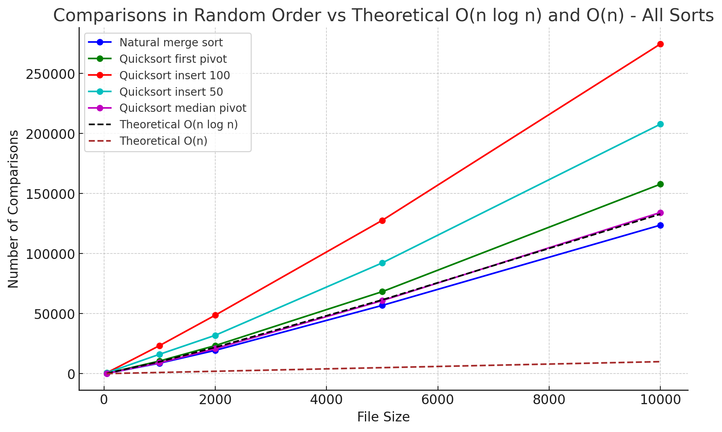
Figure 2. Chart comparing random ordered performance
We can see from the chart above that natural merge sort performed the best, followed closely by quicksort using the median pivot. Randomly ordered data shows an average case for quicksort, making it a better visual comparison but this doesn’t reflect the performance in all cases. Looking at nlogn and n lines, we can see how natural merge sort falls under n logn for random data, making it a good sort.

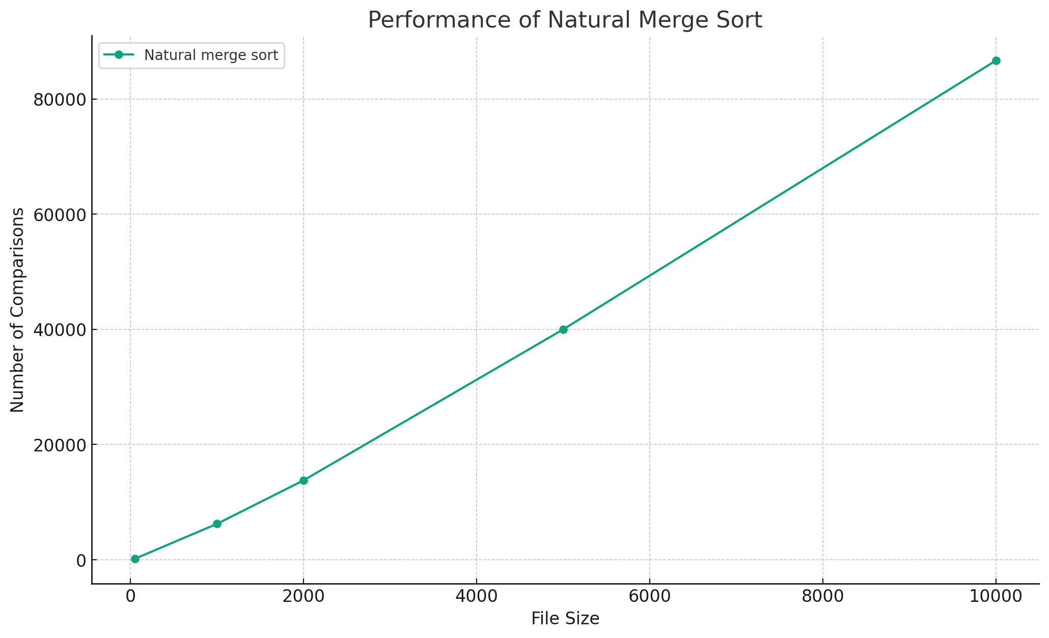

Figure 3. Natural merge sort average comparisons
Natural merge sort shows a nearly linear correlation to file size.

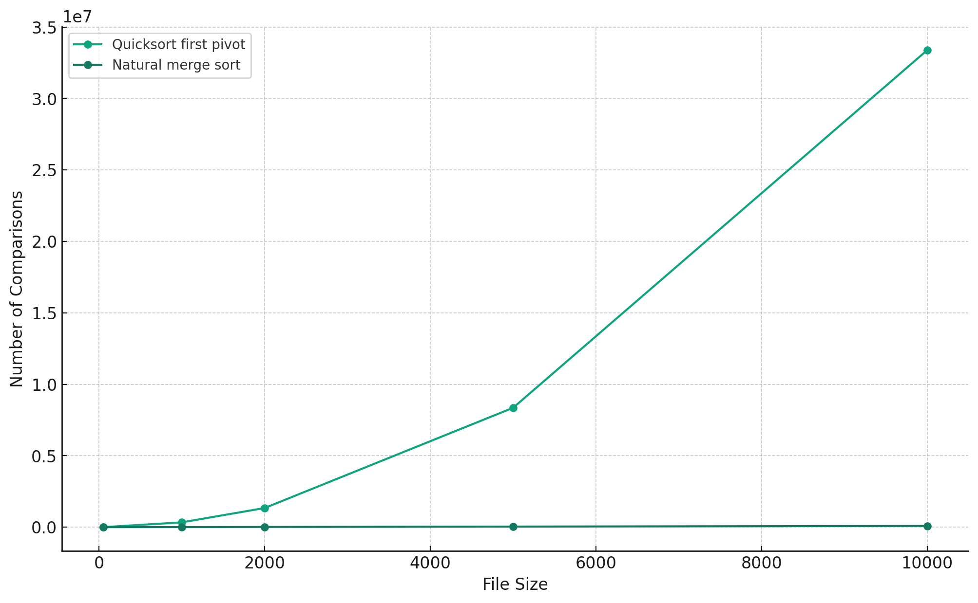

Figure 4. Natural merge and quicksort first pivot comparison
Comparatively, the number of comparisons becomes much greater at the same file size for quicksort, with noticeable growth as the file size grows.

