Alex Shah
EN.695.741.81.SP25 Information Assurance Analysis
Mod 14 Lab
May 5, 2025

Part 1 Install Wireshark

On a Ubuntu 18.04 VM I installed Wireshark and opened the PCAP file, shown below with the Wireshark version 2.6.10 shown in the terminal window.

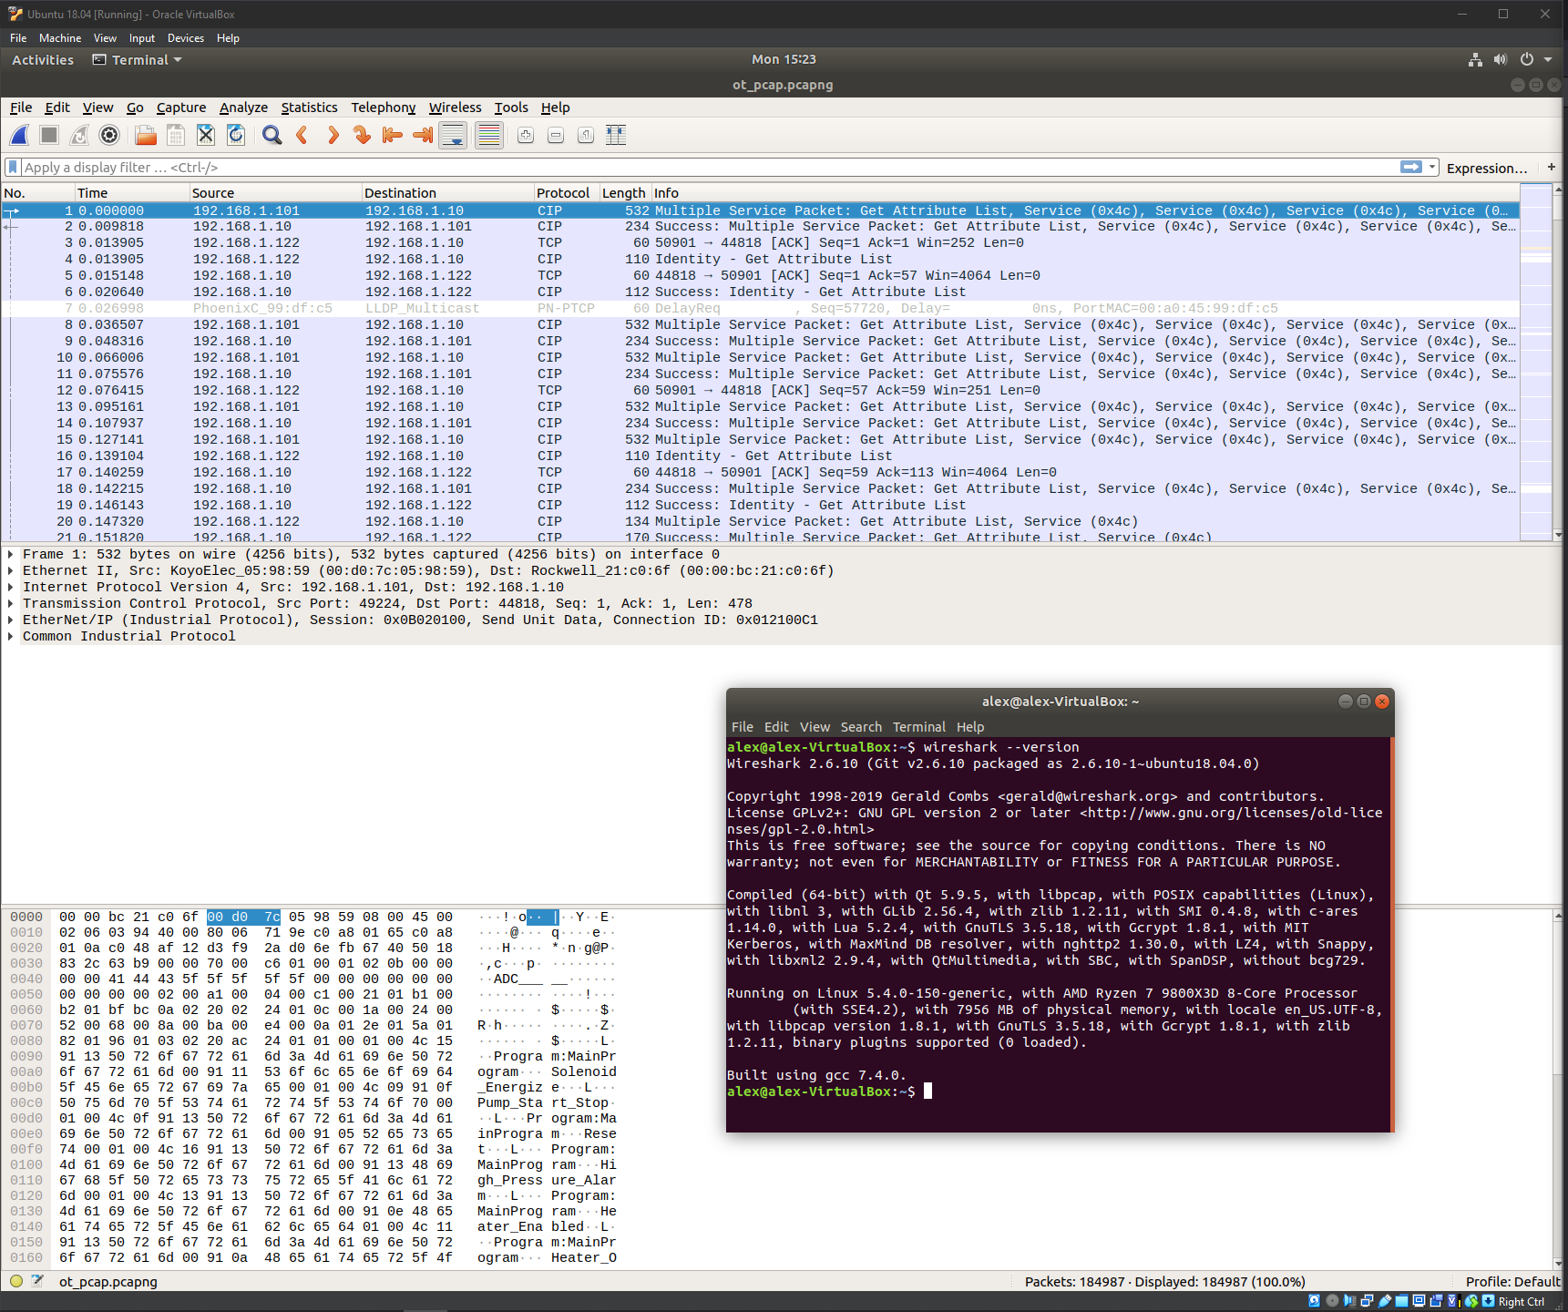

Part 2 Analysis

Using Wireshark to find the vendor for all hosts on the network; what kind of devices are 192.168.1.120, 192.168.1.213, & 192.168.1.34?

1.)

192.168.1.120 and 192.168.1.213 appear to be VMWare Virtual machines according to the MAC addresses. 192.168.1.34 appears to be a Dell device from the MAC address.

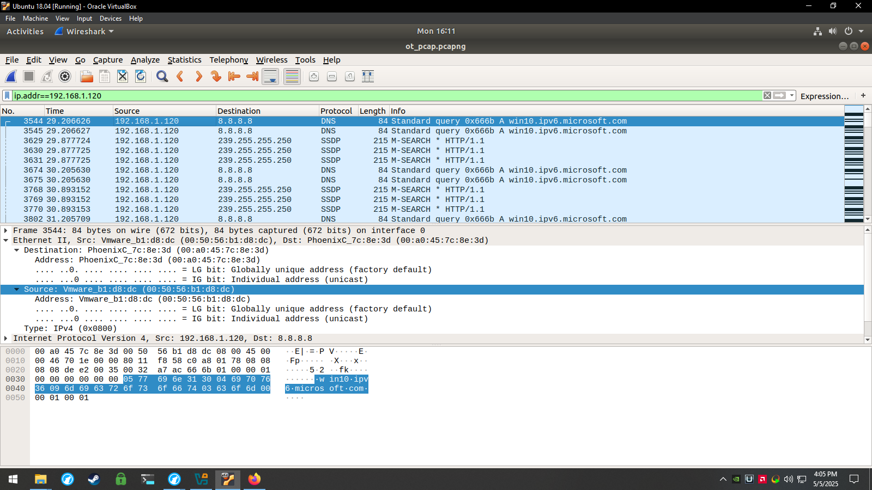
Figure 1: 192.168.1.120 Source Detail

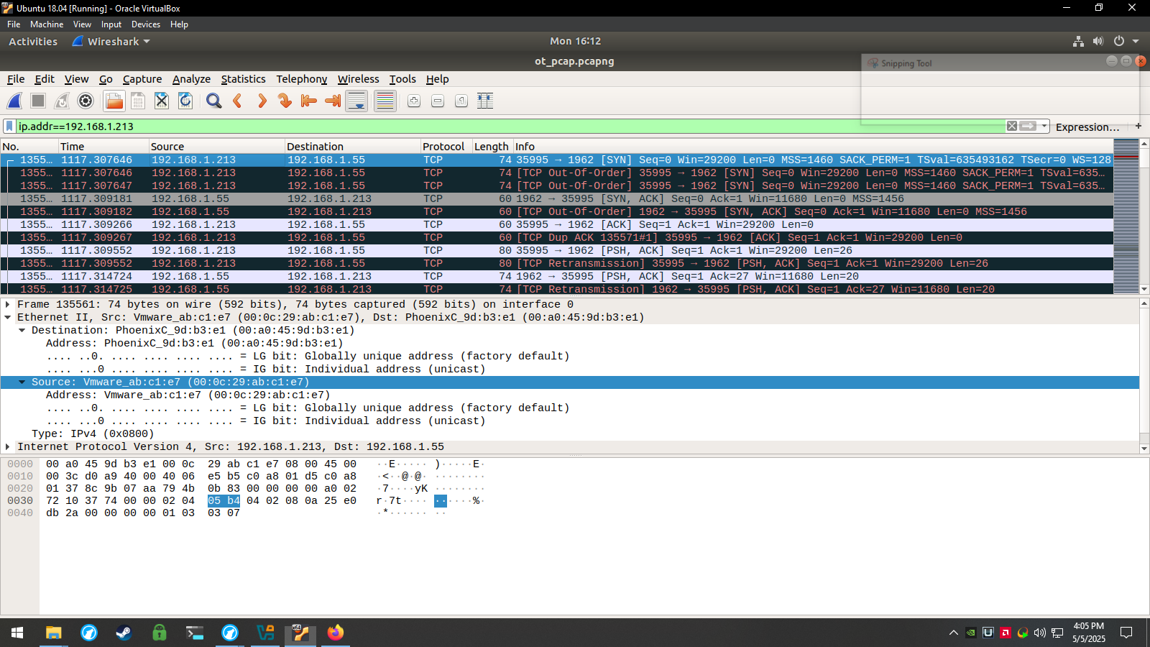
Figure 2: 192.168.1.213 Source Detail
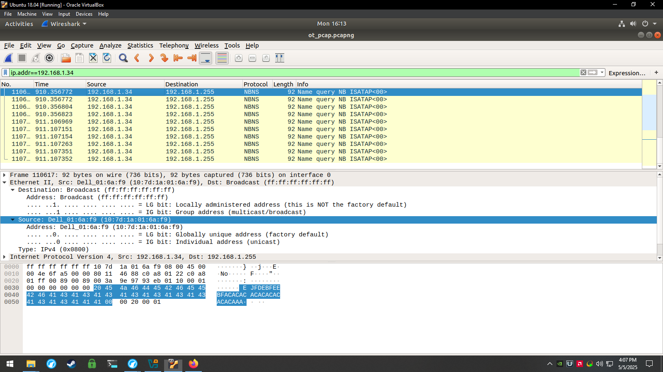
Figure 3: 192.168.1.34 Source Detail

Use bro-cut to parse the conn.log file. Is there a host which initiates a high number of TCP connections?

2.)

Using bro-cut to show the host and destination IP and port and protocol, and filtering for TCP using grep, there are only 6 lines that use TCP. 4 of which are form 192.168.1.213 to another device on the network 192.168.1.55, one from 192.168.1.101 to another local device 192.168.1.10, and one from 192.168.1.122 to 192.168.1.10 as before. None of the hosts make a significant amount of connections but the number of packets between 192.168.101 and 192.1 68.1.122 communicating with 192.168.1.10 on port 44818 are higher than the rest.

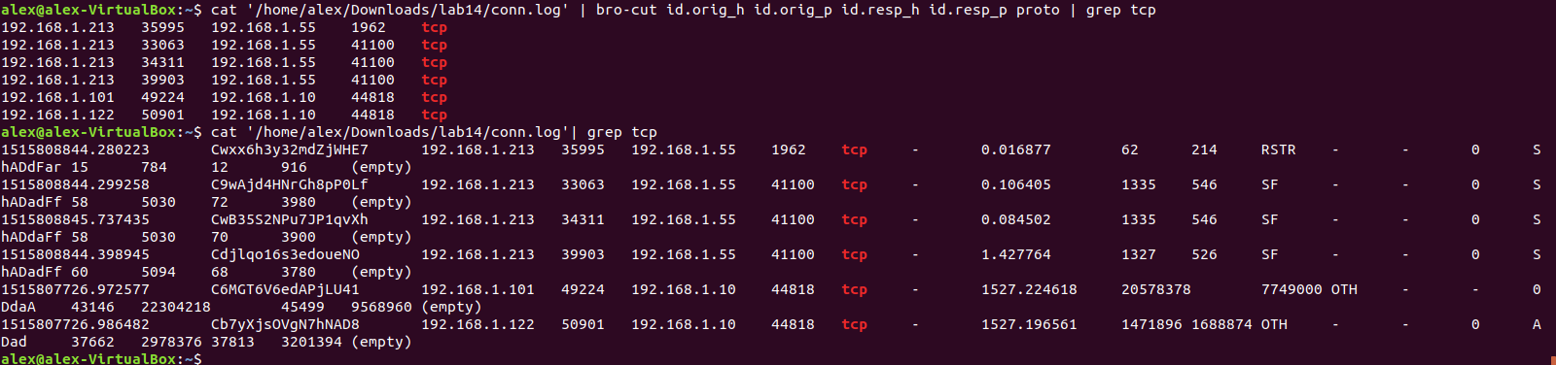
Figure 4: Bro-cut showing TCP connections

Use Wireshark to examine the most “talkative” host’s traffic. Does this look like Nmap scanning Note: "Talkative" means- the most packets or traffic/sessions seen

3.)

The host 192.168.1.10 has the largest number of packets in Wireshark’s endpoints view. It communicated many CIP and ACK packets with 192.168.101 and 192.168.122 with the destination port being 44818. This seems to show legitimate “Common Industrial Protocol” traffic on the known port for CIP 44818.
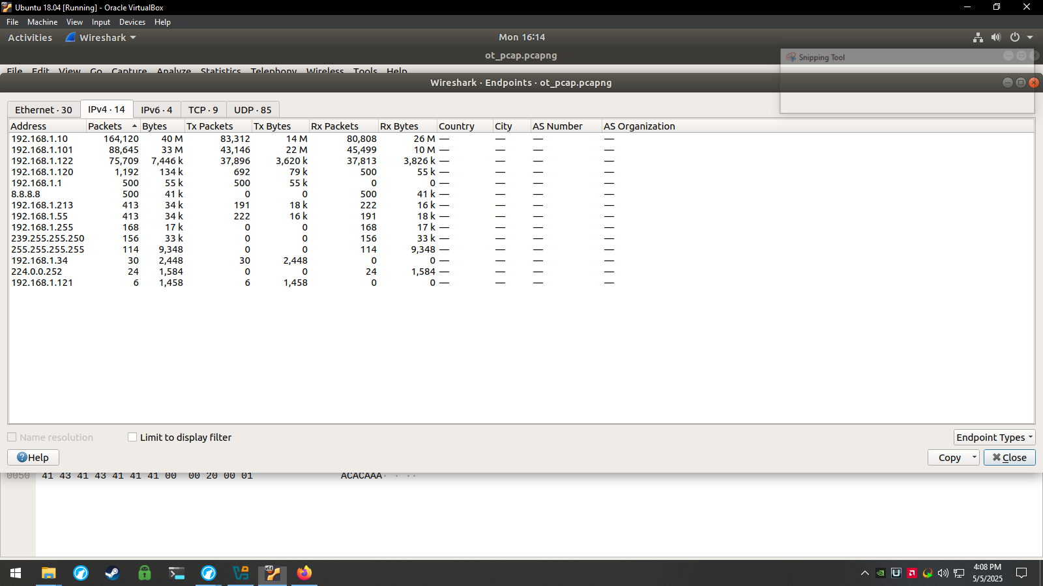
Figure 5: 192.168.1.10 has the most packets

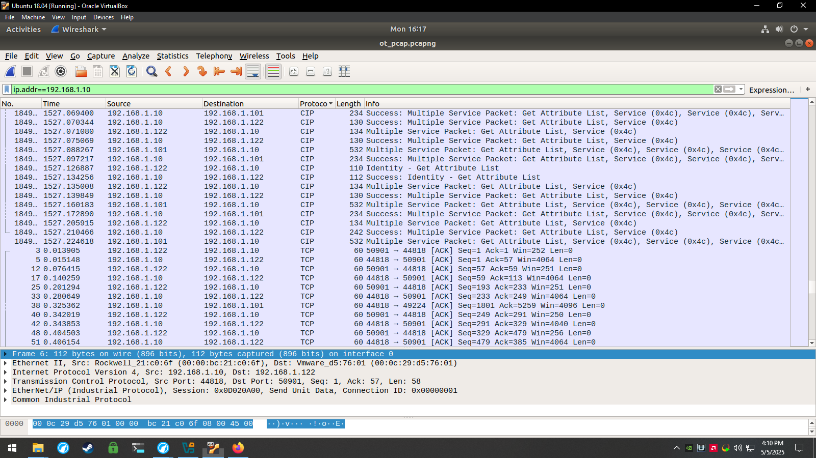
Figure 6: CIP and ACK traffic to and from 192.168.1.10

Each entry in the conn.log file has a “proto” field. Use grep and bro-cut to count the number of ICMP connections. Is there evidence of ping sweeping?

4.)

There is only one entry that has ICMP in conn.log where presumably the router at 192.168.1.1 communicates with 192.168.1.120. In wireshark the traffic looks to be multiple failed attempts to query or resolve subdomains on google.com like “clients2.google.com”

Figure 6: bro-cut showing ICMP lines

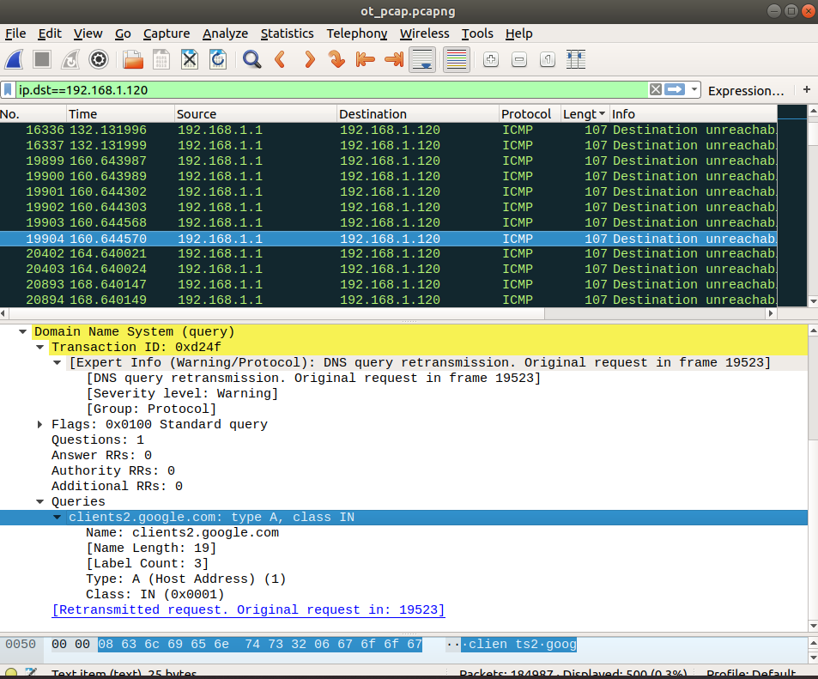
Figure 7: ICMP packets to 192.168.1.120 in wireshark

Each conn.log entry has a field “id.resp_p” which indicates the destination port. Use bro-cut to summarize the connections between hosts in terms of port number. Google any suspicious port numbers you find. Is there evidence of exploitation?

5.)

See appendix for a full list of IP/ports

There are several destination ports listed in conn.log, totaling 11. Port 44818 we saw as CIP traffic common for ICS systems. Port 53 is DNS traffic that seems to go to Google’s public DNS. Port 547 is commonly used for DHCPv6 addressing, which should be legitimate traffic. Port 1900 seems to be legitimate traffic to a multicast IP address, which is commonly used for SSDP Simple Service Discovery protocol but it could be used for scanning. Ports 137 and 138 seem to be for Windows NetBIOS which could be legitimate traffic or scanning for vulnerable Windows services. Port 5355 seems to be name discovery for host or MAC address, which could be used for scanning or legitimate traffic. But port 1, 1947, 1962, and 41100, seem to be unusual ports, with port 1 being uncommonly use, and the rest being non standard or product related that could be legitimate depending on the vendor and products on the network, or ephemeral ports that could be used in an attempt to scan the network.

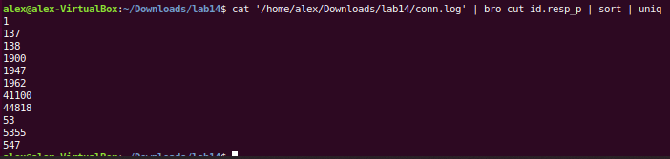
Figure 8: Destination port numbers found in conn.log

Appendix

Ports part 1:

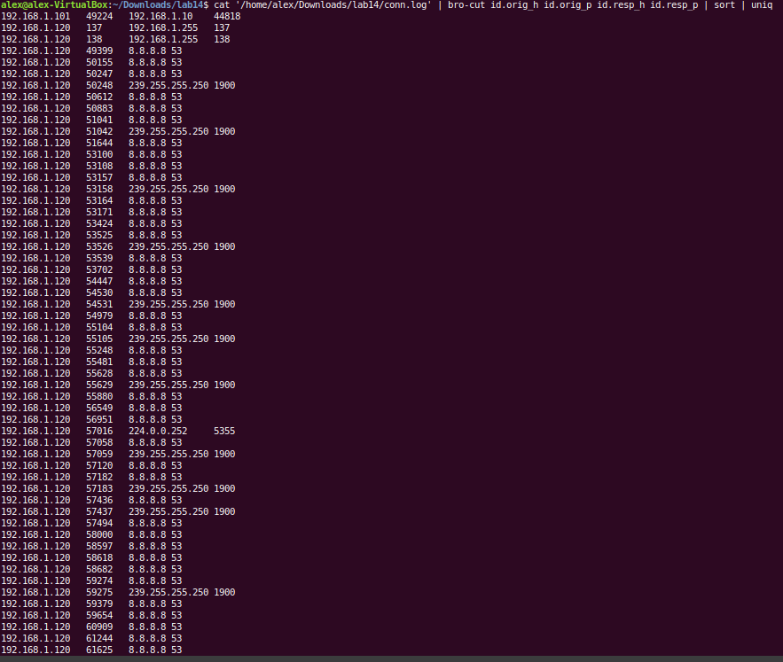

Ports part 2:

