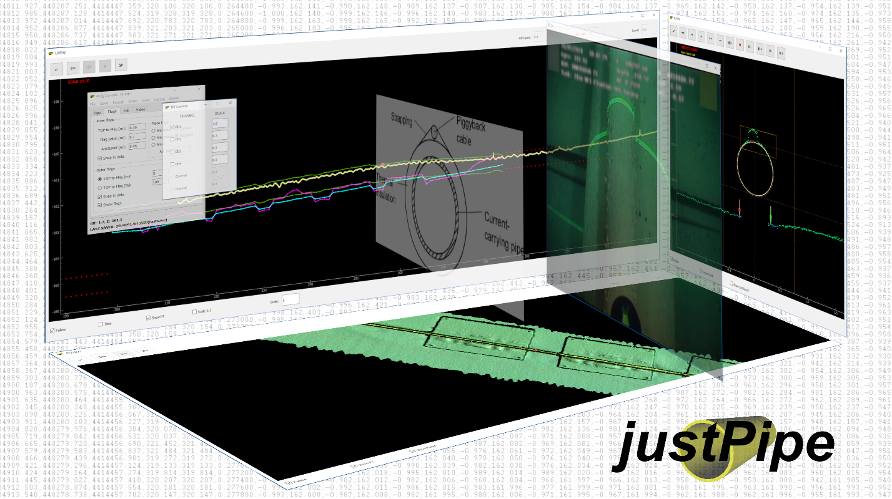

Copyright © 2026 Aleksandr Kaiurin
akayurin@gmail.com

INTRODUCTION 3
PREREQUISITES 4
HOW IT WORKS 5
DATA PREPARATION 6
Seabed profiles 6
Georeferenced image 7
Tide files 7
Pipetracker data 7
Digital Video 7
USER INTERFACE 8
Main Control menu functions 9
Main Control tabs 9
Views controls functions 9
USING JUSTPIPE 11
Loading data 11
Setting up pipe and seabed digitizing 11
Placing TOP and markers 14
TOP selection 16
TOP 3D interpolation 16
Applying tide 17
Processing pipetracker 17
Snapping TOP to pipetracker 19
Digital video 19
Re-setting flags 20
POI 21
Colors settings 21
Layout settings 21
Saving work 21
Automatic mode 22
Data export 22
Hotkeys and Mouse buttons 23

INTRODUCTION
justPipe application is developed to provide fast, reliable and flexible tool for digitizing of pipelines as well as umbilicals and cables based on seabed profiles data acquired during inspections or construction.
Depending on product geometry and conditions, two main strategies are usually used for digitizing. Automatic digitizing may be undertaken when product is well defined on the seabed and seabed conditions allow for accurate seabed markers placement. In any case, the digitized data must be QC’ed and corrected, if necessary, afterwards. This may take as long as another strategy – manual digitizing. In this case, manual placement of top and markers may take longer time.
Due to advanced algorithms and flexible settings, justPipe combines both strategies taking advantages of processing speed from automatic approach and reliability from the manual one. It allows for fast automatic placement of pipe elements and QC in one run.
The software capabilities include:
- Automatic and manual digitizing of product top and seabed markers (adjacent and mean seabed) based on seabed profiles
- Basic processing of pipetracker data (data rejection, smoothing and levelling)
- Snapping top to processed pipetracker data
- Tide correction of processed data
- Digital video stills playback to assist in digitizing
- Export to industry software compatible formats
Presently, the application data formats are compatible with Fugro Starfix and Eiva.

PREREQUISITES
You may need to install video codecs pack for digital video playback if application is run on Windows. It is recommended to install LAVFilters pack.

HOW IT WORKS
The main advantage of using justPipe is fast and accurate pipe top (TOP – Top Of Pipe) and markers placement. Since these are the most time-consuming tasks during pipes digitizing, the following approaches were used to achieve digitizing speed and accuracy:
- Use of specific and accurate TOP detection and marker placement algorithms
- Immediate access to settings for fast reaction to changing conditions
- Intuitive and simple user interface to minimize time of interaction
Application is intended to automatically place TOP and markers as much as possible. Processor just goes through profiles with minimum intervention, verifying automatic placement and doing QC at the same time. If automatic detection fails due to inadequate settings or position initializing issue, it is easy to re-try with different settings or to change initial search position just in one click. At any time, processor can manually place TOP in one click if he is not happy with automatic detection results. Interactive pipe placement assistant is available. When TOP position changes, markers follow it. Adaptive markers placement mode allows for adequate placement at freespans and burials. Markers positions may also be adjusted manually at any time.

DATA PREPARATION
The input data may include:
- Seabed profiles in configurable ASCII XPA or SITRAS v.5 format
- Georeferenced image in TIF or PNG format accompanied by corresponding world files (optional)
- Tide files in ASCII format (optional)
- Pipetracker files in ASCII CSV (*.fug) or EIVA PIP format (optional)
- Digital video logged using Fugro or VisualSoft data structure (optional)
Seabed profiles are necessary while other data are optional.

Seabed profiles
Seabed profiles data may either be obtained from single scans (profiles) or DTM sections. They may be obtained from any source supporting SITRAS format or capable of configuring output of cross-profiles in dX, Z format.
To obtain scan profiles from Fugro software it is necessary:
- Import processed selected MBE and general data into Edit database
- Set primary devises and recompute KP in Edit (runline must be imported as KP reference)
- Make pipe and flags, it is not necessary to place it accurately since it is needed only as profiles reference
- Export profiles in SITRAS format using DataIO
To obtain DTM profiles from EIVA NaviModel it is necessary to:
- Create DTM
- Import runline for KP reference
- Import ROV (or other) track in ETR format
- Create new pipe and add sideflags, it is not necessary to place it accurately since it is needed only as profiles reference
- Export profiles in SITRAS RAW (embedded) or specific XPA format
Reasonable cross-profile export settings should be set in EIVA NaviModel since excess points will slow down both exporting and.
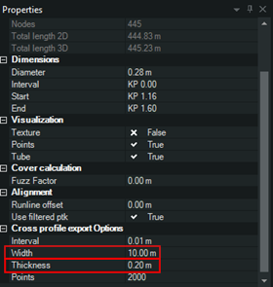

Georeferenced image
The georeferenced images in TIF or PNG format may be created from DTM using any available tool. World files must accompany images. Note that it may take longer to load large images. There is limitation to image size of 10 billion pixels (may be increased on request).

Tide files
ASCII tide files may be generated using any available tool. File extension must be ‘tid’. The format of tide file is:
dd/mm/YYYY HH:MM:SS.SSS,T
05/12/2023 05:40:00.000,0.689
Note that profiles and tide file must be in the same time zone.

Pipetracker data
Two pipetracker data formats are presently supported:
CSV format (must be saved with extension *.fug):
Time, Easting, Northing,TOPDepth
02/01/2024 16:15:51.666,551947.374,571487.435,18.093
And standard EIVA PIP format:
2024:08:27:12:34:56.770 526472.838 4435822.973 0.30996 119.927 16

Note that it is not necessary to have accurate KP at import stage since it will be recomputed based on profiles data after import.

Digital Video
Digital video acquired during inspection may be either in standard Fugro or VisualSoft structure.

USER INTERFACE
The application UI consists of four main standalone windows and optional DV control and DV windows for each video channel if DV is loaded.
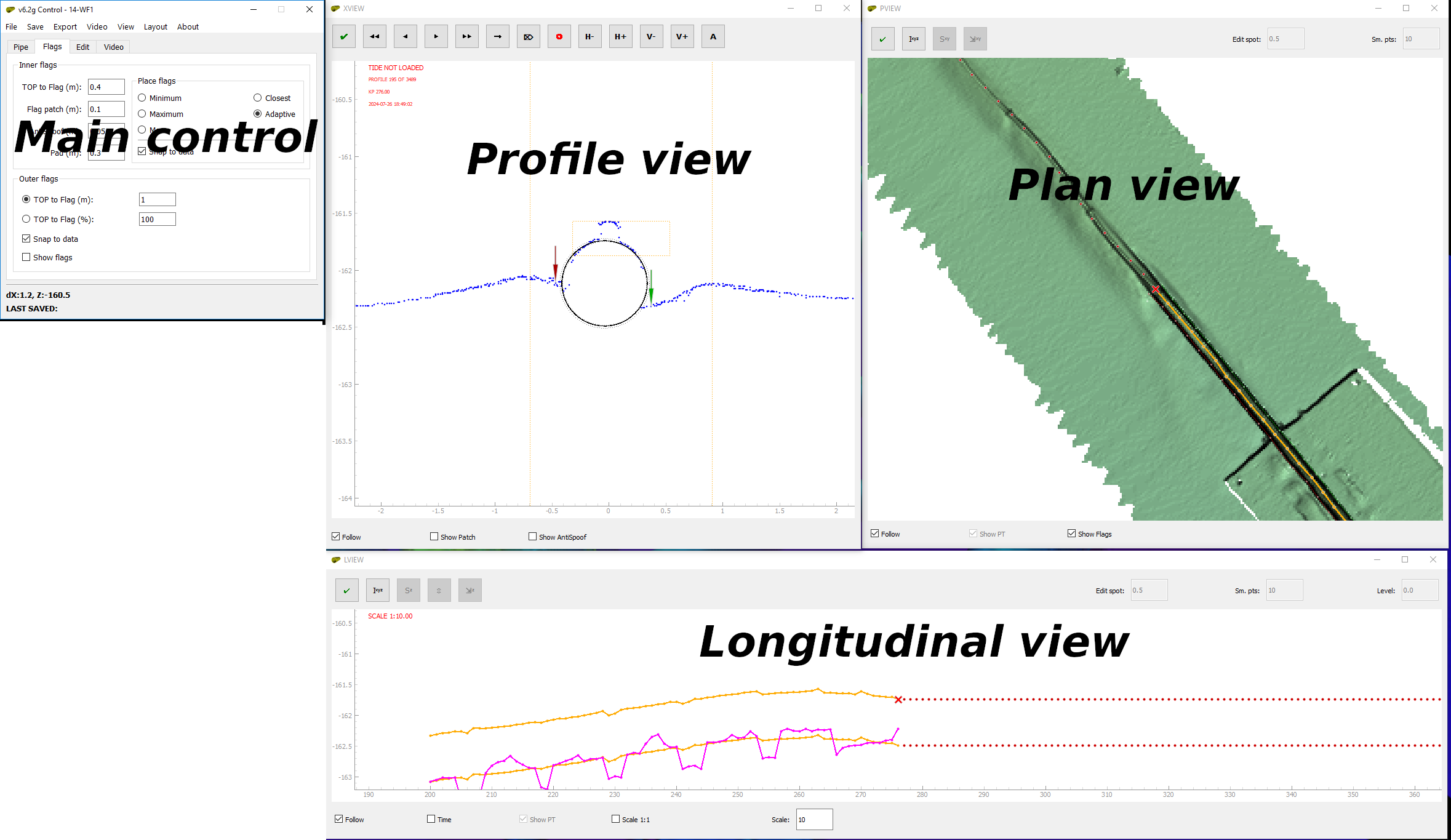

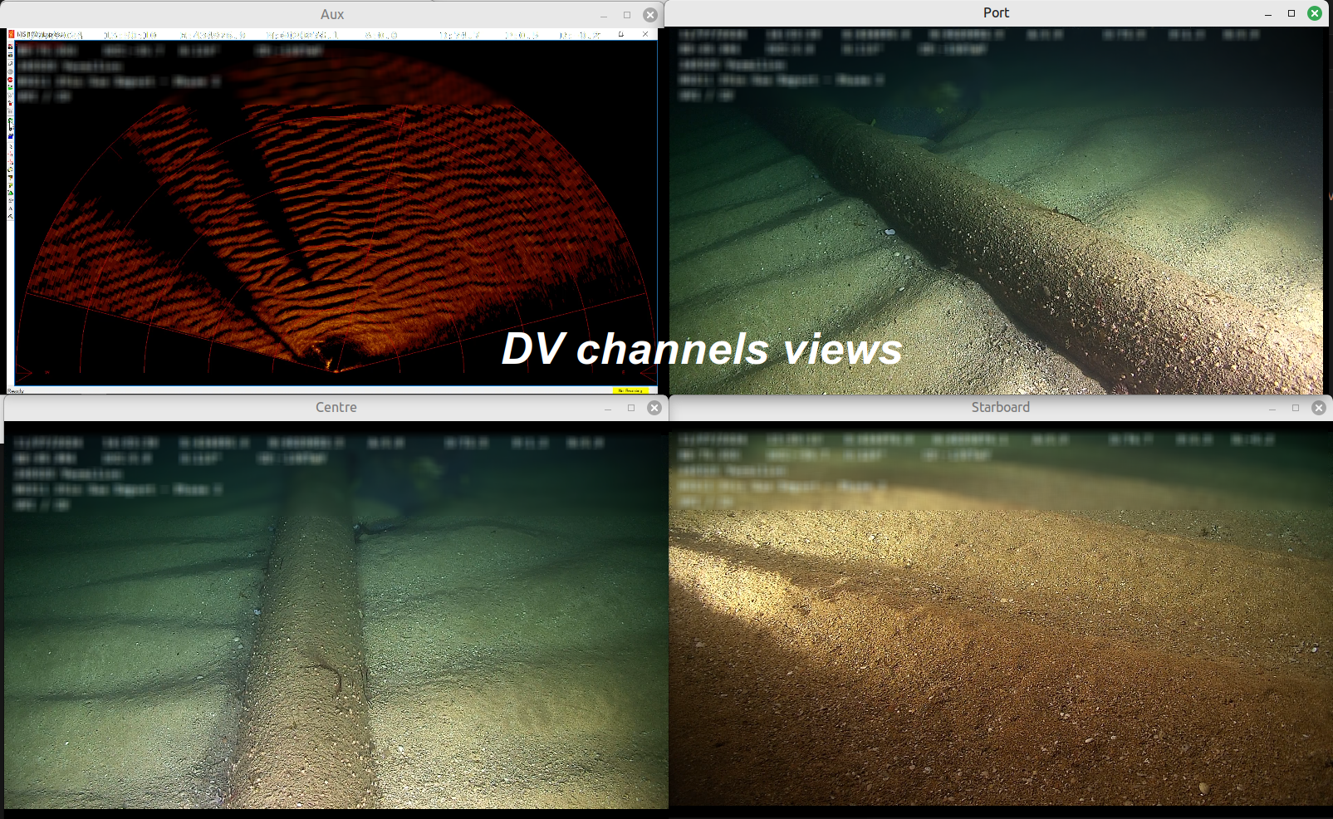

Main Control is used for application configuration and contains menu, four tabs and status bar.
Profile view represents seabed profile, pipe, markers and search window view.
Plan view represents plan view with georeferenced image overlaid by pipe, marker lines and pipetracker data.
Longitudinal view represents longitudinal view with pipe top / bottom, mean adjacent seabed and mean seabed lines as well as pipetracker data.

Main Control menu functions
File -> Load profiles / Load geoimage / Load tide / Load pipetracker / Load saved work - Loading data
Save -> Save work - Saving current work
Export -> Export EIVA / Export SFX - Exporting data
Video -> Build playlist / Load playlist - Creating and loading DV index
View -> XView / PView / LView / DV Control - Show application windows
Layout -> Save layout / Load layout / Edit colors / Load colors - Saving and loading application settings
About – Help and information

Main Control tabs
Pipe - TOP digitizing and profile settings
Flags - Markers digitizing settings
Edit - Pipetracker / Pipe edit options
Video - DV settings

Views controls functions
Profile view
 | Mark POI (Point of Interest) – also on Plan and Long views
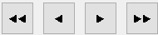 | Step forward / backward; Go to start / to end
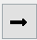 | Go to last visited profile
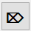 | Reset flags on selection or to end
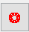 | Show / hide pipe assistant
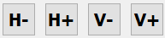 | Increase / decrease horizontal / vertical search windows
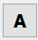 | Auto mode on selection or to end
 | Centre view on profile – also on Plan and Long views
 | Show / hide adjacent markers patches
 | Show / hide ‘Antispoof’ ring

Plan view
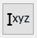 | 3D Interpolate TOP – also on Long view
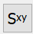 | Smooth pipetracker in horizontal plane (E, N)
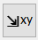 | Snap TOP to pipetracker in horizontal plane (E, N)
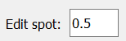 | Set pipetracker eraser side – also on Long view
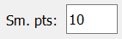 | Set length of smoothing window in horizontal plane
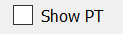 | Show / hide pipetracker data - also on Long view
 | Show / hide markers lines (to show outer markers, ‘Show flags’ checkbox must be ticked on Main control Flags tab)
Long view
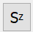 | Smooth pipetracker in vertical plane (Z)
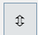 | Level pipetracker
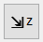 | Snap TOP to pipetracker in vertical plane (Z)
 | Set length of smoothing window in vertical plane
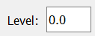 | Pipetracker level value
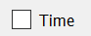 | Show Time / KP on horizontal axis
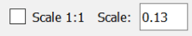 | Set vertical scale of view (this may be changed by pressing  ‘-/+’ keys

USING JUSTPIPE

Loading data
Work starts with loading of profiles data in XPA or SITRAS (CR2) formats. Profiles can be loaded either using File -> Load profiles menu or by drag-and-drop of file to any of view windows. The application supports drag-and-drop of all the supported file types.
Georeferenced image (optional) may be loaded before or after profiles by selecting File -> Load geoimage or by drag-and-drop.
Tide (optional) may be loaded after profiles by selecting File -> Load tide or by drag-and-drop.
Pipetracker data (optional) may be loaded after profiles by selecting File -> Load pipetracker or by drag-and-drop.

Setting up pipe and seabed digitizing
Once profiles are loaded, they will appear in view windows. To start digitizing TOP and seabed, digitizing parameters should be set. This is to be done in ‘Pipe’ and ‘Flags’ tabs of Main Control.
Pipe settings are composed of two parts – pipe geometry and search window.
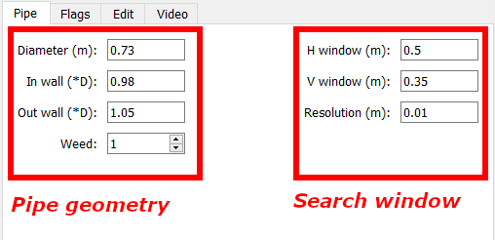

Pipe geometry is specified by pipe diameter in meters, ‘Inner wall’ and ‘Outer wall’ as multiple of diameter. ‘Walls’ settings depend on actual pipe diameter and profile data variation relative to pipe diameter. The ‘inner’ value is selected so the inner part of the profile data falls as close as possible to pipe, while ‘outer’ is selected so that profile data variation falls into ‘inner’ - ‘outer’ span. For larger products ‘inner’ - ‘outer’ span is normally narrower since profile data variation is usually smaller relative to pipe diameter. While for smaller diameters, ‘outer’ setting may reach 1.3-1.5 of pipe diameter. In any case, these settings may be adjusted ‘on-the-fly’ if pipe geometry or data quality changes. This will not affect digitized part of the product. See some examples of pipe geometry settings below.
‘Weed’ setting is used to thin out profile data if necessary.
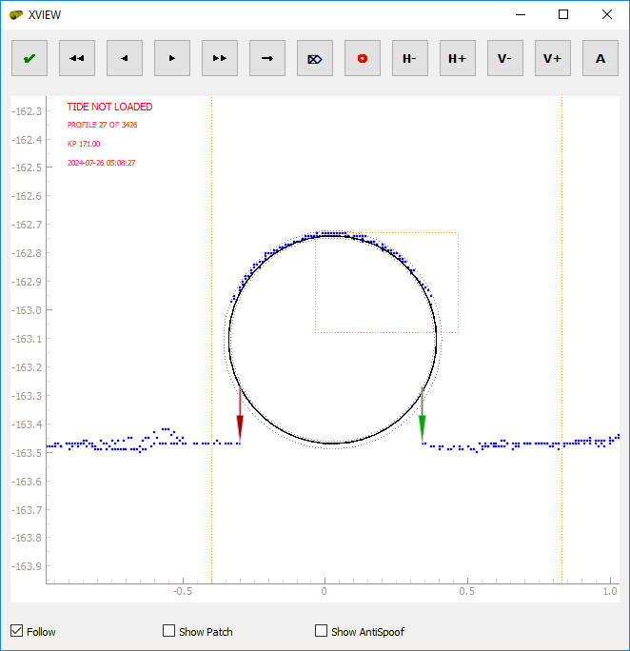 | 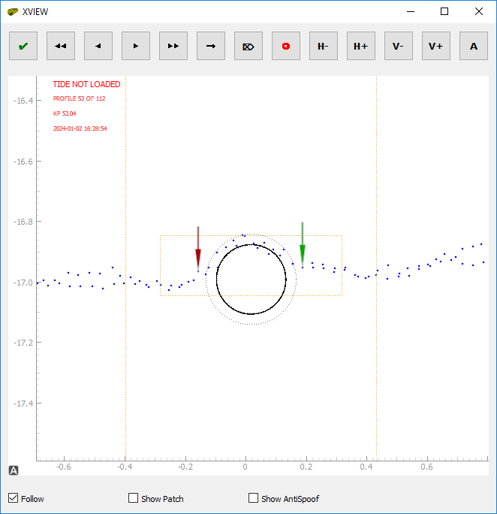 | 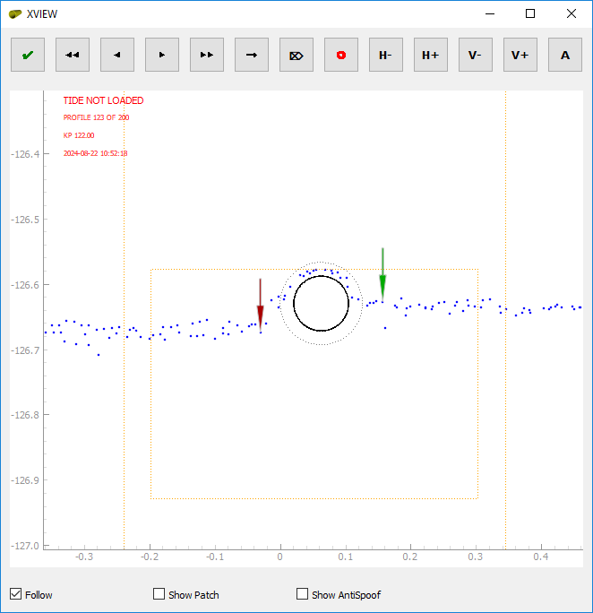
OD = 0.73m  Inner Wall = 0.98  Outer Wall = 1.05 | OD = 0.23m  Inner Wall = 0.98  Outer Wall = 1.30 | OD = 0.084m  Inner Wall = 0.98  Outer Wall = 1.50

Search window settings are defined by ‘horizontal size’, ‘vertical size’ and ‘resolution’ in meters. These are limits of TOP position search. The ‘resolution’ sets accuracy of TOP placement. Horizontal center (dX) of the search window is set as horizontal position of pipe on the previous profile regardless direction of digitizing. The highest data point of the profile within horizontal window is set as upper limit of vertical window. The search window is shown as orange dashed box on the Profile view. Part of the profile used for analysis spans by value of pipe radius both sides of search window. It is shown on the Profile view as two orange vertical dashed lines to the left and right of search box. Note that search box and profile limits are not shown on a previously digitized (‘visited’) profile. Cross in the center of the pipe will be shown instead.
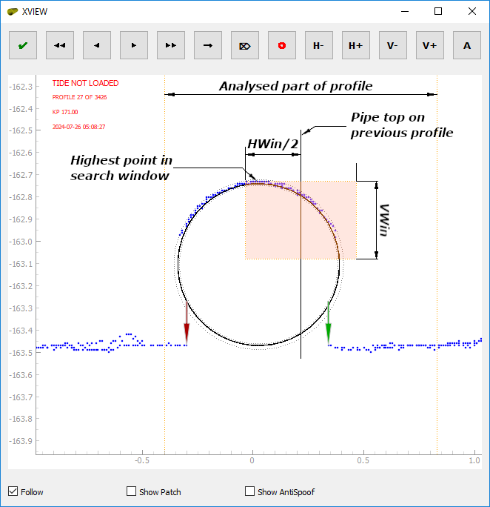

Markers settings are specified in ‘Flags’ tab of Main Control. There are four modes of placing adjacent (inner) flags: ‘Minimum’,’ Maximum’, ‘Mean’ and ‘Adaptive’.
Marker placement is defined by ‘TOP to Flag’ distance and ‘Flag patch’ length in meters. ‘TOP to Flag’ distance sets start of profile patch to search marker position from TOP. ‘Flag patch’ sets size of the profile part from start.
In ‘Minimum’, ‘Maximum’ or ‘Mean’ modes, markers positions will be sought within patch. If ‘Snap to data’ checkbox is checked in ‘Minimum’ or ‘Maximum’ mode, markers will be placed at exact min/max profile point within patch. Otherwise, markers will be placed at min/max depth of patch at ‘TOP to Flag’ distance from TOP. Snapping is not applied for ‘Mean’ mode and markers will be always placed at mean depth of patch at ‘Top to Flag’ distance to TOP.

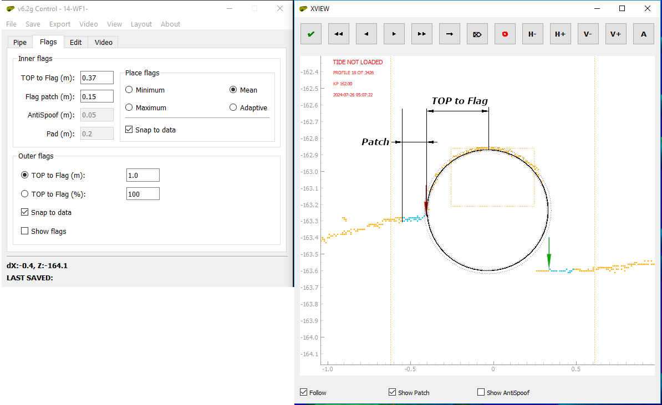
The above three modes may be used in the areas of relatively flat adjacent seabed with a few freespans or burials. Otherwise, ‘Adaptive’ mode is preferable.
‘Adaptive’ mode is developed to accurately place adjacent markers in the areas with rough adjacent seabed and in buried/spanning sections. This is more advanced algorithm allowing for more precise detection of spans/burial heights. Although, depending on data quality and seabed conditions, may require more manual intervention. Two additional settings – ‘AntiSpoof’ and ‘Pad’ in meters are available for ‘Adaptive’ mode. ‘AntiSpoof’ indicates distance from pipe wall where profile points are ignored. I.e., no markers will be placed within ‘AntiSpoof’ ring. ‘Pad’ distance indicates distance from TOP to be ignored. This is useful in case of noisy data.

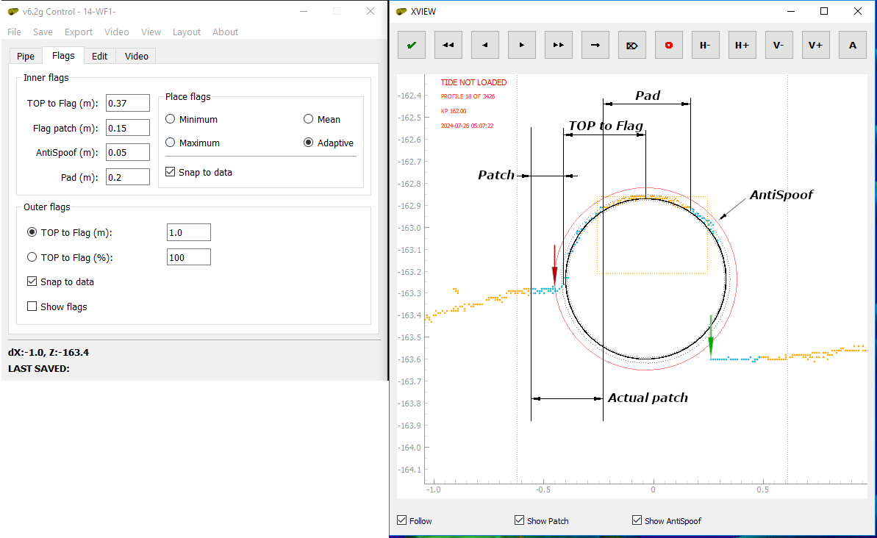

Distance of mean seabed (outer) markers may be selected either as a constant value or as percentage of current profile (swath) width. If the distance exceeds profile width, the markers will be placed at the outermost profile data points. ‘Show flags’ checkbox to be checked to show outer markers on views windows. ‘Snap to data’ option is available.

Placing TOP and markers
Once pipe and markers parameters are set, you can start digitizing by pressing buttons on Profile view window or pressing ‘Home’ / ‘End’ (first / last profiles) or ‘Z’ / ‘X’ (previous / next profiles) keys. Once you made a step to next profile, the previous one is flagged as ‘visited’. Pipe and markers will not change if you come back unless you reset it. The algorithm takes position of TOP across-profile as initial for the next profile. Once you stepped to the next one, TOP will be sought within search window centered on initial position. Algorithm tries to find the best fit of pipe shape to profile. If expected position of TOP is outside the TOP window and TOP was placed in a wrong position, you can move mouse pointer to expected across-profile position of pipe (regardless vertical position) and press ‘Space’ key. This will re-initialize search window centered on across-track mouse pointer position. Markers will be placed accordingly. It is recommended to keep search window size as small as it is reasonable since increasing of the window increases calculations time. As a rule of thumb, pipe crown should always be within search window
On the example below there is pipeline with DEH piggyback on its top. Since the upper vertical limit of search window is selected as highest point of profile within horizontal window, vertical window may be quite narrow if DEH is digitized and wider if pipe is digitized.

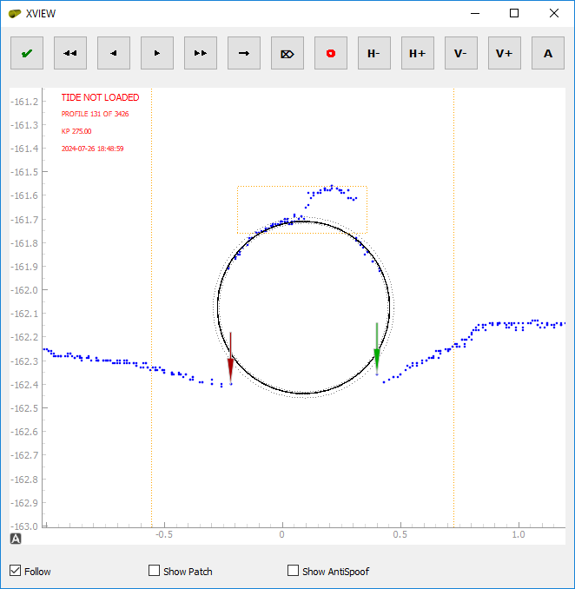 | 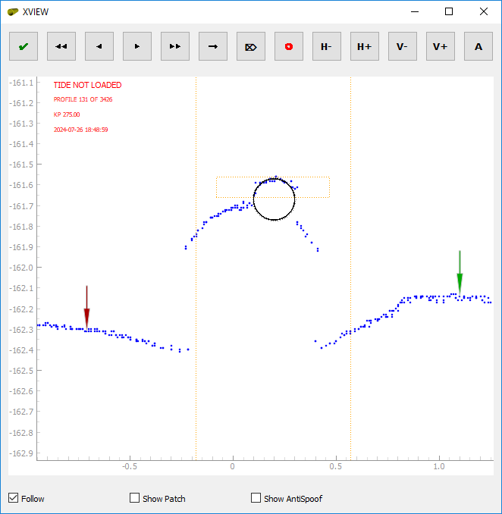
OD = 0.73m  Vertical window = 0.20m  Pipe crown to fall into search window | OD = 0.20m  Vertical window = 0.10m  DEH crown to fall into search window

Window size may be accurately set in ‘Pipe’ tab of Main Control, or quickly adjusted with step of 5cm by pressing buttons in Profile view window.
If pipe cannot be accurately placed automatically or by pressing ‘Space’ key, it is possible to manually place top by clicking Left mouse button in the expected TOP. To help in accurate placement of the pipe, interactive ‘Assistant’ may be turned on / off by pressing button in Profile view window or by pressing ‘C’ key. The button icon will turn green while assistant is on.
At every TOP move, adjacent markers will be re-placed automatically. They also may be re-placed manually by clicking Right mouse button in the desired position of the profile. Left or right marker will be replaced accordingly if mouse pointer is to the left / right from TOP. Outer markers may be replaced by holding ‘Ctrl’ key and clicking Right mouse button.
As you go forward, the visited / unvisited (parts of the pipe will be shown on Plan and Longitudinal view as line and dots accordingly. You can jump to any part of pipe by double-clicking Left mouse button in Plan or Longitudinal view. If you jump to visited profile, the TOP and flags will not change unless you re-set.

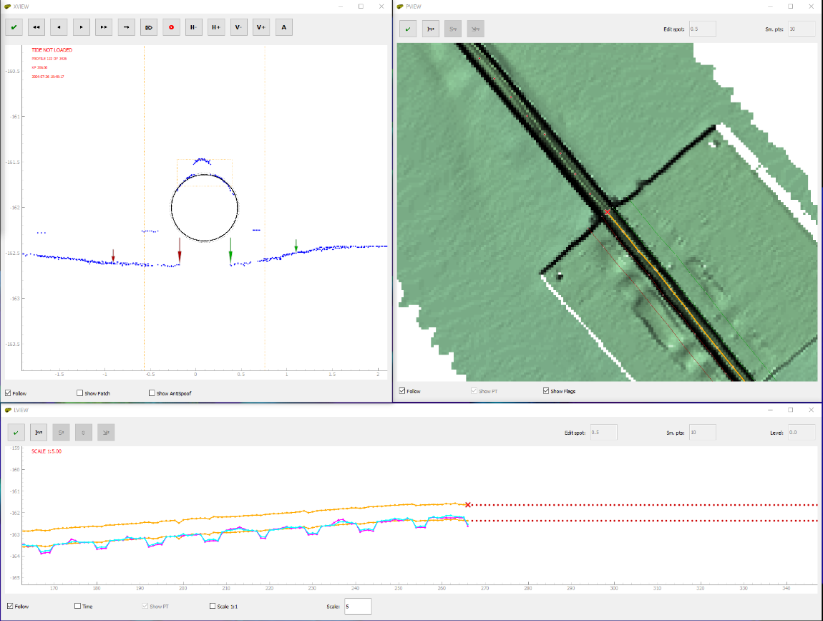

You can jump to last visited profile of current visited part by pressing button in Profile view or ‘E’ key.

TOP selection
You can select TOP section (both visited and unvisited) by clicking Right mouse button in Plan or Longitudinal view. First click defines first selection point, while second click – the last one. Selection will be highlighted yellow both on Plan and Longitudinal views. Selection may be used for interpolation, re-setting, auto-mode running and snapping to pipetracker.

TOP 3D interpolation
Sometimes minor parts of TOP may be interpolated (like at anodes, fieldjoints, short burials or mattresses, structures, etc.). To interpolate TOP section, it must be selected by selection tool (see above). Interpolation is performed either by pressing button on Plan or Longitudinal view or by pressing ‘I’ key.

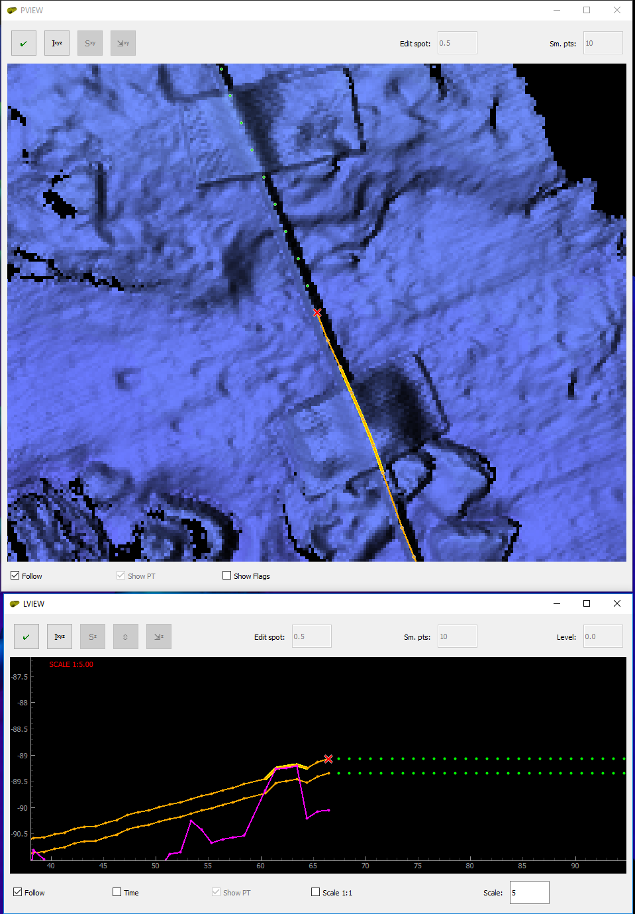 | 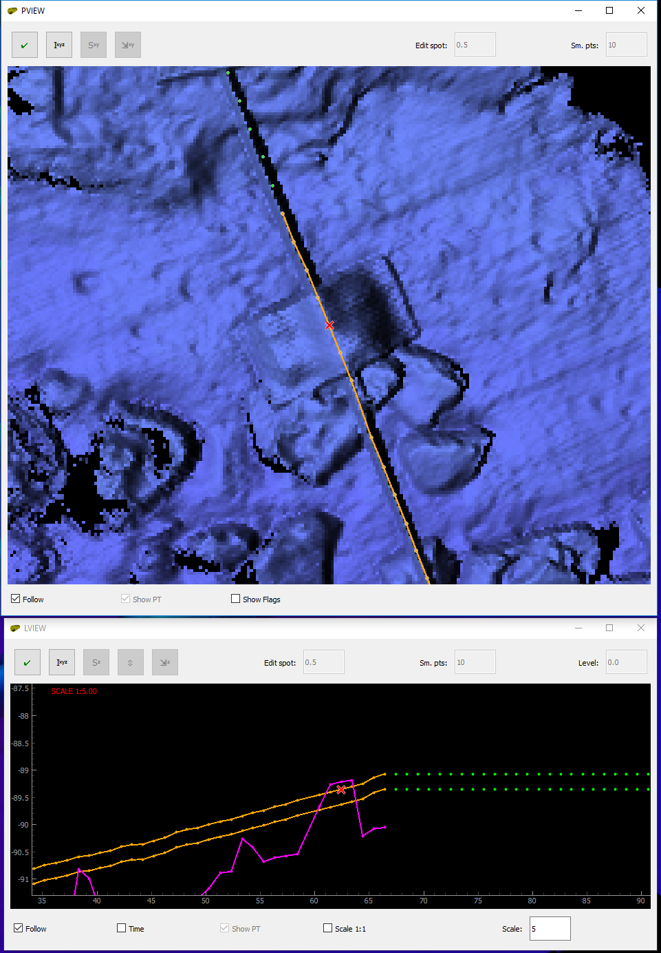
Before interpolation | After interpolation

Note that markers on the interpolated part will be re-placed automatically in accordance with current ‘Flags’ settings. You may need to re-visit interpolated section and adjust TOP or markers.

Applying tide
Tidal data can be loaded either using File -> Load tide menu or by drag-and-drop of file to any of view windows. If loaded, they will be applied to profiles and pipetracker. Once tidal data is loaded, tide indicator on Profile view will change from to . Tide can be unapplied and re-applied by unticking / ticking ‘Apply tide’ checkbox in ‘Pipe’ tab of Main Control. Tide indicator will change accordingly .

Processing pipetracker
Pipetracker data (either raw or processed and saved ‘spt’ file) can be loaded either using File -> Load pipetracker menu or by drag-and-drop of file to any of view windows. Note that profile data is used as KP reference for pipetracker. Therefore, profiles must be loaded prior to pipetracker. If tide is applied to profiles, the same tide will be applied to pipetracker.
To enable pipetracker processing, select ‘Pipetracker’ option in ‘Edit’ tab of Main control.

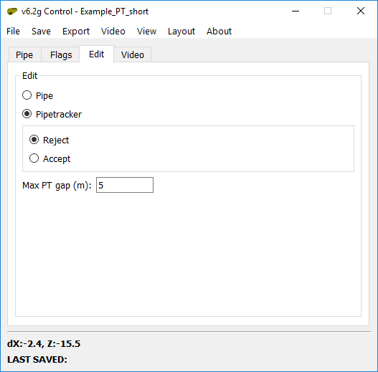

The following actions are available:
- Rejecting / accepting of data
- Smoothing in plan and vertical planes
- Levelling
To reject data (usually spikes), select ‘Reject’ option in ‘Edit’ tab of Main control. To accept data, select ‘Accept’. Reject / accept modes may be switched by pressing ‘Alt’ key. Rectangular eraser will appear on Plan and Longitudinal views (red for rejection and green for acceptation). Size of the eraser may be set for each view individually by setting ‘Edit spot’ value . Rejected data will be shown as red dots.
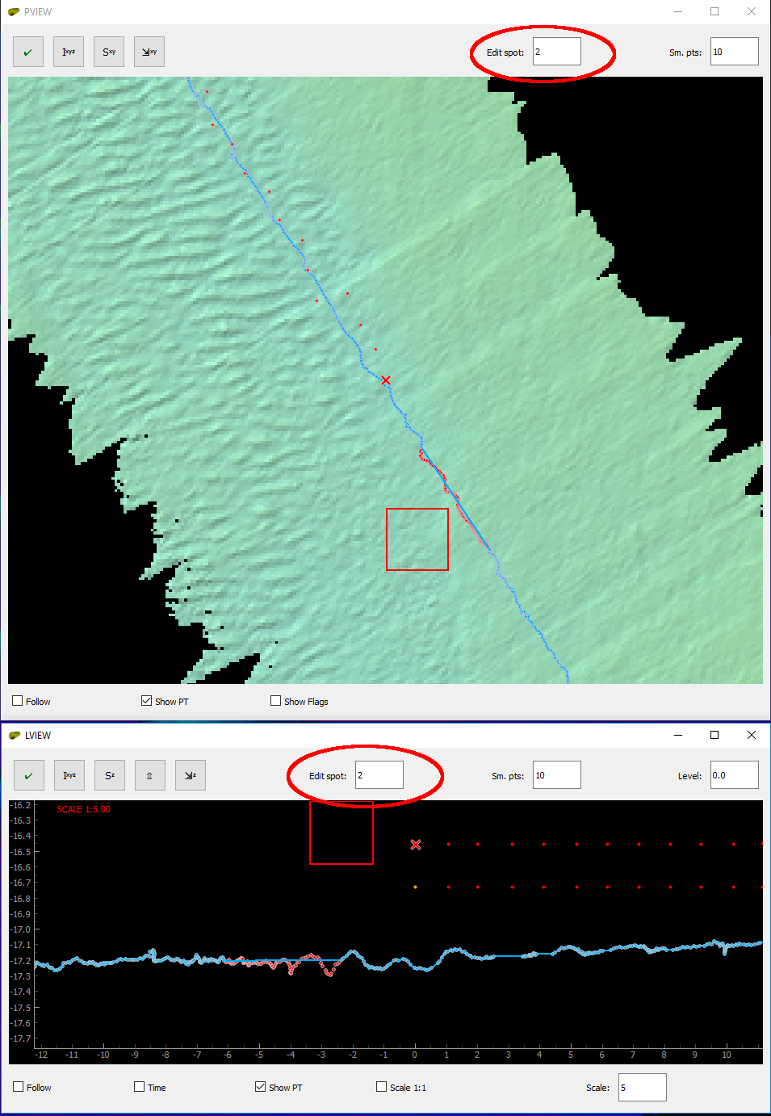

To smooth data, set value in ‘Sm. Pts’ window of Plan view for smoothing in horizontal plane and in Longitudinal view for smoothing in vertical plane. This value sets number of data points of moving average window. ‘Max PT Gap’ setting in ‘Edit’ tab of Main Control sets maximum gap in data (in meters) to be treated as continuous accepted dataset. If gap exceeds this value, smoothing window will break at this gap. Note that start and end sections of size equal to smoothing window will not be smoothed.
Press button in Plan view to smooth pipetracker data in horizontal plane and button in Longitudinal view to smooth in vertical plane.
Each time the smoothing is applied, it is applied to raw accepted data. To unapply smoothing, run smoothing with window size = 0 points.
Usually, the pipetracker data should be moved in vertical plane to match TOP at exposed sections, i.e. levelled. To level pipetracker data, you need to estimate required shift value, set it in ‘Level’ window of Longitudinal view and press button in Longitudinal view. The shift is applied to original data, not to shifted. Original data will be grayed on Longitudinal view.

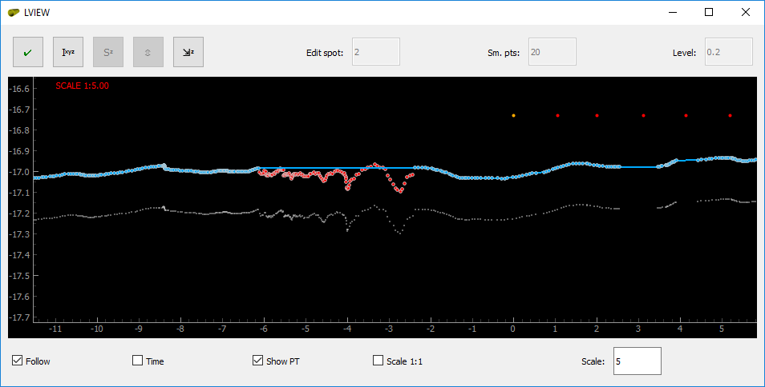

Snapping TOP to pipetracker
TOP in buried sections may snapped to pipetracke in horizontal and vertical planes individually. ‘Max PT gap’ value is used for setting snapping rejection criteria. TOP will not be snapped to rejected part of pipetracker exceeding gap value. Press button in Plan view and button in Longitudinal view to snap top in horizontal and vertical planes accordingly. If selection is made using selection tool, only selected part will be snapped. Otherwise, the whole pipe will be snapped to pipetracker where available. Note that markers will be re-set automatically for the snapped section. You may need to re-visit snapped section to adjust pipe top or markers.

Digital video
ROV digital video may be used to assist in pipe digitizing. To load DV, DV index should be created. Firstly, the DV structure and naming convention should be specified.

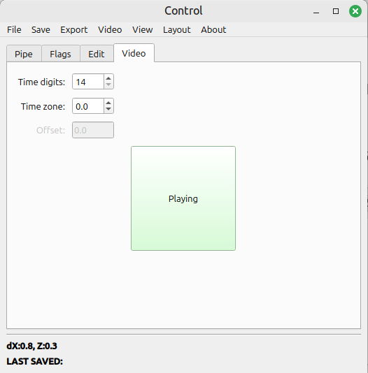
Normally, DV file name contains DV start time. This time is used for creating DV index. Format of time depends on acquisition software. For instance, Fugro DV file name convention specifies 14 digits (yyyymmddhhmmss), while VisualSoft one specifies 17 digits (yyyymmddhhmmsssss). Set number of digits in the ‘Video’ tad of Main Control. Select Video -> Build playlist menu of Main Control. This will prompt to select folder with video and save index file with ‘pll’ extension.
Index file can be loaded either using Video -> Load playlist menu or by drag-and-drop of playlist file to any of view windows. DV channels views will appear.
Channels views may be closed, if necessary. To open closed views select DV Control in the Main Control -> View menu.
If DV and profiles were logged in different time, time zone should be set in ‘Video’ tab of Main Control. Note, it sets time difference from profiles to video. There is no playback option. DV stills will be shown for time of selected profile. To stop stills, press ‘Pause’ button in ‘Video’ tab of Main Control. To start it again, press ‘Play’.

Re-setting flags
Pipe or its part may be re-flagged to ‘unvisited’ if necessary, by pressing button in Profile view or ‘0’ key. If pipe section is selected by selection tool, only section will be re-set. Otherwise, part of pipe from current profile to end will be re-set.

POI
You can mark points of interest (POI) if you need to return to the profile later for some reason (for instance, highlighting sections to be snapped to pipetracker) by pressing button. POI will be marked by red cross in Plan and Longitudinal views. POI button icon will change to  or the marked profile. Press POI button again when on the marked profile to unmark POI.

Colors settings
Colors of graphics elements may be edited, saved and loaded. To edit colors, select Layout -> Edit colors menu in the Main Control. The color palette will appear. Press buttons to change elements’ colors.

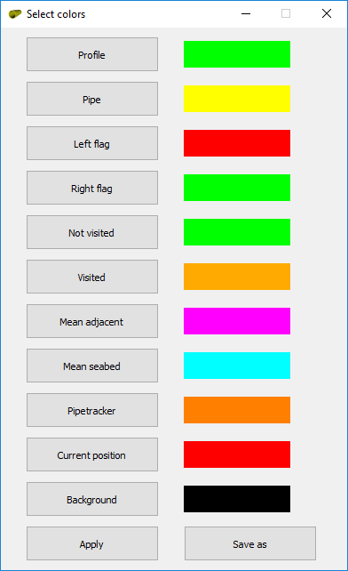

You can apply new settings to current session and save them as ‘plt’ file. This file can be loaded when necessary by selecting Layout -> Load colors menu or by drag-and-drop of file to any of view windows.

Layout settings
Once data loaded, pipe and markers settings, windows size and position, colors are set, the current settings including all the listed may be saved to ‘lyt’ file by selecting Layout -> Save layout menu of Main Control. This file can be loaded when necessary by selecting Layout -> Load layout menu or by drag-and-drop of file to any of view windows.

Saving work
Current working session including settings, layout and colors settings may be saved to ‘wrk’ file by selecting Save -> Save work menu in Main Control. This will prompt to select path to stored file. Name of the last saved file will be indicated in status bar. If pipetracker data is loaded, it will also be saved along including current processing status to ‘spt’ file. There is fast saving option. If you press ‘Ctrl’+’S’ keys when Profile, Plan or Longitudinal view is active, ‘wrk’ file and ‘spt’ file (if pipetracker loaded) will be saved to location of loaded profiles file. This will be indicated by saved file name followed by Fastsave in status bar.
Saved session may be loaded by selecting File -> Load saved work menu or by drag-and-drop of file to any of view windows. This will restore exact current status of processed profiles as well as processing, layout and color settings. Processed and saved pipetracker data and georeferenced image should be loaded separately. If tide data was loaded to saved session, the status of tide application will be restored.

Automatic mode
Selected section or section from current profile to end may be fully automatically processed with current settings. This is not recommended since you may need to re-visit each profile for QC. Better strategy is to digitize profiles one by one performing QC at the same time. Run it if pipe is well defined on the profile and adjacent seabed is flat and uniform.
To run automatic processing press button in Profile view or press ‘Ctrl’+’A’ keys. Note that application will freeze until the processing is completed. Message will pop up once the processing is completed.
TOP will be automatically processed only at ‘unvisited’ sections. Markers may be re-processed with new settings at ‘visited’ sections. TOP will not be reprocessed. TOP may be re-processed if flags re-set (see ‘Re-setting flags’ section).

Data export
Digitized TOP and markers may be exported to Fugro Edit or EIVA dig formats from Export menu of Main control. Depending on EIVA NaviModel height settings, it may be required to flip digitized lines vertically to match application settings. Pipe digitized line contains pipe flag while flag lines to be flagged manually by selecting relevant line type. Tide will be applied or unapplied depending on whether ‘Apply tide’ checkbox in ‘Pipe’ tab of Main Control is checked/unchecked

Hotkeys and Mouse buttons

Keyboard
X / Z | One profile Forward / Backward
Home / End | First / Last profile
E | Last visited profile in the visited section
0 | Reset all profiles forward
Space | Auto-snap TOP
I | 3D interpolate
C | Show / hide pipe assistant
Ctrl+S | Fast save work (same folder as original profiles)
Alt | In PT edit mode – switch Accept / Reject
-_ / += | Change Lview exaggeration
Mouse
Left Mouse Button (XView) | Force TOP
Right Mouse Button (XView) | Force inner flags / (+Ctrl) outer flags
Double Left Mouse Button (LView / PView) | Jump to selected clicked profile
Right Mouse Button (LView / PView) | Select chunk start / end

