justPipe v.3
User Manual

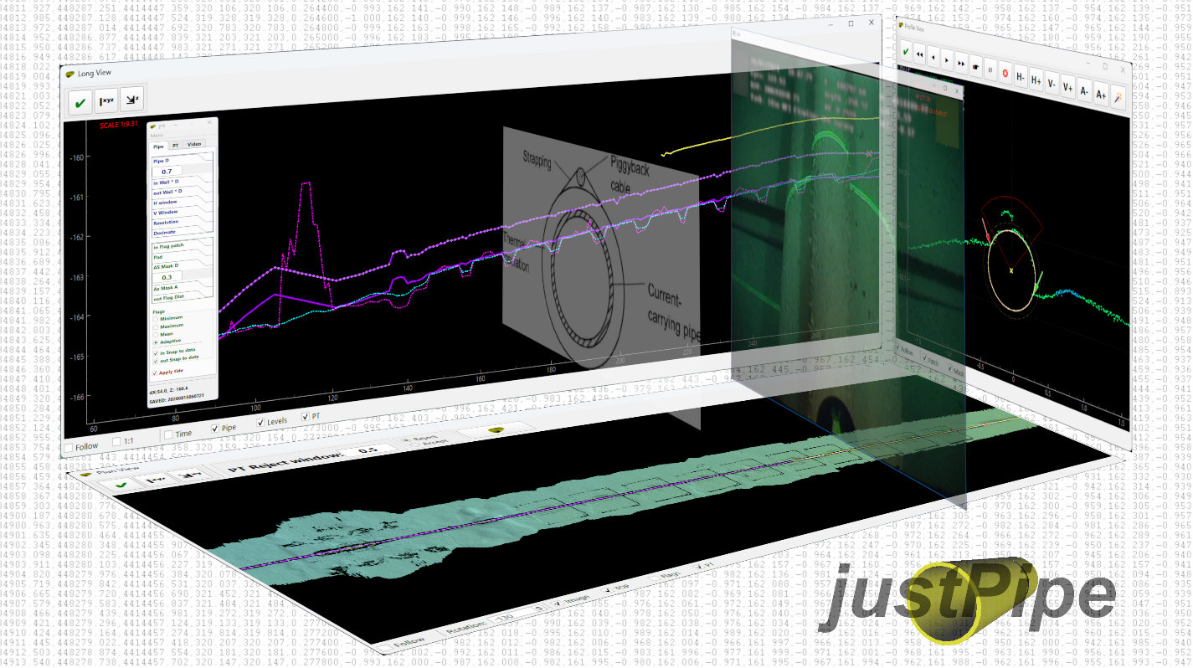

Copyright © 2026 Aleksandr Kaiurin
akayurin@gmail.com

INTRODUCTION 3
PREREQUISITES 4
HOW IT WORKS 5
DATA PREPARATION 6
Seabed profiles 6
Georeferenced image 7
Tide files 7
Pipetracker data 7
Digital Video 7
USER INTERFACE 8
Main control menu functions 8
Main control tabs and functions 8
Views controls functions 10
USING JUSTPIPE 11
Loading data 11
Setting up pipe and seabed digitizing 11
Placing TOP and markers 13
TOP selection 13
TOP 3D interpolation 14
Applying tide 14
Processing pipetracker 14
Snapping TOP to pipetracker 15
Digital video 16
Re-setting TOP and markers 17
POI 17
Colors settings 17
Saving work 17
Automatic processing 18
Data export 18
Hotkeys and Mouse buttons 19

INTRODUCTION
justPipe application is developed to provide fast, reliable and flexible tool for digitizing of subsea pipelines, umbilicals and cables based on seabed profiles data acquired during inspections or construction surveys.
Depending on product geometry and conditions, two main strategies are usually used for digitizing. Automatic digitizing may be undertaken when product is well defined on the seabed and seabed conditions allow for accurate seabed markers placement. In any case, the digitized data must be QC’ed and corrected, if necessary, afterwards. This may take as long as another strategy – manual digitizing. In this case, manual placement of top and markers may take longer time.
Due to advanced algorithms and flexible settings, justPipe combines both strategies taking advantages of processing speed from automatic approach and reliability from the manual one. It allows for fast automatic placement of pipe elements and QC in one run.
The software capabilities include:
- Automatic and manual digitizing of product top and seabed markers (adjacent and mean seabed) based on seabed profiles
- Basic processing of pipetracker data (data rejection, smoothing and levelling)
- Snapping top to processed pipetracker data
- Tide correction of processed data
- Digital video playback to assist in digitizing
- Export to industry software compatible formats
Presently, the application data formats are compatible with Fugro Starfix and Eiva.

PREREQUISITES
You may need to install video codecs pack for digital video playback if application is run on Windows. It is recommended to install LAVFilters package.

HOW IT WORKS
The main advantage of using justPipe is fast and accurate pipe top (TOP – Top Of Pipe) and markers placement. Since these are the most time-consuming tasks during pipes digitizing, the following approaches were used to achieve digitizing speed and accuracy:
- Use of specific and accurate TOP detection and marker placement algorithms
- Immediate access to settings for fast reaction to changing conditions
- Intuitive and simple user interface to minimize time of interaction
Application is intended to automatically place TOP and markers as much as possible. Processor just goes through profiles with minimum intervention, verifying automatic placement and doing QC at the same time. If automatic detection fails due to inadequate settings or position initializing issue, it is easy to re-try with different settings or to change initial search position just in one click. At any time, processor can manually place TOP in one click if he is not happy with automatic detection results. Interactive pipe placement assistant is available. When TOP position changes, markers follow it. Adaptive markers placement mode allows for adequate placement at freespans and burials. Markers positions may also be adjusted manually at any time.

DATA PREPARATION
The input data may include:
- Seabed profiles in configurable ASCII XPA or SITRAS v.5 format
- Georeferenced image in TIF or PNG format accompanied by corresponding world files (optional)
- Tide files in ASCII format (optional)
- Pipetracker files in ASCII CSV (*.fug) or EIVA PIP format (optional)
- Digital video logged using Fugro or VisualSoft data structure (optional)
Seabed profiles are necessary while other data are optional.

Seabed profiles
Seabed profiles data may either be obtained from single scans (profiles) or DTM sections. They may be obtained from any source supporting SITRAS format or capable of configuring output of cross-profiles in dX, Z format.
To obtain scan profiles from Fugro software it is necessary:
- Import processed selected MBE and general data into Edit database
- Set primary devises and recompute KP in Edit (runline must be imported as KP reference)
- Make pipe and flags, it is not necessary to place them accurately since they are only needed for profiles reference
- Export profiles in SITRAS format using DataIO
To obtain DTM profiles from EIVA NaviModel it is necessary to:
- Create DTM
- Import runline for KP reference
- Import ROV (or other) track in ETR format
- Create new pipe and add sideflags, it is not necessary to place them accurately since they are only needed for profiles reference
- Export profiles in SITRAS RAW (embedded) or specific XPA format
Reasonable cross-profile export settings should be set in EIVA NaviModel since excess points will slow down both exporting.
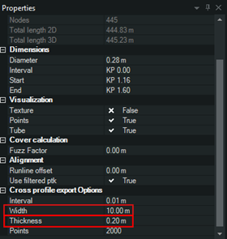

Georeferenced image
The georeferenced images in TIF or PNG format may be created from DTM using any available tool. If georeferenced data is not embedded into image file, world files must accompany image. Note that it may take longer to load large images. There is limitation to image size of 10 billion pixels (may be increased on demand).

Tide files
ASCII tide files may be generated using any available tool. File extension must be ‘tid’. The format of tide file is:
dd/mm/YYYY HH:MM:SS.SSS,T
05/12/2023 05:40:00.000,0.689
Note that profiles and tide file must be in the same time zone.

Pipetracker data
Two pipetracker data formats are presently supported:
CSV format (must be saved with extension *.fug):
Time, Easting, Northing,TOPDepth
02/01/2024 16:15:51.666,551947.374,571487.435,18.093
And standard EIVA PIP format:
2024:08:27:12:34:56.770 526472.838 4435822.973 0.30996 119.927 16

Note that it is not necessary to have accurate KP at import stage since it will be recomputed based on profiles data after import.

Digital Video
Digital video acquired during inspection may be either in standard Fugro or VisualSoft structure.

USER INTERFACE
The application UI consists of four main standalone windows.
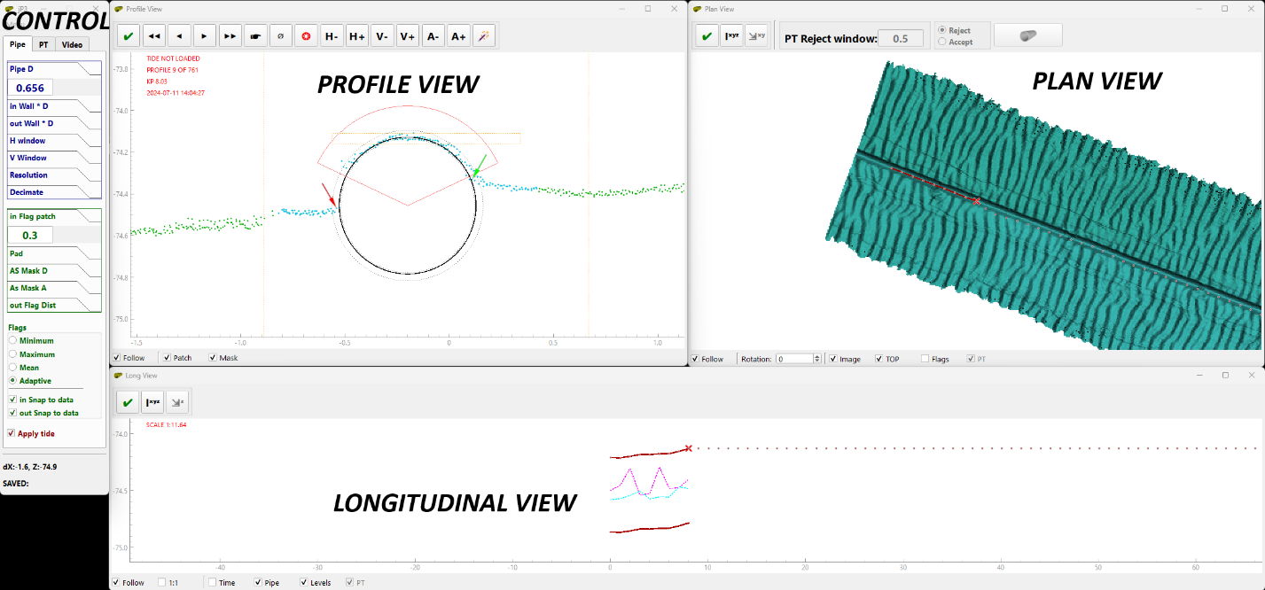

Main Control is used for application configuration and contains menu, four tabs and status bar.
Profile view represents seabed profile, pipe, markers and search area view.
Plan view represents plan view with georeferenced image overlaid by pipe, marker lines and pipetracker data.
Longitudinal view represents longitudinal view with pipe top / bottom, mean adjacent seabed and mean seabed lines as well as pipetracker data.

Main control menu functions
Load profiles / Load geoimage / Load tide / Load pipetracker / Load saved work - Loading data
Save work - Saving current work
Export EIVA / Export SFX - Exporting data
Build DV index / Load DV index - Creating and loading DV index
XView / PView / LView / DV Control - Show windows
Edit palette – Set elements colors
Manual – Opens User manual
License – Shows licenses

Main control tabs and functions
Pipe – Profile, TOP and markers digitizing settings
PT – Pipetracker processing settings
Video - DV settings

Pipe PT (pipetracker)
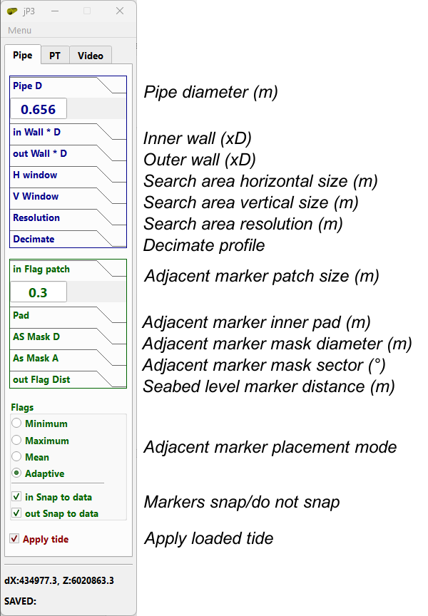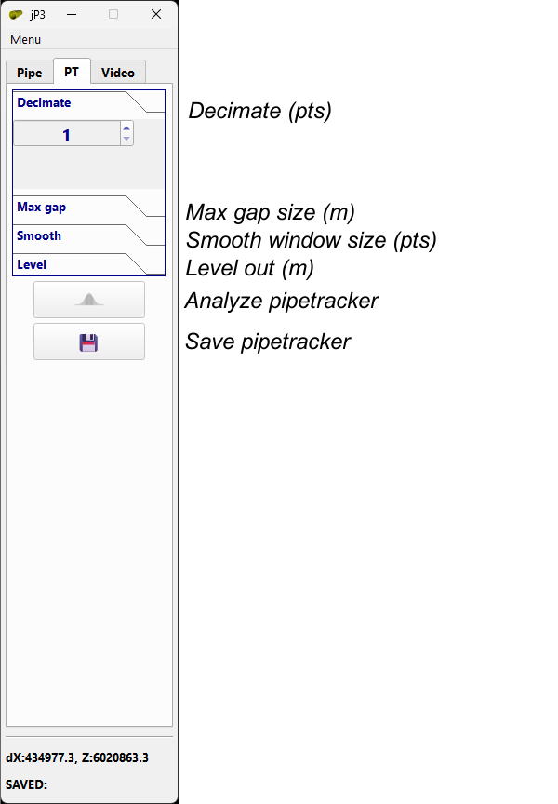

Digital Video
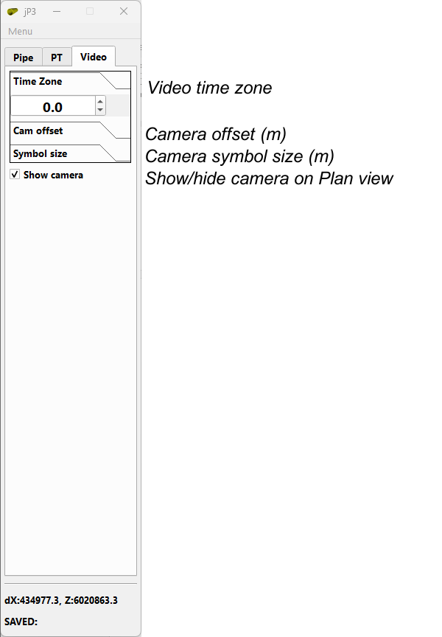

Views controls functions
Profile view
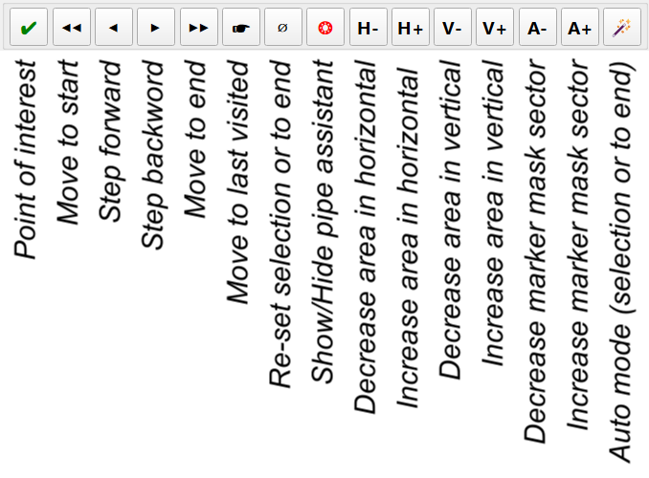

Plan view Long view
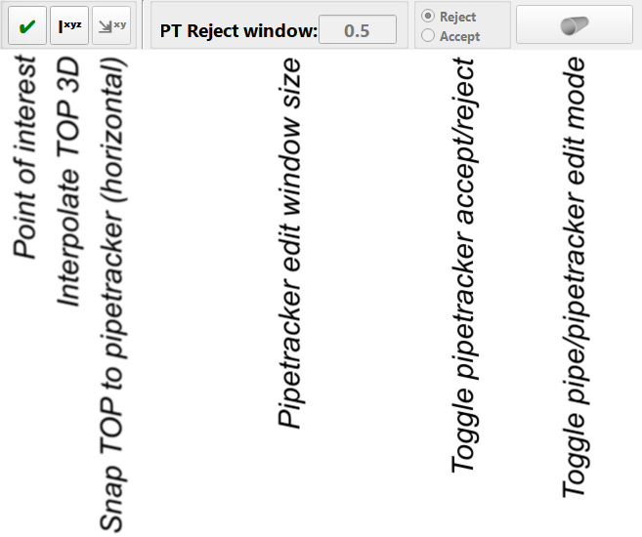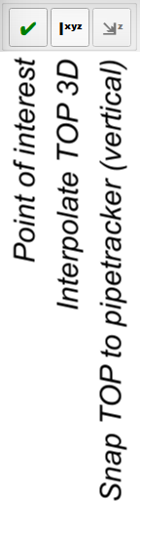

USING JUSTPIPE

Loading data
Work starts with loading of profiles data in XPA or SITRAS (CR2) formats. Profiles can be loaded either using Load profiles menu or by drag-and-drop of file to any of view windows. The application supports drag-and-drop of all the supported file types.
Georeferenced image (optional) may be loaded before or after profiles by selecting Load geoimage or by drag-and-drop.
Tide (optional) may be loaded after profiles by selecting Load tide or by drag-and-drop.
Pipetracker data (optional) may be loaded after profiles by selecting Load pipetracker or by drag-and-drop.

Setting up pipe and seabed digitizing
Once profiles are loaded, they appear in view windows. Digitizing parameters must be set up in ‘Pipe’ tab of Main control.
Pipe settings are composed of two parts – pipe geometry and search window.
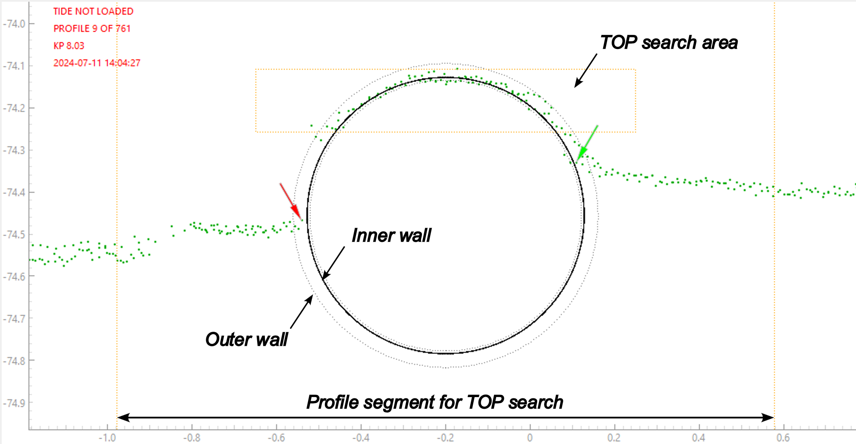
Pipe geometry is specified by pipe diameter in meters, ‘Inner wall’ and ‘Outer wall’ as multiple of diameter. ‘Walls’ settings are used for better fit of pipe shape to profile points. Those settings depend on actual pipe diameter and profile points variation relative to pipe diameter. The ‘inner’ value is selected so the inner part of the profile data falls as close as possible to pipe shape, while ‘outer’ is selected so that profile data variation falls into ‘inner’ - ‘outer’ span. For larger products ‘inner’ - ‘outer’ span is normally narrower since profile data variation is usually smaller relative to pipe diameter. While for smaller diameters, ‘outer’ setting may reach 1.3-1.5 x pipe diameter. In any case, these settings may be adjusted ‘on-the-fly’ if pipe geometry or data quality changes. This will not affect digitized part of the product.
Search window settings are defined by ‘horizontal size’, ‘vertical size’ and ‘resolution’ in meters. These are limits of TOP position search. The ‘resolution’ sets accuracy of TOP placement. Horizontal center (dX) of the search area is set as horizontal position of pipe on the previous profile regardless direction of digitizing. The highest data point of the profile within horizontal window is set as upper limit of vertical window. The search area is shown as orange dashed box on the Profile view. Part of the profile used for analysis spans by value of pipe radius both sides of search window. It is shown on the Profile view as two orange vertical dashed lines to the left and right of search box. Note that search box and profile limits are not shown on a previously digitized (‘visited’) profile. Cross in the center of the pipe will be shown instead.

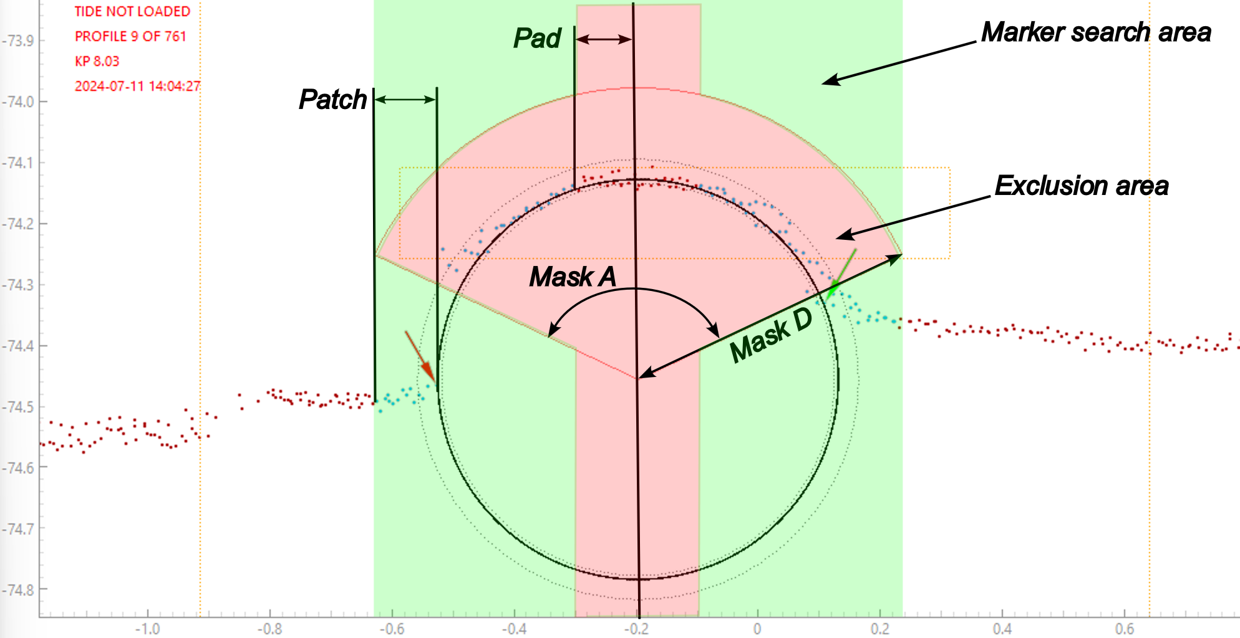Markers settings are specified in a lower part of ‘Pipe’ tab of Main control. There are four modes of placing adjacent (inner) flags: ‘Minimum’,’ Maximum’, ‘Mean’ and ‘Adaptive’.
Profile section for placement of adjacent seabed markers is defined as ‘Patch’. This patch is set as distance from pipe center equal to pipe radius plus ‘in Flag patch’ value either side of pipe.
Mean seabed marker distance from pipe center is set up by ‘out Flag Dist’ parameter.
In ‘Minimum’, ‘Maximum’ or ‘Mean’ modes, markers positions will be sought within patch. If ‘Snap to data’ checkbox is checked in ‘Minimum’ or ‘Maximum’ mode, markers will be placed at exact min/max profile point within patch. Otherwise, markers will be placed at min/max depth of the patch. Snapping is not applied for ‘Mean’ mode and markers will be always placed at mean depth of the patch.
The above three modes may be used in the areas of relatively flat adjacent seabed with a few freespans or burials. Otherwise, ‘Adaptive’ mode is preferable.
‘Adaptive’ mode is developed to accurately place adjacent markers in the areas with rough adjacent seabed and in buried/spanning sections. This is more advanced algorithm allowing for more precise detection of spans/burial heights. Although, depending on data quality and seabed conditions, may require more manual intervention.
In the ‘Adaptive’ mode, if the profile is noisy, exclusion area may be set up. This area is defined by ‘Pad’ - distance from pipe center and mask sector, defined by radius (‘D’) and angle (‘A’).

Placing TOP and markers
Once pipe and markers parameters are set, digitizing may be run by pressing 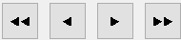 buttons on Profile view window or pressing ‘Home’/‘End’ (first / last profiles) or ‘Z’/‘X’ (previous / next profiles) keys. Once a step to next profile is made, the previous one is flagged as ‘visited’. Pipe and markers will not change if you come back unless you reset it. The algorithm takes position of TOP across-profile as initial for the next profile. Once you have stepped to the next one, TOP will be sought within search window centered on initial position. Algorithm finds the best fit of pipe shape to profile. If expected position of TOP is outside the TOP window and TOP was placed in a wrong position, you can move mouse pointer to expected across-profile position of pipe (regardless vertical position) and press ‘Space’ key. This will re-initialize search window centered on across-track mouse pointer position. Markers will be placed accordingly. It is recommended to keep search window size as small as it is reasonable since increasing of the window increases calculations time. As a rule of thumb, pipe crown should always be within search window
Window size may be accurately set in ‘Pipe’ tab of Main control, or quickly adjusted with step of 5cm by pressing 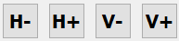buttons in Profile view window.
If pipe cannot be accurately placed automatically or by pressing ‘Space’ key, it is possible to manually place top by clicking Left mouse button in the expected TOP. To help in accurate placement of the pipe, interactive ‘Assistant’ may be turned on / off by pressing 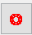 button in Profile view window or by pressing ‘C’ key. The button icon will turn green while assistant is on.
At every TOP move, adjacent markers will be re-placed automatically. They also may be re-placed manually by clicking Right mouse button in the desired position of the profile. Left or right marker will be replaced accordingly if mouse pointer is to the left / right from TOP. Outer markers may be replaced by holding ‘Ctrl’ key and clicking Right mouse button.
As you go forward, the visited / unvisited (parts of the pipe will be shown on Plan and Longitudinal view as line and dots accordingly. You can jump to any part of pipe by double-clicking Left mouse button in Plan or Longitudinal view. If you jump to visited profile, the TOP and flags will not change unless you re-set.
You can jump to last visited profile of current visited part by pressing 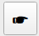 button in Profile view or ‘E’ key.

TOP selection
You can select TOP section (both visited and unvisited) by clicking Right mouse button in Plan or Longitudinal view. First click defines first selection point, while second click – the last one. Selection will be highlighted yellow both on Plan and Longitudinal views. Selection may be used for interpolation, re-setting, auto-mode running and snapping to pipetracker.
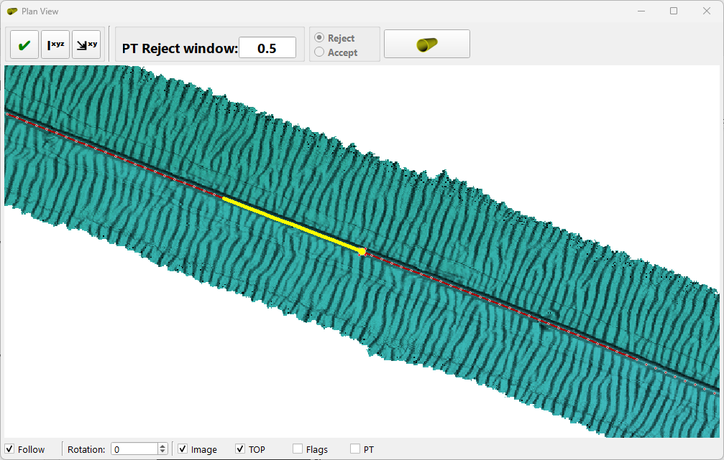
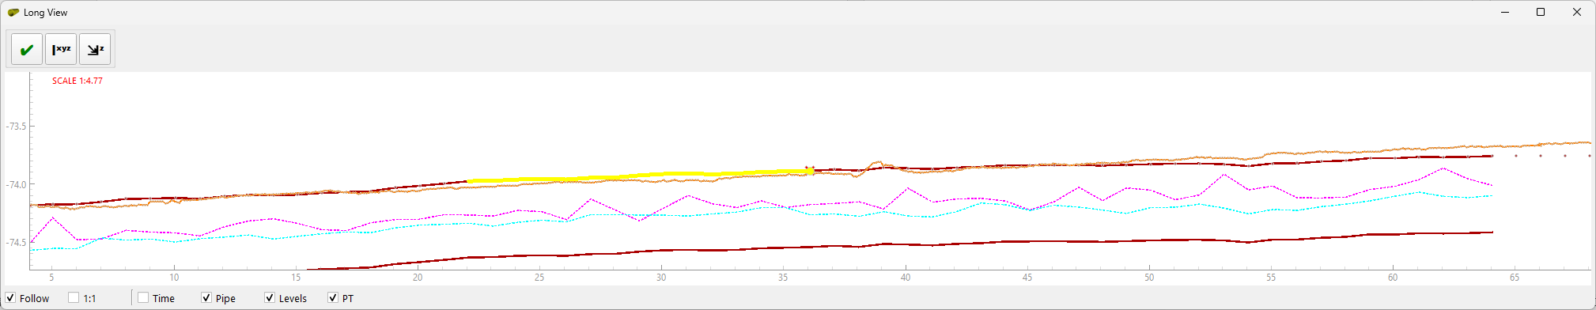

TOP 3D interpolation
Sometimes minor parts of TOP may be interpolated (like at anodes, fieldjoints, short burials or mattresses, structures, etc.). To interpolate TOP section, it must be selected by selection tool (see above). Interpolation is performed either by pressing 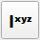 button on Plan or Longitudinal view or by pressing ‘I’ key.
Note that markers on the interpolated part will be re-placed automatically in accordance with current settings. You may need to re-visit interpolated section and adjust TOP or markers.

Applying tide
Tidal data can be loaded either using Load tide menu or by drag-and-drop of file to any of view windows. If loaded, they will be applied to profiles and pipetracker. Once tidal data is loaded, tide indicator on Profile view will change from to . Tide can be unapplied and re-applied by unticking / ticking ‘Apply tide’ checkbox in ‘Pipe’ tab of Main control. Tide indicator will change accordingly .

Processing pipetracker
Either raw or processed (saved as ‘spt’ file) pipetracker data can be loaded either using Load pipetracker menu or by drag-and-drop of file to any of view windows. Note that profile data is used as KP reference for pipetracker. Therefore, profiles must be loaded prior to pipetracker. If tide is applied to profiles, the same tide will be applied to pipetracker.
Pipetracker data may be downsampled by selecting ‘Decimate’ value in PT tab of Main control. All other changes will be applied to downsample dataset unless another downsamping value is set. The downsampled dataset is saved once the pipetracker is saved.
To enable/disable pipetracker editing, press 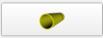 button on Plan view. Icon of button will change to 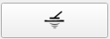
The following actions are available:
- Rejecting / accepting of data
- Smoothing in plan and vertical planes
- Levelling
- Statistical analysis and shift
To reject/accept data, toggle corresponding radiobutton on Plan view 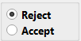. Selector size may be set up on Plan view 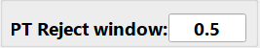.
To smooth data, set value in ‘Smooth’ window of PT tab of Main control and press corresponding button.
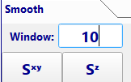
This value sets number of data points for moving average window. ‘Max gap’ setting sets maximum gap in pipetracker data (in meters) to be treated as continuous accepted dataset. If gap exceeds this value, smoothing window will break at this gap. Note that start and end sections of size equal to smoothing window will not be smoothed.
Each time the smoothing is applied, it is applied to raw accepted data. To unapply smoothing, run smoothing with window size = 0 points.
Usually, the pipetracker data should be moved in vertical plane to match TOP at exposed sections, i.e. levelled. To level pipetracker data, you need to estimate required shift value, set it in ‘Level’ window of PT tab of Main control and press 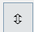 button. The shift is applied to original data.
More advanced way involves statistical analysis. This may be started by pressing 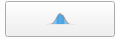 button on PT tab of Main control. The method involves estimation of the averaged shift of pipetracker track in vertical and lateral planes relative to digitized parts of the pipe. Shift may be applied once computed.
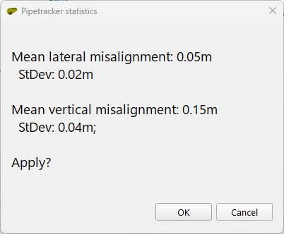

Snapping TOP to pipetracker
‘Unvisited’ sections of pipe may be snapped to pipetracker in horizontal and vertical planes individually by pressing corresponding buttons 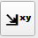 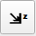 on Plan or Longitudinal view respectively. If selection is made using selection tool, only selected part will be snapped. Otherwise, the entire pipe will be snapped to pipetracker where available. Note that markers will be re-set automatically for the snapped section in accordance with current markers’ placement setting. You may need to re-visit snapped section to adjust pipe top or markers.

Digital video
ROV digital video may be used to assist in pipe digitizing. To load DV, DV index should be created. Select ‘Build DV Index’ in Main control menu. In the loaded application select DV folder and required DV index file name and location.
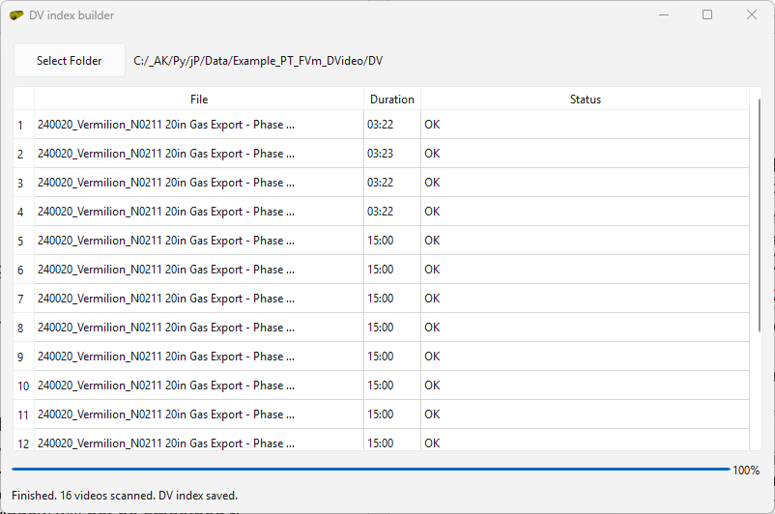
Once index file is created, it may be loaded by selecting ‘Load DV Index’ in Main control menu or just by drag-and-drop.
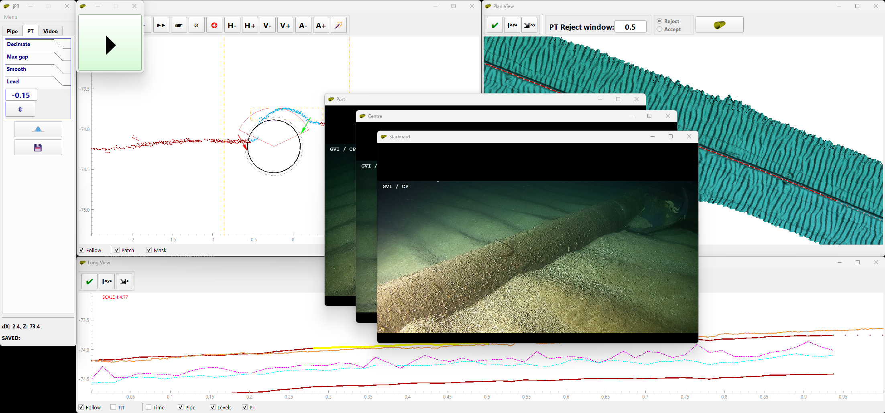
Available DV channels’ players will be loaded. They may be closed and opened back, if necessary, by selecting ‘DV control’ in Main control menu. Large ‘Play/Pause’ button will appear on top of windows. This button stops/starts video frames playing when moving through profiles. Note that video is not played continuously. It only jumps from profile to profile frames.
If DV and profiles were logged in different time zone, it should be set in ‘Video’ tab of Main Control. Note, it sets time difference from profiles to video. Camera offset and camera symbol size may be set in ‘Video’ tab.

Re-setting TOP and markers
Pipe or its part may be re-flagged to ‘unvisited’ if necessary, by pressing 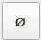 button in Profile view or ‘0’ key. If pipe section is selected by selection tool, only section will be re-set. Otherwise, part of pipe from current profile to end will be re-set.

POI
You can mark points of interest (POI) if you need to return to the profile later for some reason (for instance, highlighting sections to be snapped to pipetracker) by pressing  button. POI will be marked by red cross in Plan and Longitudinal views. POI button icon will change to  or the marked profile. Press POI button again when on the marked profile to unmark POI.

Colors settings
Colors of graphics elements may be edited, saved and loaded. To edit colors, select Edit palette in the Main Control menu. The color palete will appear. Press buttons to change elements’ colors.
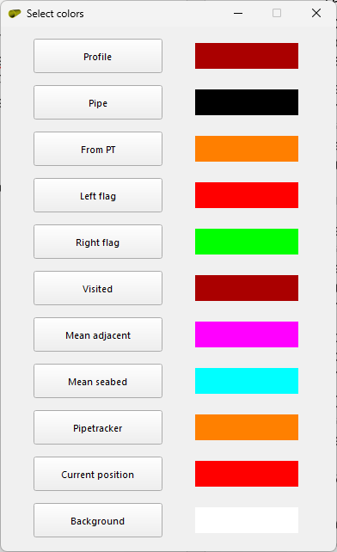
The color settings as well as windows’ positions are saved when the application is closed and will be restored on the next application start.

Saving work
Current working session including settings, layout and colors settings may be saved to ‘wrk’ file by selecting Save work in Main Control menu. This will prompt to select path to stored file. Name of the last saved file will be indicated in status bar. If pipetracker data is loaded, it will also be saved along including current processing status to ‘spt’ file. There is fast saving option. If you press ‘Ctrl’+’S’ keys when Profile, Plan or Longitudinal view is active, ‘wrk’ file and ‘spt’ file (if pipetracker loaded) will be saved to location of loaded profiles file. This will be indicated by saved file name followed by Fastsave in status bar.
Saved session may be loaded by selecting Load saved work menu or by drag-and-drop of file to any of view windows. This will restore exact status of processed profiles as well as processing, layout and color settings. Processed and saved pipetracker data and georeferenced image should be loaded separately. If tide data was loaded to saved session, the status of tide application will be restored.

Automatic processing
Selected section or section from current profile to end may be fully automatically processed with current settings. This is not recommended since you may need to re-visit each profile for QC. Better strategy is to digitize profiles one by one performing QC at the same time. Run it if pipe is well defined on the profile and adjacent seabed is flat and uniform.
To run automatic processing press 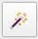 button in Profile view or press ‘Ctrl’+’A’ keys. Note that application will freeze until the processing is completed. Message will pop up once the processing is completed.
TOP will be automatically processed only at ‘unvisited’ sections. Markers may be re-processed with new settings at ‘visited’ sections. TOP will not be reprocessed. TOP may be re-processed if flags re-set (see ‘Re-setting TOP and markers section).

Data export
Digitized TOP and markers may be exported to Fugro Edit or EIVA dig formats from Export menu of Main control. Depending on EIVA NaviModel height settings, it may be required to flip digitized lines vertically to match application settings. Pipe digitized line contains pipe flag while flag lines to be flagged manually by selecting relevant line type. Tide will be applied or unapplied depending on whether ‘Apply tide’ checkbox in ‘Pipe’ tab of Main Control is checked/unchecked

Hotkeys and Mouse buttons

Keyboard
X / Z | One profile Forward / Backward
Home / End | First / Last profile
E | Last visited profile in the visited section
0 | Reset all profiles forward
Space | Auto-snap TOP
I | 3D interpolate
C | Show / hide pipe assistant
Ctrl+S | Fast save work (same folder as original profiles)
Alt | In PT edit mode – switch Accept / Reject
Mouse
Left Mouse Button (XView) | Force TOP
Right Mouse Button (XView) | Force inner flags / (+Ctrl) outer flags
Double Left Mouse Button (LView / PView) | Jump to selected profile
Right Mouse Button (LView / PView) | Select chunk start / end
CTRL + Mouse Wheel (LView) | Change Lview exaggeration

