SIMPLE TIDE FILTER MANUAL

SimpleTideFilter
SimpleTideFilter application was developed to simplify and speed up noisy water level observations processing before applying in the bathy data processing environment. With SimpleTideFilter it is possible to:
- Decimate observed data;
- Shift tide data vertically and in time;
- Reject (de-spike) observed data;
- Apply FIR, Gaussian, Median or Mean filter to smooth decimated data.
The application consists of Main window that includes Menu, Controls and Data Plot.
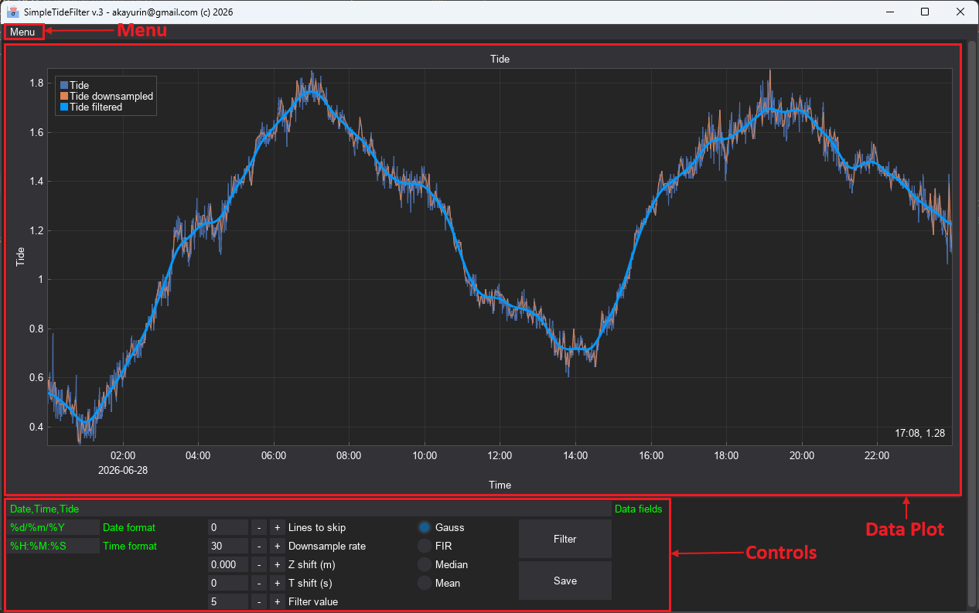

Source data
Source water level data should be provided in ASCII format and must necessarily contain Date, Time and Tide in separate fields. The application recognizes space, tab, comma and semicolon as field separators. Note that files may contain other data that will not be considered in the processing. Data format may be configured (see below).
The application is sensitive to foreign data like headers, corrupted strings, etc. and may fail to load data should those exist in the data files. Prior to import data, irrelevant strings should be removed from the files. For example, Qinsy acquisition software adds multiple header lines in the RTK tide files when logging. Those header lines should be removed. If data file contains single header line, that can be indicated by ‘Lines to skip’ setting in Controls section of the application before loading.

Configuring file and data format
Apart from ‘Lines to skip’ setting, there are three settings that may be configured:
- ‘Data fields’ setting specifies data string format. As noted above, the file string must contain separate Date, Time and Tide fields (regardless their names) separated by space, tab, comma or semicolon. Other fields may also exist the user must tag mandatory fields as ‘Date, ‘Time’ and ‘Tide’. Other fields may be tagged arbitrarily by unique tags. Field tags must be separated by comma. See examples below:
06/04/2026,00:00:00,-0.19 | Date,Time,Tide
06/04/2026 00:00:00 -0.19 | Date,Time,Tide
06/04/2026,00:00:00,-0.19,000,111,222 | Date,Time,Tide,A,B,C

- ‘Date format’ setting specifies Date field format. See examples below (for the 6th of April 2026):
06/04/2026 | %d/%m/%Y
04/06/2026 | %m/%d/%Y
06-04-2026 | %d-%m-%Y
06:04:2026 | %d:%m:%Y

- ‘Time format’ setting specifies Time field format. See examples below:
01:55:55 | %H:%M:%S
01:55:55.0 | %H:%M:%S.%f
01:55:55.00 | %H:%M:%S.%f
01:55:55.000 | %H:%M:%S.%f

Loading and navigating data
Data nay be loaded either from Menu->Load tide(s)… or by drag-and-drop. Multiple files loading is supported.
Once loaded, data may be decimated in order to reduce redundant data by selecting ‘Downsample rate’ (every n^{th} sample will be left). Data may be shifted vertically or in time by setting ‘Z shift (m)’ and ‘T shift (s)’ values. The smoothed data will be shifted accordingly.
Data plot may be zoomed in and out by scrolling mouse wheel in the data plot. Vertical and horizontal scale may be adjusted by scrolling mouse wheel on the respective axis (the axis will be highlighted).
Rectangle selection with right mouse button will zoom plot to selected limits. Left mouse button double-click will restore full view.
Right mouse button click on the plot will enable additional view options.

Data rejection/acceptation
Erroneous data or spikes may be rejected and re-accepted. To select region for editing hold ‘Ctrl’ key and select region with right mouse button. Green edit region will be shown on data plot. Press ‘Delete’ key to reject and ‘Insert’. Note that by pressing ‘Delete’ the data will be interpolated – not deleted. Edit region can be moved, resized or re-selected. Note that once selected, it will stay on the data plot until the application is closed.

Data smoothing
Four filters are available:
- Finite Impulse Response (FIR);
- Gaussian;
- Median;
- Mean.
FIR and Gaussian filter are most relevant for smoothing tide data. Filter value may be set by ‘Filter value’ control. Note that filter value means different parameters for different filters. Filter takes decimated shifted data. Value should be selected as best fit of the filtered curve. Press ‘Filter’ button once ‘Filter value’ is set.
Settings saving
All the settings will be saved to configuration file on application close. The settings will be loaded next time application starts. Config file contents may be checked from Menu-> Show settings file...

Result export
Decimated, shifted and filtered result may be exported to ASCII format either from Menu->Save filtered… or by pressing ‘Save’ button. All data will be saved as single file. ‘Date’ and ‘Time’ formats are the same as in the source files. ‘Date’ and ‘Time’ fields will be separated by space, ‘Tide’ field will be separated by comma.

