INSTRACTION
How to add a new language for the JavaSubProviderApp
1. This step is necessary for adding Vosk model, which responds for recognizing an audio of an initial video file (the language of a voice-over video). If the original video's voiceover differs from the language you're adding, you can skip this step!
Create a new folder with short language name by analogy inside this directory: ./javaSubProvider/src/main/resources/app_components/vosk.
For example, fr:
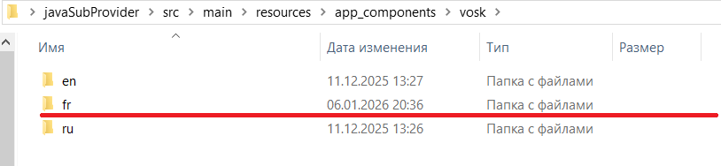
«fr» will be language of voice acting of an INITIAL VIDEO!
Download a new Vosk model: https://alphacephei.com/vosk/models unzip the archive and this archive contains move into the created folder before («fr») and OBLIGATORY rename moved folder into «vosk-model»! All folder into: ./vosk/some_short_name_language/ have name «vosk-model»!
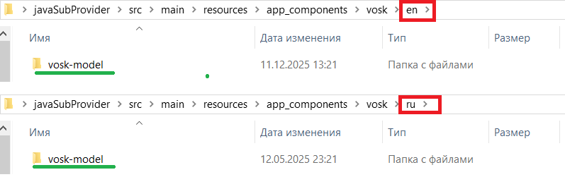
P.S.
For current Russian language is being used model: vosk-model-small-ru-0.22 (an initial voice acting of a video)
For current English language is being used model: vosk-model-en-us-0.22-lgraph (an initial voice acting of a video)

2. This step is necessary for adding languages for translation service (the Libretranslate service).
Open ./javaSubProvider/src/main/java/ru/home/video/model/enums/LanguageType.java as a txt file and add a new short and full name of adding language by analogy:
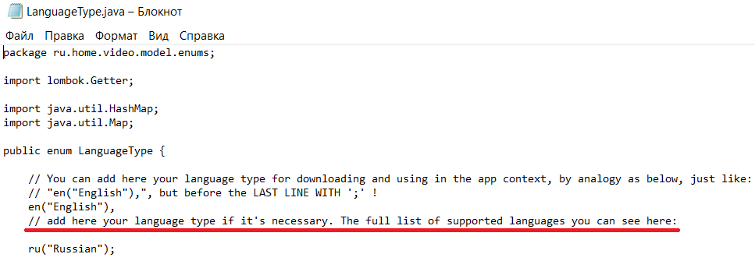
example:
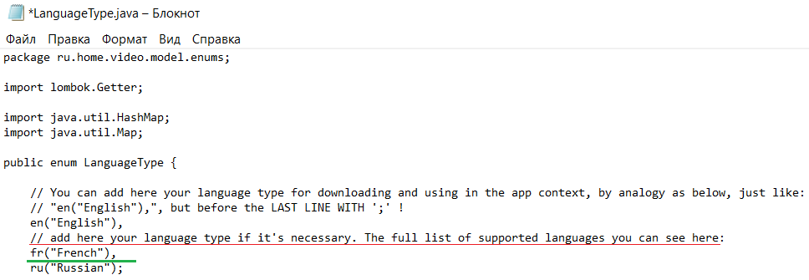
Save and close the file! Link on existence language packs: https://www.argosopentech.com/argospm/index/
(sometimes it has to be open with VPN).
P.S.
The all-language models are saved automatically here:
./javaSubProvider/src/main/resources/app_components/lang_models
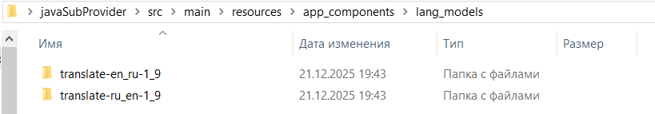

3. This step is necessary for reflection of the added language couple on graphical user interface (GUI).
Open ./javaSubProvider/src/main/java/ru/home/video/config/LanguageConfig.java as txt file.
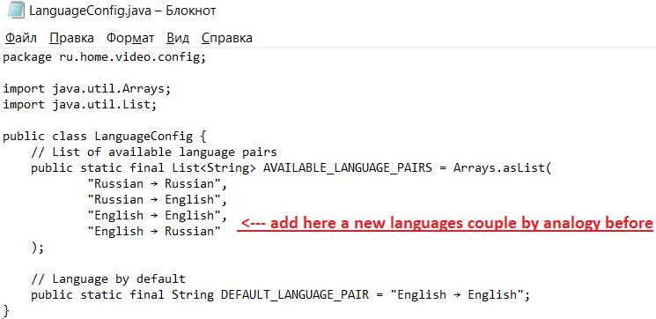
add new language couple by analogy above.
example:
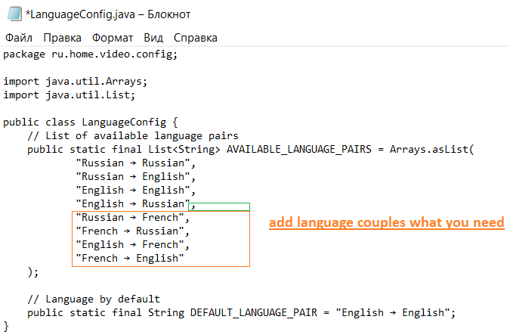
Save and close the file!
Now you can restart the app!

