16/06/2019 Food classification - **InceptionV3** (152 layers)

32 classes (750/250 train/test)

optimizer=SGD(lr=0.005, momentum=0.9)

30 epochs

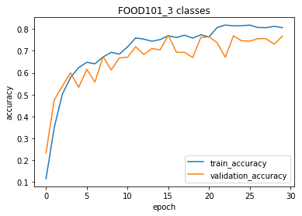

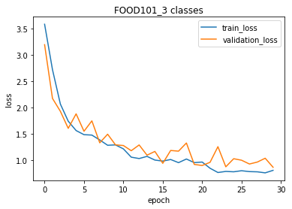

16/06/2019 Food classification - **InceptionV3** (152 layers)

32 classes (750/250 train/test)

optimizer=SGD(**lr=0.001**, momentum=0.9)

**80 epochs**

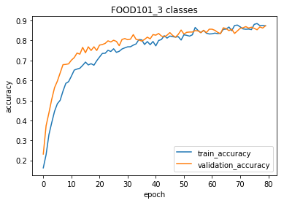

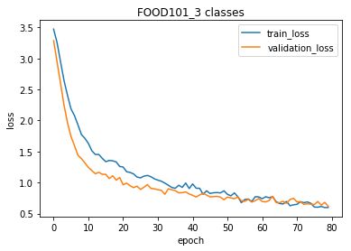

16/06/2019 Food classification - **MobileNetv2** (88 layers)

32 classes (750/250 train/test)

optimizer=SGD(**lr=0.001**, momentum=0.9)

**30 epochs**

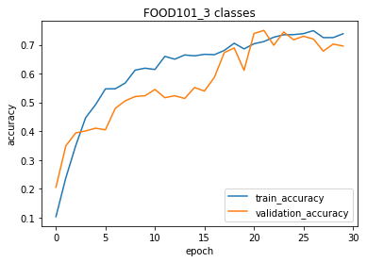

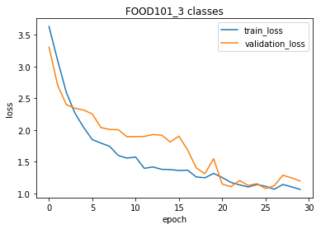

16/06/2019 Food classification - **MobileNetv2** (88 layers)

32 classes (750/250 train/test)

optimizer=SGD(**lr=0.005**, momentum=0.9)

**80 epochs**

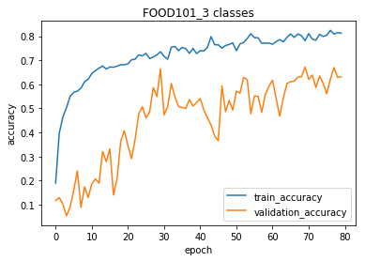

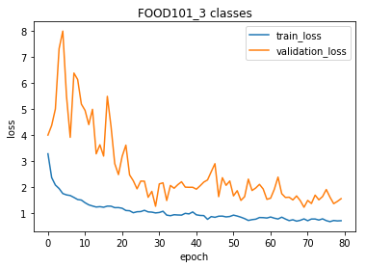

17/06/2019 Food classification - **MobileNetv2** (88 layers)

32 classes (750/250 train/test)

optimizer=SGD(**lr=0.01**, momentum=0.1)

**50 epochs**

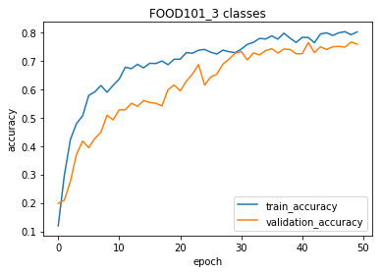

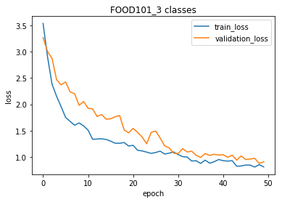

17/06/2019 Food classification - **MobileNetv2** (88 layers)

32 classes (750/250 train/test)

optimizer=SGD(**lr=0.01**, momentum=0.1)

**80 epochs**

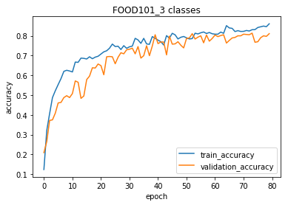

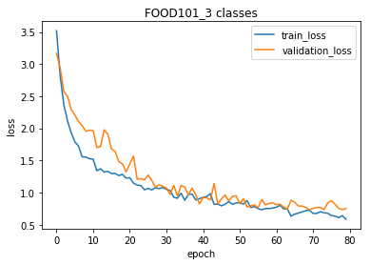

22/06/2019 Food classification - **InceptionV3** (152 layers)

32 classes (750/250 train/test)

optimizer=SGD(**lr=0.001**, momentum=0.9)

**150 epochs**

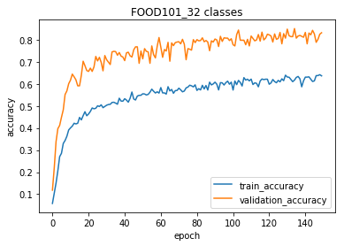

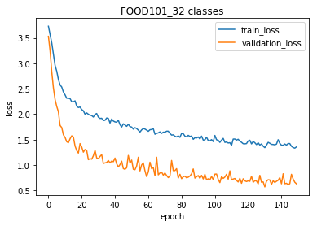

**train_datagen = ImageDataGenerator(rescale=1./255,**

**shear_range=45,**

**zoom_range=0.7,**

**fill_mode='constant',**

**rotation_range=180,**

**width_shift_range=.5,**

**height_shift_range=.5,**

**horizontal_flip=True,**

**vertical_flip=True,**

**channel_shift_range=100.,**

**brightness_range=[0.5,1.0],**

**zca_whitening=True)**

22/06/2019 Food classification - **InceptionV3** (152 layers)

32 classes (750/250 train/test)

optimizer=SGD(**lr=0.001**, momentum=0.9)

**100 epochs**

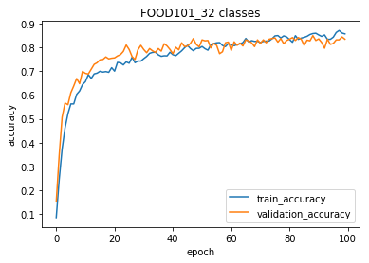

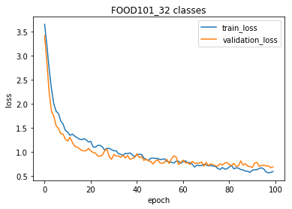

**train_datagen = ImageDataGenerator(rescale=1./255,**

**shear_range=25, # 5-th from 45 to 25**

**zoom_range=0.2, # 5-th from 0.7 to 0.2**

**fill_mode='constant',**

**rotation_range=90, #3-rd itteration from 180 to 90**

**width_shift_range=.25, # 5-th from 0.5 to 0.25**

**height_shift_range=.25, # 5-th from 0.5 to 0.25**

**horizontal_flip=True)**

23/06/2019 Food classification - **InceptionV3** (152 layers)

32 classes (750/250 train/test)

optimizer=SGD(**lr=0.001**, momentum=0.9)

**200 epochs**

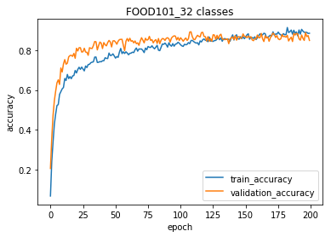

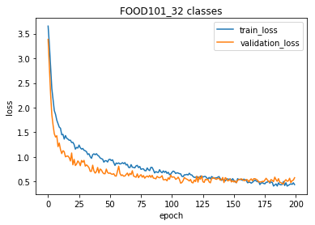

**train_datagen = ImageDataGenerator(rescale=1./255,**

**shear_range=30, # 6-th from 25 to 30**

**zoom_range=0.3, # 6-th from 0.2 to 0.3**

**fill_mode='constant',**

**rotation_range=180, #6-rd itteration from 90 to 180**

**width_shift_range=.25, # 5-th from 0.5 to 0.25**

**height_shift_range=.25, # 5-th from 0.5 to 0.25**

**horizontal_flip=True)**

23/06/2019 Food classification - **InceptionV3** (152 layers)

32 classes (750/250 train/test)

optimizer=SGD(**lr=0.001**, momentum=0.9)

**150 epochs**

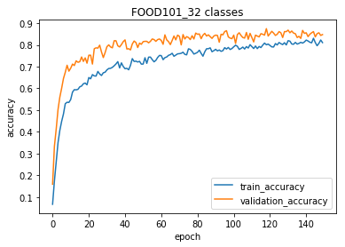

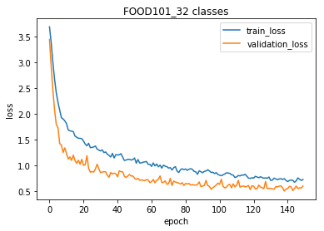

**x = Dropout(0.2)(x) # 7-th Without Dropout**

**zoom_range=0.5, # 7-th from 0.3 to 0.5**

25/06/2019 Food classification - **InceptionV3** (152 layers)

32 classes (750/250 train/test)

optimizer=RMSprop(lr=0.0001)

Frozen layers

