
HOSE & SILICONE

Low Smoke,

Low Toxicity Hose

(LSLT RailSil Hose)

Silicone coolant, heater and turbo charger hoses for use where low smoke low toxicity is a requirement.

Leyland Hose and Silicone LSLT grade silicone, is specifically designed for use in MASS TRANSIT applications and other areas where re resistance and low smoke, low toxic bi-product standards are required.

Suitable for use with all coolants including OAT. (See our separate coolant chart compatibility).

- 3, 4 or 5 ply construction depending on inner diameter.

- 2mm minimum liner.

- Colour – black, grey or brick red.

- Meta aramid reinforcement fabric.

- Temperature range: -55°C up to +250°C.

- Working pressure: 4 bar minimum. *Varies according to diameter, higher pressure is possible with smaller diameters. See separate chart for full details.

Leyland Hose and Silicone hoses are fire resistant to:

UL 94-V0 (3mm)

They also meet the following standards:

• BS6853: 1999 Cat 1a
• EN 45545-2
• NF F-16-101 Categories F1 and I2
• DIN 5510-2
• LUL 1-085 A2 Table 4
Physical Properties:
Hardness: | 60 – 75 +/- 5 Shore A
Tensile strength (M/Pa): | 7.0 (Min)
Elongation at break (%): | 200% (Min)
Tear strength (Kn/M): | 18Kn/M (Min)
Compression set 22hrs at 175°C (%): | 30% (Max)
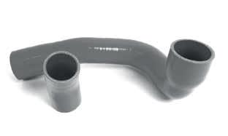

Customer options

Anti-Abrasion Sleeves

Anti-abrasion sleeves can be applied to protect against localised vibration and abrasion.

Part Marking

Part marking with Leyland, or customer logo, part number, date, etc. can be applied according to customer requirements.

Location Marking

Clamp lines or location cut outs can be added to aid installation.

Leyland Hose and Silicone manufacture a wide range of standard diameters in straight hose and 90 degree elbows. Bespoke hoses comprising shaped hoses, turbo-charger hoses and flexible spiral wire reinforced hose, can all be manufactured according to customer requirements or drawings.
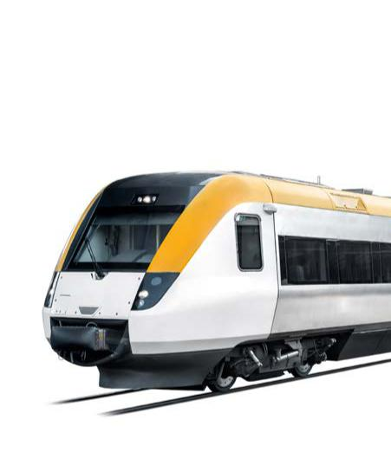

We also assist in the design and specification selection for new projects and applications.

www.lhss.co.uk

15

