
HOSE & SILICONE

Stepless® Screw Clamps

Oetiker Clamps
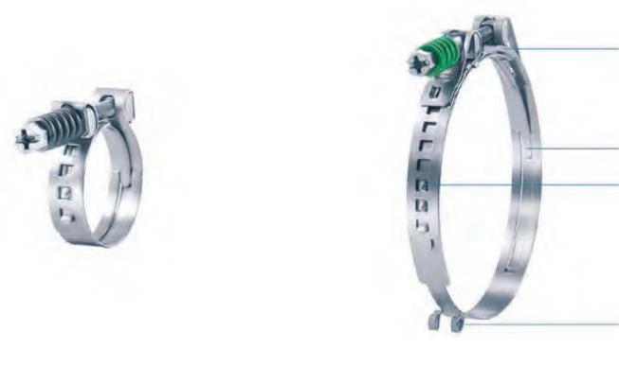

SELF TENSIONING SCREW CLAMPS
Bridge

Tongue-in-grove design

Interlock with multiple diameter adjustments

Installation aid of large

diameters

Choice of engagement positions: Clamp can be adjusted to several different nominal diameters

Narrow Band: Concentrated transmission of clamping force, complies with SAE J1508 Type SSPC

3600 Stepless®: Uniform compression, or uniform surface pressure

Burr-free strip edges: Reduced risk of damage to the part being clamped

Self-tensioning: Compensates for thermal cycle diameter changes
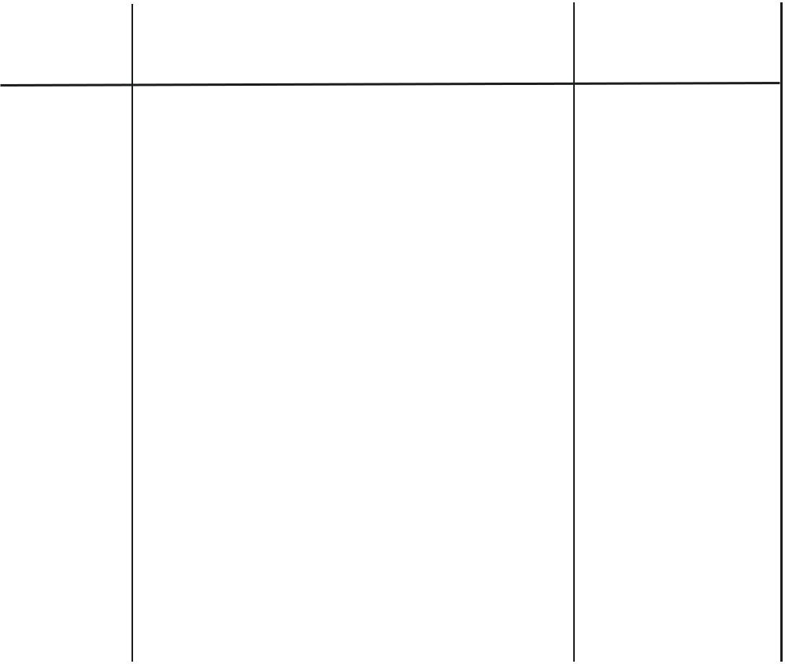

Part No | Description | Size Range (mm)
17800170 | Stepless self tensioning screw clamp s/steel | 18-24
17800172 | Stepless self tensioning screw clamp s/steel | 22-28
17800174 | Stepless self tensioning screw clamp s/steel | 26-32
17800175 | Stepless self tensioning screw clamp s/steel | 30-36
17800176 | Stepless self tensioning screw clamp s/steel | 34-40
17800177 | Stepless self tensioning screw clamp s/steel | 37.5-45
17800178 | Stepless self tensioning screw clamp s/steel | 42.5-50
17800179 | Stepless self tensioning screw clamp s/steel | 47.5-55
17800180 | Stepless self tensioning screw clamp s/steel | 49-60
17800181 | Stepless self tensioning screw clamp s/steel | 54-65
17800182 | Stepless self tensioning screw clamp s/steel | 59-70
17800183 | Stepless self tensioning screw clamp s/steel | 64-75
17800184 | Stepless self tensioning screw clamp s/steel | 69-80
17800185 | Stepless self tensioning screw clamp s/steel | 74-85
17800186 | Stepless self tensioning screw clamp s/steel | 79-90
17800187 | Stepless self tensioning screw clamp s/steel | 84-95
17800188 | Stepless self tensioning screw clamp s/steel | 89-100
17800189 | Stepless self tensioning screw clamp s/steel | 94-105
17800190 | Stepless self tensioning screw clamp s/steel | 99-110

www.lhss.co.uk

22

