

学生实验实习报告册

学年学期： | 2022-2023 学年(秋)学期
课程名称： | 数据工程综合实践
学生学院： | 理学院
专业班级： | 11082303
学生学号： | 2023213851
学生姓名： | 李昌峻
联系电话： | 18225098300

重庆邮电大学教务处印制

目 录
- 教师评阅记录表
- 实验报告

教师评阅记录表
【重要说明】
- 学生提交报告册最终版时，必须包含此页，否则不予成绩评定。
- 本报告册模板内容格式除确实因为填写内容改变了布局外，不得变更其余部分的格式，否则不予成绩评定。

报告是否符合考核规范 | ☑ 符合 □ 不符合
报告格式是否符合标准 | ☑ 符合 □ 不符合
报告是否完成要求内容 | ☑ 是 □ 否
报告评语：
报告成绩：
评阅人签名（签章） XXX
2023年 1 月 10 日

实验或实习报告
课程名称 | 数据工程综合实践 |  | 课程编号 | A2041050
开课学院 | 计算机学院/人工智能学院
指导教师 | XXX
实验实习地点 | 综合实验大楼B517
学号 |  | 姓名
2023213851 |  | 李昌峻
- 赛题解读与方案概述
1、赛题解读
本赛题是：提供用户在2016年1月1日至2016年6月30日之间真实线上线下消费行为，预测用户在2016年7月领取优惠券后15天以内的使用情况。
登录天池平台，可以得到四个文档：
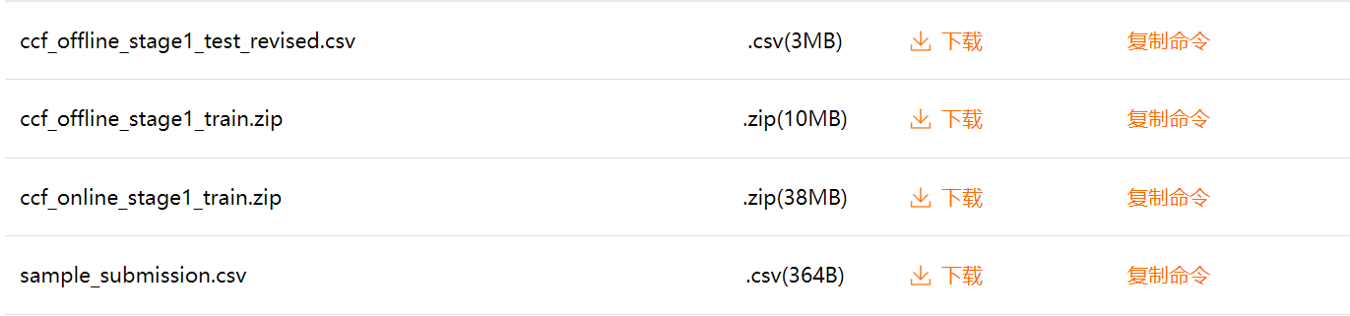
通过下载分析得到：ccf_offline_stage1_train.csv为训练用的数据集，ccf_offline_stage1_test_revised.csv为对七月份测试用的数据集，sample_submission.csv为提交样例，在最后一列增加是否消费的几率。
2、方案概述
将对_train中的数据进行分析，提取特征工程，然后使用XGBoost模型对7月的数据进行预测。
- 数据预处理
- 此处没有像任务一一样对数据进行处理，在后续打标中，将任务一的处理单独提取出特征，以便于机器学习
- 对所有读入的csv文件中的空值keep_default_na = False，都是object值，即str类型。
- 删除重复项dftrain.drop_duplicates(inplace=True)

- 数据划分与打标
采用时间滑窗法，对数据进行时间上的划分dataset分别是优惠券接收日期为4.14-5.14、5.14-6.14，需要预测数据7.1-7.15。feature为1.1-4.13、2.1-5.13，需要预测的为7.15-7.30。
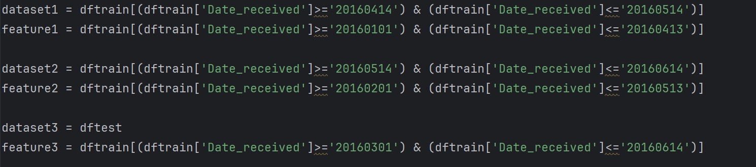
打标将融合在特征工程之中
- 特征工程
通过人工提取特征工程，对“getUserRelatedFeature”即关于用户的特征，对“getMerchantRelatedFeature”即关于商家的特征，对“getCouponRelatedFeature”即关于优惠券相关的特征，对“getUserMerchantRelatedFeature”即关于用户与商家之间的特征，对“getOtherRelatedFeature”即关于其他的特征，如用户接受优惠券之间关系等。
主要核心代码：
- def getReceivedUseGap(dates):
- dates = dates.values
- # print(dates)
- receive,use = dates[0],dates[1]
- return (date(int(use[0:4]),int(use[4:6]),int(use[6:8])) - date(int(receive[0:4]),int(receive[4:6]),int(receive[6:8]))).days

- def getUserRelatedFeature(feature):
- # 用来连接的df
- t = feature['User_id'].copy()
- t.drop_duplicates(inplace=True)

- # 特征：用户购买商家类数（类数不重复）
- t1 = feature[feature['Date']!='null'][['User_id','Merchant_id']].copy()
- t1.drop_duplicates(inplace=True)
- t1['Merchant_id'] = 1
- t1 = t1.groupby('User_id').agg('sum').reset_index()
- t1.rename(columns={'Merchant_id':'User_buy_merchant_count'},inplace=True)

- t2 = feature[(feature['Date']!='null') & (feature['Coupon_id']!='null')][['User_id','Distance']].copy()
- t2.replace('null',-1,inplace=True)
- t2['Distance'] = t2['Distance'].astype(float)
- t2.replace(-1,np.nan,inplace=True)
- # 特征：用户距离已用消费券消费店铺的最大、最小、平均、中位距离
- t2_1 = t2.groupby('User_id').agg('max').reset_index()
- t2_1.rename(columns={'Distance':'User_max_distance'},inplace=True)
- t2_2 = t2.groupby('User_id').agg('min').reset_index()
- t2_2.rename(columns={'Distance':'User_min_distance'},inplace=True)
- t2_3 = t2.groupby('User_id').agg('mean').reset_index()
- t2_3.rename(columns={'Distance':'User_mean_distance'},inplace=True)
- t2_4 = t2.groupby('User_id').agg('median').reset_index()
- t2_4.rename(columns={'Distance':'User_median_distance'},inplace=True)

- #特征：用户使用优惠券消费次数
- t3 = feature[(feature['Coupon_id']!='null') & (feature['Date']!='null')][['User_id']].copy()
- t3['User_buy_use_coupon_count'] = 1
- t3 = t3.groupby('User_id').agg('sum').reset_index()

- # 特征：用户消费次数
- t4 = feature[(feature['Date']!='null')][['User_id']].copy()
- t4['User_buy_count'] = 1
- t4 = t4.groupby('User_id').agg('sum').reset_index()

- # 特征：用户接收优惠券数目
- t5 = feature[(feature['Coupon_id'] != 'null')][['User_id']].copy()
- t5['User_received_count'] = 1
- t5 = t5.groupby('User_id').agg('sum').reset_index()

- # 特征：用户接收并使用消费券间隔天数
- t6 = feature[(feature['Coupon_id'] != 'null') & (feature['Date'] != 'null')][['User_id', 'Date_received', 'Date']].copy()
- t6['User_received_use_gap'] = t6[['Date_received', 'Date']].apply(getReceivedUseGap, axis=1)
- t6 = t6[['User_id', 'User_received_use_gap']]

- # 特征：用户接收并使用优惠券的最大、最小、平均间隔天数
- t7 = t6.copy()
- t7_1 = t7.groupby('User_id').agg('max').reset_index()
- t7_1.rename(columns={'User_received_use_gap':'User_received_use_max_gap'},inplace=True)
- t7_2 = t7.groupby('User_id').agg('min').reset_index()
- t7_2.rename(columns={'User_received_use_gap':'User_received_use_min_gap'},inplace=True)
- t7_3 = t7.groupby('User_id').agg('mean').reset_index()
- t7_3.rename(columns={'User_received_use_gap':'User_received_use_mean_gap'},inplace=True)

- # 特征：用户浏览总数
- t8 = feature[['User_id']].copy()
- t8['User_browser_count'] = 1
- t8 = t8.groupby('User_id').agg('sum').reset_index()

- userFeature = pd.merge(t,t1,on='User_id',how='left')
- userFeature = pd.merge(userFeature,t2_1,on='User_id',how='left')
- userFeature = pd.merge(userFeature,t2_2,on='User_id',how='left')
- userFeature = pd.merge(userFeature,t2_3,on='User_id',how='left')
- userFeature = pd.merge(userFeature,t2_4,on='User_id',how='left')
- userFeature = pd.merge(userFeature,t3,on='User_id',how='left')
- userFeature = pd.merge(userFeature,t4,on='User_id',how='left')
- userFeature = pd.merge(userFeature,t5,on='User_id',how='left')
- userFeature = pd.merge(userFeature,t6,on='User_id',how='left')
- userFeature = pd.merge(userFeature,t7_1,on='User_id',how='left')
- userFeature = pd.merge(userFeature,t7_2,on='User_id',how='left')
- userFeature = pd.merge(userFeature,t7_3,on='User_id',how='left')
- userFeature = pd.merge(userFeature,t8,on='User_id',how='left')
- # userFeature = pd.merge(userFeature,t9,on='User_id', how='left')

- # 特征：用户消费总量中使用优惠券占比
- userFeature['User_buy_use_coupon_rate'] = userFeature['User_buy_use_coupon_count']/userFeature['User_buy_count']
- # 特征：用户接收总量中使用优惠券占比
- userFeature['user_received_coupon_use_rate'] = userFeature['User_buy_use_coupon_count']/userFeature['User_received_count']

- # 对于次数或者数目或占比，将Nan转换为0
- userFeature['User_buy_merchant_count'].replace(np.nan,0,inplace=True)
- userFeature['User_buy_use_coupon_count'].replace(np.nan,0,inplace=True)
- userFeature['User_buy_count'].replace(np.nan,0,inplace=True)
- userFeature['User_received_count'].replace(np.nan,0,inplace=True)
- userFeature['User_buy_use_coupon_rate'].replace(np.nan,0,inplace=True)
- userFeature['user_received_coupon_use_rate'].replace(np.nan,0,inplace=True)

- return userFeature

- def getMerchantRelatedFeature(feature):

- t = feature['Merchant_id'].copy()
- t.drop_duplicates(inplace=True)

- # 特征：商家卖出数目
- t1 = feature[(feature['Date']!='null')][['Merchant_id']].copy()
- t1['Merchant_sale_count'] = 1
- t1 = t1.groupby('Merchant_id').agg('sum').reset_index()

- # 特征：商家核销数目
- t2 = feature[(feature['Coupon_id']!='null') & (feature['Date']!='null')][['Merchant_id']].copy()
- t2['Merchant_sale_use_coupon_count'] = 1
- t2 = t2.groupby('Merchant_id').agg('sum').reset_index()

- # 特征：商家优惠券的总数量
- t3 = feature[(feature['Coupon_id']!='null')][['Merchant_id']].copy()
- t3['Merchant_give_count'] = 1
- t3 = t3.groupby('Merchant_id').agg('sum').reset_index()

- t4 = feature[(feature['Coupon_id']!='null') & (feature['Date']!='null')][['Merchant_id','Distance']].copy()
- t4['Distance'].replace('null',-1,inplace=True)
- t4['Distance'] = t4['Distance'].astype(float)
- t4['Distance'].replace(-1,np.nan,inplace=True)
- # 特征：商家已核销优惠券中距离的最小\最大\平均\中值
- t4_1 = t4.groupby('Merchant_id').agg('max').reset_index()
- t4_1.rename(columns={'Distance':'Merchant_max_distance'},inplace=True)
- t4_2 = t4.groupby('Merchant_id').agg('min').reset_index()
- t4_2.rename(columns={'Distance':'Merchant_min_distance'},inplace=True)
- t4_3 = t4.groupby('Merchant_id').agg('mean').reset_index()
- t4_3.rename(columns={'Distance':'Merchant_mean_distance'},inplace=True)

- merchantFeature = pd.merge(t,t1,on='Merchant_id',how='left')
- merchantFeature = pd.merge(merchantFeature,t2,on='Merchant_id',how='left')
- merchantFeature = pd.merge(merchantFeature,t3,on='Merchant_id',how='left')
- merchantFeature = pd.merge(merchantFeature,t4_1,on='Merchant_id',how='left')
- merchantFeature = pd.merge(merchantFeature,t4_2,on='Merchant_id',how='left')
- merchantFeature = pd.merge(merchantFeature,t4_3,on='Merchant_id',how='left')

- # 特征：商家卖出总量中优惠券的核销占比
- merchantFeature['Merchant_sale_use_coupon_rate'] = merchantFeature['Merchant_sale_use_coupon_count']/merchantFeature['Merchant_sale_count']
- # 特征：商家发放总量中优惠券的核销占比
- merchantFeature['Merhcant_give_coupon_use_rate'] = merchantFeature['Merchant_sale_use_coupon_count']/merchantFeature['Merchant_give_count']

- # 次数项目和占比类型数据，Nan用0替代(之所以最后转化，是防止上两个特征提取时出现分母为零溢出)（另外，上两个特征值的计算，只要分子分母一个为pd.nan结果就为nd.nan）
- merchantFeature['Merchant_sale_use_coupon_count'].replace(np.nan,0,inplace=True)
- merchantFeature['Merchant_sale_count'].replace(np.nan,0,inplace=True)
- merchantFeature['Merchant_give_count'].replace(np.nan,0,inplace=True)
- merchantFeature['Merchant_sale_use_coupon_rate'].replace(np.nan,0,inplace=True)
- merchantFeature['Merhcant_give_coupon_use_rate'].replace(np.nan,0,inplace=True)

- return merchantFeature

- def getDiscountType(s):
- if ':' in s:
- return 1
- else:
- return 0
- # 暂没用到
- def getDiscountRate(s):
- if ':' in s:
- x = s.split(s)
- return float(x[1])/float(x[0])
- else:
- return float(s)

- def getDiscountMan(s):
- if ':' in s:
- x = s.split(':')
- return int(s[0])
- else :
- return 0

- def getDiscountJian(s):
- if ':' in s:
- x = s.split(':')
- return int(x[1])
- else:
- return 0

- def getDiscountRate(s):
- if ':' in s:
- rate = 1 - float(s.split(":")[1])/float(s.split(":")[0])
- return rate
- else:
- return float(s)

- def getCouponRelatedFeature(dataset):

- t = dataset.copy()
- # 特征：消费券发放的周号\月份
- t['Coupon_give_weekday'] = t['Date_received'].astype(str).apply(lambda x: date(int(x[0:4]),int(x[4:6]),int(x[6:8])).weekday()+1)
- t['Coupon_give_monthday'] = t['Date_received'].astype(str).apply(lambda x: int(x[6:8]))
- t['Discount_rate'] = t['Discount_rate'].astype(str)
- # 特征：消费券是否是满减类型
- t['Coupon_discount_type'] = t['Discount_rate'].apply(getDiscountType)
- # 特征：消费券满减的满\减
- t['Coupon_discount_man'] = t['Discount_rate'].apply(getDiscountMan)
- t['Coupon_discount_jian'] = t['Discount_rate'].apply(getDiscountJian)
- # 特征：优惠券打折类型力度
- t['Coupon_discount_rate'] = t['Discount_rate'].apply(getDiscountRate)
- # t['Coupon_discount_rate'] = t['Discount_rate'].apply(lambda x: float(x) if ':' not in x else np.nan)

- # 特征：每种优惠券的数目
- t1 = dataset[['Coupon_id']].copy()
- t1['Coupon_count'] = 1
- t1 = t1.groupby('Coupon_id').agg('sum').reset_index()

- couponFeature = pd.merge(t,t1,on='Coupon_id',how='left')

- return couponFeature

- def getUserMerchantRelatedFeature(feature):

- t = feature[['User_id','Merchant_id']].copy()
- t.drop_duplicates(inplace=True)

- # 特征1：一个客户在一个商家一共买的次数
- t1 = feature[(feature['Date']!='null')][['User_id','Merchant_id']].copy()
- t1['User_Merchant_buy_count'] = 1
- t1 = t1.groupby(['User_id','Merchant_id']).agg('sum').reset_index()

- # 特征2：一个客户在一个商家一共收到的优惠券
- t2 = feature[(feature['Coupon_id']!='null')][['User_id','Merchant_id']].copy()
- t2['User_Merchant_received_count'] = 1
- t2 = t2.groupby(['User_id','Merchant_id']).agg('sum').reset_index()

- # 特征3：一个客户在一个商家使用优惠券购买的次数
- t3 = feature[(feature['Date_received']!='null') & (feature['Date']!='null')][['User_id','Merchant_id']].copy()
- t3['User_Merchant_buy_use_coupon_count'] = 1
- t3 = t3.groupby(['User_id','Merchant_id']).agg('sum').reset_index()

- # 特征4：一个客户在一个商家浏览的次数
- t4 = feature[['User_id','Merchant_id']].copy()
- t4['User_Merchant_browse_count'] = 1
- t4 = t4.groupby(['User_id','Merchant_id']).agg('sum').reset_index()

- # 特征5：一个客户在一个商家没有使用优惠券购买的次数（暂留）
- t5 = feature[(feature['Date_received']=='null') & (feature['Date']!='null')][['User_id','Merchant_id']].copy()
- t5['User_Merchant_buy_not_use_coupon_count'] = 1
- t5 = t5.groupby(['User_id','Merchant_id']).agg('sum').reset_index()

- userMerchantFeature = pd.merge(t,t1,on=['User_id','Merchant_id'],how='left')
- userMerchantFeature = pd.merge(userMerchantFeature,t2,on=['User_id','Merchant_id'],how='left')
- userMerchantFeature = pd.merge(userMerchantFeature,t3,on=['User_id','Merchant_id'],how='left')
- userMerchantFeature = pd.merge(userMerchantFeature,t4,on=['User_id','Merchant_id'],how='left')
- userMerchantFeature = pd.merge(userMerchantFeature,t5,on=['User_id','Merchant_id'],how='left')

- # 特征6：用户在某商家接收优惠券中使用的占比
- userMerchantFeature['User_Merchant_received_use_coupon_rate'] = userMerchantFeature['User_Merchant_buy_use_coupon_count']/userMerchantFeature['User_Merchant_received_count']
- # 特征7：用户在某商家消费中使用优惠券支付的占比
- userMerchantFeature['User_Merchant_buy_use_coupon_rate'] = userMerchantFeature['User_Merchant_buy_use_coupon_count']/userMerchantFeature['User_Merchant_buy_count']
- # 特征8：用户在某商家浏览次数中消费的占比
- userMerchantFeature['User_Merchant_browse_use_coupon_rate'] = userMerchantFeature['User_Merchant_buy_count']/userMerchantFeature['User_Merchant_browse_count']
- # 特征9：用户在某商家浏览中使用优惠券消费占比
- userMerchantFeature['User_Merchant_browser_use_coupon_rate'] = userMerchantFeature['User_Merchant_buy_use_coupon_count']/userMerchantFeature['User_Merchant_browse_count']

- return userMerchantFeature

- def isFirstReceived(s):
- a,b = s.split('_')
- b = b.split(':')
- if(int(a)-min([int(t) for t in b]))==0:
- return 1
- return 0

- def isLastReceived(s):
- a,b = s.split('_')
- b = b.split(':')
- if(int(a)-max([int(t) for t in b]))==0:
- return 1
- return 0

- def getBeforeReceivedGap(s):
- a,b = s.split('_')
- b = b.split(':')
- list = []
- for i in b:
- gap = (date(int(a[0:4]),int(a[4:6]),int(a[6:8])) - date(int(i[0:4]),int(i[4:6]),int(i[6:8]))).days
- if gap>0:
- list.append(gap)
- if len(list)==0:
- return -1
- return min(list)

- def getAfterReceivedGap(s):
- a,b = s.split('_')
- b = b.split(':')
- list = []
- for i in b:
- gap = (date(int(i[0:4]),int(i[4:6]),int(i[6:8])) - date(int(a[0:4]),int(a[4:6]),int(a[6:8]))).days
- if gap>0:
- list.append(gap)
- if len(list)==0:
- return -1
- return min(list)

- # 赛题leakage
- def getOtherRelatedFeature(dataset):

- # 特征：某用户所有领取优惠券数量
- t1 = dataset[(dataset['Coupon_id']!='null')][['User_id']].copy()
- t1['Other_user_received_count'] = 1
- t1 = t1.groupby('User_id').agg('sum').reset_index()

- # 特征：某用户领取特定优惠券数量
- t2 = dataset[(dataset['Coupon_id']!='null')][['User_id','Coupon_id']].copy()
- t2['Ohter_user_coupon_received_count'] = 1
- t2 =t2.groupby(['User_id','Coupon_id']).agg('sum').reset_index()

- t3 = dataset[(dataset['Coupon_id']!='null')][['User_id','Coupon_id','Date_received']].copy()
- t3_ = t3.copy()
- # 只对'Date_received'列实行加和函数，但是整体返回的是分组列和选中的‘Date_received‘列
- t3 = t3.groupby(['User_id','Coupon_id'])[['Date_received']].agg(lambda x: ':'.join(x)).reset_index()
- t3.rename(columns={'Date_received':'Date_received_concat'},inplace=True)
- t3 = pd.merge(t3_,t3,on=['User_id','Coupon_id'],how='inner')
- # 特征：用户特定的优惠券领取是否是第一次\最后一次领取
- t3['Other_user_is_first_received'] = pd.DataFrame(t3['Date_received'].astype(str).apply(lambda x:x+'_')+t3['Date_received_concat']).applymap(isFirstReceived)

- t3['Other_user_is_last_received'] = pd.DataFrame(t3['Date_received'].astype(str).apply(lambda x:x+'_')+t3['Date_received_concat']).applymap(isLastReceived)
- # print(t3.head(100))
- t3.drop('Date_received_concat',axis=1,inplace=True)

- # 特征：一个用户某天所接收到的所有优惠券的数量
- t4 = dataset[(dataset['Coupon_id']!='null')][['User_id','Date_received']].copy()
- t4['Other_user_oneday_received_count'] = 1
- t4 = t4.groupby(['User_id','Date_received']).agg('sum').reset_index()

- # 特征：一个用户某天接收到特定优惠券的数量
- t5 = dataset[(dataset['Coupon_id']!='null')][['User_id','Coupon_id','Date_received']].copy()
- t5['Other_user_oneday_Coupon_received_count'] = 1
- t5 = t5.groupby(['User_id','Coupon_id','Date_received']).agg('sum').reset_index()

- # 特征：用户领取某优惠券日期与上次\下次领取相同优惠券的日期间最小天数间隔，没有则 - 1
- t6 = dataset[(dataset['Coupon_id'] != 'null')][['User_id','Coupon_id' , 'Date_received']].copy()
- t6_ = t6.copy()
- t6 = t6.groupby(['User_id','Coupon_id'])[['Date_received']].agg(lambda x: ':'.join(x)).reset_index()
- t6.rename(columns={'Date_received':'Date_received_concat'},inplace=True)
- t6 = pd.merge(t6,t6_,on=['User_id','Coupon_id'],how='inner')
- t6['Other_user_coupon_before_received_gap'] = pd.DataFrame(t6['Date_received']+"_"+t6['Date_received_concat']).applymap(getBeforeReceivedGap)
- t6['Other_user_coupon_after_received_gap'] = pd.DataFrame(t6['Date_received']+"_"+t6['Date_received_concat']).applymap(getAfterReceivedGap)
- t6.drop(['Date_received_concat'],axis=1,inplace=True)

- otherFeature = pd.merge(t1,t2,on=['User_id'],how='left')
- otherFeature = pd.merge(otherFeature,t3,on=['User_id','Coupon_id'],how='left')
- otherFeature = pd.merge(otherFeature,t4,on=['User_id','Date_received'],how='left')
- otherFeature = pd.merge(otherFeature,t5,on=['User_id','Coupon_id','Date_received'],how='left')
- otherFeature = pd.merge(otherFeature,t6,on=['User_id','Coupon_id','Date_received'],how='left')

- return otherFeature

- def isWeekend(day):
- if day>=1 and day<=5:
- return 0
- else:
- return 1

- def getLabel(row):
- row = row.values
- a = str(row[0])
- b = str(row[1])
- # print(a,b)
- if a=='null' or b=='null':
- return 0
- elif (date(int(b[0:4]),int(b[4:6]),int(b[6:8])) - date(int(a[0:4]),int(a[4:6]),int(a[6:8]))).days <= 15:
- return 1
- else:
- return 0

- 模型设计与融合
本环节的模型设计我自认为不是很好，只使用了XGBoost模型进行预测。对其中的参数设置：
- params={'booster':'gbtree',
- 'objective': 'binary:logistic',
- 'eval_metric':'auc',
- 'gamma':0.1,
- 'min_child_weight':1.1,
- 'max_depth':5,
- 'lambda':10,
- 'subsample':0.7,
- 'colsample_bytree':0.7,
- 'colsample_bylevel':0.7,
- 'eta': 0.01,
- 'tree_method':'exact'
- }
通过人工对train-auc参数观察，利用plt绘制折线图：
- watchlist = [(dataTrain, 'train')]
- evals_result = {}
- model = xgb.train(params, dataTrain, num_boost_round=3000, evals=watchlist, evals_result=evals_result)

- # Plotting the AUC curve for the training data
- train_auc = evals_result['train']['auc']
- plt.figure(figsize=(10, 6))
- plt.plot(range(1, len(train_auc) + 1), train_auc, label='Train AUC')
- plt.xlabel('Number of boosting rounds')
- plt.ylabel('AUC')
- plt.title('Training AUC Curve')
- plt.legend()
- plt.grid(True)
- plt.show()
得到以下图像：
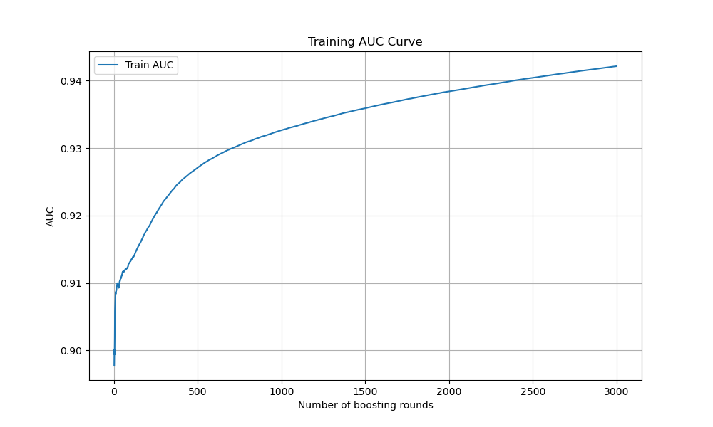
对小rounds进行精确，得到以下图像：
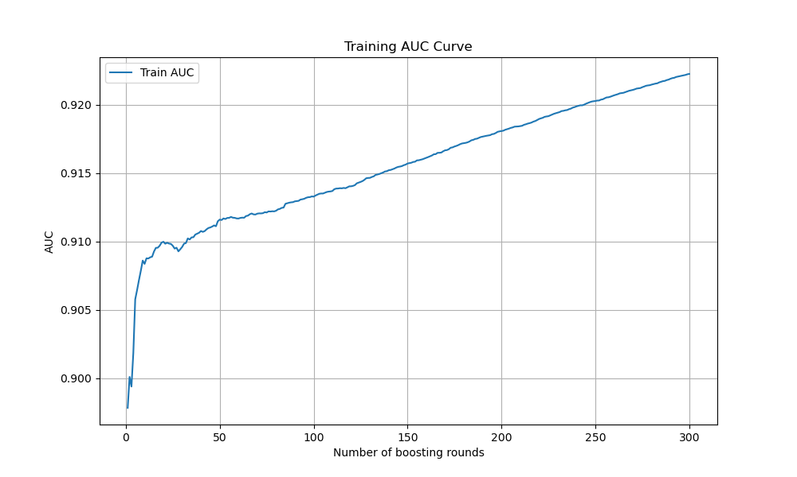
因此人工判断，当number of boosting rounds 较小时，AUC相对较好，以防止过拟合。
- 项目总结
由于记错了任务时间，本次任务二完成较为匆忙。因为对机器学习板块学习较浅，因此没有融合模型，只是单独针对XGBoost进行了预测，并通过更改其中的数据，想得到最大值。但实验得到，auc最高只达到了0.7583，并不是很理想。
但是，本人非常感谢有这次CSA数据工程项目，当初报名的时候，才是一名大一新生，甚至还没用过Python，经过了任务一和任务二的完成，我也算是对Python有了入门，并且对机器学习有了一定的了解。干感谢CSA云行工作室提供了这次机会，希望工作室越办越好！

- 最优线上成绩与历史提交成绩记录（截图，另请务必提供线上测评ID以便查验;历史提交成绩记录指全部的成绩提交记录，而不是某一天的）
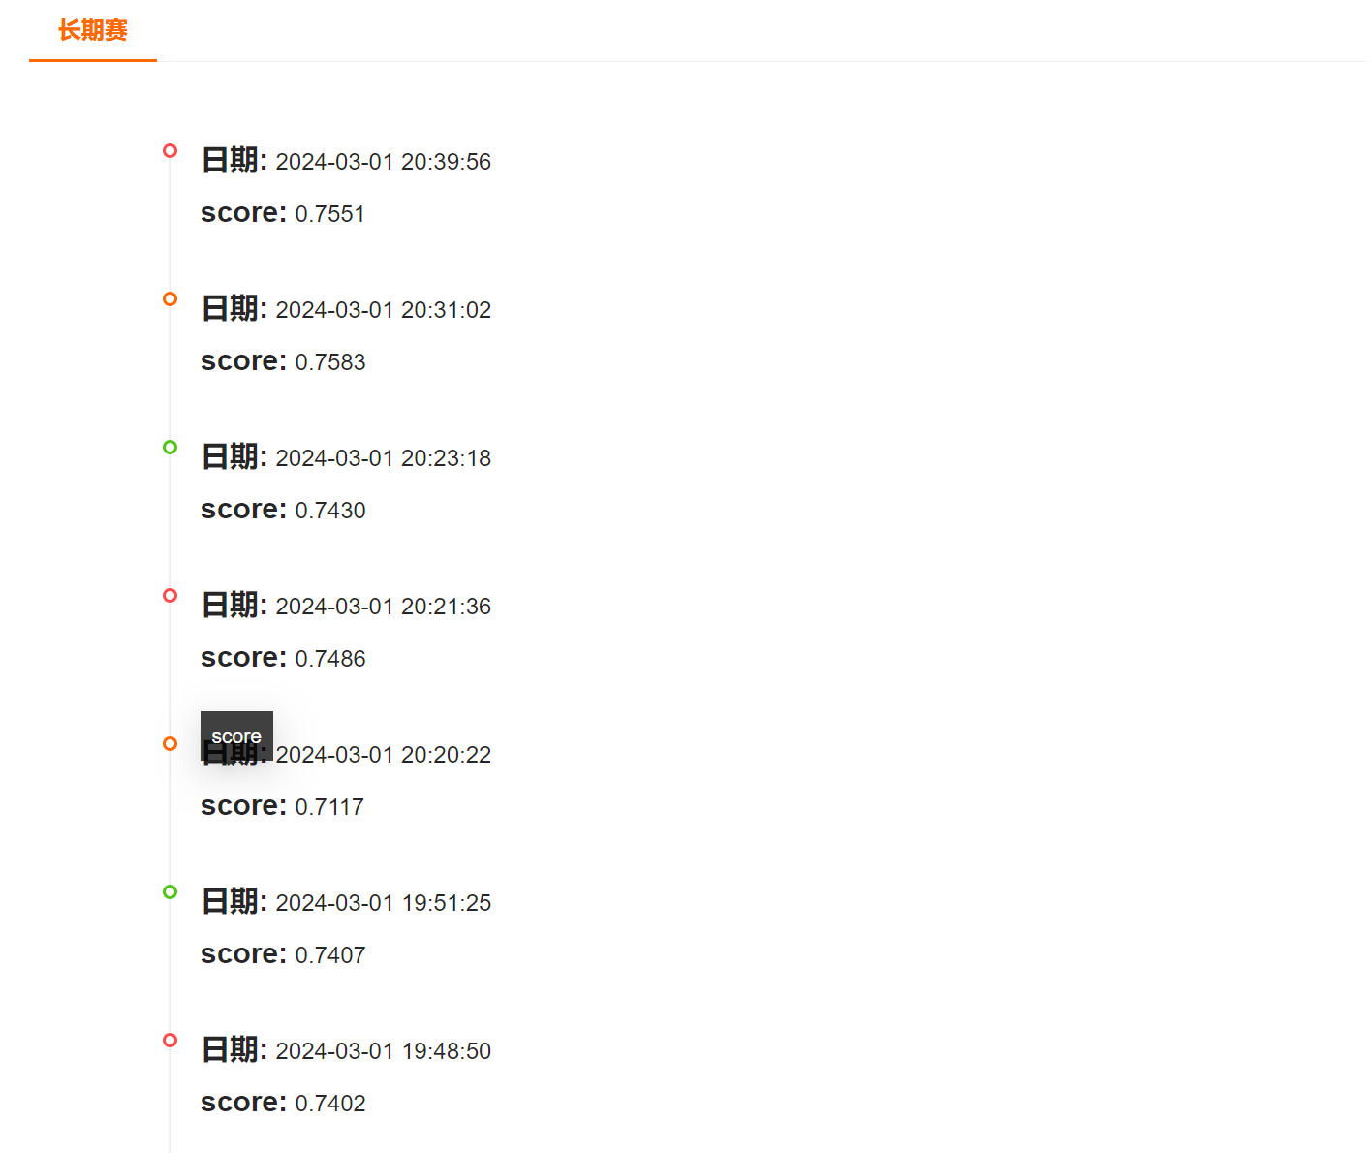
最佳成绩：
