Title

N-Methyl-D-Aspartate Receptors drive striatal calcium signaling *in* vivo and modulate continuous learning.

Authors

Alex A. Legaria, Mason Barrett, Jordyn Czarny, Alexxai V. Kravitz.

Abstract.

Here, we studied the subcellular source and function of striatal calcium signaling *in vivo* using a combination of bulk calcium recordings, pharmacology and behavioral assessment. We report that systemic and local antagonism of striatal NMDARs strongly diminish spontaneous and behaviorally evoked calcium, in addition to disrupting learning from rewarded actions on a moment-to-moment basis. These results provide novel insight into the role and mechanisms of striatal calcium signaling.

Main text.

Previously, we showed that *in vivo* bulk calcium recordings in the striatum primarily reflect non-somatic changes in calcium (REF). However, the subcellular source of these calcium changes and their function remained unknown. A dive into the literature revealed that in *ex vivo* studies N-Methyl-D-Aspartate receptors (NMDARs) are the primary source of dendritic calcium (REF). Therefore, to test assess whether NMDARs contribute to striatal calcium activity *in vivo*, we performed bulk calcium recordings and antagonized NMDARs using the non-competitive antagonist MK-801. Specifically, we expressed GCaMP8f in striatal neurons in the dorsomedial striatum (DMS). We targeted GCaMP8f expression to Drd1-expressing spiny projection neurons (D1-SPNs, N mice, X females, Y males), or Drd2-expressing SPNs (D2-SPNs, N mice, X females, Y males) using a Cre-Lox viral strategy, or in all striatal neurons (N mice, X females, Y males).

We first recorded a 15-minute baseline period, and then injected, intra-peritoneally (i.p.), MK-801 (0.3mg/Kg), or saline (only in mice where GCaMP8f was expressed in all striatal neurons) as control. To test whether calcium signaling was disrupted by NMDAR antagonism, we first evaluated the rate of spontaneous calcium transients after an MK-801 or saline injection (see methods for detection strategy). Strikingly, mice injected with MK801, but not saline-injected mice, showed a strong decrease in spontaneous calcium transients after 10 minutes. After 30 minutes, mice injected with MK801 displayed a transient rate lower than 20% compared to their baseline period, while a transient rate of over 60% was observed after a saline injection (Figure 1C,D). No difference was observed in the effect of MK-801 between the D1-SPN, D2-SPN, and all-neurons groups, suggesting that this effect is not isolated to a specific neuronal population.

Next, to test whether this diminishment in calcium transients was restricted to spontaneous calcium changes, we trained mice on an operant food self-administration task (REF), where mice had to poke on a nose-port to receive a food pellet. We again expressed GCaMP8f in DMS D1-SPNs (N mice, X females, Y males), or D2-SPNs (N mice, X females, Y males). We injected saline or MK-801 and recorded bulk calcium activity while the mice performed the task. After a saline injection, we observed an increase in calcium activity prior to the retrieval of the pellet and a strong reduction after pellet retrieval, while the mouse was consumed the pellet, consistent with previous reports (Figure 1F, REFs). In contrast, after an MK-801 injection, the increase in calcium prior to pellet retrieval, and the reduction post-retrieval was substantially diminished (Figure 1G-H), suggesting that NMDAR antagonism not only spontaneous but also behaviorally evoked calcium changes. We found no difference in the calcium response to the pellet retrieval in D1-MSNs and D2-MSNs, nor the effects of MK-801 in these responses (Extended Data Figure 2). Interestingly, mice poked and received pellets at similar rates (Figure1 I,J), suggesting that bulk calcium activity in striatal neurons is not necessary for executing previously learned operant actions.

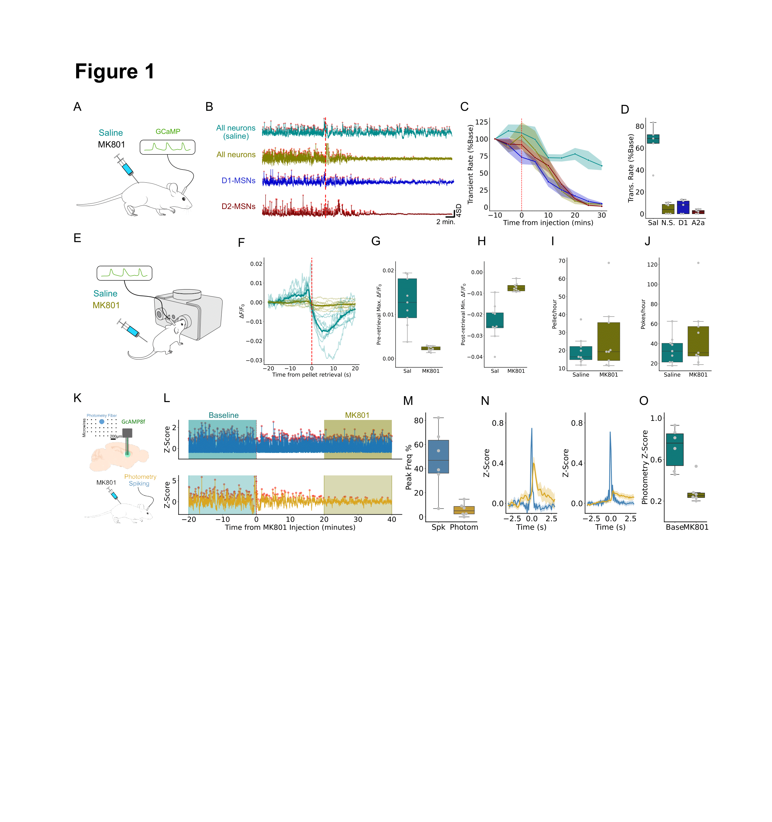

**Figure 1. Systemic antagonism of NMDARs strongly reduces striatal calcium activity, partially independent of action potential-driven activity**. (A) Bulk striatal calcium activity was recorded before and after i.p. injection of the non-competitive antagonist MK-801. (B) Example calcium activity traces after saline or MK-801 injection in all striatal populations, D1-MSNs, or D2-MSNs. Red dotted line indicates time of injection. Red dots indicate identified peaks in calcium activity (“transients”). (C) Transient rate time course in 5 minute bins around saline or MK-801 injection, normalized to the first 5 minutes of the recording. (D) Quantification of the transient rate for the last 10 minutes (20 to 30 minutes post-injection). (E) Mice were trained on an operant task, where they nose-poked on a feeding device to obtain a food reward. Saline or MK-801 was injected i.p. while bulk calcium activity in the striatum was recorded. (F) Calcium activity around pellet retrieval. (G) Quantification of pre-retrieval response. (H) Quantification of post-retrieval inhibition. (I) Pellet rate. (J) Poke rate. (K) Simultaneous *in vivo* electrophysiology an calcium recordings before and after systemic MK-801 injection. (L) Example trace of simultaneous average firing rate (top) and calcium activity (bottom) before and after MK-801 injection. (M) Frequency of rapid increase in firing rate (Bursts) or calcium activity, normalized to the baseline period. (N) Firing bursts of similar magnitude on baseline and MK-801 period (in blue), and concurrent calcium activity (gold). (O) Quantidication of area under the curve in (

A plausible mechanism for these effects of MK801 on calcium signal is that they are driven by a proportional reduction in action potential activity. Indeed, NMDARs have been reported to be important for burst firing activity (REFs) and backpropagating (BP) action potentials been proposed as the source of the non-somatic changes observed in bulk calcium recordings *in vivo* (REF)*,* potentially through BP-action potential activation of NMDARs (REF). To test for this possibility, we performed simultaneous *in vivo* electrophysiology and bulk calcium recordings (Figure 1K, N mice, X females, Y males, see online methods and REF) while the mice explored an open field arena. We recorded a baseline period for 20 minutes, and then injected MK-801 (0.3mg/Kg), and recorded for 40 more minutes (Figure 1L). Consistent with our previous experiment, we observed a strong decrease in calcium activity after MK-801 injection, which was strongest 20 minutes after MK-801 injection. To identify the effects of MK-801 on firing activity, we found peaks in activity in the average firing rate (i.e. “bursts”, see Online Methods). Interestingly, we found that MK-801 injection also reduced the frequency of firing bursts, confirming an important role of NMDARs in firing activity. However, we found that calcium transients were significantly more strongly reduced, with bursts showing a ~50% reduction in frequency, while calcium transients showed over 90% reduction in frequency. This suggests that NMDAR distinctly and disproportionally contribute to calcium activity and firing rate. To further characterize this, we identified firing bursts in the baseline and post-MK801 periods that had similar amplitudes and assessed the calcium activity around these bursts (see Online Methods). In the baseline period, in average, firing bursts co-occurred with increases in calcium activity (Figure 1N). In contrast, in the post-MK801 period, spiking bursts of similar amplitudes displayed significantly lower concurrent increases in calcium (Figure 1N, O). In other words, calcium activity co-occurring with firing bursts was substantially smaller after MK-801 injection. Importantly, we did not observe these differences between the baseline period and post-injection period in mice injected with saline (Extended Data Figure 3). These results suggest that NMDARs differentially modulate burst firing activity and non-somatic calcium activity, having a significantly larger contribution to calcium changes. Additionally, these results provide evidence that BP-action potentials are unlikely to drive calcium changes detected by bulk calcium recordings.

An important caveat of these experiments is that i.p. injections of MK-801 lead to global antagonism of all NMDARs. Therefore, the observed effects cannot be attributed to NMDARs of striatal neurons alone, but can be the result of other mechanisms, such as a decrease in global excitatory drive. To remedy this, we combined local infusions of MK-801 or saline, with bulk calcium recordings in the DMS (Figure 2A, N mice, X females, Y males). We first recorded a baseline period, after which the mice were infused with saline or different doses of MK-801 (1uL of 0.1mg/mL, 1mg/mL, 2mg/mL, or 4mg/mL) and then placed in their home-cage (see Online Methods). After ~30 minutes, calcium recordings were restarted for at least 45 minutes (Figure 2B). We observed a consistent, strong, dose-dependent decrease in spontaneous calcium transients after MK-801 infusion, compared to saline (Figure 2C), with the 2mg/mL and 4mL doses reducing the transient rate down to <20%. To further characterize these effects, we analyzed changes in power of the calcium signal at different frequencies. Again, we found a robust, dose-dependent, decrease in power in all frequencies after MK-801 infusion (Figure 2D-F). Together, these results demonstrate that striatal NMDARs are the primary driver of striatal calcium signaling.

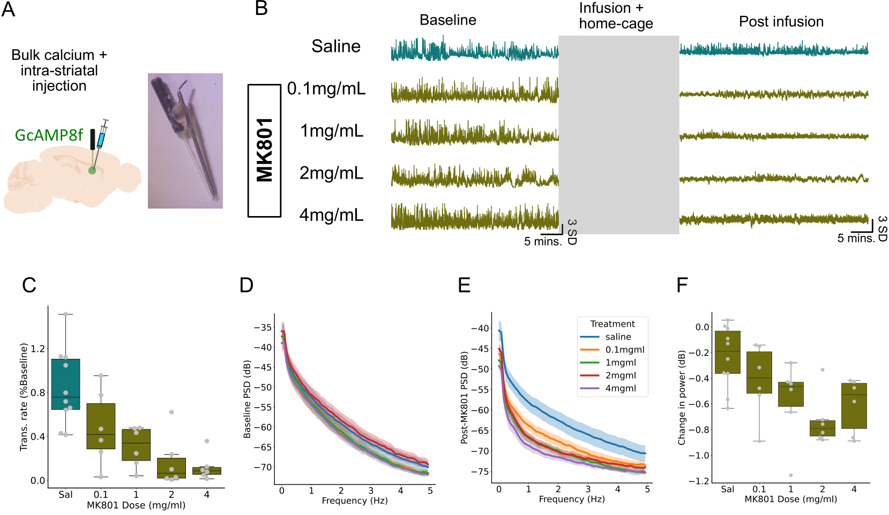

**Figure 2. Antagonism of striatal NMDARs robustly diminishes striatal bulk calcium activity.** (A) Bulk calcium recordings were coupled with local infusions of saline or MK-801. (Right) Photo of the optic fiber-cannula implant bundle. (B) Example traces of calcium activity before infusion (baseline) and after infusion (Post infusion) of saline or different doses of MK-801. All the traces belong to the same mouse in different sessions. (C) Quantification of transient rate post infusion, normalized to the baseline period transient rate. (D) Calcium signal power in baseline period. (E) Calcium signal power in the post infusion period. (F) Power difference in post infusion period and baseline period.

Next, we sought to understand the function of this striatal NMDAR-driven calcium signaling. Striatal calcium activity is correlated with reward-related behavior (REFs), yet, mice were able to execute an operant task to obtain food after systemic NMDAR antagonism at similar levels to saline injections (Figure 1I,J). However, it has been hypothesized that calcium is important for learning, functioning as a third factor in a three-factor plasticity rule (REFs) or, analogously, as an eligibility trace that helps reinforcement of actions that were specifically relevant for obtaining the reward. Under this framework, antagonism of striatal NMDARs should not prevent execution of previously learned behaviors but should disrupt new learning and the update of “action values”.

To test this hypothesis, we trained mice on a two-armed bandit task in their home-cage, using an open-source operant feeding device that contains two nose-ports (REF). In this task, a nose-poke on one side (e.g. left) was associated with an 80% probability of receiving a food reward, while poking on the other side (e.g. right) was associated with a 20% probability of receiving a reward. These probabilities were reversed every time the mouse received 30 rewards. Importantly, mice were trained for at least two weeks, until they had reached pre-established performance thresholds (see Online Methods). Then, mice were implanted with bilateral cannulas in the DMS. After recovery from surgery (see Online Methods) mice were tested on an 8-hour session of the task. Prior to the test session, mice were food restricted for up to 24 hours, and immediately prior to the beginning of the session either saline or MK-801 (1uL/hemisphere at a 4mg/mL concentration) was infused (Figure 3A). Mice were able to perform the task after saline or MK-801 infusion (Figure 3B), obtaining a similar number of pellets (Figure 3C) and poking a similar number of times (Figure 3D), demonstrating that mice were able to execute the task. However, after MK-801 infusion displayed deficits in learning. Specifically, after an MK-801 infusion mice displayed a higher ratio in the number of pokes needed obtain a single pellet (Figure 3E). Moreover, we observed that prior to the probability reversals, where mice should be making the highest proportion of correct choices, mice infused with MK-801 showed a significantly lower accuracy (Figure 3F). In contrast, after the probability reversals, when mice are making the most mistakes, the accuracy of mice after MK-801 infusion was similar to saline-infused mice (Figure 3F). This suggests that MK-801 may differentially affect learning from rewarded choices (hereon “wins”) than from unrewarded choices (hereon “losses”). To further assess this, we looked into learning metrics that can dissociate these forms of learning. To assess learning from wins, we first quantified “win-stay” behavior. We observed that after MK-801 infusion, mice are significantly to less likely to repeat an action that was rewarded on the prior trial. To expand on this, we used a logistic regression to assess the influence of previously rewarded actions on current choice (see Online Methods, REFs). We observed that after MK-801 infusion, previously rewarded trials had as significantly lower influence in current choices compared to saline infusions (Figure 3I). Finally, we fit a reinforcement learning (RL) model that has distinct learning rates for learning from wins and losses (Figure S5, REFs). We found that after MK-801 infusion, mice have a lower learning rate for learning from wins (Figure 3J). In contrast, when we assessed learning from losses, we observed no difference between saline and MK-801 infusions in “lose-shift” behavior, the regressor coefficients of a logistic regression that quantifies the influence of unrewarded actions on current choice, or in the RL-fitted “loss learning rate.” Importantly, these effects were dependent on the proportion of NMDARs antagonized (i.e. dose-dependent), as i.p. MK-801 injections led to stronger effects (Figure S6), while local striatal infusion with a lower dose of MK-801 led to milder effects (Figure S7). Finally, to test whether these effects where due to an increase in non-goal-directed behavior (e.g. exploratory) rather a disruption in learning, we repeated these experiments using a fixed-ratio 1 (FR1) task, where one poke was always associated with a 100% probability of reward and the other sideo to a 0% probability of reward (N mice, X females, Y males). Mice that received MK-801 (either intra-striatally or i.p.) were as accurate as mice that received saline, both groups being over >90% accurate, and displayed similar “win-stay” behavior (Figure S8). These results demonstrate that striatal NMDARs are necessary for continuous learning, but not for the execution of previously learned actions.

All together, these experiments demonstrate that NMDARs are the primary drivers of striatal calcium signaling and are critical for continuous learning. Although more experiments are needed, our results support that in addition to supporting burst firing activity, NMDAR-driven striatal calcium activity is consistent with the function of an eligibility trace that tracks, on a moment-to-moment basis, which striatal neurons are eligible for dopamine-driven plasticity. This is consistent with the correlations observed between striatal calcium and specific motor patterns (REFs), *ex vivo* reports of the essential role of NMDARs and calcium in dopamine-driven striatal plasticity (REFs), and theoretical models of striatal plasticity rules (REFs). More generally, our work provides *in vivo* evidence of previously proposed neural mechanisms for credit assignment in the basal ganglia.

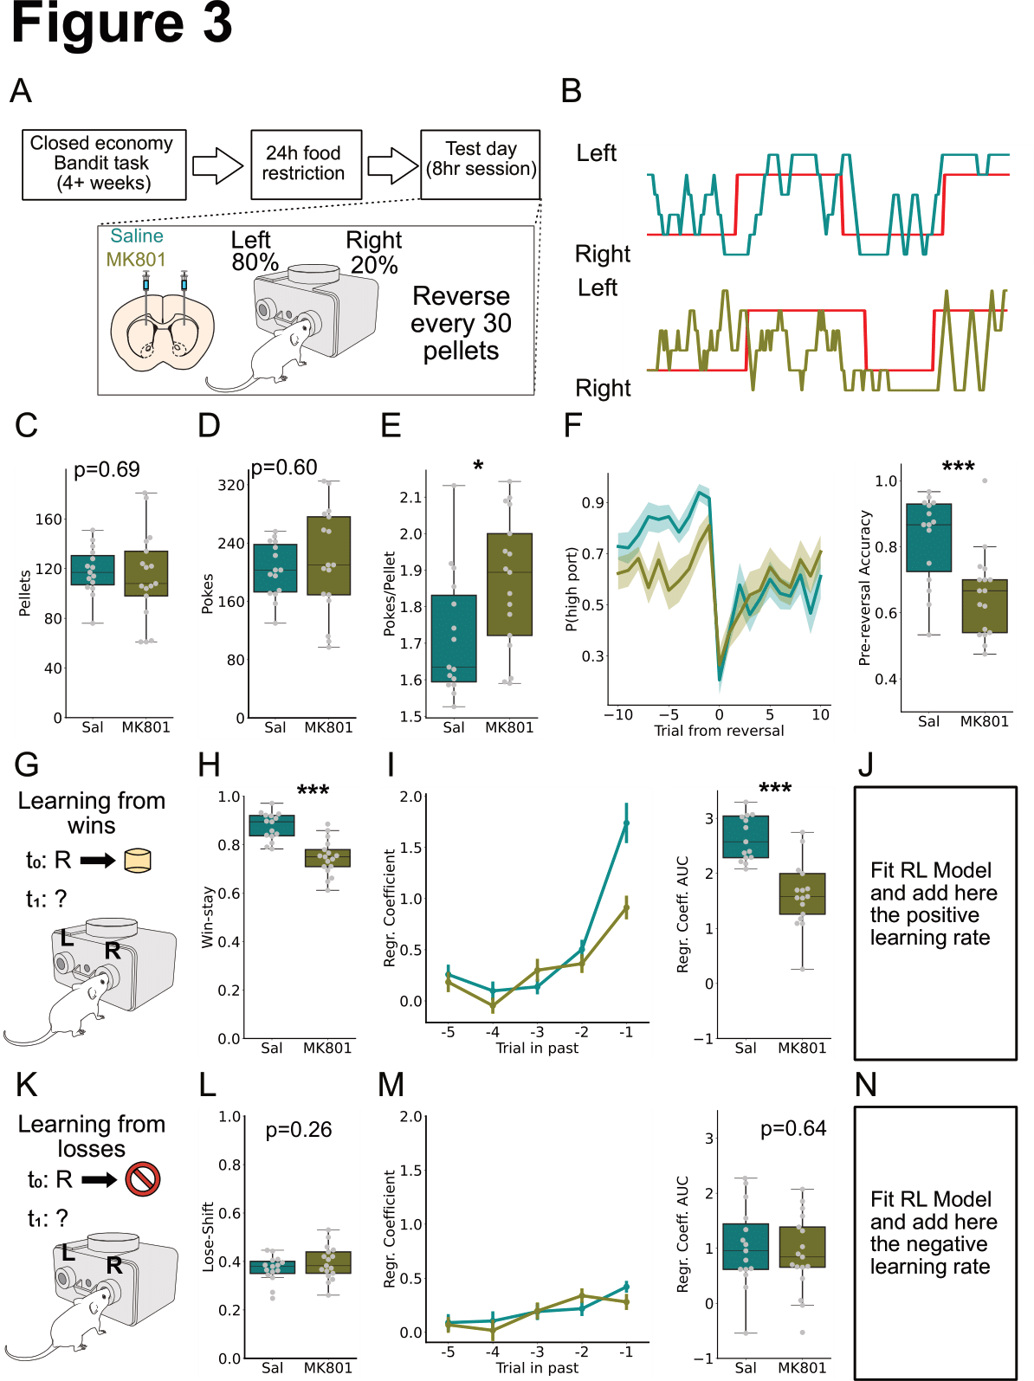

**Figure 3. Antagonism of striatal NMDARs disrupt learning from rewarded actions.** (A) Experimental paradigm. (B) Sample traces of test session after a saline infusion (top) or MK-801 infusion (bottom) in the same mouse. (C) Number of pellets acquired in a test session. (D) Number of pokes in test session. (E) Pokes per pellet in test session. (F) (Left) Peri-event histogram showing the probability of mouse poking on the “high-probability port.” Trial 0 is when the probabilities are reversed. (Right) Average accuracy (probability of poking in high-probability port) in the 10 trials prior to the reversal. (G-H) Assessment of learning from rewarded trials. (H) Quantification of the entire test session win-stay behavior. (I) (Left) Regressor coefficient of logistic regression that measure influence of previously rewarded actions on choice. (Right) Sum of (left). (J) Positive learning rate parameter as estimated by RL model. (K-L) Assessment of learning from unrewarded trials. (L) Quantification of lose-shift. (M) Same as (I) but for unrewarded trials. (N) Negative learning rate parameter as estimated by RL model.