Observations and Conclusion

* The chemical energy in the batteries transforms into electrical energy allowing the EV3 regulated motors to rotate. This rotation creates motion and gives torque to the catapult arm. The launch of the catapult puts the ball into a projectile motion. This issues the kinetic energy of the ball which makes it travel a certain distance before coming to a halt.

The launcher is made of two EV3 motors, an arm and a ball holder. The ball holder ought to be solid enough and deep enough as to hold the ball firmly, for the ball could slip over it if the speed and/or the acceleration is too high. Furthermore, the catapult only rotates through 110 degrees then stops. This way, it allows the ball to leave the ball holder and continue its trajectory towards the desired destination.

* The launching mechanism does not shoot in a straight line yet in a projectile. Since other than gravity, there is no other force acting upon the ball, it would be put under a constant downwards acceleration (g). There are no external Consequently, the trajectory cannot be changed.

Future improvements

* Our robot is set to fire the ball to 120 cm away.

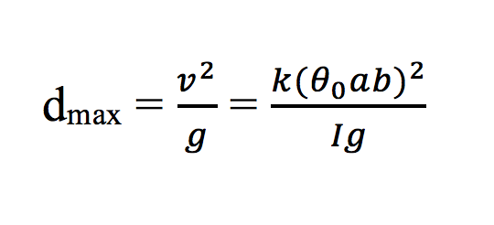

With this formula, the expected initial velocity the ball can be calculated. A method could be implemented. It takes the desired distance as an argument and returns the initial velocity. From this, the ball could be emitted to the projectile motion in the intention of landing at the desired place. However, the accuracy of the launcher would decrease with the increase of the distance fired. This could be explained by the enlargement of small errors on a large distance. Errors occur in the accuracy of the rotated angles and the velocity, the stability and air friction.

Possible solution to minimizing error:

Hardware: increase the stability of the launcher.

If the arm of the catapult is yet firm enough, motions that are too fast would cause it to wobble and dysfunction.

Software: implement a odometry correction like thread to correct the motors.

Using the same idea as the odometry correction we used in lab 3, we could adjust the angle that the motors rotate through so that it corresponds to the launch angle more precisely.