Infrastructure processing instructions

Required scripts:

Cost-surface processing.py

Node processing.py

**Processing steps:**

Step 1. Create data CSV table of subfactor weightings

Step 2. Create cost-surface

Step 3. Create node layers

Step 4. Running Graphab

**Step 1. Create data CSV table of subfactor weightings**

Present the data and weightings describing the subfactors in a 3 column table similar to below (**data CSV**). Where the first column is the file path and the second and 3rd column describes the weightings.

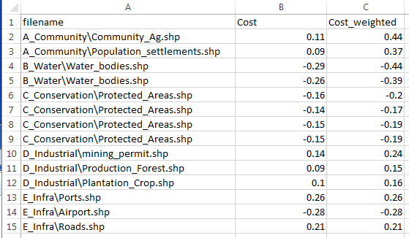

**Step 2. Create cost-surface**

Run “Cost-surface processing.py”

This script does the following:

1. Converts a contour layer into a raster slope layer for a specific pixel size
2. Makes a list of the filenames described by **data CSV**
3. Clips and converts the original shapefile
4. Converts the shapefile to raster for a specified pixel size
5. Weights the subfactor layers and topographic layers
6. Combines all the layers
7. Exports the layer as a .tif.

**Step 3. Create node layers**

Run “Node processing.py”

1. Converts shapefiles into raster files using the cost-surface as a template to ensure the same number of cells, alignment, and cell size.
2. Exports the layer as a .tif

**Step 4. Running Graphab**

The following diagrams illustrate the setup

*1. Identify node layer*

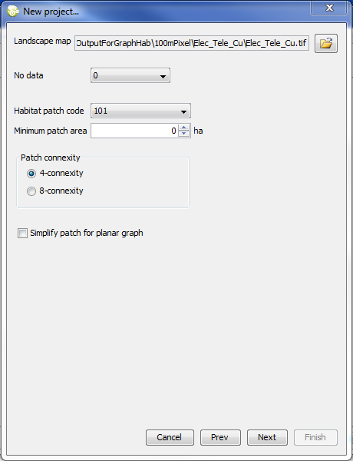

*2. Identify cost surface*

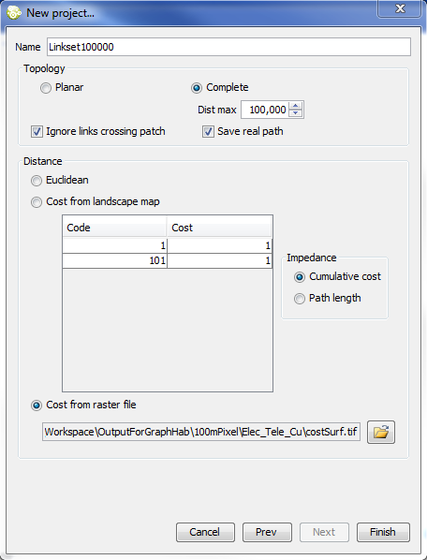

*3. Output – least-cost path network*

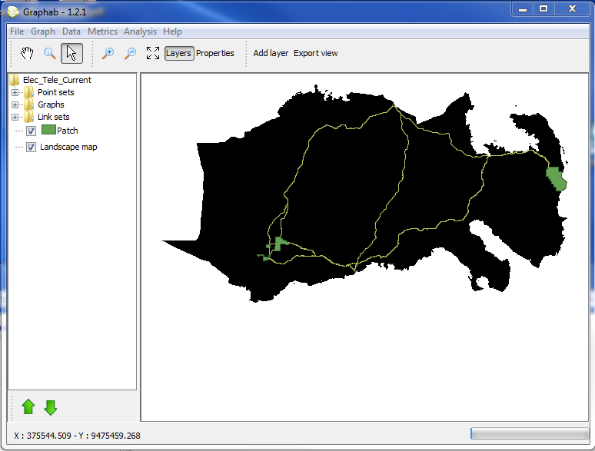

*4. Identify minimum spanning tree*

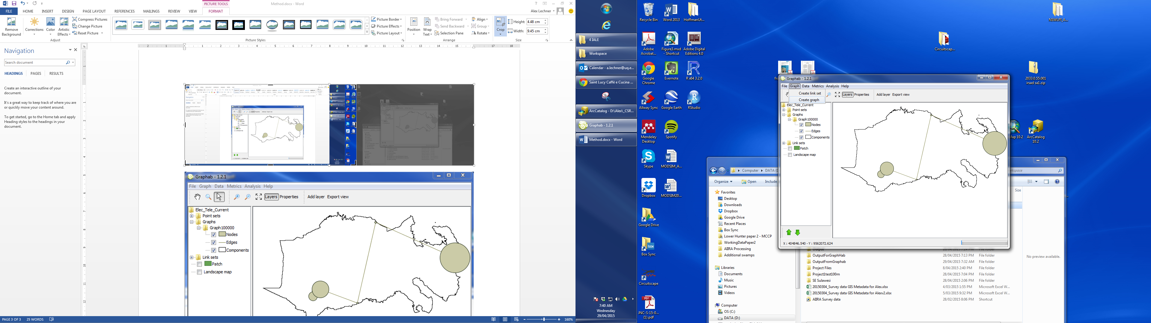

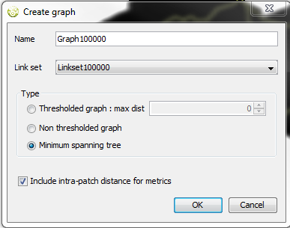

*5.Output – minimum spanning tree*

