<Car Renting Application>

Analysis and Design Document

Student:Lecu Alexandru-Călin

**Group:30234**

Revision History

|  |  |  |  |
| --- | --- | --- | --- |
| **Date** | **Version** | **Description** | **Author** |
| <dd/mmm/yy> | <x.x> | <details> | <name> |
|  |  |  |  |
|  |  |  |  |
|  |  |  |  |

Table of Contents

I. Project Specification 4

II. Elaboration – Iteration 1.1 4

1. Domain Model 4

2. Architectural Design 4

2.1 Conceptual Architecture 4

2.2 Package Design 4

2.3 Component and Deployment Diagrams 4

III. Elaboration – Iteration 1.2 4

1. Design Model 4

1.1 Dynamic Behavior 4

1.2 Class Design 4

2. Data Model 4

3. Unit Testing 4

IV. Elaboration – Iteration 2 4

1. Architectural Design Refinement 4

2. Design Model Refinement 4

V. Construction and Transition 5

1. System Testing 5

2. Future improvements 5

VI. Bibliography 5

# Project Specification

*Car Renting Application este o aplicatie web pentru inchirierea masinilor care poate fi utilizara de clientii care doresc sa inchirieze o masina si de angajatii companiei.*

*Clientii pot face urmatoarele operatii:*

* *Login cu username si password*
* *Cautarea unei masini disponibile in perioada data pentru inchiriere intr-un oras anume*

*Angajatii companiei pot face urmatoarele operatii:*

* *Logarea cu username si password*
* *Marcarea unui client care a adus masina inapoi dupa perioada de inchiriere*

# Elaboration – Iteration 1.1

# Domain Model

*[Define the domain model and create the conceptual class diagrams]*

# Architectural Design

## Package Design

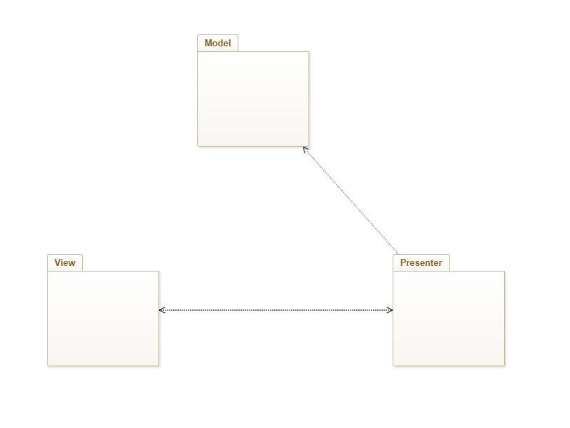

## Component and Deployment Diagrams

# Deployment Diagrams

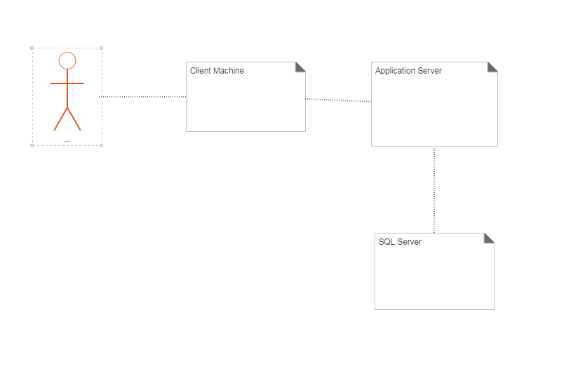

# Elaboration – Iteration 1.2

# Design Model

## Dynamic Behavior

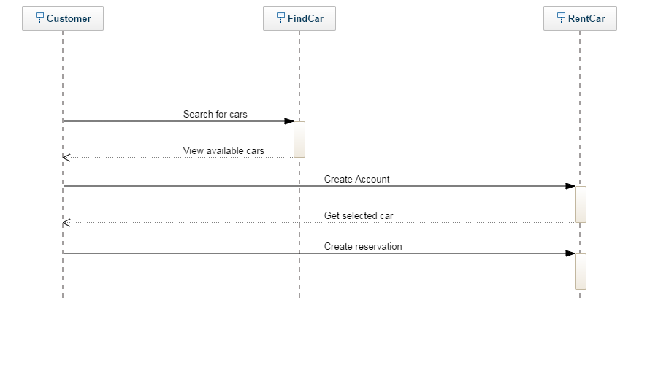

## Class Design

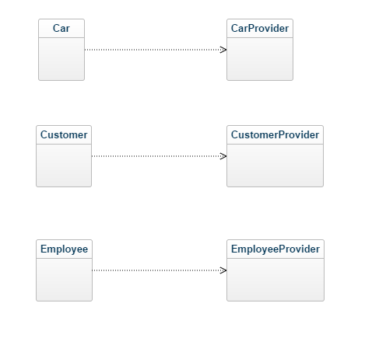

# Data Model

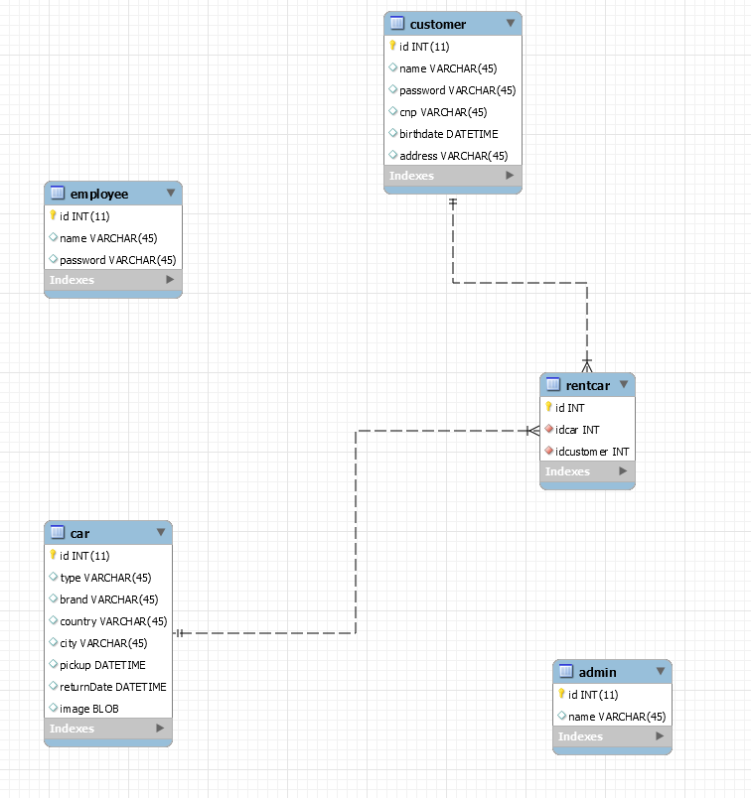

# Construction and Transition

# System Testing

*[Describe how you applied integration testing and present the associated test case scenarios.]*

# Future improvements

*[Present future improvements for the system]*

# Bibliography