**Introduction**

In this report, the system management functions of one of the popular operation systems - macOS will be investigated. The process management and file management will include in this case study report. The version of macOS used in this report is 10.15.7 macOS Catalina (Fig.1), which was released in October 2020.

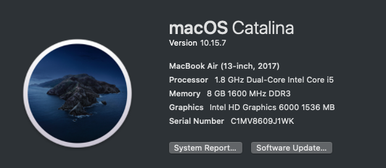 (Fig .1 Version of macOS)

**Process Management**

Process Management is one of the Macintosh Operating System by Apple. The Activity Monitor (Fig.2) of macOS is the main process management utility. It is similar to Windows Task Manager. For all macOS system devices, we need to click the Launchpad of the Dock. So that the user can find out that Activity Monitor is inside the folder call Utilities. It is the basic way to access the Activity Monitor. There are some short-cuts to access the Activity Monitor, press the command button and space button, then type the word “Activity Monitor”. Finally, it also can access it.

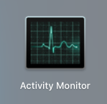(Fig.2 Logo of Activity Monitor)

The Activity Monitor is similar to Windows Task Manager, which can show the processes of your devices. The Activity Monitor gives the user CPU, Memory, Energy, Disk, and Network information on our devices. This utility is also giving the user different detail of each component. This report will mainly talk about the CPU information interface.

The CPU information interface (Fig.3) will show how many percentages of CPU and GPU space are using, the using time at CPU and GPU, the number of threads (macOS allows multithread), the PID, and the user ID of each process. The user can double click the specific process or select it and press the ‘i’ logo button, then get further specific information about that process in an information box (Fig.4) (Fig.5). This information box contains the actual and virtual memory size, the number of faults and system calls, and more.



(Fig .3 Default interface (CPU information) of Activity Monitor)

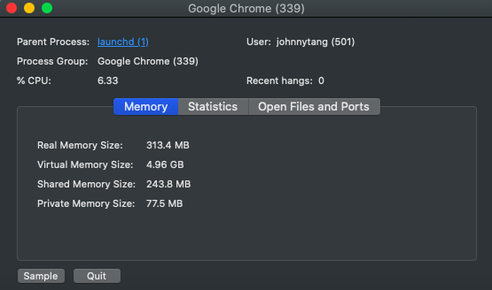(Fig .4 Specific information of memory about process ’Google Chrome’)

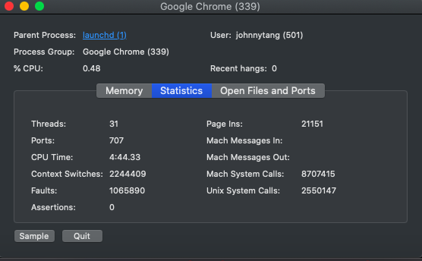(Fig .5 Specific information of statistics about process ’Google Chrome’)

There is some summarized information at the bottom of the CPU information interface. It shows how many parentages of CPU that system and user used or idle at the current with the words and line chart. Moreover, it also shows how many processes are running and the total number of threads which those processes created.

The Activity Monitor permits the user to end all processes. It contains their threads and the zombie process. There are two ways to stop or destroy the process. The first way is to click on the process that the user wants to stop, then click the cross-logo button at the left. The second way is to open the information box of the selected process that click the quit or force quit buttons. This move will let the process form running state to exit state.

There are further functions of Activity Monitor. Those functions are Sample Process, Spindump, System Diagnostics, and Spotlight Diagnostics functions. Those four functions will create a report to show to the user.

The Sample Process function will be sampling the selected process then giving the user the details of the selected process within the report (Fig.6). The report will contain the process name, path, load address, version, identifier, launch time, and more. If the user wants to keep the report, they can press the Save button.

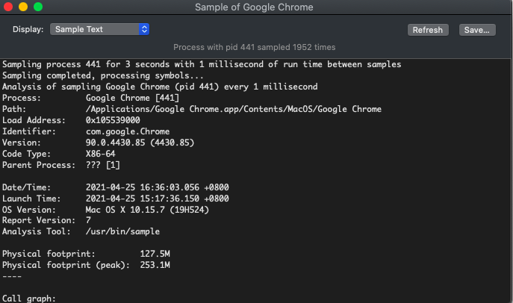(Fig .6 Sample text report of process ’Google Chrome’)

The Spindump function will create the report for zombie process which were terminated using force quit (Fig.7). The System Diagnostics will write the details based on the logs of the macOS devices. Spotlight Diagnostics also will write the details based on all running processes of the macOS devices.

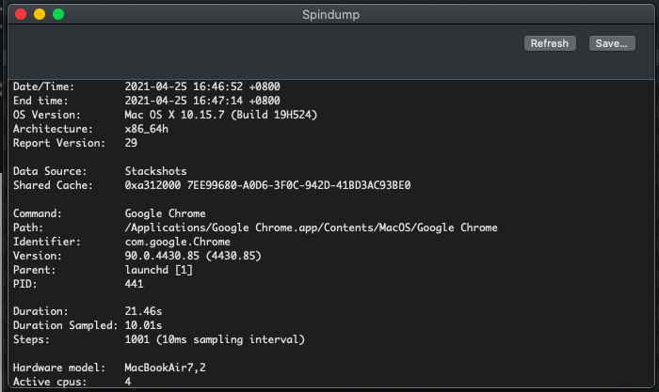Fig .7 Spindump text report of process ’Google Chrome’)

If the user wants to set the priority of the process, macOS needs to use another utility call Terminal to type some command to set the priority. The command “nice -n <priority> <command> <arguments to command>” can set the priority of the process before it begins. After this move, the higher priority process will go to Ready state then the lower priority process will move to Ready/Suspend state. The command “renice -n <priority> <pid>” or “sudo renice -n <priority> <pid>” can set the priority of the running process (Fig .8). The <priority> range will be 20 to –20, -20 is the top priority, and 20 is the low priority. The default priority of the process is 0.

 (Fig .8 set the process 1081 to the highest priority with Terminal)

**File Management**

File Management is one of the Macintosh Operating System by Apple. The Finder (Fig.9) of macOS is the main file management utility. The Finder can always find at the Dock, which makes it very convenient to call this utility. The short-cuts method of access Activity Monitor is also working on access Finder, just the final step change to type “Finder”.

(Fig .9 logo of Finder)

When the user starts the Finder (Fig.10), it will show the recent files that the user accessed or opened. The user can double-click the file to open or access it. The Finder allows the user to set the files display method, viewing the files as icons, in a list, in columns, or a gallery. For each display method, Finder will provide some simple information of the files, like size, kind, and date of creation or modification. If the user wants further information about the specific file, they can right-click the selected file and click the word “get info”, then the information box will occur. The user also can rename the selected file or folder.

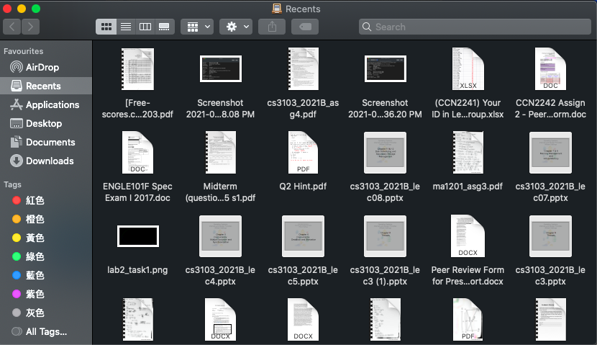(Fig .10 default interface of Finder)

The different files or folders allocate at the default block or path, like the file downloaded from the network will allocate in the block called "Download". On the left-hand side of the Finder, it can easily let users access different blocks and open the file or folder. The Finder allows the user to change the block of the file or folder. They can shift the selected file or folder to the block of Finder left-hand side, then the block of the file will change. The other way is to press the command and C buttons to copy the specific file or folder then press the option, command, and V buttons to paste it to some path or block that the user wants.

There is the function of a tag of Finder to let the user group the file or folder but not affect the original block or path of them (Fig.11). The Finder can sort the file and folder in the tags or blocks by some elements like the name, date of creation, size, and more.

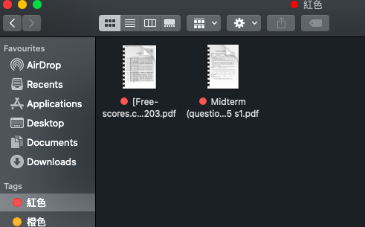(Fig .11 the red tags)

There are some folders or files that the user wants to delete. The user can select the specific file or folder, then right-click and select the word “Move to bin”. After this action, the selected file or folder will not be deleted yet and move to the Bin block. Bin will store those items and let the user decide which of them are really removed from the device or put back to the original block.

Finder uses Hierarchical File System Plus (HFS+) to manage the file to replace File Allocation Table (FAT). The Finder will allocate the file of the block with a B-tree. The B-tree of each block even bin will store the metadata, which provides the main details of the file, to identify the file. It is the OS concept behind the Finder and macOS.

**Reference**

1. Apple. (n.d.). Activity Monitor User Guide. Retrieved April 24, 2021, from <https://support.apple.com/en-gb/guide/activity-monitor/welcome/mac>
2. Apple. (n.d.). Activity Monitor User Guide - Run system diagnostics in Activity Monitor on Mac. Retrieved April 24, 2021, from <https://support.apple.com/en-gb/guide/activity-monitor/actmntr2225/10.14/mac/10.15>
3. David, B. (2020, May 11). Prioritizing Processes On Your Mac Within Terminal. Medium. <https://medium.com/macoclock/prioritizing-processes-on-your-mac-within-terminal-ecb8c2fdebd3>
4. HFS+ Overview. (n.d.). NTFS.Com. Retrieved April 25, 2021, from <http://ntfs.com/hfs.htm>