City University of Hong Kong

2020 – 2021 Sem B

EE3103 Operating Systems

**Written Assignment: Case Study**

**Introduction:**

As most of the desktop users are running Windows as their operating system, Windows 10 Pro version 2H20 (Fig 1) is chosen to be the study case in the assignment. The following will cover **process management** and **memory management** of Windows 10 as the study case.

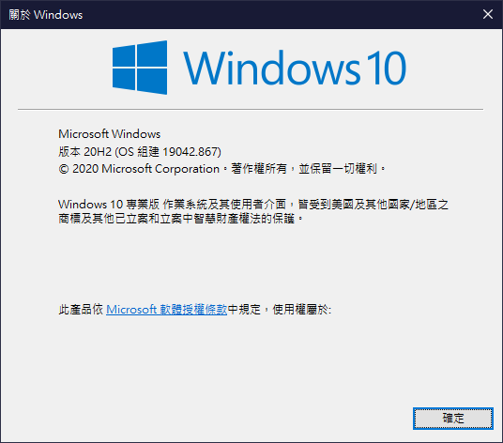

**Fig 1:** Windows Version 20H2

**Section 1: Process management in Windows 10**

**What utilities are available in Windows 10 for performing Process management?**

There are many utilities Windows use to managing process, but not all of them can be accessed by the users. The following will focus on **Task Manager** which can be accessed by the user.

**Task Manager**

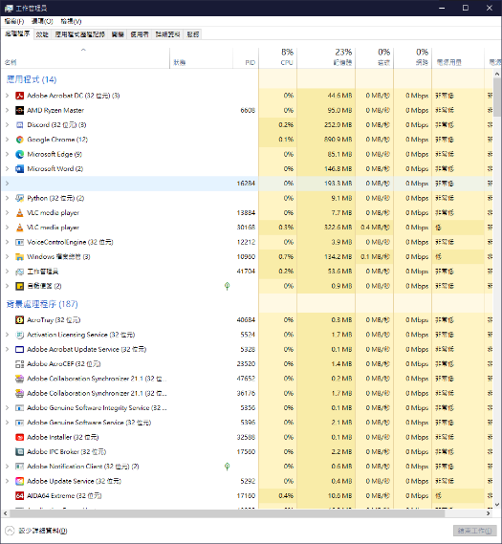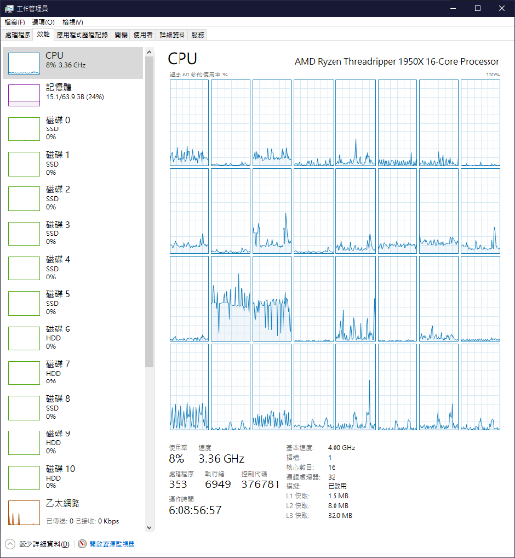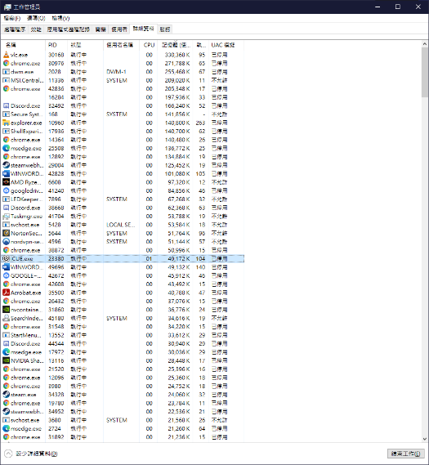

|  |  |  |
| --- | --- | --- |
| **Fig 2:** Task Manager - Process page | **Fig 3:** Task Manager - Performance page | **Fig 4:** Task Manager - Details page |

Task Manager is a utility created by Microsoft to allow users to have directly control of non-critical process. It has lots of different functions, like displaying running process, process settings, computer recourse displaying and more. Task Manager is set to be disallowed to open in multiple windows at a time by Microsoft.

**How to access Task Manager?**

Task Manager can be access by many ways which can be generalize in 3 parts. The first one is indirect access. User can access Task Manager by right click on the taskbar can open Task Manager in the menu; user can press Windows Key + X at the same time to open Task Manager in the menu; user can open Task Manager in the traditional way which is pressing Ctrl + Shift + Del at the same time and click Task Manager in the menu. The second method is to access Task Manager directly, which is the fastest way, user can either press Ctrl + Shift + Esc at the same time or open taskmgr.exe directly via File Explorer with path “C:\Windows\System32\taskmgr.exe”, both ways can bring up the Task Manager. The last method is accessing the software by searching it, either by searching Task Manager in the start menu or use Windows Key + R to open the Run Box and search for taskmgr, both ways can access it.

**What information is provided by Task Manager?**

Task Manager has two operating mode, the Simple View mode and Detailed mode. There is only limited information is provided in the simple mode, which the name of the software running in the foreground, with right click on the software name and click Properties, it will show more information of the software in a new window, displaying information like the path of the .exe file. In the same menu, user can click Open File Location to the location of the running software.

On the other hand, Detailed mode provide a lot more information which contains of 7 Tabs by the following order: Process, Performance, App History, Startup, Users Details, Services.

In Process Tab (Fig 2), it provides the information of all the process both foreground and background in a table, with their CPU, Memory, Disk, Network usage in percentage, and the power usage of a process by default, more information can be display if a use right clicks on the column name of the table. For example, PID, the name of .exe file running by the process, or GPU usage, Status, with PID as the process ID. If a program has no responses, the Status will show as “Not Responding”. Process can be sort if a user clicks on the column name, the table is sort by name by default. When sorting by process names, the process will categorize into 3 section, which are Apps (foreground process), Background Process and Windows Process (Windows critical process).

If a user right clicks on a process, it will show up a menu which include the following rows: Expand (Collapse), Resource values, Create dump file, Open File Location, Properties. Some applications have multiple processes running and they will be grouped in the process table. Expand (or Collapse) will display (or hide) the processes within the application on the table. Resource values can let a user to choose whether display the resource used by the process by the value or percentage. Create dump file will capture the snapshot of the system memory that the process is using and save it as a file.

In Performance Tab (Fig 3), real-time graph of different computer part usage will be shown, like CPU, Memory, all the disks, all the internet connection and all GPU. In App History Tab, programmes are shown in a table with the amount of CPU time the program had used. In Startup Tab, programmes are shown in a table with their distributor, Disk I/O usage at Startup, CPU usage at Startup. The user can disable a program to start itself automatically when the computer turns on in this tab. In Users Tab, a table with user and the resource they are using will be display.

In Details Tab (Fig 4), the table displays a detailed version of the table in Process tab. By default, the following column will be display. PID which is the Process ID. Status which is the process status whether “Running”, “Suspended” or “Not Responding”. If a process is minimized by the user and has been idle for a long time, the process will be suspended. If a process did not response to the system, “Not Responding” will be display and if the user wants to terminate a no response process, the system will kill the process. User names which shows the user of the process, it can be user himself or “SYSTEM”, “LOCAL SERVICE”, the last two are usually critical process running by windows. CPU which is the percentage of CPU resources the process is currently using. Memory which is the amount of physical memory used by the process, which is only use by that process and non-sharable. Threads which is the number of running threads used by the process. More columns can be shown if the user right clicks the column name and select “Show Columns” and click the item the user wants to display.

If a user right clicks on a process, it will show up a menu which include the following rows. Some of them are similar to the Process tab like Create dump file, Open File Location, Properties. Their feathers are the same as those mentioned above. But some of them are not, like Analyse wait chain which can let the user view which thread the process is waiting for if there is any thread waiting for resource to be release that currently occupied by other process. It can be helpful to trace whether there is a deadlock or not.

In Services Tab, a table of services will be display, with theirs Process ID as PID, their information of what that services serves as Description, the Status of the services which will either be “Running” or “Stopped” and Group which the services in.

**What operations can be performed with Task Manager?**

|  |  |  |
| --- | --- | --- |
|  |  |  |
| **Fig 5:** Simple View – Right Click Menu | **Fig 6:** Process Page - Right Click Menu | **Fig 7:** Details Page - Right Click Menu |

In the Simple View (Fig 5), there is only limited operations can be performed with Task Manager which are Switch To, End Task, Run New Process, more detailed usage will be mention in the Details View. Content of the right click menu depends on the process.

In Process Tab (Fig 2), if a user right clicks on a process, it will show up a menu (Fig 6) which include the following rows (which depends on the process): Restart (explorer.exe only), Switch To, End Task, Go to details (tab). Restart is use for restart a process by terminate the process and restart the executable file again. Switch To will switch to the process the user clicks from the Task Manager. End process will terminate the process, but process created by this process may not be terminate.

In Details Tab (Fig 4), if a user right clicks on a process, it will show up a menu (Fig 7), most of the penal are the same as the penal in Process tab, but here the tab provides more operations. The rows are: End Tasks, End process tree, Set priority, Set affinity, Go to service (tab). End process tree will terminate the process with all its child process and the process created by this process. Set priority can set the priority of the process from Realtime, High, Above normal, Normal, Below normal and Low, with different priority setting, process will have different priority when processing. Set affinity can decide which processor the process will run on. Process can run on all processors by default. This can be useful if the CPU have a processor running on a higher clock speed and the user want to assign a process on that processor.

In Services Tab, if a user right clicks on a service, it will show up a menu. Click Stop will stop a running service, Click Start will start a non-running service. Restart will stop the service first and start it again.

**Section 2: Memory management in Windows 10**

**What utilities are available in Windows 10 for performing Process management?**

In windows, users are not allowed to manage memory directly by themselves, but rather user can monitor the memory. The following will focus on **Performance Monitor** and **Resource Monitor** which can be accessed by the user.

**Performance Monitor**

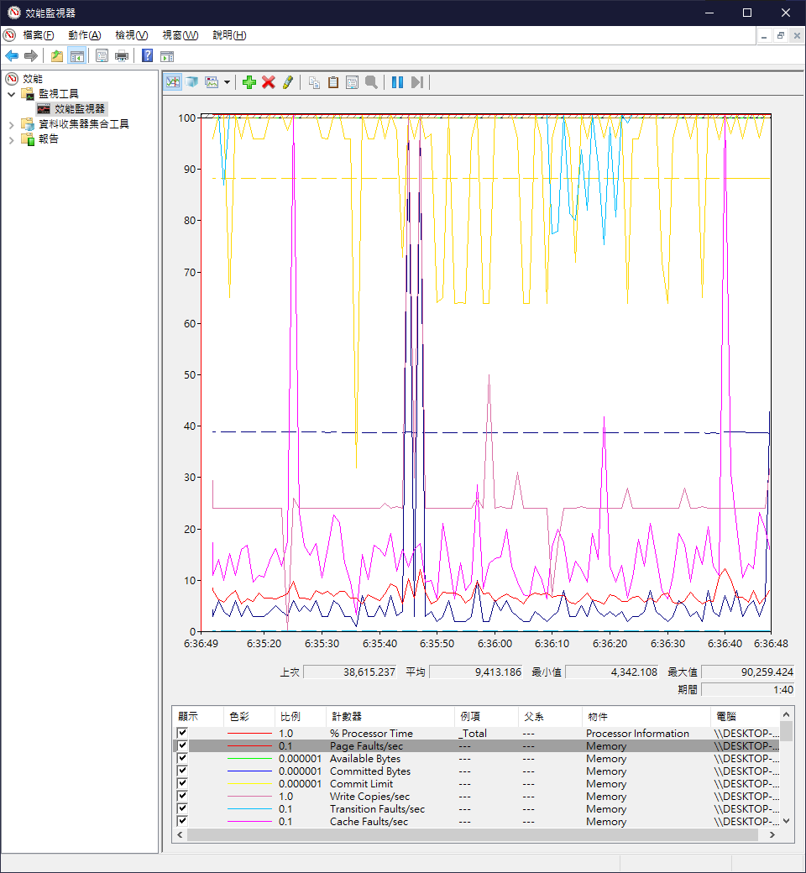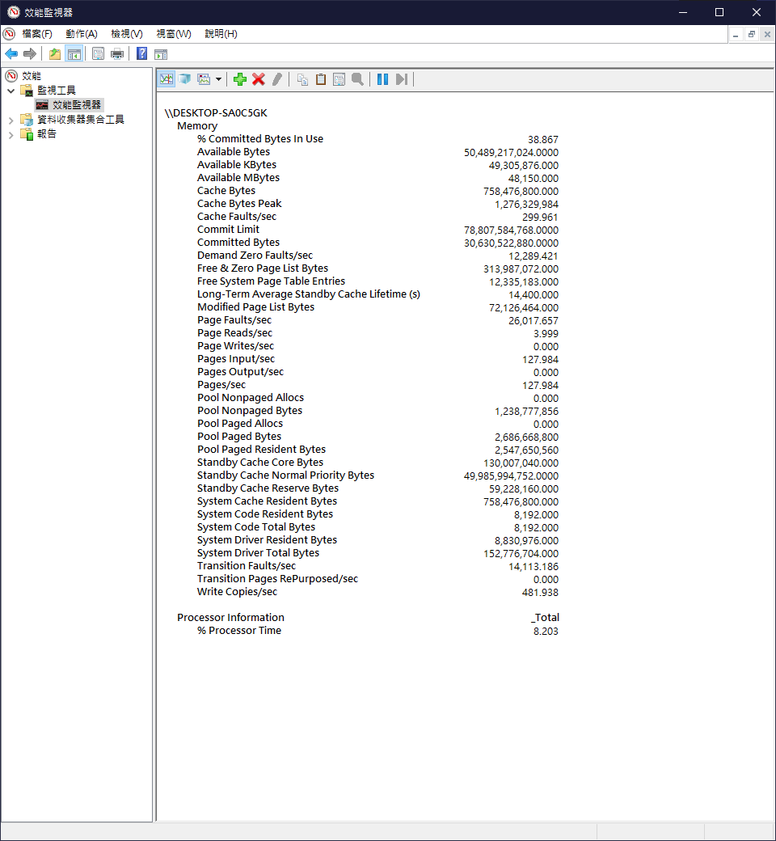

**Fig 8:** Performance Monitor – Memory graph **Fig 9:** Performance Monitor – Memory report

Performance Monitor (Fig 8) is utility created by Microsoft to allow users to monitor the resource used by program and systems in a detailed graph for example CPU usage, memory usage, disk I/O and more. In this study case, we will focus on memory.

**How to access Performance Monitor?**

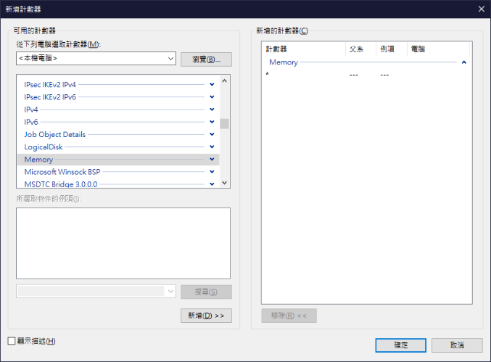

**Fig 10:** Performance Monitor – Adding memory as the monitoring parameter

Performance Monitor can be access by many ways. By pressing the Windows Key + X, then Computer Management, double click Performance, double click Performance Monitor. Or by pressing the Windows Key + R to open the Run Box, then search for “prefmon”. User either use Windows search to search for “prefmon” or open prefmon.exe directly via File Explorer with path “\System32\prefmon.exe”. Above methods can all access the Performance Monitor.

To add memory as the monitoring parameter, the user first need to click on the green Plus icon, then select Memory in the list, click Add and click OK.

**What information is provided by Performance Monitor?**

Performance Monitor can display the memory situation on graph (Fig 8) or generate a report (Fig 9). The real-time graph is a graph with time as the x-axis, and reporting different value related to the memory. For example, Available Bytes which is the total available bytes the system can use, Cache Bytes, Cache Faults/sec which count number of page fault that occur when a program references a section of an open file that is not currently locate in physical memory. Demand Zero Faults/sec witch count the number of page fault that the memory manager finds the block of memory its needs and not in RAM as it was swapped out to disk.

Pages/sec is the combination of input and output paging counting. Pages Input/sec is the rate of pages that swap from the disk to the memory while Pages Output/sec being the rate of pages swap from the memory to disk. Page Reads/sec is the rate for the disk to read for solving page faults. Page Writes/sec is the rate that pages are written to the disk to free up space for the physical memory. Page Faults/sec is the rate which the processor is handling page faults. These numbers can reflect how much did the swapping pages affect the performance of the disk.

**What operations can be performed with Performance Monitor?**

A report can be generated with detailed data of the above parameter, by clicking Copy Properties icon and save it on a notepad. Or click the Paste Properties icon to observe the data in the Performance Monitor.

**Resource Monitor**

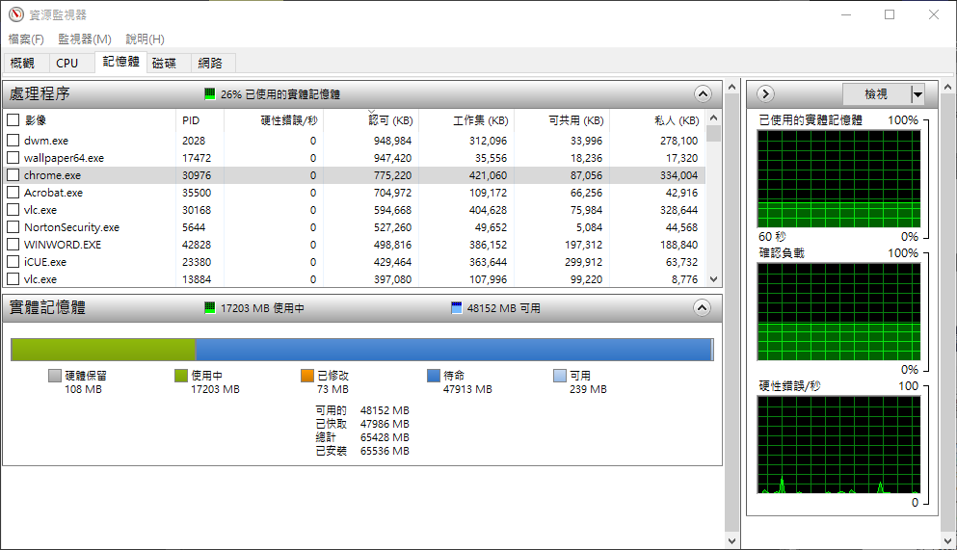

**Fig 11:** Resource Monitor – Memory as the monitoring parameter

Resource Monitor (Fig 11) is utility created by Microsoft to allow users to monitor the resource used by program and systems in a detailed graph for example CPU usage, memory usage, disk I/O and network usage. In this study case, we will focus on memory.

**How to access Resource Monitor?**

By open Task Manager first, then go to the Performance Tab, click Performance Monitor at the bottom and open it. Or by pressing the Windows Key + X, then Computer Management, double click Performance and click Open Resource Monitor. Or by pressing the Windows Key + R to open the Run Box, then search for “resmon”. User either use Windows search to search for “resmon” or open resmon.exe directly via File Explorer with path “\System32\ resmon.exe”. Above methods can all access the Performance Monitor. To add memory as the monitoring parameter, the user click memory as the parameter on the bar.

**What information is provided by Resource Monitor?**

Similar to Performance Monitor, Resource Monitor can display the memory situation on a table and on a bar. The real-time bar is a bar the total physical memory installed as the length and how much physical memory is Hardware Reserved, In Use, Modified, Standby and Free. With detailed number below stated how much of the physical memory are available, cached and installed (64 GB in this case).

Process are listed in a table with their .exe file name, with their Process ID as PID, Commit as the amount of virtual memory reserved by Windows for the particulate process, Woking Set as the amount of physical memory the process is using in real-time, Sharable as the amount of physical memory the process is using and can be shared with other process, Private as the amount of physical memory that can not be shared with other process and the process is currently in use.

If a user right clicks on a process, it will show up a menu which include Analyse wait chain. Its functions are as same as mentioned in the Task Manager’s Details Tab.

**What operations can be performed with Resource Monitor?**

If a user right clicks on a process, it will show up a menu which include End Tasks which terminate a process, End process tree which terminate the process with all its child process and the process created by this process. Their functions are as same as mentioned in the Task Manager’s Details Tab. Other than that, in Resource Monitor can click Suspend Process to pause a running process, and Resume Process to unpause a paused process.

**What are the OS concepts related to the utilities?**

Task Manager is related to process handling, while Performance Monitor focusing on memory paging and segmentation with Resource Monitor focusing on physical memory utilization and process.

**Reference:**

Brinkmann, M. (2017, December 28). *A detailed Windows Resource Monitor guide*. Ghacks. https://www.ghacks.net/2017/12/28/a-detailed-windows-resource-monitor-guide/

Dunning, Z. (2018, August 23). *Pages Per Second Counters*. Power Admin. https://www.poweradmin.com/blog/pages-per-second-counters/

Glenn, W. (2020, August 28). *Seven Ways to Open the Windows Task Manager*. How-To Geek. https://www.howtogeek.com/66622/stupid-geek-tricks-6-ways-to-open-windows-task-manager/

Goedtel, M. (2018, August 22). *Memory pages per second*. Microsoft Docs. https://docs.microsoft.com/en-us/azure/monitoring/infrastructure-health/vmhealth-windows/winserver-memory-pagespersec

Hoffman, C. (2020, August 21). *Windows Task Manager: The Complete Guide*. How-To Geek. https://www.howtogeek.com/405806/windows-task-manager-the-complete-guide/

iSunshare. (n.d.-a). *5 Ways to Open Performance Monitor on Windows 10*. Retrieved April 26, 2021, from https://www.isunshare.com/windows-10/5-ways-to-open-performance-monitor-on-windows-10.html

iSunshare. (n.d.-b). *7 Ways to Access Resource Monitor in Windows 10*. Retrieved April 26, 2021, from https://www.isunshare.com/windows-10/7-ways-to-access-resource-monitor-in-windows-10.html

Manes, C. (2016, August 4). *How to get the most out of Resource Monitor in Windows 10*. GFI Software‘s Blog. https://techtalk.gfi.com/how-to-get-the-most-out-of-resource-monitor-in-windows-10/

Marcho, C. (2019a, March 15). *The Basics of Page Faults*. Microsoft. https://techcommunity.microsoft.com/t5/ask-the-performance-team/the-basics-of-page-faults/ba-p/373120

Marcho, C. (2019b, March 16). *Windows Performance Monitor Overview*. Microsoft. https://techcommunity.microsoft.com/t5/ask-the-performance-team/windows-performance-monitor-overview/ba-p/375481