**CS4335 Assignment 1 Deadline: 11:59 a.m., Thursday, 21st, Oct, 2021**

**（NOTE: Late submission will not be processed）**

**Question 1: (40 points)** For the interval scheduling problem, given jobs (s, f) :

(0, 4), (2, 5), (5, 7), (4, 7), (6, 7), (4, 6), (6, 8), (9, 12), find a maximum subset of mutually compatible jobs.

**Question 2: (45 points)** Consider the following graph.

5

4

6

5

9

4

2

5

4

2

4

8

2

1

3

8

1

3

2

7

1

Use Prim’s algorithm to compute a minimum spanning tree (40 marks).

How many minimum spanning trees are in the above graphs, draw all of them (No need to write the process for finding the trees) (5 marks)

**Question 3: (15 points) Words in a tree.**

Given a tree of n nodes, each node in the tree has a depth. The root has depth 0. Now consider n words, each word i has a count fi. We want to store the words into the tree, one word per node such that the total distance will be minimized. The total distance of a storage is calculated as

*f1d1+f2d2+…+fndn,*

where *di* is the node depth for word i

Design an algorithm to solve the problem (5 points). Prove that your algorithm is correct. (10 points)

**e.g.**

Given a tree with six nodes (figure 1) and we want store 6 words, ***I am a primary school student****,* with counts shown as below,

I: 30, am: 26, a: 22, primary: 16, school: 13, student: 6

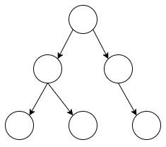

figure 1

There are several ways to store these words. The following are two storage methods with the corresponding distances.

