Student name: Student ID

Week 3: In-Lecture Exercise:

Given the following graph and the weights of their edge

[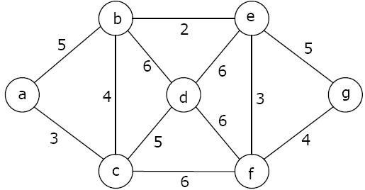](http://www.google.co.uk/url?sa=i&rct=j&q=&esrc=s&source=images&cd=&cad=rja&uact=8&ved=0ahUKEwi7u53B5q3WAhWDlZQKHWYCAlUQjRwIBw&url=http://www.geeksforgeeks.org/algorithms-gq/graph-minimum-spanning-tree-gq/&psig=AFQjCNF_oc1c5Lcp2o76C_6VlvWUSizQbg&ust=1505792006503290)

Use Kruskal’s algorithm (basic one) to find a MST.

**Solution**: