Lab 2 EE2005 Week 4

|  |  |  |
| --- | --- | --- |
| Name: | Lab Session: L01 | TA: |
| Score: | /10 |  |

**Task 1**

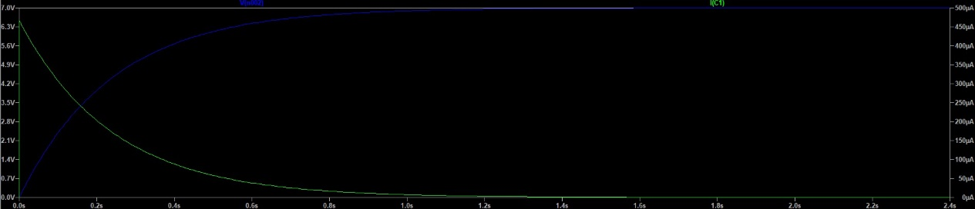

|  |  |  |
| --- | --- | --- |
|  |  |  |
|  |  |  |
|  |  |  |
|  |  |  |
|  |  |  |

|  |  |  |
| --- | --- | --- |
|  |  |  |
|  |  |  |
|  |  |  |
|  |  |  |
|  |  |  |

**How are the voltage and current affected by the resistance and capacitance values of the RC circuit?**

AS $τ=RC$, $τ$ remain unchanged, which we can see that $V_{C}/V_{0}=V_{C}/9V$, so the voltage and current only affected by the input voltage.

**Task 2**



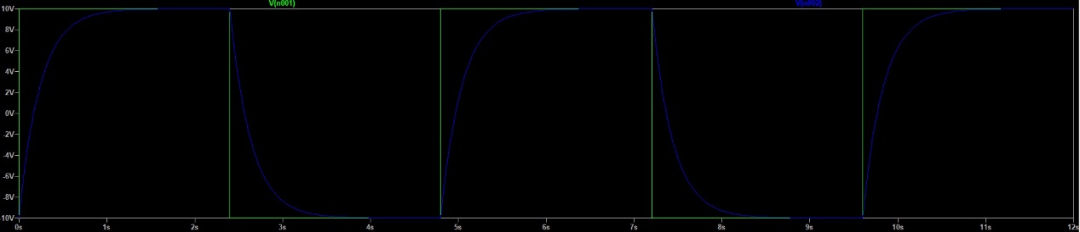



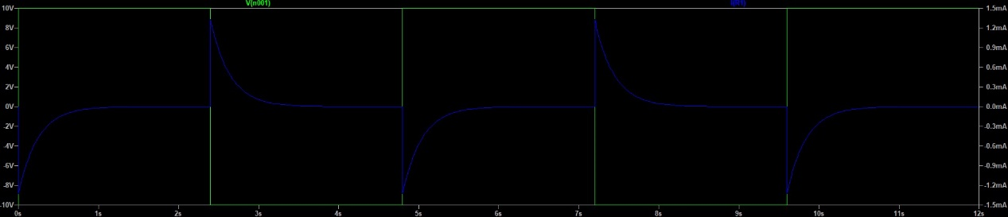



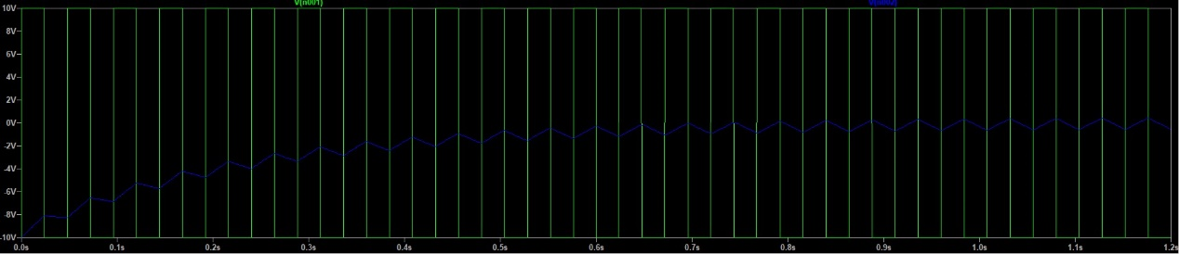



When the $V_{s}(t)$ change from -10V to 10V, $V_{c}(t)$ will change from -10V to 10V exponentially for 2.4s.

When the $V_{s}(t)$ change from 10V to -10V, $V_{c}(t)$ will change from 10V to -10V exponentially for 2.4s.

When the $V_{s}(t)$ change from -10V to 10V, $i_{R}(t)$ will change from -1.5mA to 0A exponentially for 2.4s.

When the $V_{s}(t)$ change from 10V to -10V, $i_{R}(t)$ will change from 1.5mA to 0A exponentially for 2.4s.

Thus, we can notice that the voltage of the charger and the current of the resistor are affected by the source voltage and its time period.

**Task 3**

$$V_{0}=7V$$

$$R=15KΩ$$

$$τ_{0}=\frac{L}{R}=\frac{1}{150000}=6.67µs$$

|  |  |  |  |  |
| --- | --- | --- | --- | --- |
| $$t (s)$$ | $$V_{L} (V)$$ | $$i_{R} (A)$$ | $$Calculated V_{R} (V)$$ | $$V_{L}+V_{R} (V)$$ |
| $$0$$ | $$7V$$ | $$70pA$$ | $$70pA×15KΩ \\ =1.05µV$$ | $$7.0000V$$ |
| $$τ_{0}=6.67µs$$ | $$2.5761V$$ | $$295.26µA$$ | $$295.26µA×15KΩ \\ =4.4290V$$ | $$7.0051V$$ |
| $${3τ}_{0}=20µs$$ | $$348.01mV$$ | $$443.47µA$$ | $$443.47µA×15KΩ \\ =6.6252V$$ | $$7.0001V$$ |
| $${5τ}_{0}=33.3µs$$ | $$47.055mV$$ | $$463.53µA$$ | $$463.53µA×15KΩ \\ =6.9529V$$ | $$7.0000V$$ |

**Is KVL satisfied in this circuit at all time?**

Yes, as $V_{L}+V_{R}≈V_{0}$ with $error=\frac{7.0051-7}{7}=0.000728$ which the result can be consider as the KVL is still satisfied.