**EE2005 Lab Report**

**Operational Amplifier**

**Lab Section: L02**

**Abstract**

1. **Description of Components**

**1.1 Operational Amplifier (op amp)**

We use the 741 op-amp in this lap. According to Texas Instruments [1], this op-amp offers lots of features as well as prevent overload on the input and output. It can provide an open-loop amplifier mode and closed-loop amplifier mode.

**1.2 pin configuration**

According to Texas Instruments[1], 741 op amp’s pin1 is an offset null. Pin 2 is an inverting input. Pin 3 is a noninverting input. Pin 4 is the negative supply voltage. Pin 5 is offset null. Pin 6 is an Amplified signal output. Pin 7 is the positive supply voltage. Pin 8 is the left floating pin.

1. **Analysis of the Circuit**

**2.1 Inverting Amplifier**

Our op amp’s output connected back to the input. We use closed-loop gain to conduct the lap. Different from open-loop gain, the closed-loop gain can output the voltage stably. In this experiment, we connected the inverting pin to test the inverting voltage. Depends on the formula Vo = R2/R1*Vi, therefore I chose 5k ohms and 20k ohms to fulfill the experiment requirement (gain of about 4). The maximum voltage of the op-amp depends on the supply voltages so the maximum and minimum voltage is between -5V and 5V. Saturation will happen when I input more than 1.25V (5/4) or less than -1.25V.

**2.2 Digital-to-Analog Converter (DAC)**

We use a 4-channel SPST switch and op-amp (inverting input) to build a DAC. It provides 2^4 = 16 combinations to fulfill different situations.

**2.3 DAC with Comparator Output**

Depends on parts 2.2, I add one more op-amp(non-inverting input) to build a comparator output. I set the reference voltage is 1V. Therefore, if my input combination of DAC reaches or exceeds 1-0-0-0. The LED will be lit.

1. **Experimental Results**

**3.1 Inverting Amplifier**

The result is the same as what I predicted. The maximum and minimum voltage is 5V and -5V respectively.

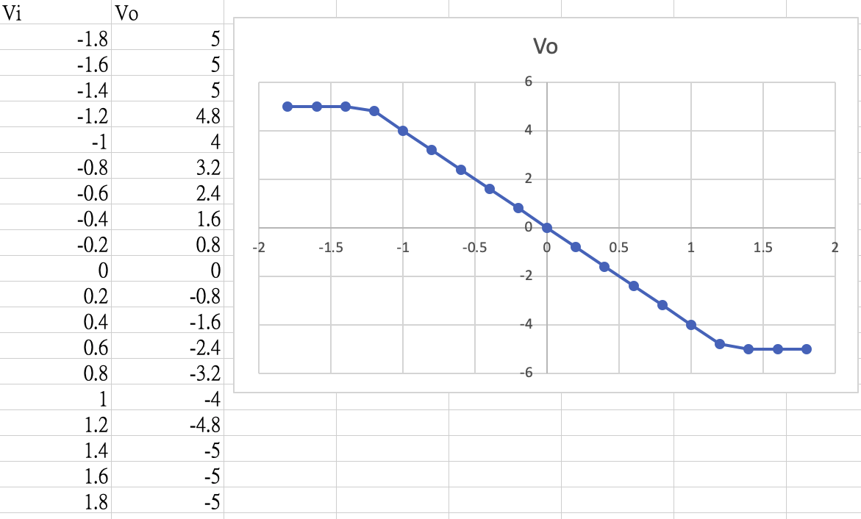

The input and output is a linear relationship and follows the formula Vo = R2/R1*Vi. 4 time gain.

**3.2 Digital-to-Analog Converter (DAC)**

I chose 2k ohms for Rf and R1, 4k ohms for R2, 6k ohms for R3 and 8k ohms for R4.

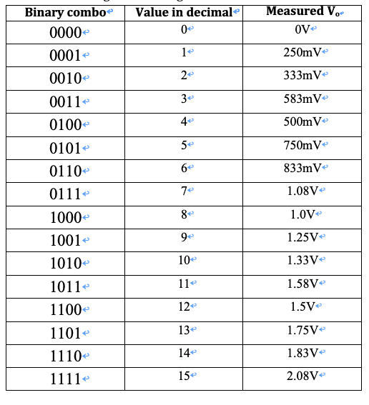

From the table, we can see that the output voltage is different and follows by the combination. We can design different function if the voltage reaches a specific voltage. For example, if the voltage reaches 1.08V, the LED will lit and when the voltage reaches 1.83, the LED will change to red color.

**3.3 DAC with Comparator Output**

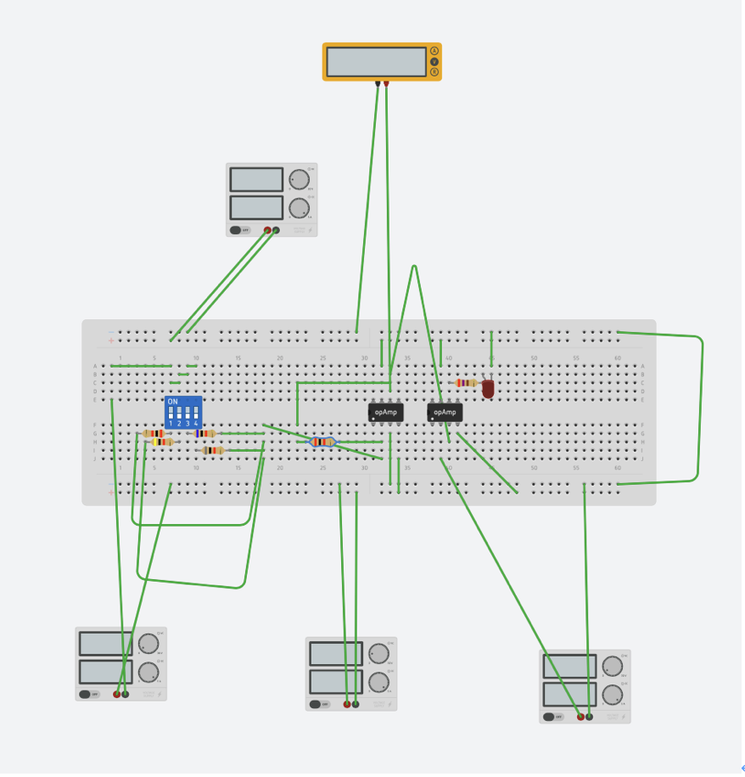

It is the circuit I designed. I set the reference voltage to be 1V. When the combination is reached or exceeds 1-0-0-0. It means the voltage is equal to or more than 1V. The LED will be lit.

1. **Discussion**

Experiment part 1 and part 2, the measured result is not the same as theoretical predictions. Maybe the measured source is not ideal. The resistors have errors. Finally, the result is not the same as theoretical predictions.

Sometimes when my combination reached or exceeds 1-0-0-0 the lights still not lit. I think it maybe has some loss in the wire or resistor from the source to the light. Also, the resistor is not an ideal resistor in real. It will have little error in each resistor. In experiment part 3, I use 6 resistors to form my circuit. If each resistor has little error, the output voltage will different. It is the result that sometimes I input enough voltage but the light still not lit.

1. **Conclusions**

Experiment is totally different with theoretical predictions. If I conduct the experiment next time, I should calculate the error in the experiment. For example, experiment part 3 I found the voltage of 1-0-0-0 combination is 1V then I set the reference voltage of LED is 1V. It is not a good practice. It is because we will have loss in actual experiment. The loss maybe come from wire, source, resistor… Therefore, when we need to design a circuit or device, we need to consider the error.

**References**

Refer to “Examples of reference list entries – IEEE style” on the website below.

http://libguides.library.cityu.edu.hk/citing/ieee

[1] TEXAS INSTRUMENTS LM741 Operation Amplifier (2015, October). ***T****exas****I****nstrument.* Available: https://www.ti.com/lit/ds/symlink/lm741.pdf