**AST10401 Introduction to Electrical Engineering**

**Assignment 1 Solution (Due: 26 October 2018, 4:30PM)**

**Section A (80 marks)**

1. Use nodal analysis to find Vo and the power of the 40V voltage source in circuit below.

(8 marks)

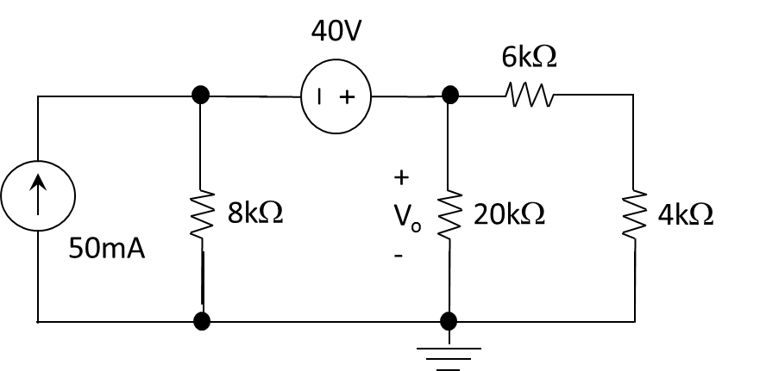

b

a



1. Use mesh analysis, determine the mesh currents i1 and i2 and the power of the 3A current source in the circuit shown below.

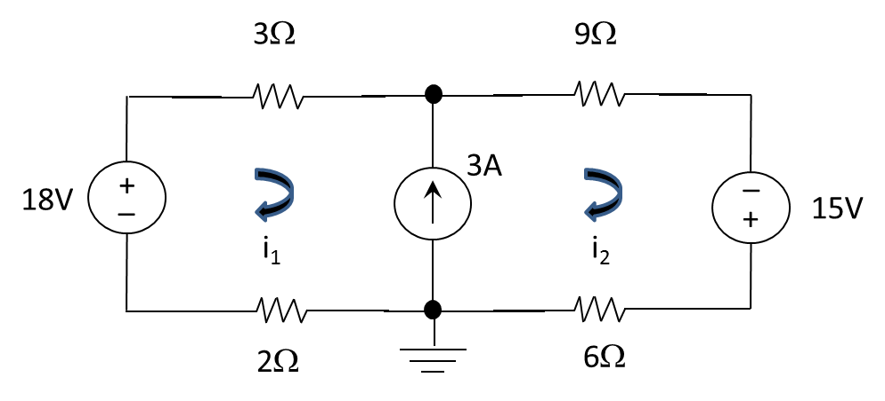

(8 marks)



1. Determine the voltage across the 10k resistor Vx, below.

(8 marks)

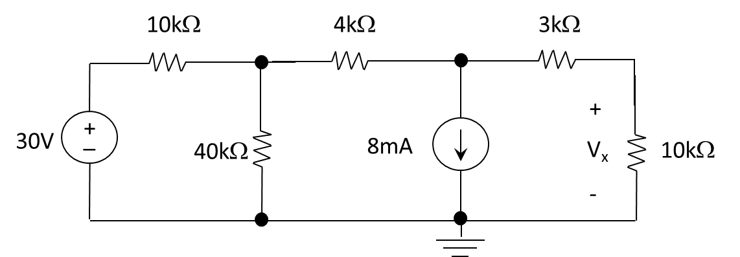



1. Consider the circuit shown below, use nodal voltage analysis to determine the voltages at node X and Y and the power of the 6 resistor.

(8 marks)

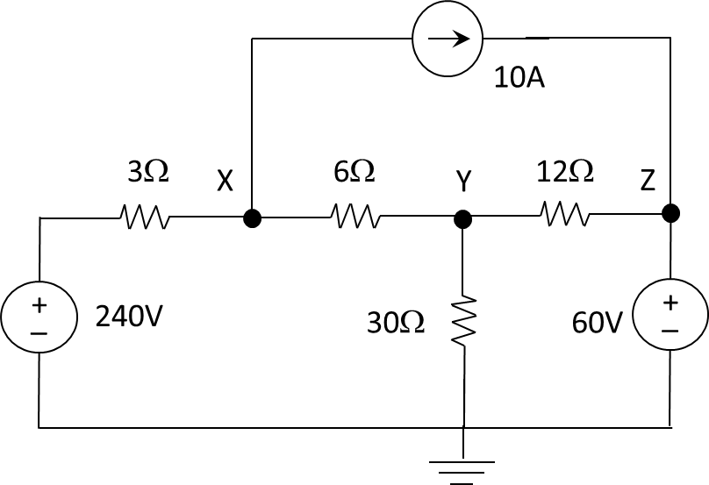



1. Consider the circuit shown below. Use nodal voltage analysis to find v1 and v2.

(8 marks)

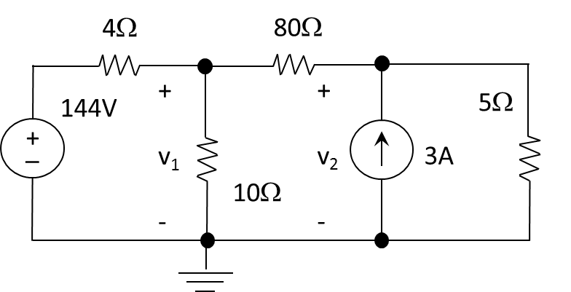

Sol:



1. Determine the mesh currents i1, i2 and the power of the 15 resistor in the circuit below.

(8 marks)

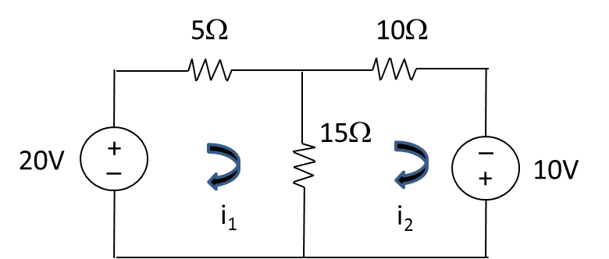



1. Apply **Superposition** to find the voltage Vx below.

(10 marks)

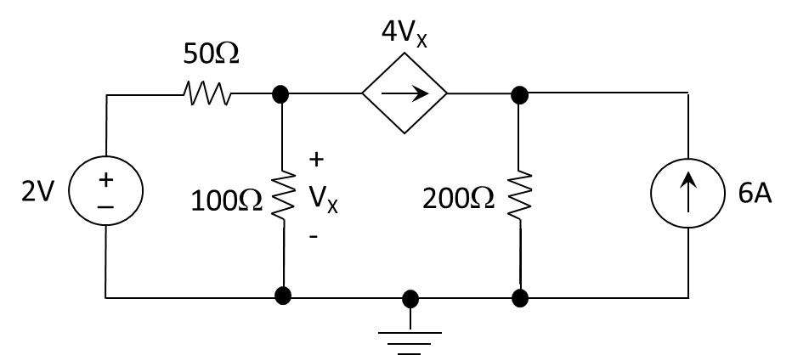



1. Use the superposition principle to find *i*o and *v*o in the circuit below.

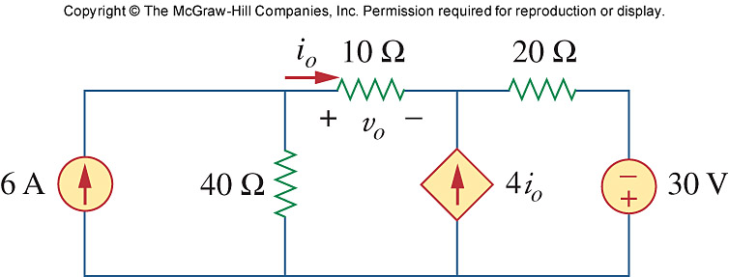

(14 marks)

Sol:

Let vo = v1 + v2, where v1 and v2 are due to the 6-A and 80-V sources respectively. To find v1, consider the circuit below

40 Ω

6 A

+

_

4 i1

V1

10 Ω

20 Ω

I1

va

Vb

At node a,

 (1)

At node b,

–I1 – 4I1 + (vb – 0)/20 = 0 or vb = 100I1

But  which leads to vb = 10(va - vb ) or vb = 0.9091va (2)

Substituting (2) into (1),

5va – 3.636va = 240 or va = 175.95 and vb = 159.96

However, v1 = va – vb = 15.99 V.

To find v2, consider the circuit below.

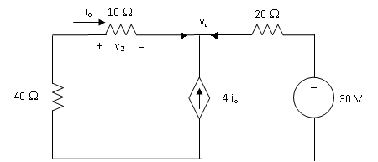



But 







vo = v1 + v2 =15.99 + 2 = **17.99 V** and io = vo/10= **1.799 A**.

1. By source transformation and nodal analysis, determine *ix* in the circuit below.

(8 marks)

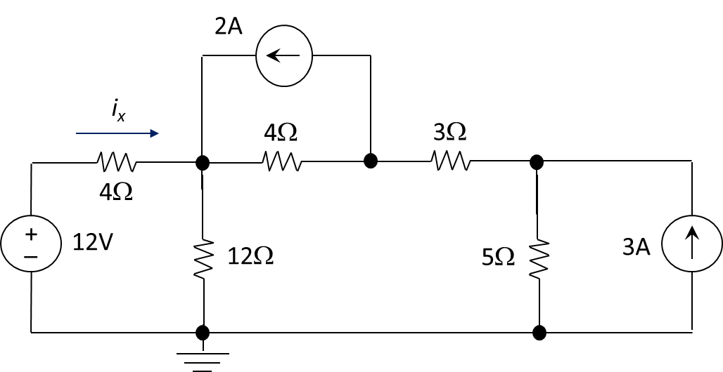

By source transformation,



**Section B (108 marks)**

1. Use mesh analysis to find ***i*1**, ***i*2**, and ***i*3** in the following circuit.

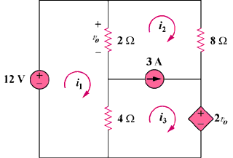

(12 marks)

Sol:

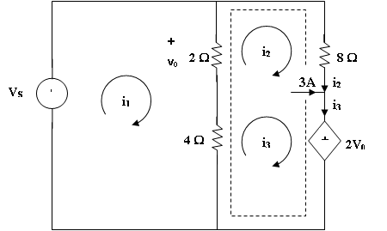

For mesh 1,

2(i1 – i2) + 4(i1 – i3) – 12 = 0 which leads to 3i1 – i2 – 2i3 = 6 (1)

For the supermesh, 2(i2 – i1) + 8i2 + 2v0 + 4(i3 – i1) = 0

But v0 = 2(i1 – i2) which leads to -i1 + 3i2 + 2i3 = 0 (2)

For the independent current source, i3 = 3 + i2 (3)

Solving (1), (2), and (3), we obtain,

i1 = **3.5 A**, i2 = **-0.5 A**, i3 = **2.5 A**.

1. Use superposition to find ix shown in the following circuit.

(12 marks)

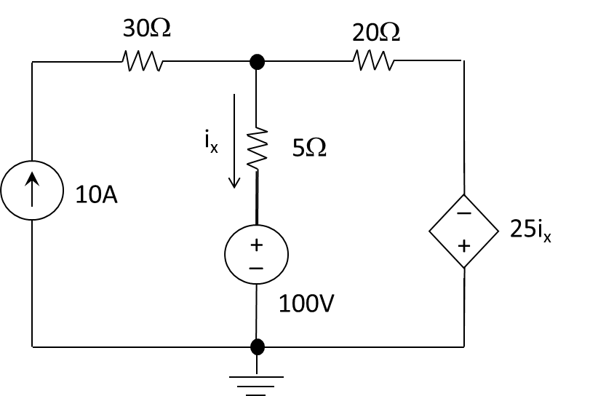

a

Turn off 100V



Turn off 10A



1. Find the Thevenin equivalent of the following circuit to the left of the terminals A-B.

(15 marks)

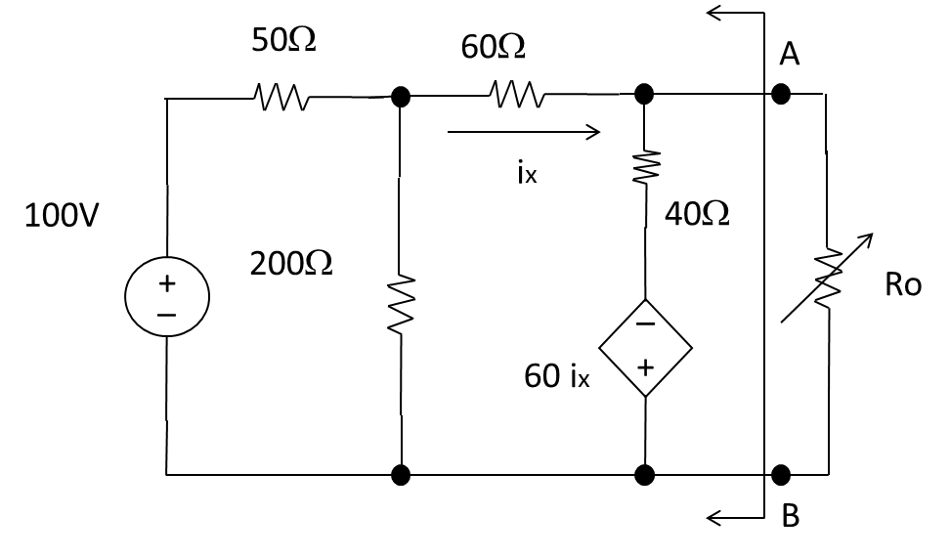

After a couple of source transformations the circuit can be simplify to





The Thevenin resistance can be found by apply a test source:





Or



1. Find the maximum power transfer to Ro

(3 marks)



1. The variable resistor (Ro) is adjusted until the power dissipated in Ro is 1.5W. Find the values of Ro that satisfy this condition

(5 marks)





Consider the following circuit.

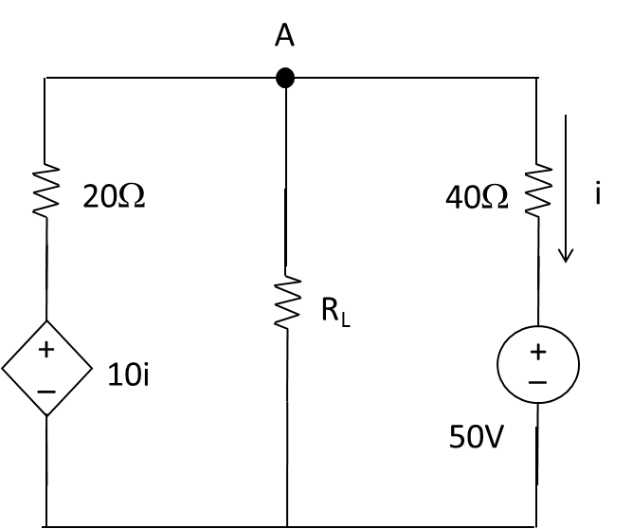

1. Determine the value of RL such that the resistance would receive a maximum power transfer.

(8 marks)

Apply a 1V test source to find the Thevenin resistance.

The current through 40 = 1/40 = 0.025A

The current through 20 = (1 - 10(0.025))/20 = 0.0375A

The current generated by the 1V test source = 0.0625A

The Thevenin resistance RTh = 1/0.0625 = 16

1. For the result in (a), calculate the maximum power transfer to RL.

(8 marks)



(VTh – 10i1)/20 + (VTh – 50)/40 = 0

i1 = (VTh – 50)/40

VTh /20 – (VTh – 50)/80 + (VTh – 50)/40

VTh = 10V

Maximum power transfer to RL = (VTh)2/(4RTh) = 1.5625W

1. Suppose a 30V voltage source is added between node A and 40 resistor so that node A is connected to the positive terminal of the source. With your answers to (a) and (b), determine the value of RL such that the resistance would receive a maximum power transfer and also determine the maximum power transfer to that RL. Note that no mark will be given if you fail to use your answers to (a) and (b).

(6 marks)

It is equivalent to say the 50V voltage source change to 80V

It means the voltage source is scaled up by 80/50 = 1.6 times

The new Thevenin voltage = 1.6 VTh = 1.6(10) = 16V

The RTh remains unchanged = 16  

Maximum power transfer to RL = (1.6VTh)2/(4RTh) = (1.6)21.526 = 4W

Consider the circuit shown below.

y

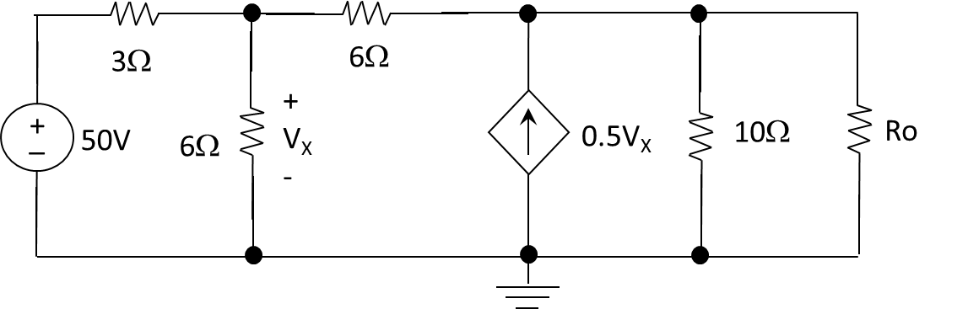

1. Find Ro such that the resistor receives the maximum power transfer in the circuit. Also determine the maximum power transfer to the resistor Ro.



(12 marks)

Find Thevenin voltage



Find Thevenin resistance (replacing Ro by 1V source)



When Ro = RTh = 10, the resistor receives the maximum power transfer from the circuit

The Max Power of the resistor = (VTh)2/(4RTh) = 694.44W.

1. If we replace Ro by a short wire, determine the current in the short wire.

(4 marks)

By Thevenin theorem, it is simply a circuit with Thevenin voltage and Thevenin resistor connect in a single loop.

So the current of the short wire is Vth / Rth = (500/3)/10 = 16.67A

1. Consider the circuit with nodes A and B as its two terminals shown below.

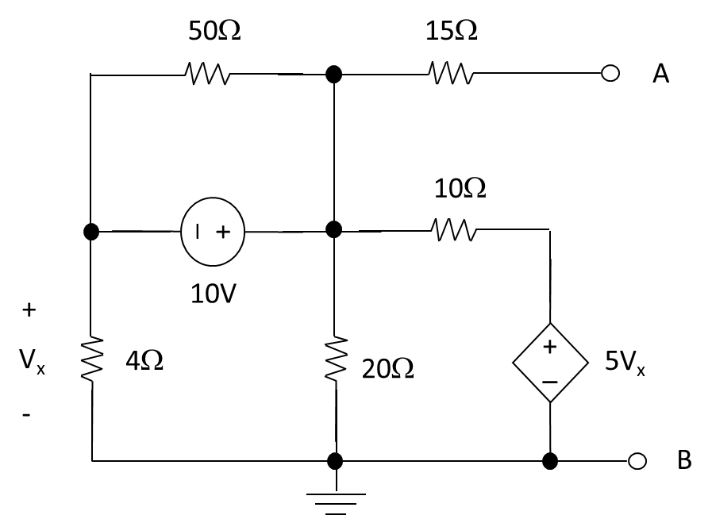

* 1. Find the Thevenin voltage of the circuit.

(6 marks)



* 1. Find the Thevenin resistance of the circuit.

(6 marks)



* 1. If we connect a resistor Ro between nodes A and B, find the resistance of Ro such that Ro will receive the maximum power transferred from the circuit. Also determine the maximum power received by Ro when it is connected to the circuit.

(3 marks)



* 1. Now we remove the resistor Ro in (c) and connect an unknown device X between nodes A and B. Given that the power of X is +2W, determine the voltage across nodes A and B (i.e. the voltage across X).

(5 marks)



* 1. With the same settings in (d), determine the voltage across nodes A and B (i.e. the voltage across X) if the 10V voltage source in circuit replaced by a 2.8V voltage source.

(5 marks)

