**AST10401 Introduction to Electrical Engineering**

**Tutorial 10 Solution**

1. Find the output voltage *vo*(*t*) for t ≥ 0 in the circuit below.

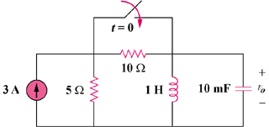

Sol:

At t = 0-, we obtain, iL(0) = 3x5/(10 + 5) = 1A

and vo(0) = 0.

For t >= 0, the 10-ohm resistor is short-circuited and we have a parallel RLC circuit with a step input.

* = 1/(2RC) = (1)/(2x5x0.01) = 10

ωo = 1/ = 1/ = 10

Since α = ωo, we have a critically damped response.

Thus, i(t) = Is + [(A + Bt)e-10t], Is = 3

i(0) = 1 = 3 + A or A = -2

vo = Ldi/dt = [Be-10t] + [-10(A + Bt)e-10t]

vo(0) = 0 = B – 10A or B = -20

Thus, vo(t) = **(200te-10t) V**

1. Find *v*(*t*) for *t* ≥ 0 in the circuit below.

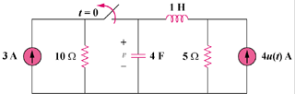

Sol:

We may transform the current sources to voltage sources. For t = 0-, the equivalent circuit is shown in Figure (a). It is now in standard form.

#### (a)

##### +

##### v

##### −

#### 10 Ω

### 5 Ω

##### 30V

+

−

#### i

#### 4F

#### (b)

##### +

##### v

##### −

##### 20V

+

−

#### i

#### 1 H

#### 5 Ω

i(0) = 30/15 = 2 A, v(0) = 5x30/15 = 10 V

For t >= 0, we have a series RLC circuit, shown in (b).

* = R/(2L) = 5/2 = 2.5

 = 0.5, clearly α > ωo (overdamped response)

s1,2 =  = -4.95, -0.0505

v(t) = Vs + [A1e-4.95t + A2e-0.0505t], Vs = 20.

v(0) = 10 = 20 + A1 + A2 or

A2 = –10 – A1 (1)

i(0) = -2 = Cdv(0)/dt, so dv(0)/dt = -2/4 = -1/2

Hence, -0.5 = -4.95A1 – 0.0505A2 (2)

A1 = 0.20512, A2 = –10.20512

v(t) = **[20 + 0.20512e–4.95t – 10.20512e-0.05t] V**

1. Obtain the inductor current for both *t* < 0 and *t* ≥ 0 in following circuit.

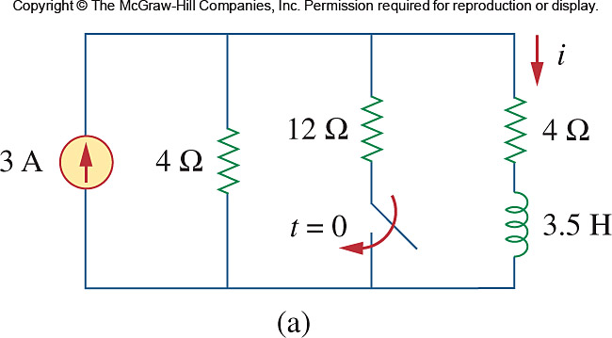

Sol:

Before t = 0, i is obtained by current division or

**1.5A**

After t = 0,



, 



, 





1. Find *v*o(*t*) for *t* ≥ 0 in the following circuit

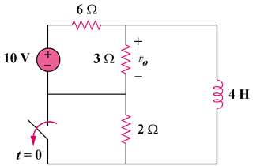

Ans:

Let i be the inductor current.

For t < 0, the inductor acts like a short circuit and the 3 resistor is short-circuited so that the equivalent circuit is shown in Fig. (a).

##### 10

+

#### 6

##### 3

#### i

#### (a)

##### 10

+

#### 2

##### 3

#### i

#### (b)

#### 6

#### v

#### io



For t > 0, , 

To find , consider the circuit in Fig. (b).









 is the voltage across the 4 H inductor and the 2 resistor



