**AST10401 Introduction to Electrical Engineering**

**Tutorial 11 Solution**

Find *v*(*t*) for *t* ≥ 0 in the circuit below.

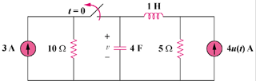

Sol:

We may transform the current sources to voltage sources. For t = 0-, the equivalent circuit is shown in Figure (a).

#### (a)

##### +

##### v

##### −

#### 10 Ω

### 5 Ω

##### 30V

+

−

#### i

#### 4F

#### (b)

##### +

##### v

##### −

##### 20V

+

−

#### i

#### 1 H

#### 5 Ω

i(0) = 30/15 = 2 A, v(0) = 5x30/15 = 10 V

For t >= 0, we have a series RLC circuit, shown in (b).

* = R/(2L) = 5/2 = 2.5

 = 0.5, clearly α > ωo (overdamped response)

s1,2 =  = -4.95, -0.0505

v(t) = Vs + [A1e-4.95t + A2e-0.0505t], Vs = 20.

v(0) = 10 = 20 + A1 + A2 or

A2 = –10 – A1 (1)

i(0) = -2 = Cdv(0)/dt, so dv(0)/dt = -2/4 = -1/2

Hence, -0.5 = -4.95A1 – 0.0505A2 (2)

A1 = 0.20512, A2 = –10.20512

v(t) = **[20 + 0.20512e–4.95t – 10.20512e-0.05t] V**

There are two switches 1 and 2 in the circuit shown below. Switch 1 has been opened and switch 2 has been closed for a long time. At *t* = 0, Switch 1 is closed and switch 2 is opened.

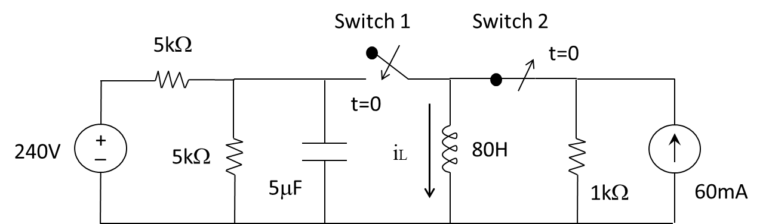

1. Find the inductor current and capacitor voltage at t = 0.



1. Find the inductor current when *t* tends to ∞.



1. Determine the inductor current iL(t) for t ≥ 0















There are two switches in the circuit shown below. When S1 is in position *a*, S2 is closed. When S1 is in position b, S2 is open. S1 has been in position *a* for a long time. At *t* = 0 it moves to position b.

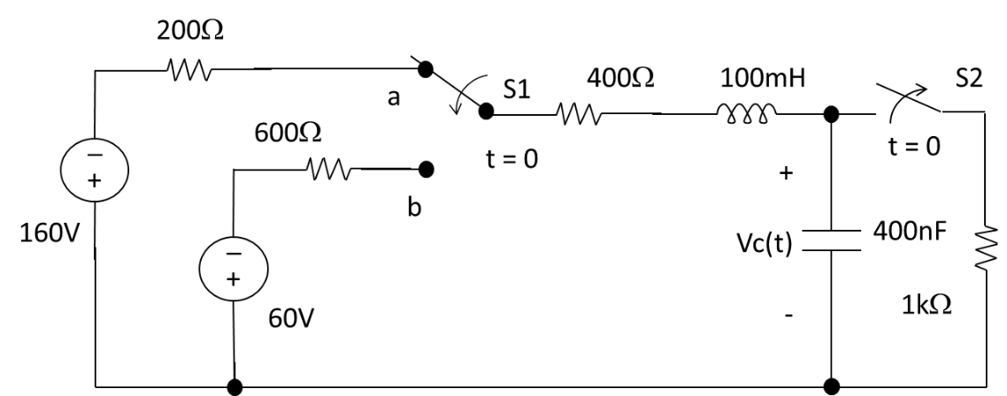

*iL*(*t*)

1. Find *iL*(0) and *VC*(0)

iL(0) = -160/1600 = -100mA

vc(0) = 1000 iL(0) = -100V

1. Find the expression of the capacitor voltage *Vc*(t) for t ≥ 0



1. Determine the expression of the inductor current *iL*(*t*) for t ≥ 0

