**AST10401 Introduction to Electrical Engineering**

**Tutorial 12 Solution**

Q1.

Find the current *i* in the following circuit, when *vs*(t) = 50cos(200t).

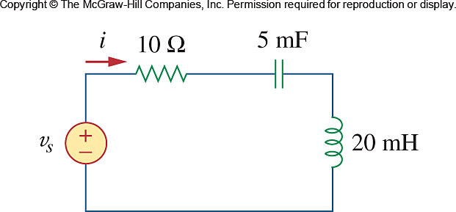



 







Q2.

Find *v*(*t*) in the *RLC* circuit below.

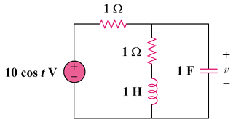

25 cos(t) V

Sol:

,







,



Thus, v(t) = **15.812 cos(t – 18.43) V**

Q3.

Calculate *i*(*t*) in the circuit below.

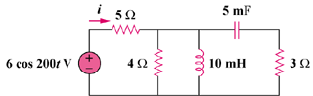

**50cos(200t) V**













Thus, i(t) = **8 cos(200t – 7.96) A**

Q4.

In the circuit below, calculate power absorbed by the resistor and inductor. Find the average power supplied by the voltage source.

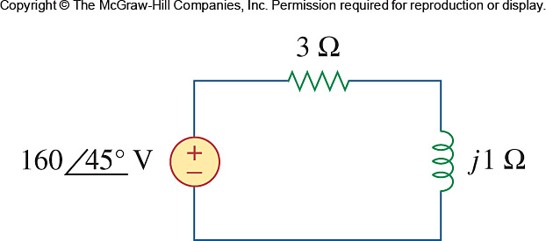

Ans:



