AST10401 Introduction to Electrical Engineering

Tutorial 1 Solution

1. A current of 3.2 A flows through a conductor. Calculate how much charge passes through a cross-section of the conductor in 20 seconds.

Ans: q = it = 3.2 x 20 = 64 C

1. Given that the positive charge below gains 10J when it moves from b to a. Find the potential difference between a and b.



***b***

***a***

+2C

Ans:

q = 2C and Wba = +10J but Vab = Wba / q so Vab = 10/2 = 5V

1. Given that the negative charge below gains 10J when it moves from b to a. If we know that Va = 3V, find Vb.

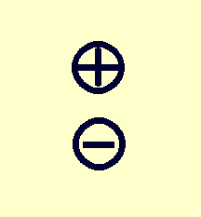

***b***

***a***

-2C

Ans:

q = -2C and Wba = +10J but Vab = Wba / q so Vab = 10/(-2) = -5V now Va = 3V

Vab = Va – Vb so Vb = 8V

1. Find the power absorbed by each element below.

12V

4A

10V

_

+

_

+

2A

Ans:

(a) p= |v||i| = 10(4) = 40W (b) p = -|v||i| = -12 (2) = -24W

1. Calculate the power absorbed or supplied by each element in the following circuit.

4A + 6V –

9V

2

1

+

–

-

–

_



4A

+

3V

–

Ans:

For the 9-V voltage source, p = -4 (9) = **–36 W**

For element 1, p = 4 (6) = **24W**

For element 2, p = 4 (3) = **12W**