AST10401 Introduction to Electrical Engineering

Tutorial 2 Solution

1. Use KCL to find the branch currents *I*1 to *I*4.



Ans:

At node 2, 

At node 1, 

At node 4, 

At node 3, 

Hence,



1. In the circuit below, obtain *v*1, *v*2, and *v*3.

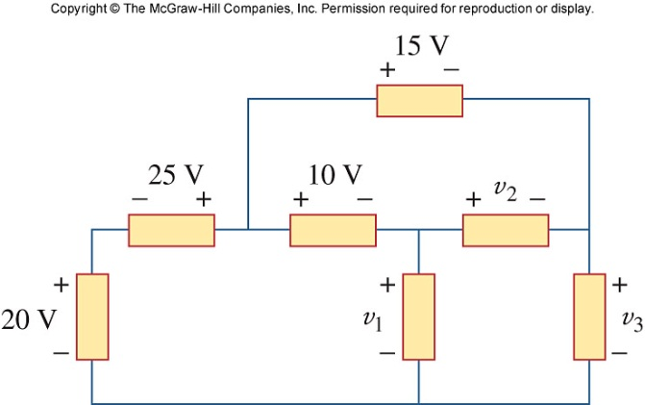

Ans:

# +

# v1

**-**

# + v2 -

# +

# v3

**-**

# – 25v+

# + 10v-

# + 15v-

# +

# 20v

# -

# loop 1

# loop 2

# loop 3

For loop 1, -20 -25 +10 + v1  = 0 **v1 = 35v**

For loop 2, -10 +15 -v2 = 0 **v2 = 5v**

**For loop 3, -v1 +v2 +v3 = 0** v3 = 30v

3) Obtain v1 through v3 in the circuit shown below.

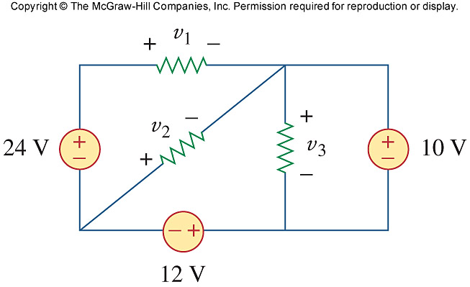

Applying KVL around the entire outside loop we get,

–24 + v1 + 10 + 12 = 0 or v1 = 2V

Applying KVL around the loop containing v2, the 10-volt source, and the 12-volt source we get,

v2 + 10 + 12 = 0 or v2 = –22V

Applying KVL around the loop containing v3 and the 10-volt source we get,

–v3 + 10 = 0 or v3 = 10V

4) From the following circuit, find I, the power dissipated by the resistor, and the power absorbed by each source.

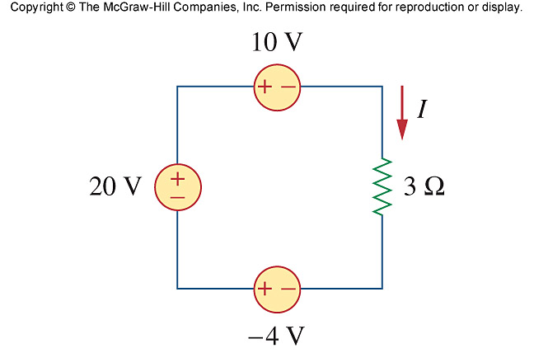

Applying KVL around the loop, we obtain

–20 + 10 + 3i –(–4) = 0 **i = 2A**

Power dissipated by the resistor:

p = i2R = 4(3) = **12W**

Power absorbed by the sources:

p20V = 20 ((–2)) = **–40 W**

p10V = 10 (2) = **20W**

p4V = (–4)(–2) = **8W**

5) Find Vx in the following circuit

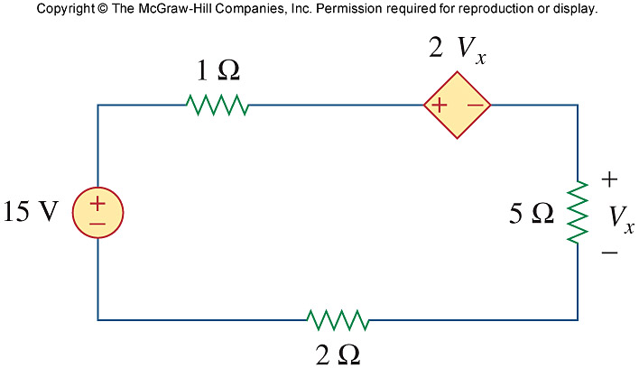

Ans:

Applying KVL,

-15 + (1+5+2)I + 2 Vx = 0

But Vx = 5I,

-15 +8I + 10I =0, I = 5/6

Vx  = 5I = 25/6 = **4.167 V**

6) Find Vo in the circuit below and the power dissipated by the controlled source.

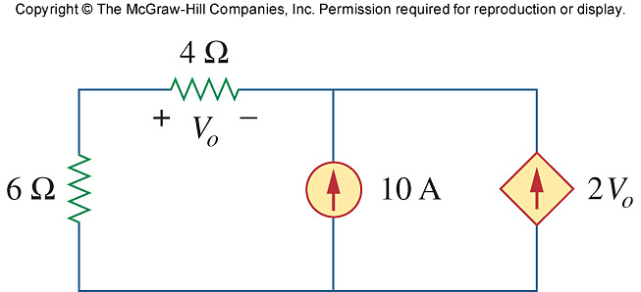

# 4 Ω

# + v0 -

# 10A

# 6 Ω

# 2v0

At the node, KCL requires that

 = 0 v0 =  **–4.444V**

The current through the controlled source is

i = 2V0 = -8.888A

and the voltage across it is

v = (6 + 4) i0 (where i0 = v0/4) = 10

Hence,

p2 vi = (-8.888)(-11.111) = **98.75 W**