**AST10401 Introduction to Electrical Engineering**

**Tutorial 3 Solution**

1. If *R*eq = 50 Ω in the circuit below, find *R*.

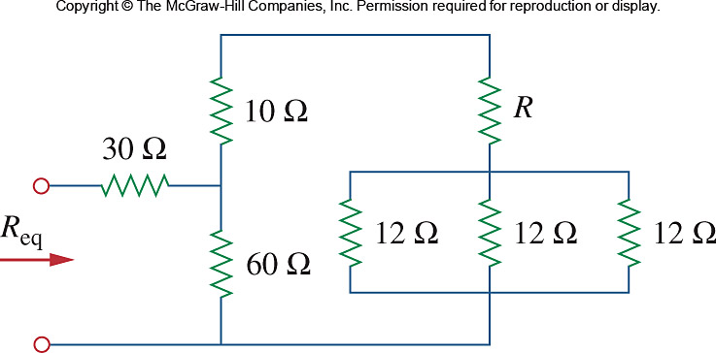

Let R0 = combination of three 12Ω resistors in parallel

 Ro = 4



 74 + R = 42 + 3R

R = **16 Ω**

1. For the circuit below, determine i1 to i5.

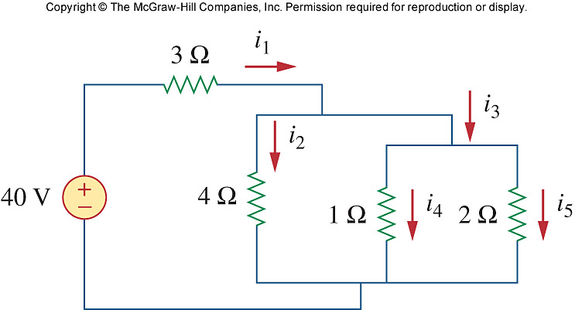









3) For the circuit below, obtain ***v*1** and ***v*2**.

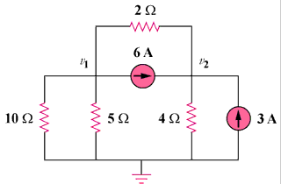

**12 A**

**6 A**

# At node 1,

 120 = - 8v1 + 5v2 (1)

At node 2,

 72 = – 2v1 + 3v2 (2)

Solving (1) and (2),

v1 = **0 V**, v2 = **24 V**

4) Use nodal analysis to obtain ***v0*** in the circuit below.

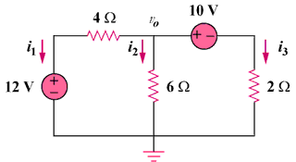

Sol:

**i1 + i2 + i3 = 0 **

v0 = **8.727 V**

5) Use nodal voltage analysis to find the power of 2A current source in the following circuit. Is the current source is supplying source or absorbing source?



Sol:



6) Using nodal analysis, find ***vo*** in the circuit below

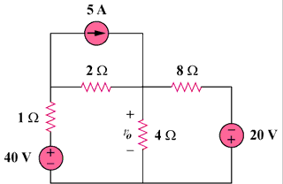

–

**+**

# 40 V

–

**+**

# 20 V

# 8 Ω

# 5 A

# v1

# v0

# 4 Ω

# 2 Ω

# 1 Ω

At node 1,  3v1 - v0 = 70 (1)

At node 0,  4v1 - 7v0 = -20 (2)

Solving (1) and (2), v0 = **20 V**

7) Determine voltages *v*1 through *v*3 in the circuit below using nodal analysis.

0.5

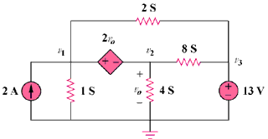

0.125

0.25

1

Sol:

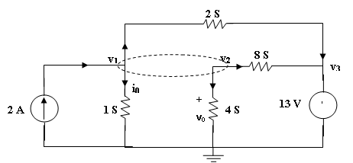

At the supernode,

2 = v1 + 2 (v1 - v3) + 8(v2 – v3) + 4v2, which leads to 2 = 3v1 + 12v2 - 10v3 (1)

But

v1 = v2 + 2v0 and v0 = v2.

Hence

v1 = 3v2 (2)

v3 = 13V (3)

Substituting (2) and (3) with (1) gives,

v1 = **18.858 V**, v2 = **6.286 V**, v3 = **13 V**