**AST10401 Introduction to Electrical Engineering**

**Tutorial 4 Solution**

1. Use mesh current analysis to calculate the power associated with each voltage source in the following circuit.



*ic*

*ib*

*ia*

Ans:

Three mesh equations are:





P(40V) = -|40||5.6|=-224W

P(20V) = -|20||0.8|=-16W

1. Use superposition to find *vo* in the following circuit.

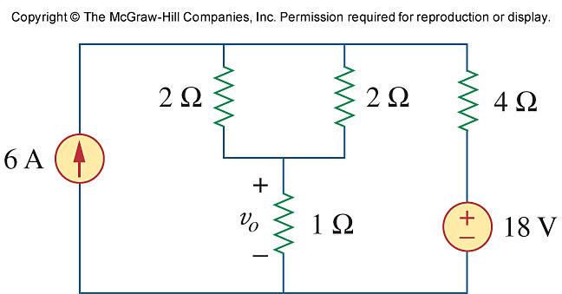

Ans:

Let vo = v1 + v2, where v1 and v2 are due to 6-A and 20-V sources respectively. We find v1 using the circuit below.

1 Ω

4 Ω

+

_

v1

2 Ω

6 A

2 Ω

2//2 = 1 Ω,



We find v2 using the circuit below.

1 Ω

4 Ω

18 V

+

_

v2

2 Ω

+

_

2 Ω



vo = v1 + v2 = 4 + 3 = **7 V**

1. Using superposition, find Vo in the circuit below.

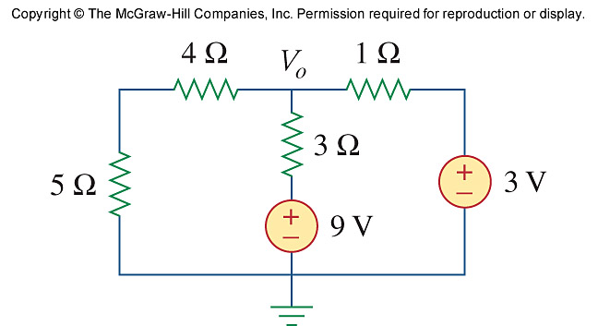

Let Vo = V1 + V2, where V1 and V2 are due to 9-V and 3-V sources respectively. To find V1, consider the circuit below.

+

_

3 Ω

9 V

**V**1

9 Ω

1 Ω



To find V2, consider the circuit below.

3 Ω

3 V

9 Ω

**V**1

+

_



Vo = V1 + V2 = **4.1538 V**

1. Using nodal analysis, find ***v0*** in the following circuit.

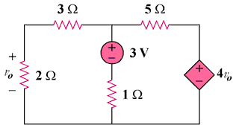

0V

Ans:

–

+

# 3V

**4V0**

**+**

**V0**

**–**

+

–

# 1 Ω

# i1

# 2 Ω

# 3 Ω

# 5 Ω

# i2

# i3

# v1

i1 + i2 + i3 = 0 

But  so that v1 + 5v1 - 15 + v1 - 

or v1 = 15x5/(27) = 2.778 V, therefore vo = 2v1/5 = **1.1111 V**

1. For the bridge network in the circuit, find ***Io*** using mesh analysis.

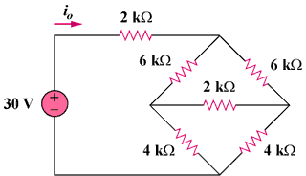

Ans:

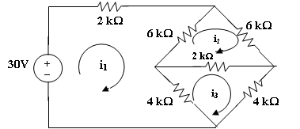

Assume all currents are in mA and apply mesh analysis for mesh 1.

-30 + 2i1+6 i1– 6i2 +4 i1 – 4i3 15 = 6i1 – 3i2 – 2i3 (1)

for mesh 2,

0 = 6i2  + 2i2 – 2i3 + 6i2 - 6i1 0 = -3i1 + 7i2 – i3 (2)

for mesh 3,

0 = 4i3 + 4i3  - 4i1 + 2i3 - 2 i2 0 = -2i1 – i2 + 5i3 (3)

Solving (1), (2), and (3), we obtain,

io = i1 = **4.286 mA**.

1. For the circuit below, find *v*1, *v*2, and *v*3 using nodal analysis. (Hint: consider nodes 1 and 2 as a supernode)

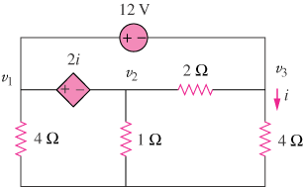

0V

Ans:

Nodes 1 and 2 form a supernode; so do nodes 1 and 3. Hence

 (1)

.

V1 . V2  2 V3

4 1 4

Between nodes 1 and 3,

 (2)

Similarly, between nodes 1 and 2,

 (3)

But . Combining this with (2) and (3) gives

. (4)

Solving (1), (2), and (4) leads to



1. Use mesh analysis to obtain ***io*** in the circuit below: (Hint: identify a supermesh)

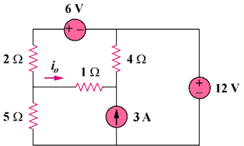

Ans:

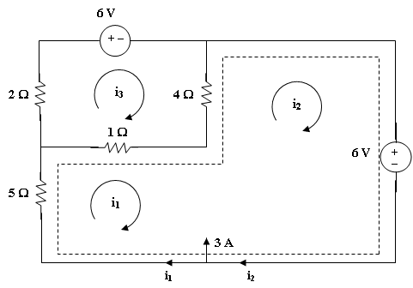

12V

Loop 1 and 2 form a supermesh. For the supermesh,

5i1  + 1i1 - 1i3 + 4i2 - 4 i3  + 12 = 0 (1)

For loop 3, 6 + 4i3 – 4i2 + 1i3 - 1i1 +2 i3 = 0 (2)

Also, i2 = 3 + i1 (3)

Solving (1) to (3), i1 = -3.067, i3 = -1.3333; io = i1 – i3 = **-1.7333 A**

1. Using Mesh Analysis, find ***vo*** and ***io*** in the circuit below.

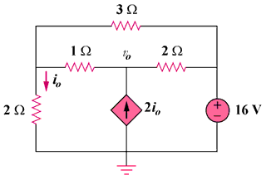

**–**

+

# 1 Ω

# i1

+

**v0 or**

–

+

**v0**

–

# i2

# 2 Ω

# 16V

# 2 Ω

# (b)

# 3 Ω

# i1

# 2 Ω

# i1

# i2

# i3

# 2 Ω

# 1 Ω

**–**

+

# 16 V

# 0

# i2

# 2i0

# (a)

For the supermesh in figure (a),

3i1 + 2i2 – 3i3 + 16 = 0 (1)

At node 0, i2 – i1 = 2i0 and i0 = -i1 which leads to i2 = -i1 (2)

For loop 3, -i1 –2i2 + 6i3 = 0 which leads to 6i3 = -i1 (3)

Solving (1) to (3), i1 = (-32/3)A, i2 = (32/3)A, i3 = (16/9)A

i0 = -i1 = **10.667 A**, from fig. (b), v0 = i3-3i1 = (16/9) + 32 = **33.78 V**.