**AST10401 Introduction to Electrical Engineering**

**Tutorial 5 solution**

1. Use superposition to find *vx* in the following circuit.

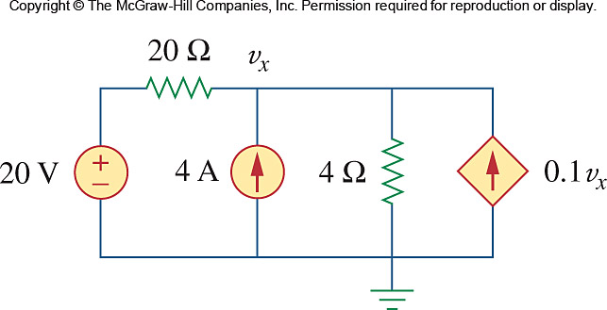





1. Use superposition to find Vo in the circuit below.

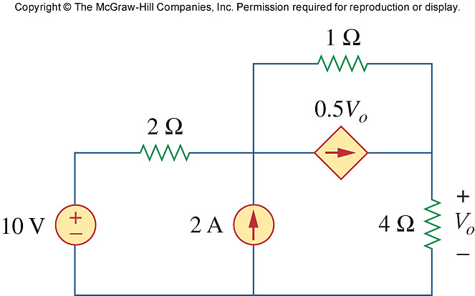

Let Vo = V1 + V2, where V1 and V2 are due to 10-V and 2-A sources respectively. To find V1, we use the circuit below.

10 V

+

_

V1

2 Ω

1 Ω

0.5 V1

+

_

10 V

_

V1

2 Ω

0.5 V1

+

_

- +

1 Ω

+

4 Ω

i

-10 + 7i – 0.5V1 = 0

But V1 = 4i

`

To find V2, we use the circuit below.

2 A

+

_

V2

2 Ω

0.5 V2

4 V

_

V2

2 Ω

0.5 V2

+

_

- +

1 Ω

+

4 Ω

i

1 Ω

4 Ω

- 4 + 7i – 0.5V2 =0

But V2 = 4i



Vo = V1 + V2 = 8 +3.2 =**11.2 V**

1. Find the Thevenin equivalent looking into terminals a-b of the circuit below and solve for *ix*.

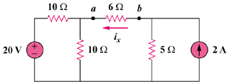

To find RTh, consider the circuit in Fig. (a).

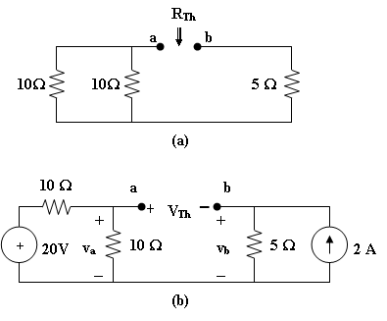

RTh = 10||10 + 5 = 10 ohms

To find VTh, consider the circuit in Fig. (b).

vb = 2(5) = 10 V, va = 20/2 = 10 V

But, -va + VTh + vb = 0, or VTh = va – vb = 0 volts, so ix = 0A

1. Obtain the Thèvenin equivalent circuits of the circuit below with respect to terminals *a* and *b*.

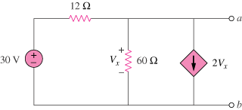

50 V

Ans:

Since VTh = Vab = Vx, we apply KCL at the node a and obtain

 

To find RTh, consider the circuit below.

12 Vx a

2Vx

60

1A

At node a, KCL gives





Thus,

VTh = 1.9841 V, RTh = 476.2 mΩ

1. Determine the Thevenin equivalent at terminals ***a***-***b*** of the circuit below

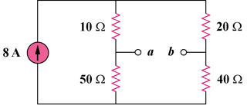

Ans:

RTh = (10 + 20)||(50 + 40) 30||90 = **22.5 ohms**

To find VTh, consider the circuit below

### 40 Ω

#### i1

#### 8A

##### VTh

+

### 20 Ω

### 50 Ω

### 10 Ω

#### i2

i1 = i2 = 8/2 = 4A (current divider), VTh = 50 i1 - 40 i2 = 40V