**AST10401 Introduction to Electrical Engineering**

**Tutorial 6 solution**

1. Find the Norton equivalent of the circuit below.

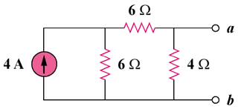

**6A**

For RN, consider the circuit in Fig. (a).

### (b)

### 4 Ω

#### 6 Ω

### 6 Ω

### IN

##### 6A

### (a)

### 4 Ω

#### 6 Ω

### 6 Ω

### RN

RN = (6 + 6)||4 = **3 ohms**

For IN, consider the circuit in Fig. (b). The 4-ohm resistor is shorted so that 6-A current is equally divided between the two 6-ohm resistors. Hence,

IN = 6/2 = **3 A**

1. Given the circuit below, obtain the Norton equivalent as viewed from terminals a-b.

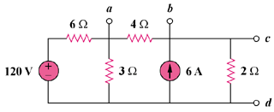

Sol

From the circuit in Fig. (a),

RN = 4||(2 + 6||3) = 4||4 = **2 ohms**

#### 6 Ω

### 2 Ω

#### (a)

### 3 Ω

#### 4 Ω

#### RTh

#### 6 Ω

### 2 Ω

#### (b)

### 3 Ω

#### 4 Ω

#### VTh

#### 6A

+

##### 120V

+

−

For IN or VTh, consider the circuit in Fig. (b). After some source transformations, the circuit becomes that shown in Fig. (c).

#### 2 Ω

#### (c)

#### 4 Ω

#### VTh

+

##### 40V

+

−

##### 12V

+

−

#### 2 Ω

#### i

Applying KVL to the circuit in Fig. (c),

-40 + 8i + 12 = 0 which gives i = 7/2

VTh  = 4i = 14 therefore IN = VTh/RN = 14/2 = **7 A**

1. Find the Norton equivalent at terminals ***a***-***b*** of the circuit below.

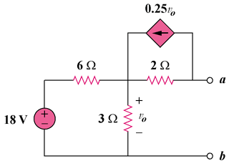

To get RTh, consider the circuit in Fig. (a).

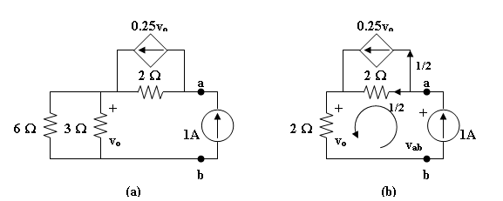

From Fig. (b),

vo = 2x1 = 2V, -vab + 2x(1/2) +vo = 0

vab = 3V

RN = vab/1 = **3 ohms**

To get IN, consider the circuit in Fig. (c).

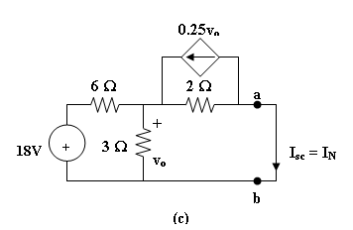

[(18 – vo)/6] + 0.25vo = (vo/2) + (vo/3) or vo = 4V

But, (vo/2) = 0.25vo + IN, which leads to IN = **1 A**

1. Obtain the Norton equivalent at terminals *a-b* of the below circuit.

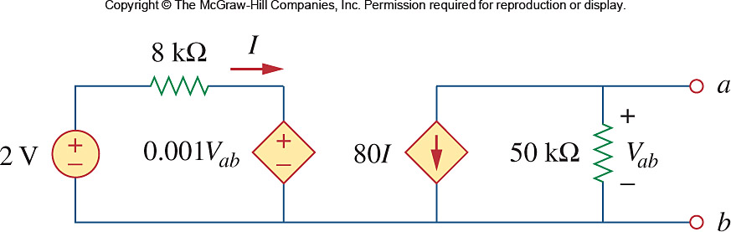

Sol:

To get RN, apply a 1 mA source at the terminals a and b as shown in Fig. (a).

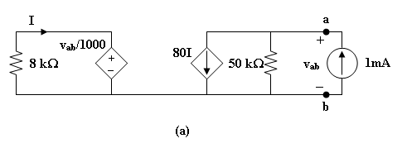

We assume all resistances are in k ohms, all currents in mA, and all voltages in volts. At node a,

(vab/50) + 80I = 1 (1)

Also,

-8I = (vab/1000), or I = -vab/8000 (2)

From (1) and (2), (vab/50) – (80vab/8000) = 1, or vab = 100

RN = vab/1 = **100 k ohms**

To get IN, consider the circuit in Fig. (b).

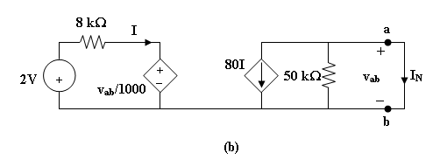

Since the 50-k ohm resistor is shorted,

IN = -80I, vab = 0

Hence, 8i = 2 which leads to I = (1/4) mA

IN = **-20 mA**

1. Referring to following circuit, use source transformation to determine the current and power in the 4-Ω resistor.

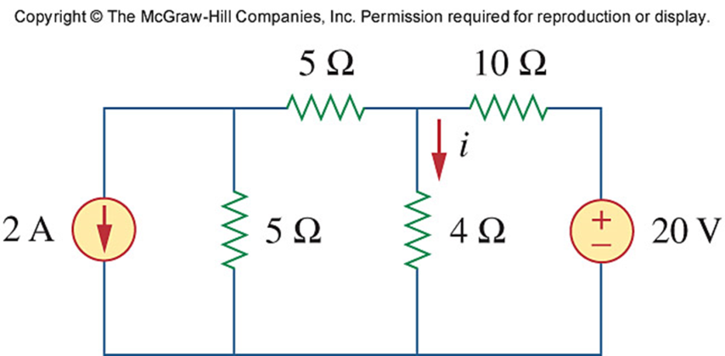

Sol

We transform the two sources to get the circuit shown in Fig. (a).

##### 10V

−

+

### 4 Ω

### 10Ω

### (a)

#### 2A

#### 5 Ω

#### 5 Ω

#### 1A

### 10Ω

#### i

### (b)

#### 2A

### 10Ω

### 4Ω

We now transform only the voltage source to obtain the circuit in Fig. (b).

10||10 = 5 ohms, i = [5/(5 + 4)](2 – 1) = 5/9 = **555.5 mA**

1. Obtain *v*o in the following circuit using source transformation.

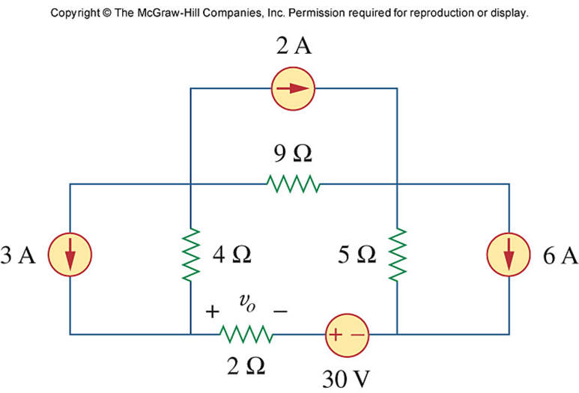

Sol:

Transforming only the current source gives the circuit below.

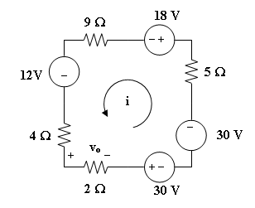

Applying KVL to the loop gives,

–(4 + 9 + 5 + 2)i + 12 – 18 – 30 – 30 = 0

20i = –66 which leads to i = –3.3

vo = 2i = **–6.6 V**

1. For the circuit below, what resistor connected across terminals ***a***-***b*** will absorb maximum power from the circuit? What is that power?

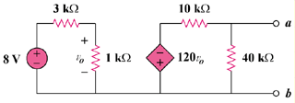

We need RTh and VTh at terminals a and b. To find RTh, we insert a 1-mA source at the terminals a and b as shown below.

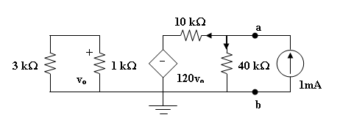

Assume that all resistances are in k ohms, all currents are in mA, and all voltages are in volts. At node a,

1 = (va/40) + [(va + 120vo)/10], or 40 = 5va + 480vo (1)

The loop on the left side has no voltage source. Hence, vo = 0. From (1), va = 8 V.

RTh = va/1 mA = 8 kohms

To get VTh, consider the original circuit. For the left loop,

vo = (1/4)8 = 2 V

For the right loop, vR = VTh = (40/50)(-120vo) = -192

The resistance at the required resistor is

R = RTh = **8 kohms**

p = VTh2/(4RTh) = (-192)2/(4x8x103) = **1.152 watts**

1. Compute the value of ***R*** that results in maximum power transfer to the 10-Ω resistor in the following circuit. Find the maximum power.

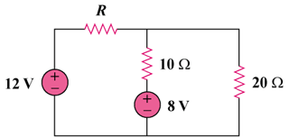

This is a challenging problem in that the load is already specified. This now becomes a "minimize losses" style problem. When a load is specified and internal losses can be adjusted, then the objective becomes, reduce RThev as much as possible, which will result in maximum power transfer to the load.

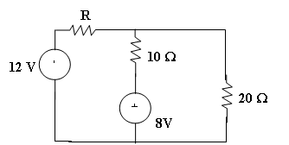

Removing the 10 ohm resistor and solving for the Thevenin Circuit results in:

RTh = (Rx20/(R+20)) and a Voc = VTh = 12x(20/(R +20)) + (-8)

As R goes to zero, RTh goes to zero and VTh goes to 4 volts, which produces the maximum power delivered to the 10-ohm resistor.

P = vi = v2/R = 4x4/10 = 1.6 watts

Notice that if R = 20 ohms which gives an RTh = 10 ohms, then VTh becomes -2 volts and the power delivered to the load becomes 0.1 watts, much less that the 1.6 watts.

It is also interesting to note that the internal losses for the first case are 122/20 = 7.2 watts and for the second case are = to 12 watts. This is a significant difference.