**AST10401 Introduction to Electrical Engineering**

**Tutorial 7 Solution**

1. Suppose we know that the unknown power absorbing device X has the characteristic *Vo* = (*Io*)2. what is *Vo* and *Io*?

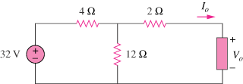

**64 V**

**X**

Sol:

At the terminals of the unknown resistance, we replace the circuit by its Thevenin equivalent.



Thus, the circuit can be replaced by that shown below.

5 Io

+ +

48 V Vo

* -

Applying KVL to the loop,





1. The voltage across a 2mF capacitor is shown below. Find the current waveform of the capacitor.

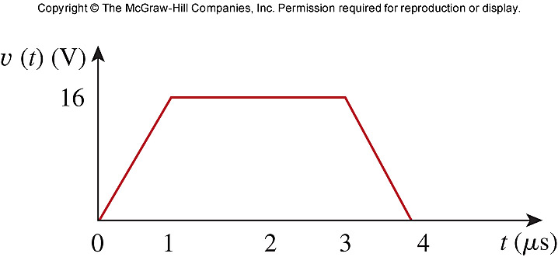

Sol:









1. The current through a 0.5-F capacitor is 6(1-e-t)A. Determine the voltage and power at t = 2s. Assume v(0) = 0.

v(t) =  = 12(t + e-t) – 12

v(2) = 12(2 + e-2) – 12 = **13.624 V**

p = iv = [12 (t + e-t) – 12]6(1-e-t)

p(2) = [12 (2 + e-2) – 12]6(1-e-2) = **70.66 W**

1. Under steady-state dc conditions, find i and v in the circuit below.

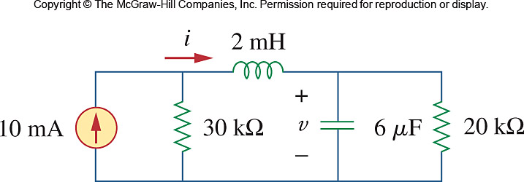

Sol:

i

+

10 mA 30kΩ v 20 kΩ

–

Using current division,

i = [30k/(30k+20k)]10 mA = **6 mA**

v = 20ki = **120 V**

1. Find ***vc***, ***iL***, and the energy stored in the capacitor and inductor in the circuit below under dc, steady-state, conditions.

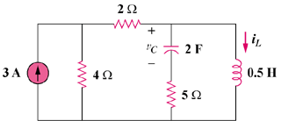

**6 A**

Under dc conditions, the circuit is as shown below:

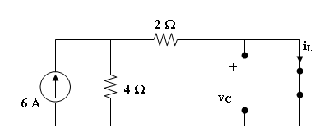

By current division,

**4A**, vc = **0V**

 **4 J**

 **0 J**

1. For the circuit below, calculate the value of R that will make the energy stored in the capacitor the same as that stored in the inductor under dc steady state conditions.

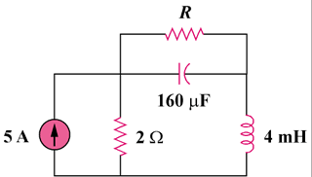

Sol:

# Under dc conditions, the circuit is equivalent to that shown below:

#### R

### 2 Ω

#### iL

#### 5 A

##### + vC −

 





If wc = wL,

 80 x 10-3R2 = 2

R = **5Ω**

1. The switch in the circuit below has been in position A for a long time. At *t* = 0, the switch moves to from position A to B.
2. *i*(0)
3. *v* long after the switch is in position *B*.
4. *i* long after the switch in position B.

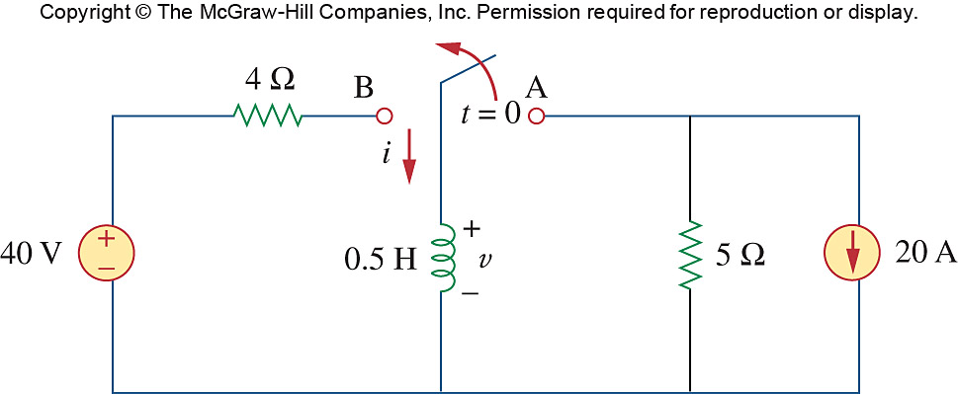

1. At t = 0-, no current flows in 5 all current from 20A source goes to the inductor. So *i* = –20A = *i*(0-). As inductor current cannot change abruptly, *i*(0-) = *i*(0) = -20A.
2. When *t* tends to ∞, the circuit will reach another steady state. At steady state, the inductor can be replaced by a short wire, so the inductor voltage v(∞) = 0V.
3. When *t* tends to ∞, the inductor can be replaced by a short wire. The short circuit current is the final inductor current *i*(∞) = 40/4 = 10A.