**AST10401 Introduction to Electrical Engineering**

**Tutorial 8 Solution**

1. If the switch shown below has been open for a long time and is closed at *t* = 0, find *vo*(*t*) for *t* ≥ 0. (Assume that there is no charge in the capacitor before t = 0).

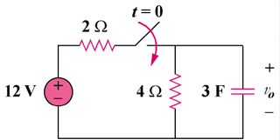

**18 V**

Ans:



,

When t ≥ 0, the circuit is not in standard form RC circuit. We need to find its Thevenin equivalent for determining the time constant.















1. In the circuit shown below, the switch has been closed for a long time and it is opened at t = 0, find v(t) for t ≥ 0

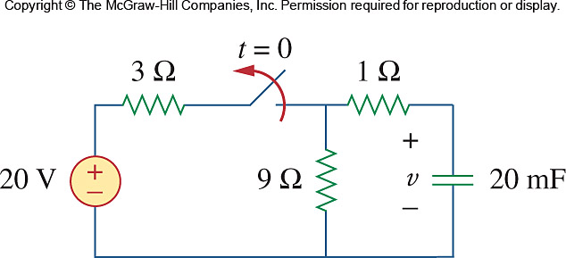

At *t* = 0, the switch is opened and the capacitor is connected to no source. That means its final capacitor voltage *v*(∞) = 0. The RC circuit gives us a Natural Response which is a special case of step response with *v*(∞) = 0. So a Natural Response is given by

$v\left(t\right)=v\left(0\right)e^{-t/τ}$*,* where $τ$ = *RC.*

To find *v*(0), we consider the RC circuit at t = 0- (i.e. before t = 0, the switch is still closed but it is about to open)

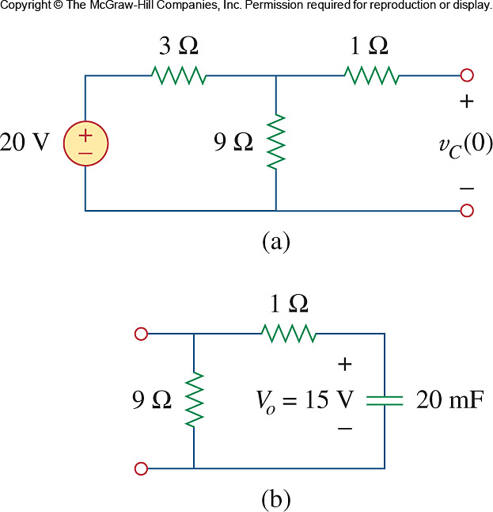

No current flow in 1 so *v*(0-) = the voltage across 9

Voltage across a capacitor cannot change instantly, so

$$v\left(0-\right)=v(0)=15V$$

For t ≥ 0, the switch is opened, the RC circuit connects no source.



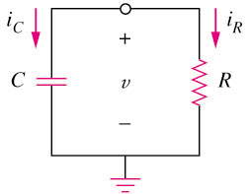

Req

The circuit can be considered as a Standard Form RC circuit with the voltage source off.

So from the point of view of the 20mF capacitor experiences one single resistance Req, it is the sum of 1  and 9. So R in the standard form RC circuit is Req = 10  

So = *Req C =* 10(20m) = 0.2s

The natural response is $v\left(t\right)=v\left(0\right)e^{-t/τ}=15e^{-t/0.2}$ for *t* ≥ 0.

1. The switch in below has been closed for a long time, and it opens at *t* = 0. Find *v*(*t*) for *t* ≥ 0.

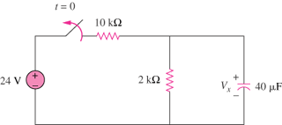

*v(t)*

Sol:



1. The switch shown below moves instantaneously from A to B at t = 0. Find v for t ≥ 0.

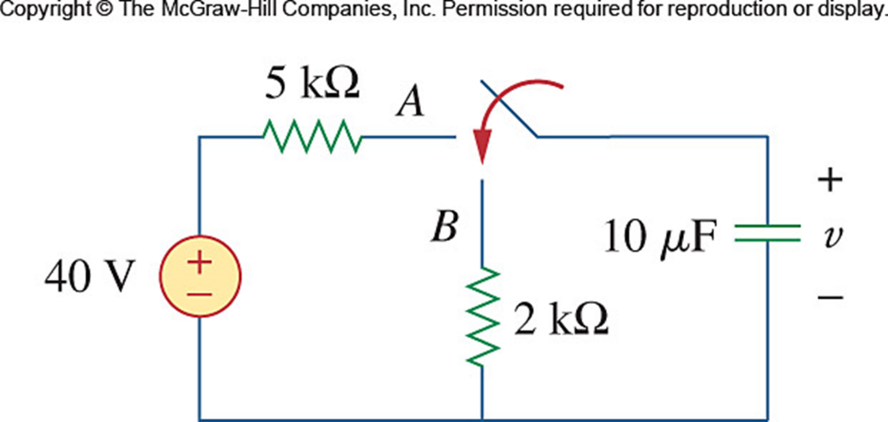

For t < 0, v(0-)=40 V.

For t > 0. we have a source-free RC circuit.





1. The switch in following cirrcuit has been in position *a* for a long time. At t = 0, it moves to

position *b*. Calculate v(t) the voltage across the 2F capacitor for t ≥ 0

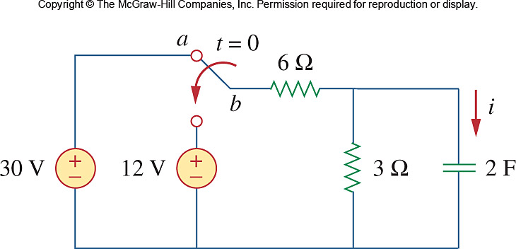

**-**

**+**



Using voltage division,

,



, 



Thus,



1. Calculate the capacitor voltage for *t* < 0 and *t* ≥ 0 for each of the circuits shown below.

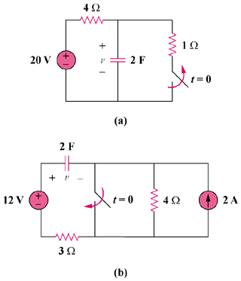

Sol:

1. Before t = 0,



After t = 0,



, , 





1. Before t = 0, , where  is due to the 12-V source and  is due to the 2-A source.



To get , transform the current source as shown in Fig. (a).



Thus,



After t = 0, the circuit becomes that shown in Fig. (b).

+

### 8 V

#### 4

+

#### v2

#### 2 F

#### 3

#### (a)

+

#### 2 F

#### 3

#### (b)

##### 12 V



, , 



