**AST10401 Introduction to Electrical Engineering**

**Tutorial 9 Solution**

1. Find *iL*(t) for t ≥ 0 in the circuit below if the initial current in the inductor is zero. Find the inductor current at t = 0.2ms.



Sol:

*iL*(0-) = *iL*(0) = 0A

*iL*(∞) = 2 (100/(100 + 100)) = 1A

Not in standard form so change the circuit into its Thevenin form:

VTh = 2(100) = 200V and RTh = 100 + 100 = 200

Req = Rth = 200

*iL*(∞) (i.e. a short wire current) = Vth / Rth  = 200/200 = 1A (the same as what we have found above.)

Time constant  = L/Req = 0.05/200 = 0.25ms



= 1 + (0 – 1) e-4000t = 1 – e-4000t

i(0.2m) = 1 – e-4000(0.2m) = 0.5507A

1. For the circuit below, find io for t > 0.

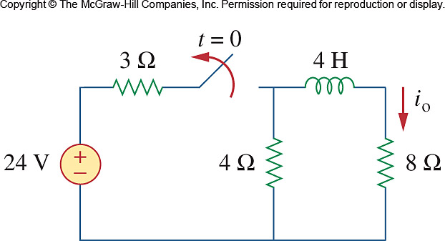

Sol:

For t<0, we have the circuit shown below.

3 Ω 4H

+

_

4 Ω

24 V 8 Ω

4H

io

4 Ω

8 A 3 Ω 8 Ω

3//4= 4x3/7=1.7143

A

For t >0, we have a source-free RL circuit.





1. Obtain the inductor current for both *t* < 0 and *t* ≥ 0 in following circuit.

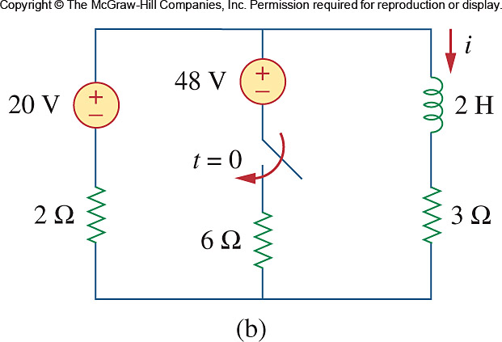

Sol:

Before t = 0,  **4 A**

Find the Thevenin equivalent, after t = 0, the 3 Ohm can be ignored.

The current flow in the “48v - 6 Ohm - 2 Ohm - 20V” circuit loop is

(48 – 20)/(2 + 6) = 28/8 A. The current flows anti clockwisely.

V_Th = 48V - Voltage across the 6 Ohm = 48 - 6(28/8) = 27V

R_TH = 3 + (6 || 2) = 4.5 Ohm

⧫ = L / R_Th = 4/9 s



i(∞) = V_Th / R_Th = 27 / 4.5 = 6A

can found by considering the circuit below, at t = ∞ when the inductor becomes a short circuit,

+

+

### 3

##### 6

##### 48 V

##### 2

##### 20 V

#### v

#### i

### 2 H

0V









1. Determine the inductor current *i*(*t*) for both *t* < 0 and *t* > 0 for each of the circuits below.

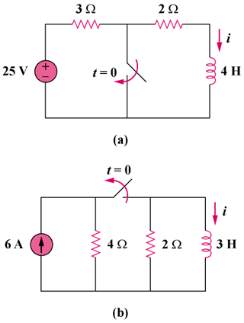

Sol:

(a) Before t = 0, 

After t = 0, no source is connected. We have a natural response 

, 



1. Before t = 0, the inductor acts as a short circuit so that the 2 and 4

resistors are short-circuited.



After t = 0, we have a source free RL circuit.

, 



1. Consider the circuit below. Find *v*0(*t*) if *i*(0) = 2 A and *v*(*t*) = 0.



 





