**Test**

Name:___________________ Student ID:________________________

Question 1

Host A sends a file of 45,200 bytes to Host B over a TCP connection. Assume the maximum segment size (MSS) is 180 bytes. The segment has no options field. The network layer adopts IPv4. The datagram has no options field. The data-link layer adopts PPP with a header of 6 bytes. Assume no bytes are stuffed in each frame. Each packet is sent out over a 100 Mbps link.

1. Explain why TCP can provide reliable file transfer between Host A and Host B.

.

1. What is the size of the first packet?
2. What is the size of the last packet?
3. What is the sequence number (in hexadecimal) of the 32nd segment?
4. Assume no congestion, calculate the time (in msec) required to transmit the file.

Question 2

Consider the SDN OpenFlow network as shown below. Suppose that the desired forwarding behavior for datagrams arriving at s1 is as follows:

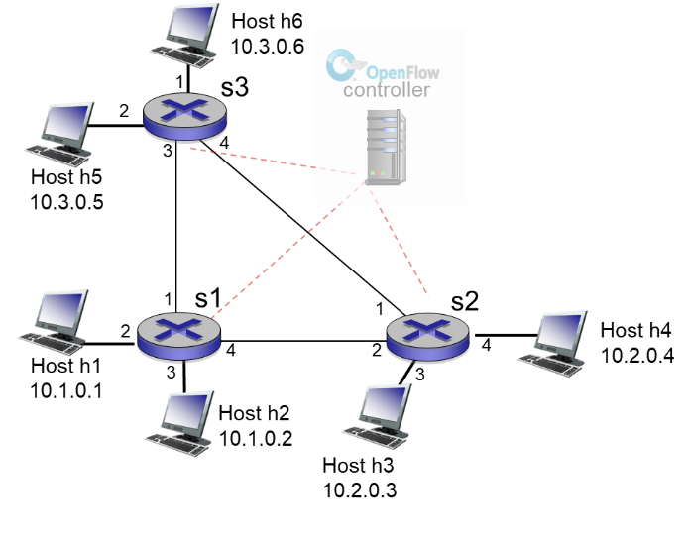

* any datagrams arriving on input port 1 from hosts h5 or h6 that are destined to hosts h3 or h4 should be forwarded over output port 4
* any datagrams arriving on input port 4 from hosts h3 or h4 that are destined to hosts h5 or h6 should be forwarded over output port 1
* any datagrams arriving on input ports 1 or 4 and destined to hosts h1 or h2 should be delivered to the host specified

Specify the flow table entries in s1 that implement this forwarding behavior.

(6 marks)

**Submission**

Enter your name, student ID number, and the answers in the MS Word document file. Submit the file by e-mail (itklchan@cityu.edu.hk) at or before 8:00 pm.

**Only the first submission is counted. All repeated submission(s) are discarded.**

**Use your student ID number as file name, e.g. 12345678.docx. File name not following this format will be deducted 1 mark.**

**Late submission is penalized. See the following table.**

|  |  |
| --- | --- |
| Late time | Penalty |
| > 5 minutes | Deduct 5 marks |
| > 10 minutes | Deduct 10 marks |
| > 15 minutes | Zero mark |