Question 1



$$1101100=100100×11+0 \\ codework=1101100$$

$$1111100=101011×11+1 \\ r\left(x\right)=1$$

$$110110000=111110×1011+10 \\ codework=110110010$$

Single errors can be detected. Because g2(x) has more than 1 term.



$$g\left(x\right)=x^{4}+x^{3}+x^{2}+2x+1 \\ 1101100000=101011×11101+1111 \\ codework=1101101111$$

Question 2







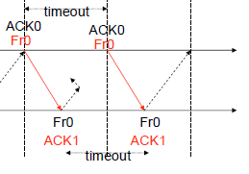

Question 3

$$efficiency=\left(1-\frac{n_{o}}{n_{f}}\right)\left(1-P_{f}\right) \\ =\left(1-\frac{n_{o}}{n_{f}}\right){\left(1-P\right)}^{n_{f}} \\ =\left(1-\frac{200×8}{2048×8}\right){\left(1-{10}^{-4}\right)}^{2048} \\ =73.5231\%$$

Question 4



|  |  |  |  |  |  |  |  |
| --- | --- | --- | --- | --- | --- | --- | --- |
| 1 | 2 | 3 | 4 | 5 | 6 | 7 | 8 |
| BI00 | AI00 | AI11 | AI21 | AREJ1 | AI11 | AI21 | AI31 |







2 old:

